# UC Work Study and Fiscal Workgroup

|  |  |
| --- | --- |
| Monthly Meeting of Best Practices | Thursday- April 6th, 2022 10am – 11am |

|  |  |
| --- | --- |
| Call Details (virtual) | <https://ucla.zoom.us/j/99484639822>  Meeting ID: 994 8463 9822 |
| Participants | On listserve: [ucwsfiscal@lists.ucmerced.edu](mailto:ucwsfiscal@lists.ucmerced.edu) |

Agenda details:

* Questions
  + UCB: I would like to discuss escheatment and garnishment of FWS wages.
    - We reached out to UCPATH ([Shree.Patel@ucop.edu](mailto:Shree.Patel@ucop.edu), [Dianna.Lopez@ucop.edu](mailto:Dianna.Lopez@ucop.edu)) and were recently given a list of uncashed checks that we cross reference to identify those with FWS funds for calendar year 2020 and 2021. We have identified 77 checks with FWS. What are you doing with your uncashed checks with FWS funds. See guidance below from FSA handbook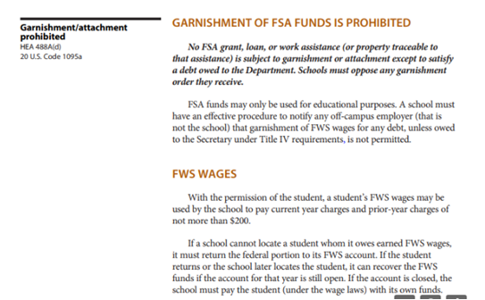
  + UCB: Our campus is about to prevent non Auxiliary funds (including Workstudy Funds) from being associated with Function Code 76 (aka Program Code 76) due to a UCOP rule stating that “Auxiliary Enterprises can only be used with auxiliary funds.”
    - Given that the FC will carry forward from the department funding to the workstudy funding, what are other schools doing about this?
  + UCD/UCB: work-study JIRA ticket 125597 [[UCP-125597] [Go-Forward] Workstudy I-159 Inbound Interface - Correct WS Award / Balance Adjustment logic - UCOP TnTJira](https://tntjira.ucop.edu/browse/UCP-125597)
* A new UCOP rule that effective **June 2023,** Function Code 76 must be used with auxiliary funds. Currently in UCPATH the split follows the department chartstring; if Dept with auxiliary funds start using function code 76, the WS fund, a non auxiliary fund, would inherit the Function code ( aka program code) 76. Our Fiscal and Controls office wants to make sure our WS funds do not inherit that function code 76. How are schools dealing with that?
* One more agenda item. If you are using People Soft campus solutions, are you using WS functionality found in Managing Work-Study> <https://docs.oracle.com/cd/E29376_01/hrcs90r5/eng/psbooks/lsfa/chapter.htm?File=lsfa/htm/lsfa47.htm>?

AdHoc Questions: