Now hiring: Summer forest ecology student assistants

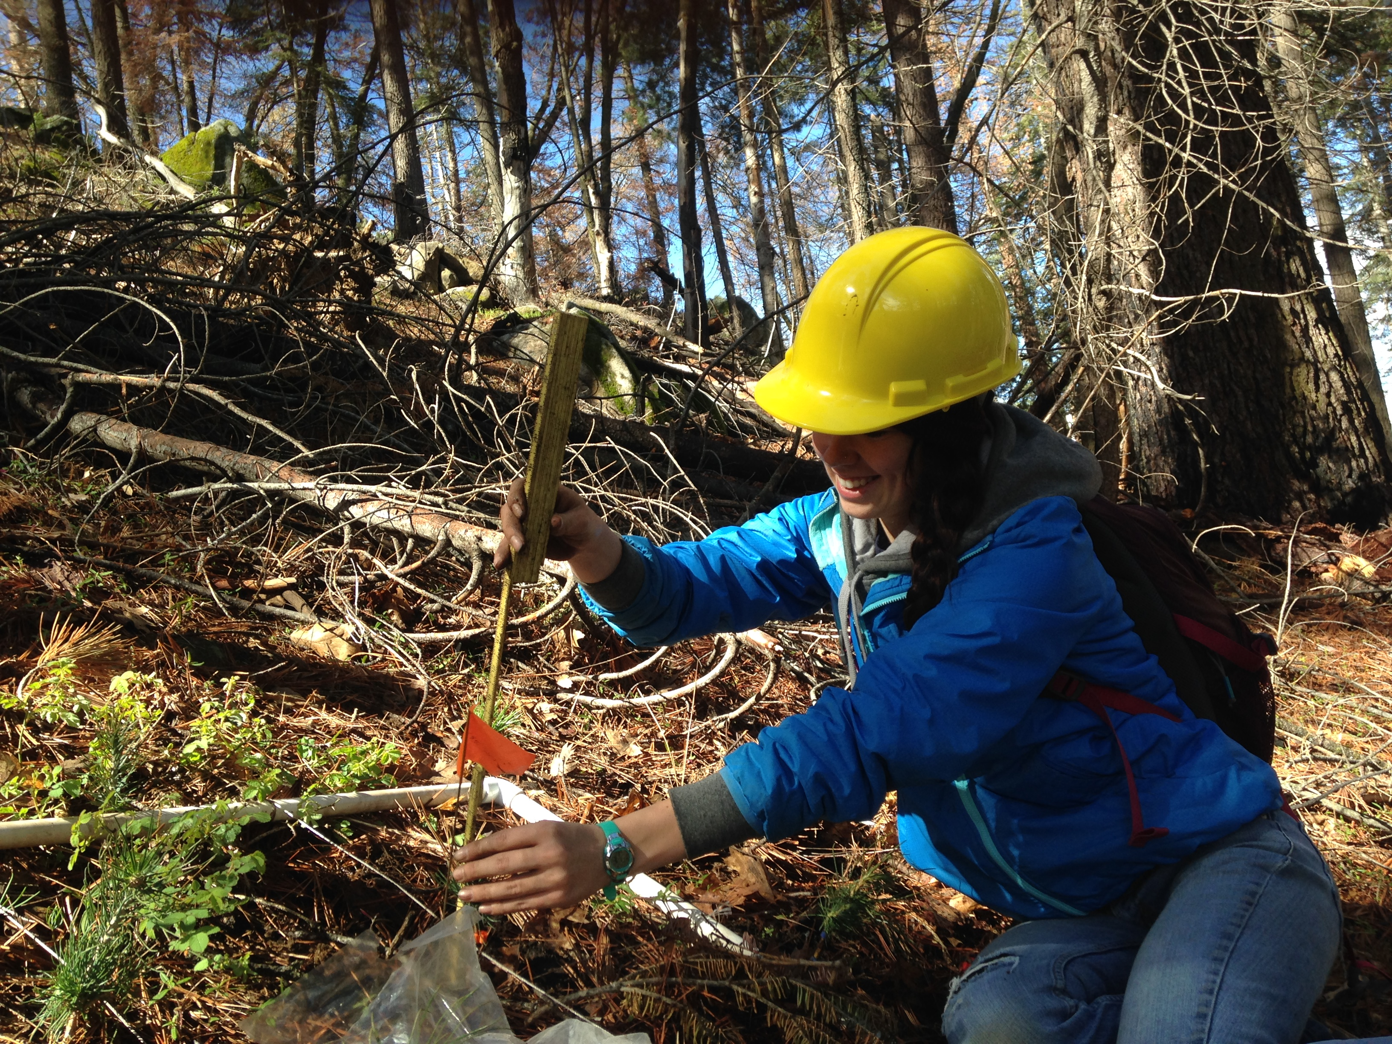

The Moran lab at UC Merced is looking for 2-3 undergraduate students to help with summer field research. Our research projects focus on growth and survival responses of forest trees to changes in their environment, including increasing heat and drought. https://sites.google.com/site/moranplantlab/

Between May 19 and Aug 10, students would work variable hours (average 15 hours/week; some weeks full time, some off) helping to plant seedlings in permanent plots within the Sierra and Tahoe National Forests, and to measure adult trees and natural and planted seedlings in both these plots and a set of plots in Sequoia National Park. Students may also be involved in data entry or analysis.
Hourly pay: $16.16

Required qualifications:
- Available to work full days off-campus for at least 2 consecutive days per week May 19-Aug 10.
- Ability to do sometimes strenuous physical work outdoors where weather conditions can be hot and there is a potential for smoke in the air
- Some prior experience hiking or doing fieldwork
- Driver's license and clean driving record
Preferred qualifications:
- Ability to identify genera of trees (eg. distinguishing pines from firs, oaks, etc.) desirable; species-level knowledge highly desirable
- Camping experience

To apply:
Job is posted on Handshake (https://ucmerced.joinhandshake.com/login ), under Job ID number (6005422)
To ensure full consideration, please submit your application before March 10.

Upload
1) Cover letter detailing:
A) What interested you in this job
B) How you match the required and preferred qualifications
C) How the job relates to your future career goals
D) Two potential references who may be contacted.
2) Your resume or CV

