Influence of drought-associated genetic variants and microbial symbionts on conifer seedling drought response under climate change

- Abstract

Under climate change, increasing drought stress has been linked directly to tree death in tropical and temperate forests and has been indirectly linked to tree death via insect or pathogen outbreaks. As ecologically and economically important tree taxa, conifer mortality tends to be more common in the drier interior forests where mortality from fire, insects, and disease result in higher rates of death. Selecting tree seedling with higher drought tolerance for reforestation may increase forest stability and carbon storage. On one hand, genome–environment associations (GEA) can be used to predict seedlings stress response by associating single nucleotide polymorphism (SNP) alleles and parameters from the accessions’ original environment. On the other hand, symbiotic microbes can influence the growth and survival of plants under drought,could be used alone or in combination with genetic selection to increase seedling drought tolerance. However, few studies have investigated how the interaction of genotype and microbiome influence drought response in trees. The goal of this study is to is to gain a synthetic understanding of conifers’ drought response based on both genotype and microbial community so as to better predict forest responses to changing climate. Specifically, I aim to investigate 1) whether rare surviving Abies religiosa seedlings planted in a dry common garden share genetic variants linked to drought-tolerance 2) whether GEA can predict Pinus ponderosa seedlings’ survival and growth in a post-fire planting better than source population alone and 3) how the interation between genotype and inoculation with dry-site vs. wet-site microbiomes affects P. ponderosa seedling’s drought responses. The results of this study will help identify seedling sources and seedling inoculation sources for forest management and conservation under increasing drought stress.

- Introduction

  - Background

Conifers are ecologically important taxa in temperate regions around the world, particularly in northern temperate and Mediterranean regions as well as often being important timber species (Li et al. 2021). Dry coniferous forest types are common throughout the western United States, especially occurring on relatively moisture-limited sites at lower elevations, including the Rocky Mountains, the Black Hills, and the Sierra Nevada (Peet 1988; Burns and Service 1990).

As one of the largest terrestrial carbon reservoirs, conifer forest can sequester carbon in their own biomass as well as in the soil which prevents increases in atmospheric CO₂ concentrations(Gurmesa et al. 2013; Laclau 2003; Frouz et al. 2009). Summed over the land area of the US, forests sequester 148-204 Tg year ⁻¹ of carbon, which would offset 10-19% of the annual fossil fuel emissions in the US(Powers et al. 2013; Birdsey, Pregitzer, and Lucier 2006; Woodbury, Smith, and Heath 2007). Particularly, in well-developed forest soils more soil organic carbon is stored under coniferous than broadleaf trees presumably because conifer litter decomposes more slowly than broadleaf litter(Hüblová and Frouz 2021). However, climate change is increasing drought stress on forests, becoming a major threat to the stability and function of forests around the world, including conifer-dominated systems (O’Brien et al. 2017).

The California drought of 2012–2016 was among the most severe in the past millennia and was especially notable for its magnitude and impacts on forest ecosystems (Lund et al. 2018; Stephenson et al. 2018). From 2010 to 2017, over 129 million trees died during this drought, largely in the southern Sierra Nevada Range from drought and the compound effects of drought and insect outbreaks (Zald et al. 2022).This drought event not only resulted in significant mortality of ecologically important large pine trees but also caused forest carbon stores disruption and forest carbon debt reallocation, creating fuel conditions conducive to more extreme fire behavior(Kern, Su, and Hill 2020). With declines in winter snowpack as well as increase in drought frequency and intensity in future, it is needed to develop forest management strategies to reduce the effects of drought on forest mortality and ecosystem services(Livneh and Badger 2020).

One of the efficient forest management strategies is the selection of drought-tolerant species and genotypes for use in reforestation after fire, harvest, or other disturbances (Clark et al. 2016). Because of their long time to reproductive maturity and large physical size, traditional trait-based breeding is much more difficult for trees than agricultural crops (Lebedev et al. 2020). In the USA, one cycle of pine species improvement with classical methods can take about 30 years (Harfouche et al. 2012). Due to advances in next generation sequencing and the use of large amounts of SNP markers, genomic selection(GS) become a popular tree seeding selection methods with shorter period and higher accuracy. Lots of studies based on GS for resistance to stresses have been conducted to date, including diseases(Torkamaneh, Laroche, and Belzile 2016), pests(Lebedev et al. 2020) and drought(Bouvet et al. 2020; Laverdière et al. 2022). For drought stress, genomic studies have demonstrated that genome–environment associations (GEA) can be used to identify adaptive loci and predict phenotypic variation(Savolainen, Lascoux, and Merilä 2013; Cortés and Blair 2018).

Widespread tree species often show local adaptation to climate and associated genetic differences(McKenney, Mackey, and Joyce 1999; Gross, Fatemi, and Simpson 2017). However, tree genetic adaptation is not the only factor influencing seedling drought responses (Bucharova 2017), and seeding reforestion could be limited by maladaptation to local microbes(Kranabetter, Stoehr, and O’Neill 2015). It has been shown that the inoculation with ectomycorrhizal fungi (EMF) and plant growth-promoting bacteria (PGPB) can enhance drought tolerance in tree seedlings (Wang et al. 2021; Tiepo et al. 2018). However, certain plant genes could play a role in shaping drought tolerance indirectly, through influencing the plant’s microbiome (Johnson et al. 2012). Gehring et al. (2017) illustrated that tree genetics could influence tree responses to drought by strongly determining its EMF community and particular combinations of plant genotype and mutualistic EMF communities can improve the survival and growth of trees with drought.

Most studies to date have focused on either tree genotype or tree microbial symbionts, but how these two factors simultaneously shape the tree seedling drought response under climate change remains unknown. Thus, a full understanding of the conifer drought responses requires consideration of the interactions between genetic variants, microbial symbionts and climate variables.

  - Study Goal

To gain a synthetic understanding of conifers’ drought response based on both genotype and microbial community so as to better predict forest responses to changing climate. Specifically, to investigate:

1) whether rare surviving Abies religiosa seedlings planted in a dry common garden share genetic variants linked to drought-tolerance.
2) whether GEA can predict Pinus ponderosa seedlings’ survival and growth in a post-fire planting better than source population alone and
3) how the interation between genotype and inoculation with dry-site vs. wet-site microbiomes affects P. ponderosa seedling’s drought responses.

The results of this study will help identify seedling sources and seedling inoculation sources for forest management and conservation under increasing drought stress.

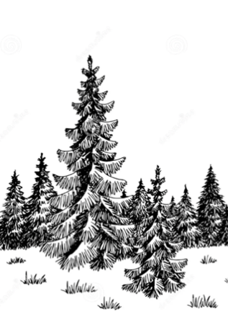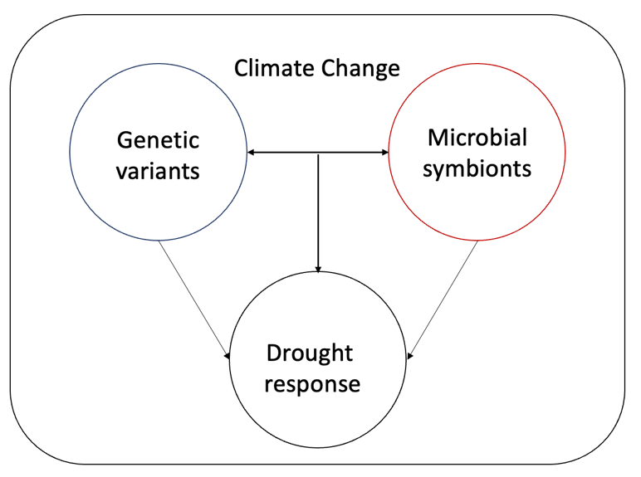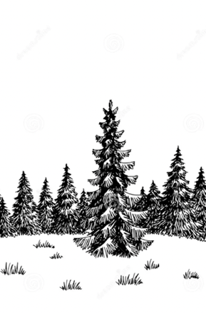

Figure 1 Genotype and microbial symbionts shape conifer drought response simultaneously under climate change

- Research plan
Chapter 1 Genetic variation among survivors of heat/drought stress in Abies religiosa versus initially planted populations.

Background
The sacred fir (Abies religiosa) is an important species for Mexican biological conservation because it provides the overwintering sites of the monarch butterfly (Danaus plexippus L.) from November to March (A.L. Cruzado-Vargas et al. 2021). The dense needles of A. religiosa provide a moderate temperature for butterflies under conditions where they would otherwise overheat or freeze (Anderson and Brower 1996). A. religiosa is widely distributed within the Trans-Mexican Volcanic Belt, at between 2400 and 3600 m a.s.l. and mostly between 19° and 20° in latitude North(A.L. Cruzado-Vargas et al. 2021). However, like forests in California, forest disturbances in monarch butterfly reserves have been directly favored by climate change, with storms, droughts, and bark beetle outbreaks casing the death for numerous trees (Gómez-Pineda et al. 2022). Understanding the difference of climate response between various population of trees plays an important role in selecting appropriate seed sources for reforestation (Ana L. Cruzado-Vargas et al. 2020).

Previous studies in firs have indicated genetic variation in drought tolerance. After sampling European silver fir (Abies alba Mill.) trees from pairs of high- and low-elevation plots on four different mountains, Roschanski et al revealed 16 SNPs which were associated with winter drought, and one of them showed strong evidence of selection with respect to elevation (Roschanski et al. 2016). Irene Cobo-Simón found SNPs related to drought resilience in Abies pinsapo, suggesting candidate genes involved in its drought adaptive capacity(Fady et al. 2020).

Dr. Cuauhtémoc Sáenz-Romero of the Universidad Michoacana de San Nicolás de Hidalgo, in Morelia, Mexico, has been studying Abies religiosa and the potential for assisted migration – moving a species or genotype into an area that is becoming climatically suitable for it due to warming – for many years. Recently he found that survival of all populations of firs seedlings was high when planted at 3000 and 3400 m sites, but most died at 2600 m. We found that, in the high- and mid-elevation gardens, seedlings transferred 125 m upward relative to their source had optimal survival at the higher elevation gardens (Figure 2), suggesting that climate change has already caused moderate maladaptation to local conditions. However, a few seedlings out of multiple moderate-to-low elevation populations could still survive and thrive in the low-elevation gardens. High-elevation (3364-3552 m) seedlings were more likely to die, yet some high-elevation seedlings did survive, which raises the question of what is different about these individuals.

For this chapter, we will be comparing the genotypes of seedlings that survived at low elevations to those from the high survival upper gardens (which will be used to represent the initial allele frequencies) to identify loci under selection. The SNPs that are at elevated frequency in low elevation survivors will be compared to sequence databases to see whether they are in genes known to be associated with drought- or heat-responses. We will also conduct a genotype-environment analysis (GEA) using the different source populations to identify loci associated with climate variation along this elevation transect.

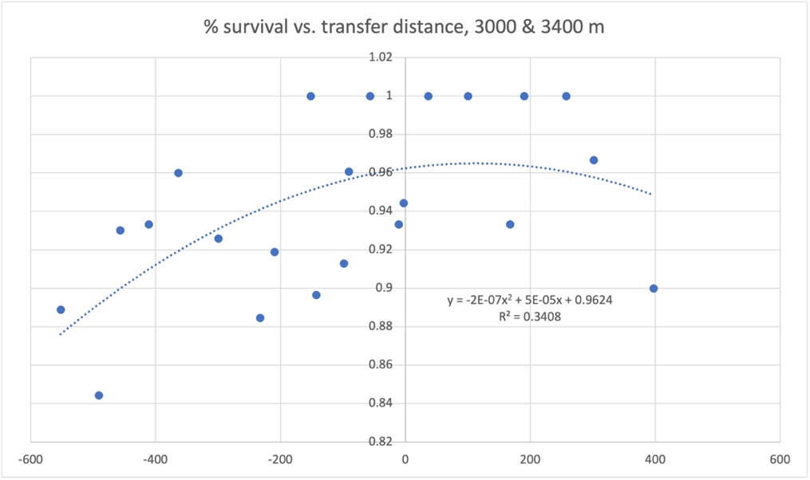
Figure 2. Population survival rate versus elevation transfer distance for Abies seedlings at in 3000 to 3400m common gardens

Questions
Q1.1 Do Abies religiosa populations from different elevations exhibit genetic differences indicative of adaptation to local climate?
Q1.2 Is survival at hotter low-elevations site linked to particular genetic variants?

Hypotheses
H1.1 Genetic differences indicating response to climate change will be found between A. religiosa populations from different elevations.
H1.2 There will be higher frequency SNP alleles associated with drought response in low elevation garden survivors relative to their source populations, indicating that the extreme conditions selected for these variants.

Methods
Needle samples were collected for all surviving seedlings from the low elevation garden (N=17) and 17-20 individuals per source population (N=217). Because survival at higher-elevation gardens was near 100%, these latter seedlings will be used to represent the “starting populations”. Needle samples were dried over silica gel and shipped to UC Merced where we extracted their DNA using DNeasy plant DNA extraction kits. The samples will be sent to the UC Davis genome center for genotyping by sequencing (GBS).

We will then identify SNPs by using Stack software package with de novo approach (Catchen et al. 2011) because there is no assembled Abies genome with which to align reads. We will filter seedling SNPs to include only diallelic sites present in at least 95% of individuals with minimum mean coverage depth of 5 and minor allele frequency (MAF) ≥ 0.10 (Martins et al. 2018). Climate variables will be downloaded for the source populations from the Digital Climatic Atlas from Mexico, and then we will perform GEA to test for associations between SNPs and climatic gradients using a latent factor mixed model implemented in LFMM2.

The seedlings survival rate of high elevation is close to 100%, so we will call these individuals the “initial planting” while the survivors in low elevation will be called “survivors”. The Fst values will be calculated using VCFtools (-FST-window-size 500,000 -FST-window-step 50,000) to test how the survivors are genetically different from the initial planting(Du et al. 2023). Furthermore, VCFtools will be used to investigate the genetic diversity of these two groups, including expected heterozygosity (He), observed heterozygosity (Ho), and nucleotide diversity (Pi).

For SNPs found to be significantly associated with climate, and those found to be at elevated frequency among survivors of the hot, dry garden site, we will identify putative functions of the genes they are linked to using a search of database at the NCBI (National Center for Biotechnology Information) (USA) with minimum e-value of <1.0 × 10⁻⁶ as the threshold to extract the Gene Ontology (GO) terms associated with the blasted hits using the program Blast2GO(Conesa et al. 2005). The three major GO terms, cellular component (CC), biological process (BP), and molecular function (MF) will be determined with the e-value hit filter < 1.0 × 10⁻⁶. Finally, details of the pathway annotation with these SNPs will be produced using the KEGG (Kyoto Encyclopedia of Genes and Genomes) database.

Border impact
The genetic data can be added to GenBank, which provides a jumping-off-point for future studies since there has been little genetic work done to date on Abies religiosa or other members of its genus. Since the environmental challenges facing California and Mexico are similar, the results of this project can be applied to the forest in the western United States. Moreover, this project can also develop international collaboration with Dr. Saenz-Romero who is a leading expert in the field of assisted migration.

Chapter 2 Testing predictive ability of climate-associated SNPs in post-fire restoration plantings.

Background
There has been much emphasis placed on the restoration of ponderosa pine (Pinus ponderosa) and dry mixed-conifer forests in the last several decades in the western United States(Addington et al. 2018). Pinus ponderosa and mixed-conifer forests are the predominant montane forest type in the Sierra Nevada, southern Cascade Range, and neighboring forested areas on the Modoc and Inyo National Forests(Safford and Stevens 2017). The contemporary forest management template for these forest types is being altering by the increasing incidence of wildfires across the southwestern United States (US)(Stevens et al. 2021). Under the increasing frequency and severity of fire and drought events, selecting seedings for reforestation has great significance, typically for post-fire management(Williams and Dumroese 2013). Forest managers need to understand what kind of seedings can better survive under changing climate in the postfire environment, especially following high severity fires, so that forests might be better managed for long-term sustainability and resilience in a changing world(Welch, Safford, and Young 2016).
Compared to traditional breeding and molecular biology methods, "climate matching" is a straightforward and economical way to select tree seedlings which involves choosing seeds populations that, when parent trees were establishing, had climatic conditions similar to those at the planting site(Prober et al. 2015; Ruiz-Talonia et al. 2014; O’Neill 2017; McKenney, Mackey, and Joyce 1999). However, the seeds selected by climate matching might not be adapted to the soil, photoperiod or species interactions in planting site (Way and Montgomery 2015). Genetic association studies could be employed to pick source trees from among more local sources whose offspring are likely to perform well under future climate but also carry other locally favored alleles(Wilcox, Echt, and Burdon 2007; Pluess et al. 2016). Even though the number of sequenced tree genomes remains low, using close relatives’ genome sequence as reference and getting partial genetic information can yield information predictive of performance under dry or hot conditions(Nystedt et al. 2013; Jaramillo-Correa et al. 2015). It was found that the frequency of 18 SNPs associated with hot/dry conditions within a population predicted survival in a garden at the hot/dry end of this species' range(Jaramillo-Correa et al. 2015). By aligning genetic sequence to Pinus lambertiana genome, 494 of the identified outlier SNPs strongly associated with climate variables predicted Sierra Nevada whitebark pine (Pinus albicaulis Engelm) forest drought response(van Mantgem et al. 2023).
Dr. Jessica Wright’s team (USDA Forest Service) has been conducting a planting experiment which mixed the locally-sourced seedlings with other seedlings from higher and lower elevation at three planting sites within the 70,944 acres burn scar of the King fire. The sites are located at elevations of 4,400 to 4,800 feet within seed zone 526. Source trees included genotypes from the planting site seed zone but also the neighboring seed zones (525 and 531) within the local breeding zone. Seedlings were planted using standard operational planting techniques, with 100 trees per acre approximately 20 feet apart. The sites were revisited each summer by teams of UC Merced undergraduates or Forest Service volunteers who measured the height, basal diameter, and proportion of live needles for all the seedlings they were able to locate. In 2020, the field team also collected needle samples from any seedlings where these samples could be collected without undue injury to the seedling. These samples were labeled and dried over silica gel for later genetic analysis. A prior analysis by Moran-lab PhD student Mengjun Shu identified SNPs associated with source-climate variation in ponderosa pine, and associated with drought responses of seedlings in the greenhouse(Shu and Moran 2023).
In this chapter, we will select seedlings cover the full range of different elevation bands in seed zones to do the genotypes sequencing. Then we will examine the samples’ genotypes at SNPs which were previously found to be associated with source-climate variation in ponderosa pine (Shu and Moran 2023). These overlapping loci will be defined as climate-associated locus whose allele frequency will be calculated for the 488 samples. Then genotypes whose source climate source is similar to current climate will be identified. The allele in these trees with higher frequency than in all the samples will be treated as locally favored. Seedlings will be scored by the number of locally favored locus. Finally, we will use multivariate statistical models to test whether geographical source or genotype better predicts seedling growth and survival.

Questions
Q2.1 Do climate associated SNPs help predict survival in post-fire planting more than geographical source?
Q2.2 Are the climate variables that were most often associated with genetic variation in wild populations the same ones that best predict survival or growth of planted seedlings?

Hypotheses
H2.1 Models including the number of climate associated SNPs will outperform models with geographic source as a predictor.
H2.2 Because April 1st snowpack and minimum winter temperature were associated with the highest number of SNPs in the wild, the values of these climate variables during the experiment will also be important in the survival and growth models.

Methods
Open-pollinated seeds were collected in the Forest Service Nursery located in Placerville, CA and bulked by low, medium, and high elevation bands before propagation. “Low” was defined as 2,500 - 4000 ft, “medium” as 4,001-5,000 ft, and “high” as 5001-6,000 ft. In order to ensure seedlings samples covering the full range of current home site climates, 488 individuals were selected for genetic sequencing. The survival and growth data for these individuals were collected.For the SNPs data, ApeKI will be as a restriction enzyme. 48-plex GBS libraries will be sequenced using an Illumina HiSeq 4000 platform. The best-performing pipeline - in terms of producing a large number of SNPs with a low percentage of paralogs - was Stacks with the P. taeda genome used as a reference (Shu and Moran, 2023). We therefore used this approach to test the genotypes for 488 Pinus ponderosa planting seedlings and identify their SNPs with the P. taeda genome as a reference.

For the source climate information, we chose 1921-1950 time period because it better approximates the conditions under which the wild trees that were grafted into the orchard became established and underwent selection as seedlings and saplings. For the planting site climate data, we chose 1991-2020 climate averages as “current climate”. All the climate data will be obtained from the California Basin Characterization Model (CA BCM), which downscales PRISM data to a 270 m grid (Flint et al. 2013).

We will examine the samples’ genotypes at SNPs which were previously found to be associated with source-climate variation in ponderosa pine. The overlapping SNPs will be treated as candidate loci to predict the seedling performance. Then we will define the locally favored alleles. Allele frequency at each climate-associated locus will be calculated for the entire samples. We will identify tree genotypes that come from climates that, for 1921-1950 are within 0.2 standard deviations of the average planting site climate in 1991-2020 for each of the climate variables. If the frequency for an allele is higher in trees from climates similar to the planting site than it is in the samples from across California, this was considered a “locally advantageous allele”. The number of these alleles for that locus (0, 1, or 2) will be calculated for each individual.

For each set of climate-associated loci, the proportion of locally favored genotype will be calculated for each individual in two ways:

$FG1= \frac{2h_{o }+h_{e } }{2T.g}$ (eq. 1)
$FG2= \frac{h_{o }+h_{e } }{T.g}$ (eq. 2)
where T.g is the number of loci genotyped for that individual, h_{o} is the number of those loci homozygous for the favored allele, and he is the number of loci heterozygous for the favored allele. FG1 assumes that allele effects tend to be additive, with the effect of two copies of the favored allele being twice as good as having a single copy. FG2, on the other hand, reflects whether an individual has the locally favored allele or not, rather than how many copies it has.

To further investigate the effects of source elevation or genotype in the context of other factors influencing seedling survival and growth, we used a similar Bayesian generalized linear modeling framework as Moran et al. (2019) and Moran et al. (2017). A simple linear mixed model will be used to get height growth rate from living individuals. Survival is treated as Bernoulli processes, with 1 denoting survival and 0 mortality. Some predictors, including site, are coded as indicator values: 1 if the seedling belongs to that group and 0 if it does not. Other variables such as last year’s height, local or source climate, and number of loci with locally favored alleles are treated as continuous.

Because sites were planted in separate years, it is not able to separate site from planting year effects; these will henceforth simply be referred to as “site” parameters, which will be included in all tested models (Table 1). As much of the mortality in seedlings often occurs in the first year of establishment, while older seedlings have higher survival rates, seedling age will be also included in all models. Other factors that were tested include height in previous year (LastHeight), local site climate variables in current year (LocalClim), source elevation band (Source), and number of loci with locally favored alleles (Genotype). Predictive Loss will be used to determine which combination of predictor variables best explained the results(GELFAND and GHOSH 1998).

Model name | Variables
S0, G0 | Site + Age
S1, G1 | Site + Age + LastHeight
S2, G2 | Site + Age + LocalClim
S3, G3 | Site + Age + Source
S4, G4 | Site + Age + Genotype
S5, G5 | Site + Age +LocalClim + LastHeight +Source
S6, G6 | Site + Age +LocalClim + LastHeight+Genotype
Table 1: Models tested. (S refers to survival, G to growth)

Border impact
The model testing result might could applied to other tree species for selecting climate-resilient seed sources for restoration plantings. Code for the full statistical models and input files for seedling data and climate will be published on Github (https://github.com/emoran5/PILA_post-fire_seedling_model). Raw DNA sequencing data will be made available at the National Center for Biotechnology Information (NCBI) and individual SNP genotypes will be made available on Dryad (https://doi.org/10.6078/D1MH7P).

Chapter 3 Manipulate seedling microbiome to test the combinational effects of genetic background and microbiome on pine drought response.

Background:
It is increasingly recognized that tree drought response is strongly influenced by symbiotic microbial communities(Kristy et al. 2022; Gorzelak et al. 2015; Bolton, Ivory, and McDowell 2013).Inoculation with microbial communities from dry environments can increase plant biotic and abiotic stress tolerance(Zhou et al. 2021; Boczoń et al. 2021). Beside the adaptive changes of plant traits due to natural selection, the changes of microbial community can also drive the trees’ positive responses to drought stress(Griffin-Nolan et al. 2021). The microbial communities with functional relevance for tree drought tolerance can be separated into two groups - mycorrhizae and endophytes.

The term mycorrhizae mean "fungus root" and can be defined as a beneficial symbiotic association between plant roots and specific soil fungi(Janerette 1991). The associations between trees and mycorrhizal fungi can enhance tree performance by different mechanisms. These associations will improve water and nutrients uptake under conductive conditions and improve tree resilience to nutrient deficiency, water scarcity, or soil-borne pathogens under limited conditions(Ouledali et al. 2018; Fouad et al. 2014; Tekaya et al. 2022). Ouledali et al illustrated that inoculation arbuscular mycorrhizal fungi (AMF) can improve turgor potential, stomatal function and mineral uptake (K, N, Zn, and Fe) for olive trees(Ouledali et al. 2018). Wang et al. showed that the inoculation of Pinus tabulaeformis with the ectomycorrhizal (ECM) Suillus variegatus could improve seeding mortality rate, height, root and leaf biomass when subjected to severe drought stress (Wang et al. 2021).

Endophytes are organisms living as symptomless colony, maybe during a part of their life cycle, inside the host plants(Arora and Ramawat 2017). Endophyte bacteria and fungi can influence the survival, growth, and health of trees (Terhonen et al. 2019). These interactions might be positive or negative. In some cases, water stress to trees can turn the innocuous endophytes into phytopathogens which will cause infection symptoms in trees (Terhonen et al. 2019). However, other endophytes can trigger host defense systems and enhance tree drought tolerance by improving the elasticity of plant cell walls(Malinowski and Belesky 2000), up-regulating the antioxidant system(Hamilton and Bauerle 2012), and producing indoleacetic acid and gibberellin (Ferus, Barta, and Konôpková 2019). The ability of endophytic fungus Beauveria bassiana in mitigating drought stress in dehydrated red oak seedlings, which manifested as a smaller decrease in leaf stomatal conductance, low free proline concentration (Ferus, Barta, and Konôpková 2019).

Certain plant genes could play a role in shaping drought tolerance indirectly through influencing the plant’s microbiome(Johnson et al. 2012; Gehring et al. 2017)It is highlighted that the mechanism of the associations between EMF colonization and plant genotypes might help tree recover from drought (Swaty et al. 2004; Griffin-Nolan et al. 2021). Few studies have examined the influence of genotypes and microbial communities on tree seedling drought responses. Thus, we want to gain an understanding of the combinational influence of gene and microbes on pine seedling drought response so as to better predict forest responses to changing conditions and inform restoration practices. In this chapter, we will collect the seeds with varying genetic drought resilience, as determined by previous analyses, germinate them in the greenhouse, and inoculate the resulting seedlings with arid-site vs. mesic-site microbial communities. The drought tolerance of these seedlings will then be tested.

Questions
Q3.1 Does inoculation with microbes from dry vs wet sites modify drought responses?
Q3.2 Is there an interactive effect between genotype and microbiome effects on seedling drought tolerance?

Hypothesis
H3.1 Inoculation of microbes from dry sites will result in higher performance for seedling drought tolerance in greenhouse experiments.
H3.2 Combination of genotypes and microbial symbiont by soil can better predict the pine seedlings survival and growth than microbial symbiont by soil in a greenhouse.

Methods
Soil samples, leaves, and litter will be collected from four field sites across CA that differ most in precipitation, and the two that differ most in climatic water deficit (CWD) within the ponderosa pine range, resulting in 4 soil treatments. Four families of ponderosa pine seeds from the Chico seed orchard that showed the two highest and two lowest levels of drought tolerance in the prior greenhouse experiment(Wu, Shu, and Moran 2023; Shu and Moran 2023). Seedlings will be collected during summer 2024, surface-sterilized, and stratified (soaked and put into refrigerator for 2 months). During 2024 fall, seeds will be grown in the greenhouse in tubes 1.4 m long with an 8 cm diameter. Ponderosa pine seedlings were previously observed to grow > 1 m of root length within the first year(Shu 2020; King, Thomas, and Strain 1997); this custom pot design allows for a root: shoot allocation of growth more closely resembling wild seedlings than standard nursery-grown seedlings. There will be 90 seedlings from each family in both wet and dry treatments, 360 seedlings in total.

Germinating seedlings will initially be separated by soil treatment to prevent contamination, sprayed with the inoculum which will be mixed in a 10:90 ratio with autoclaved high sand growing medium, with a portion of each field sample being sterilized and mixed with sterilized soil from the other sites to create a control(Cheeke et al. 2019). A thin layer of crumbled leaves and litter will distribute across the soil surface (Whitaker et al. 2017). Control seedlings will be treated with heat-killed leaves, litter, and spray(Cheeke et al. 2019). Seedlings will be randomized by family into 4x3 blocks of 12 tubes (3 replicates per family), each representing one of the 3 soil treatments, and the soil treatment blocks randomized within the greenhouse. After inoculation, half of the treatment seedlings will be kept moist (watered 2x/week), while half will be subjected to drought (watered every 2 weeks). The drought treatment process will last 8 weeks. Watering will be directly onto soil via a drip system, to avoid cross-contamination of microbes between treatments.

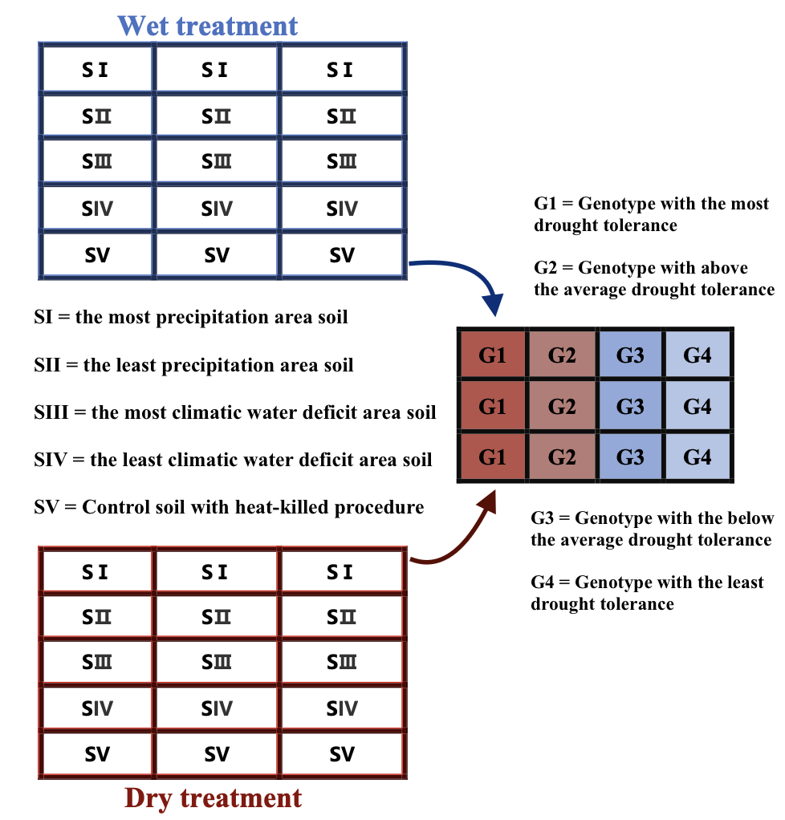
Figure 3 Design for seedling greenhouse experiment

Survival will be recorded each week, and height growth, maximum rooting depth, and root & shoot dry mass will be measured for all seedlings at the end of the treatment period. Leaf water potential (Ψ_{leaf}) will be measured on needles, using a Scholander pressure chamber (PMS Inc., Corvallis, OR USA). Measurements will be made on four fascicles (two needles per fascicle) on the upper crown. Environmental parameters will be keeping constant over the experiment to keep environmental conditions in the greenhouse similar to those in the rest of the canopy.

One-way ANOVA (Analysis of Variance) will be used to test which traits are strongly related to drought response by comparing the data from wet and dry treatment. Strong associated traits will be selected as dependent variables which are continuous. For the data of selected traits, their univariate outliers will be detected by using boxplots. Genotypes and microbial symbiont will be treated as independent variables to test its influence for selected traits separately by using two-way ANOVA. As the independent variables, genotypes will consist of 4 categorical groups (four family seedlings) while microbial symbionts will consist of 3 categorical groups (five soil types).

Two-way multivariate analysis of variance (two-way MANOVA) is often considered as an extension of the two-way ANOVA, which will be used to test the combinational influence of gene and microbes for selected traits. Normality of each of the dependent variables for all combinations of the groups of two independent variables will be tested in SPSS by using the Shapiro-Wilk test of normality, which will also predict whether there is multivariate normality for two-way multivariate analysis. Akaike information criterion (AIC) will be used to test whether the combination of genotypes and microbial symbiont can better predict the seedling drought response.

Broader impact
If inoculation with microbial communities from dry environments enhances tree seedling drought responses, this approach could provide information to boost the success of restoration plantings, with or without assisted migration of tree genotypes. Moreover, if local climate influences ponderosa pine-associated microbial communities, we will use that relationship - and any other significant environmental predictors, such as tree community composition – and future climate projections to map potential changes in pine microbial communities in California by 2100(Steidinger et al. 2020).

References
Addington, Robert, Gregory Aplet, Mike Battaglia, J.S. Briggs, Peter Brown, A.S. Cheng, Yvette Dickinson, et al. 2018. “Principles and Practices for the Restoration of Ponderosa Pine and Dry Mixed-Conifer Forests of the Colorado Front Range.” USDA Forest Service - General Technical Report RMRS-GTR 2018 (January): 1–121.
Anderson, J.B., and L.P. Brower. 1996. “Freeze-Protection of Overwintering Monarch Butterflies in Mexico: Critical Role of the Forest as a Blanket and an Umbrella.” Ecological Entomology 21: 107–16.
Arora, Jaya, and K. G. Ramawat. 2017. “An Introduction to Endophytes.” In Endophytes: Biology and Biotechnology: Volume 1, edited by Dinesh K. Maheshwari, 1–23. Sustainable Development and Biodiversity. Cham: Springer International Publishing. https://doi.org/10.1007/978-3-319-66541-2_1.
Birdsey, Richard, Kurt Pregitzer, and Alan Lucier. 2006. “Forest Carbon Management in the United States.” Journal of Environmental Quality 35 (4): 1461–69. https://doi.org/10.2134/jeq2005.0162.
Boczoń, Andrzej, Dorota Hilszczańska, Marta Wrzosek, Andrzej Szczepkowski, and Zbigniew Sierota. 2021. “Drought in the Forest Breaks Plant–Fungi Interactions.” European Journal of Forest Research 140 (6): 1301–21. https://doi.org/10.1007/s10342-021-01409-5.
Bolton, D.J., C. Ivory, and D.A. McDowell. 2013. “The Effect of Urea and Ammonia Treatments on the Survival of Salmonella Spp. and Yersinia Enterocolitica in Pig Slurry.” Journal of Applied Microbiology 114 (1): 134–40. https://doi.org/10.1111/jam.12003.
Bouvet, Jean-Marc, Chrissy Garel Makouanzi Ekomono, Oliver Brendel, Jean-Paul Laclau, Jean-Pierre Bouillet, and Daniel Epron. 2020. “Selecting for Water Use Efficiency, Wood Chemical Traits and Biomass with Genomic Selection in a Eucalyptus Breeding Program.” Forest Ecology and Management 465 (June): 118092. https://doi.org/10.1016/j.foreco.2020.118092.
Bucharova, Anna. 2017. “Assisted Migration within Species Range Ignores Biotic Interactions and Lacks Evidence.” Restoration Ecology 25 (1): 14–18. https://doi.org/10.1111/rec.12457.
Burns, Russell M., and United States Forest Service. 1990. Silvics of North America. U.S. Department of Agriculture, Forest Service.
Catchen, Julian M, Angel Amores, Paul Hohenlohe, William Cresko, and John H Postlethwait. 2011. “Stacks: Building and Genotyping Loci De Novo From Short-Read Sequences.” G3 Genes|Genomes|Genetics 1 (3): 171–82. https://doi.org/10.1534/g3.111.000240.
Cheeke, Tanya E., Chaoyuan Zheng, Liz Koziol, Carli R. Gurholt, and James D. Bever. 2019. “Sensitivity to AMF Species Is Greater in Late-Successional than Early-Successional Native or Nonnative Grassland Plants.” Ecology 100 (12): e02855. https://doi.org/10.1002/ecy.2855.
Clark, James S., Louis Iverson, Christopher W. Woodall, Craig D. Allen, David M. Bell, Don C. Bragg, Anthony W. D’Amato, et al. 2016. “The Impacts of Increasing Drought on Forest Dynamics, Structure, and Biodiversity in the United States.” Global Change Biology 22 (7): 2329–52. https://doi.org/10.1111/gcb.13160.
Conesa, Ana, Stefan Götz, Juan Miguel García-Gómez, Javier Terol, Manuel Talón, and Montserrat Robles. 2005. “Blast2GO: A Universal Tool for Annotation, Visualization and Analysis in Functional Genomics Research.” Bioinformatics 21 (18): 3674–76. https://doi.org/10.1093/bioinformatics/bti610.
Cortés, Andrés J., and Matthew W. Blair. 2018. “Genotyping by Sequencing and Genome–Environment Associations in Wild Common Bean Predict Widespread Divergent Adaptation to Drought.” Frontiers in Plant Science 9. https://www.frontiersin.org/articles/10.3389/fpls.2018.00128.
Cruzado-Vargas, A.L., A. Blanco-García, R. Cisneros, M. Gómez-Romero, L. Lopez-Toledo, E. de la Barrera, and C. Sáenz-Romero. 2021. “Reciprocal Common Garden Altitudinal Transplants Reveal Potential Negative Impacts of Climate Change on Abies Religiosa Populations in the Monarch Butterfly Biosphere Reserve Overwintering Sites.” Forests 12: 69.
Cruzado-Vargas, Ana L., Francisco J. Zamudio-Sánchez, Gabriel A. Rodríguez-Yam, Aglaen L. Carbajal-Navarro, José A. Blanco-García, Cuauhtémoc Sáenz-Romero, Ana L. Cruzado-Vargas, et al. 2020. “Growth of Naturally Regenerated Abies Religiosa (Kunth) Schltdl. & Cham. Seedlings in a Nursery and Genetic Variation among Provenances.” Revista Chapingo Serie Ciencias Forestales y Del Ambiente 26 (1): 85–96. https://doi.org/10.5154/r.rchscfa.2019.01.013.
Du, Tingting, Hangyu Qi, Ke Lin, Xin Peng, Quanxin Gao, Guoliang Yang, Shaokui Yi, and Qiongyin Tang. 2023. “Comprehensive Evaluation of Germplasm Resources of Nine Macrobrachium Rosenbergii Strains in China.” Aquaculture Reports 33 (December): 101755. https://doi.org/10.1016/j.aqrep.2023.101755.
Fady, Bruno, Filippos Aravanopoulos, Raquel Benavides, Santiago González-Martínez, Delphine Grivet, Martin Lascoux, Marcus Lindner, Christian Rellstab, Fernando Valladares, and Barbara Vinceti. 2020. “Genetics to the Rescue: Managing Forests Sustainably in a Changing World.” Tree Genetics & Genomes 16 (6): 80. https://doi.org/10.1007/s11295-020-01474-8.
Ferus, Peter, Marek Barta, and Jana Konôpková. 2019. “Endophytic Fungus Beauveria Bassiana Can Enhance Drought Tolerance in Red Oak Seedlings.” Trees 33 (4): 1179–86. https://doi.org/10.1007/s00468-019-01854-1.
Flint, Lorraine E., Alan L. Flint, James H. Thorne, and Ryan Boynton. 2013. “Fine-Scale Hydrologic Modeling for Regional Landscape Applications: The California Basin Characterization Model Development and Performance.” Ecological Processes 2 (1): 1–21. https://doi.org/10.1186/2192-1709-2-25.
Fouad, Mohamed O., Abdellatif Essahibi, Laila Benhiba, and Ahmed Qaddoury. 2014. “Effectiveness of Arbuscular Mycorrhizal Fungi in the Protection of Olive Plants against Oxidative Stress Induced by Drought.” Spanish Journal of Agricultural Research 12 (3): 763–71. https://doi.org/10.5424/sjar/2014123-4815.
Frouz, Jan, Václav Pižl, Emil Cienciala, and Jiří Kalčík. 2009. “Carbon Storage in Post-Mining Forest Soil, the Role of Tree Biomass and Soil Bioturbation.” Biogeochemistry 94 (2): 111–21. https://doi.org/10.1007/s10533-009-9313-0.
Gehring, Catherine A., Christopher M. Sthultz, Lluvia Flores-Rentería, Amy V. Whipple, and Thomas G. Whitham. 2017. “Tree Genetics Defines Fungal Partner Communities That May Confer Drought Tolerance.” Proceedings of the National Academy of Sciences 114 (42): 11169–74. https://doi.org/10.1073/pnas.1704022114.
GELFAND, ALAN E., and SUJIT K. GHOSH. 1998. “Model Choice: A Minimum Posterior Predictive Loss Approach.” Biometrika 85 (1): 1–11. https://doi.org/10.1093/biomet/85.1.1.
Gómez-Pineda, Erika, William M. Hammond, Oscar Trejo-Ramirez, Margarita Gil-Fernández, Craig D. Allen, Arnulfo Blanco-García, and Cuauhtémoc Sáenz-Romero. 2022. “Drought Years Promote Bark Beetle Outbreaks in Mexican Forests of Abies Religiosa and Pinus Pseudostrobus.” Forest Ecology and Management 505 (February): 119944. https://doi.org/10.1016/j.foreco.2021.119944.
Gorzelak, Monika A., Amanda K. Asay, Brian J. Pickles, and Suzanne W. Simard. 2015. “Inter-Plant Communication through Mycorrhizal Networks Mediates Complex Adaptive Behaviour in Plant Communities.” AoB PLANTS 7 (January): plv050. https://doi.org/10.1093/aobpla/plv050.
Griffin-Nolan, Robert J., Neha Mohanbabu, Sarah Araldi-Brondolo, Alexander R. Ebert, Julie LeVonne, Joanna I. Lumbsden-Pinto, Hannah Roden, et al. 2021. “Friend or Foe? The Role of Biotic Agents in Drought-Induced Plant Mortality.” Plant Ecology 222 (5): 537–48. https://doi.org/10.1007/s11258-021-01126-4.
Gross, Caroline L., Mohammad Fatemi, and Ian H. Simpson. 2017. “Seed Provenance for Changing Climates: Early Growth Traits of Nonlocal Seed Are Better Adapted to Future Climatic Scenarios, but Not to Current Field Conditions.” Restoration Ecology 25 (4): 577–86. https://doi.org/10.1111/rec.12474.
Gurmesa, Geshere Abdisa, Inger Kappel Schmidt, Per Gundersen, and Lars Vesterdal. 2013. “Soil Carbon Accumulation and Nitrogen Retention Traits of Four Tree Species Grown in Common Gardens.” Forest Ecology and Management, Influence of tree species on forest soils: New evidence from field studies, 309 (December): 47–57. https://doi.org/10.1016/j.foreco.2013.02.015.
Hamilton, Cyd E., and Taryn L. Bauerle. 2012. “A New Currency for Mutualism? Fungal Endophytes Alter Antioxidant Activity in Hosts Responding to Drought.” Fungal Diversity 54 (1): 39–49. https://doi.org/10.1007/s13225-012-0156-y.
Harfouche, Antoine, Richard Meilan, Matias Kirst, Michele Morgante, Wout Boerjan, Maurizio Sabatti, and Giuseppe Scarascia Mugnozza. 2012. “Accelerating the Domestication of Forest Trees in a Changing World.” Trends in Plant Science 17 (2): 64–72. https://doi.org/10.1016/j.tplants.2011.11.005.
Hüblová, Lucie, and Jan Frouz. 2021. “Contrasting Effect of Coniferous and Broadleaf Trees on Soil Carbon Storage during Reforestation of Forest Soils and Afforestation of Agricultural and Post-Mining Soils.” Journal of Environmental Management 290 (July): 112567. https://doi.org/10.1016/j.jenvman.2021.112567.
Janerette, Carol A. 1991. “An Introduction to Mycorrhizae.” The American Biology Teacher 53 (1): 13–19. https://doi.org/10.2307/4449205.
Jaramillo-Correa, Juan-Pablo, Isabel Rodríguez-Quilón, Delphine Grivet, Camille Lepoittevin, Federico Sebastiani, Myriam Heuertz, Pauline H Garnier-Géré, et al. 2015. “Molecular Proxies for Climate Maladaptation in a Long-Lived Tree (Pinus Pinaster Aiton, Pinaceae).” Genetics 199 (3): 793–807. https://doi.org/10.1534/genetics.114.173252.
Johnson, David, Francis Martin, John W. G. Cairney, and Ian C. Anderson. 2012. “The Importance of Individuals: Intraspecific Diversity of Mycorrhizal Plants and Fungi in Ecosystems.” The New Phytologist 194 (3): 614–28. https://doi.org/10.1111/j.1469-8137.2012.04087.x.
Kern, Jordan D., Yufei Su, and Joy Hill. 2020. “A Retrospective Study of the 2012–2016 California Drought and Its Impacts on the Power Sector.” Environmental Research Letters 15 (9): 094008. https://doi.org/10.1088/1748-9326/ab9db1.
King, J S, R B Thomas, and B R Strain. 1997. “Morphology and Tissue Quality of Seedling Root Systems of Pinus Taeda and Pinus Ponderosa as Affected by Varying CO2, Temperature, and Nitrogen.” Plant and Soil 195: 107–19.
Kranabetter, J. Marty, Michael Stoehr, and Greg A. O’Neill. 2015. “Ectomycorrhizal Fungal Maladaptation and Growth Reductions Associated with Assisted Migration of Douglas-Fir.” New Phytologist 206 (3): 1135–44. https://doi.org/10.1111/nph.13287.
Kristy, Brandon, Alyssa A. Carrell, Eric Johnston, Jonathan R. Cumming, Dawn M. Klingeman, Kimberly Gwinn, Kimberly C. Syring, Caroline Skalla, Scott Emrich, and Melissa A. Cregger. 2022. “Chronic Drought Differentially Alters the Belowground Microbiome of Drought-Tolerant and Drought-Susceptible Genotypes of Populus Trichocarpa.” Phytobiomes Journal 6 (4): 317–30. https://doi.org/10.1094/PBIOMES-12-21-0076-R.
Laclau, Pablo. 2003. “Biomass and Carbon Sequestration of Ponderosa Pine Plantations and Native Cypress Forests in Northwest Patagonia.” Forest Ecology and Management 180 (1): 317–33. https://doi.org/10.1016/S0378-1127(02)00580-7.
Laverdière, Jean-Philippe, Patrick Lenz, Simon Nadeau, Claire Depardieu, Nathalie Isabel, Martin Perron, Jean Beaulieu, and Jean Bousquet. 2022. “Breeding for Adaptation to Climate Change: Genomic Selection for Drought Response in a White Spruce Multi-Site Polycross Test.” Evolutionary Applications 15 (3): 383–402. https://doi.org/10.1111/eva.13348.
Lebedev, Vadim G., Tatyana N. Lebedeva, Aleksey I. Chernodubov, and Konstantin A. Shestibratov. 2020. “Genomic Selection for Forest Tree Improvement: Methods, Achievements and Perspectives.” Forests 11 (11): 1190. https://doi.org/10.3390/f11111190.
Li, Yan, Xiang Li, Ming-Hui Zhao, Zhong-Yi Pang, Jia-Tong Wei, Mulualem Tigabu, Vincent L. Chiang, Heike Sederoff, Ronald Sederoff, and Xi-Yang Zhao. 2021. “An Overview of the Practices and Management Methods for Enhancing Seed Production in Conifer Plantations for Commercial Use.” Horticulturae 7 (8): 252. https://doi.org/10.3390/horticulturae7080252.
Livneh, Ben, and Andrew M. Badger. 2020. “Drought Less Predictable under Declining Future Snowpack.” Nature Climate Change 10 (5): 452–58. https://doi.org/10.1038/s41558-020-0754-8.
Lund, Jay, Josue Medellin-Azuara, John Durand, and Kathleen Stone. 2018. “Lessons from California’s 2012–2016 Drought.” Journal of Water Resources Planning and Management 144 (10): 04018067. https://doi.org/10.1061/(ASCE)WR.1943-5452.0000984.
Malinowski, Dariusz P., and David P. Belesky. 2000. “Adaptations of Endophyte-Infected Cool-Season Grasses to Environmental Stresses: Mechanisms of Drought and Mineral Stress Tolerance.” Crop Science 40 (4): 923–40. https://doi.org/10.2135/cropsci2000.404923x.
Mantgem, Phillip J. van, Elizabeth R. Milano, Joan Dudney, Jonathan C. B. Nesmith, Amy G. Vandergast, and Harold S. J. Zald. 2023. “Growth, Drought Response, and Climate-Associated Genomic Structure in Whitebark Pine in the Sierra Nevada of California.” Ecology and Evolution 13 (5): e10072. https://doi.org/10.1002/ece3.10072.
Martins, Karina, Paul F. Gugger, Jesus Llanderal-Mendoza, Antonio González-Rodríguez, Sorel T. Fitz-Gibbon, Jian-Li Zhao, Hernando Rodríguez-Correa, Ken Oyama, and Victoria L. Sork. 2018. “Landscape Genomics Provides Evidence of Climate-Associated Genetic Variation in Mexican Populations of Quercus Rugosa.” Evolutionary Applications 11 (10): 1842–58. https://doi.org/10.1111/eva.12684.
McKenney, Daniel W., Brendan G. Mackey, and Dennis Joyce. 1999. “Seedwhere: A Computer Tool to Support Seed Transfer and Ecological Restoration Decisions.” Environmental Modelling & Software 14 (6): 589–95. https://doi.org/10.1016/S1364-8152(98)00095-4.
Moran, E.V., A. J. Das, JE Keeley, and N.L. Stephenson. 2019. “Negative Impacts of Summer Heat on Sierra Nevada Tree Seedlings.” Ecosphere 10 (6): e02776. https://doi.org/10.1002/ecs2.2776.
Moran, E.V., A. Reid, and J.M. Levine. 2017. “Adaptation to Climate along Elevation Gradients in Invasive Solidago Canadensis .” PLoS ONE 12 (9): e0185539.
Nystedt, Björn, Nathaniel R. Street, Anna Wetterbom, Andrea Zuccolo, Yao-Cheng Lin, Douglas G. Scofield, Francesco Vezzi, et al. 2013. “The Norway Spruce Genome Sequence and Conifer Genome Evolution.” Nature 497 (7451): 579–84. https://doi.org/10.1038/nature12211.
O’Brien, Michael J., Bettina M. J. Engelbrecht, Julia Joswig, Gabriela Pereyra, Bernhard Schuldt, Steven Jansen, Jens Kattge, et al. 2017. “A Synthesis of Tree Functional Traits Related to Drought-Induced Mortality in Forests across Climatic Zones.” Journal of Applied Ecology 54 (6): 1669–86. https://doi.org/10.1111/1365-2664.12874.
O’Neill, Greg. 2017. A Proposed Climate-Based Seed Transfer System for British Columbia 2 0 1 7. https://doi.org/10.13140/RG.2.2.16545.86885.
Ouledali, Sarra, Mustapha Ennajeh, Ahlem Zrig, Silvio Gianinazzi, and Habib Khemira. 2018. “Estimating the Contribution of Arbuscular Mycorrhizal Fungi to Drought Tolerance of Potted Olive Trees (Olea Europaea).” Acta Physiologiae Plantarum 40 (5): 81. https://doi.org/10.1007/s11738-018-2656-1.
Peet, R. K. 1988. “Forests of the Rocky Mountains.” In: North American Terrestrial Vegetation. (Cambridge University Press), 63.
Pluess, Andrea R., Aline Frank, Caroline Heiri, Hadrien Lalagüe, Giovanni G. Vendramin, and Sylvie Oddou-Muratorio. 2016. “Genome–Environment Association Study Suggests Local Adaptation to Climate at the Regional Scale in Fagus Sylvatica.” New Phytologist 210 (2): 589–601. https://doi.org/10.1111/nph.13809.
Powers, Elizabeth M., John D. Marshall, Jianwei Zhang, and Liang Wei. 2013. “Post-Fire Management Regimes Affect Carbon Sequestration and Storage in a Sierra Nevada Mixed Conifer Forest.” Forest Ecology and Management 291 (March): 268–77. https://doi.org/10.1016/j.foreco.2012.07.038.
Prober, Suzanne, Margaret Byrne, Elizabeth McLean, Dorothy Steane, Brad Potts, Rene Vaillancourt, and William Stock. 2015. “Climate-Adjusted Provenancing: A Strategy for Climate-Resilient Ecological Restoration.” Frontiers in Ecology and Evolution 3. https://www.frontiersin.org/articles/10.3389/fevo.2015.00065.
Roschanski, Anna M., Katalin Csilléry, Sascha Liepelt, Sylvie Oddou-Muratorio, Birgit Ziegenhagen, Frédéric Huard, Kristian K. Ullrich, Dragos Postolache, Giovanni G. Vendramin, and Bruno Fady. 2016. “Evidence of Divergent Selection for Drought and Cold Tolerance at Landscape and Local Scales in Abies Alba Mill. in the French Mediterranean Alps.” Molecular Ecology 25 (3): 776–94. https://doi.org/10.1111/mec.13516.
Ruiz-Talonia, L. F., N. M. Sánchez-Vargas, J. S. Bayuelo-Jiménez, S. I. Lara-Cabrera, and Cuauhtémoc Sáenz-Romero. 2014. “Altitudinal Genetic Variation among Native Pinus Patula Provenances: Performance in Two Locations, Seed Zone Delineation and Adaptation to Climate Change.” Silvae Genetica 63 (1–6): 139–48. https://doi.org/10.1515/sg-2014-0019.
Safford, Hugh D., and Jens T. Stevens. 2017. “Natural Range of Variation for Yellow Pine and Mixed-Conifer Forests in the Sierra Nevada, Southern Cascades, and Modoc and Inyo National Forests, California, USA.” PSW-GTR-256. Albany, CA: U.S. Department of Agriculture, Forest Service, Pacific Southwest Research Station. https://doi.org/10.2737/PSW-GTR-256.
Savolainen, Outi, Martin Lascoux, and Juha Merilä. 2013. “Ecological Genomics of Local Adaptation.” Nature Reviews Genetics 14 (11): 807–20. https://doi.org/10.1038/nrg3522.
Shu, Mengjun. 2020. “Association Genetics of Drought Tolerance in Ponderosa Pine (Pinus Ponderosa).” PhD, Merced, CA: UC Merced. https://escholarship.org/content/qt3kk7f35r/qt3kk7f35r.pdf?t=qgp3ow.
Shu, Mengjun, and Emily V. Moran. 2023. “Identifying Genetic Variation Associated with Environmental Gradients and Drought-Tolerance Phenotypes in Ponderosa Pine.” Ecology and Evolution 13 (10): e10620. https://doi.org/10.1002/ece3.10620.
Steidinger, Brian S., Jennifer M. Bhatnagar, Rytas Vilgalys, John W. Taylor, Clara Qin, Kai Zhu, Thomas D. Bruns, and Kabir G. Peay. 2020. “Ectomycorrhizal Fungal Diversity Predicted to Substantially Decline Due to Climate Changes in North American Pinaceae Forests.” Journal of Biogeography 47 (3): 772–82. https://doi.org/10.1111/jbi.13802.
Stephenson, Nathan L., Adrian J. Das, Nicholas J. Ampersee, Kathleen G. Cahill, Anthony C. Caprio, John E. Sanders, and A. Park Williams. 2018. “Patterns and Correlates of Giant Sequoia Foliage Dieback during California’s 2012–2016 Hotter Drought.” Forest Ecology and Management, Leaf to landscape responses of giant sequoia to hotter drought, 419–420 (July): 268–78. https://doi.org/10.1016/j.foreco.2017.10.053.
Stevens, Jens T., Collin M. Haffey, Jonathan D. Coop, Paula J. Fornwalt, Larissa Yocom, Craig D. Allen, Anne Bradley, et al. 2021. “Tamm Review: Postfire Landscape Management in Frequent-Fire Conifer Forests of the Southwestern United States.” Forest Ecology and Management 502 (December): 119678. https://doi.org/10.1016/j.foreco.2021.119678.
Swaty, Randy L., Ron J. Deckert, Thomas G. Whitham, and Catherine A. Gehring. 2004. “Ectomycorrhizal Abundance and Community Composition Shifts with Drought: Predictions from Tree Rings.” Ecology 85 (4): 1072–84. https://doi.org/10.1890/03-0224.
Tekaya, Meriem, Olfa Dabbaghi, Ahlem Guesmi, Faouzi Attia, Hechmi Chehab, Lotfi Khezami, Faisal K. Algathami, et al. 2022. “Arbuscular Mycorrhizas Modulate Carbohydrate, Phenolic Compounds and Hormonal Metabolism to Enhance Water Deficit Tolerance of Olive Trees (Olea Europaea).” Agricultural Water Management 274 (December): 107947. https://doi.org/10.1016/j.agwat.2022.107947.
Terhonen, Eeva, Kathrin Blumenstein, Andriy Kovalchuk, and Fred O. Asiegbu. 2019. “Forest Tree Microbiomes and Associated Fungal Endophytes: Functional Roles and Impact on Forest Health.” Forests 10 (1): 42. https://doi.org/10.3390/f10010042.
Tiepo, Angélica Nunes, Mariana Fernandes Hertel, Sâmela Santos Rocha, Anderson Kikuchi Calzavara, André Luiz Martinez De Oliveira, José Antonio Pimenta, Halley Caixeta Oliveira, Edmilson Bianchini, and Renata Stolf-Moreira. 2018. “Enhanced Drought Tolerance in Seedlings of Neotropical Tree Species Inoculated with Plant Growth-Promoting Bacteria.” Plant Physiology and Biochemistry 130 (September): 277–88. https://doi.org/10.1016/j.plaphy.2018.07.021.
Torkamaneh, Davoud, Jérôme Laroche, and François Belzile. 2016. “Genome-Wide SNP Calling from Genotyping by Sequencing (GBS) Data: A Comparison of Seven Pipelines and Two Sequencing Technologies.” PLOS ONE 11 (8): e0161333. https://doi.org/10.1371/journal.pone.0161333.
Wang, Jiaxing, Haoqiang Zhang, Jing Gao, Yu Zhang, Yaqin Liu, and Ming Tang. 2021. “Effects of Ectomycorrhizal Fungi (Suillus Variegatus) on the Growth, Hydraulic Function, and Non-Structural Carbohydrates of Pinus Tabulaeformis under Drought Stress.” BMC Plant Biology 21 (1): 171. https://doi.org/10.1186/s12870-021-02945-3.
Way, Danielle A., and Rebecca A. Montgomery. 2015. “Photoperiod Constraints on Tree Phenology, Performance and Migration in a Warming World: Photoperiod Limits on Tree Climate Responses.” Plant, Cell & Environment 38 (9): 1725–36. https://doi.org/10.1111/pce.12431.
Welch, Kevin R., Hugh D. Safford, and Truman P. Young. 2016. “Predicting Conifer Establishment Post Wildfire in Mixed Conifer Forests of the North American Mediterranean-Climate Zone.” Ecosphere 7 (12): e01609. https://doi.org/10.1002/ecs2.1609.
Whitaker, Briana K., Jonathan T. Bauer, James D. Bever, and Keith Clay. 2017. “Negative Plant-Phyllosphere Feedbacks in Native Asteraceae Hosts – a Novel Extension of the Plant-Soil Feedback Framework.” Ecology Letters 20 (8): 1064–73. https://doi.org/10.1111/ele.12805.
Wilcox, Phillip L., Craig E. Echt, and Rowland D. Burdon. 2007. “Gene-Assisted Selection Applications of Association Genetics for Forest Tree Breeding.” In Association Mapping in Plants, edited by Nnadozie C. Oraguzie, Erik H. A. Rikkerink, Susan E. Gardiner, and H. Nihal De Silva, 211–47. New York, NY: Springer. https://doi.org/10.1007/978-0-387-36011-9_10.
Williams, Mary I., and R. Kasten Dumroese. 2013. “Preparing for Climate Change: Forestry and Assisted Migration.” Journal of Forestry 111 (4): 287–97. https://doi.org/10.5849/jof.13-016.
Woodbury, Peter B., James E. Smith, and Linda S. Heath. 2007. “Carbon Sequestration in the U.S. Forest Sector from 1990 to 2010.” Forest Ecology and Management 241 (1): 14–27. https://doi.org/10.1016/j.foreco.2006.12.008.
Wu, Dean, Mengjun Shu, and Emily V. Moran. 2023. “Heritability of Plastic Trait Changes in Drought-Exposed Ponderosa Pine Seedlings.” Ecosphere 14 (3): e4454. https://doi.org/10.1002/ecs2.4454.
Zald, Harold S. J., Chance C. Callahan, Matthew D. Hurteau, Marissa J. Goodwin, and Malcolm P. North. 2022. “Tree Growth Responses to Extreme Drought after Mechanical Thinning and Prescribed Fire in a Sierra Nevada Mixed-Conifer Forest, USA.” Forest Ecology and Management 510 (April): 120107. https://doi.org/10.1016/j.foreco.2022.120107.
Zhou, Xiu Ren, Lei Dai, Gui Fang Xu, and Hong Sheng Wang. 2021. “A Strain of Phoma Species Improves Drought Tolerance of Pinus Tabulaeformis.” Scientific Reports 11 (1): 7637. https://doi.org/10.1038/s41598-021-87105-1.

