Now hiring: Summer forest ecology student assistants

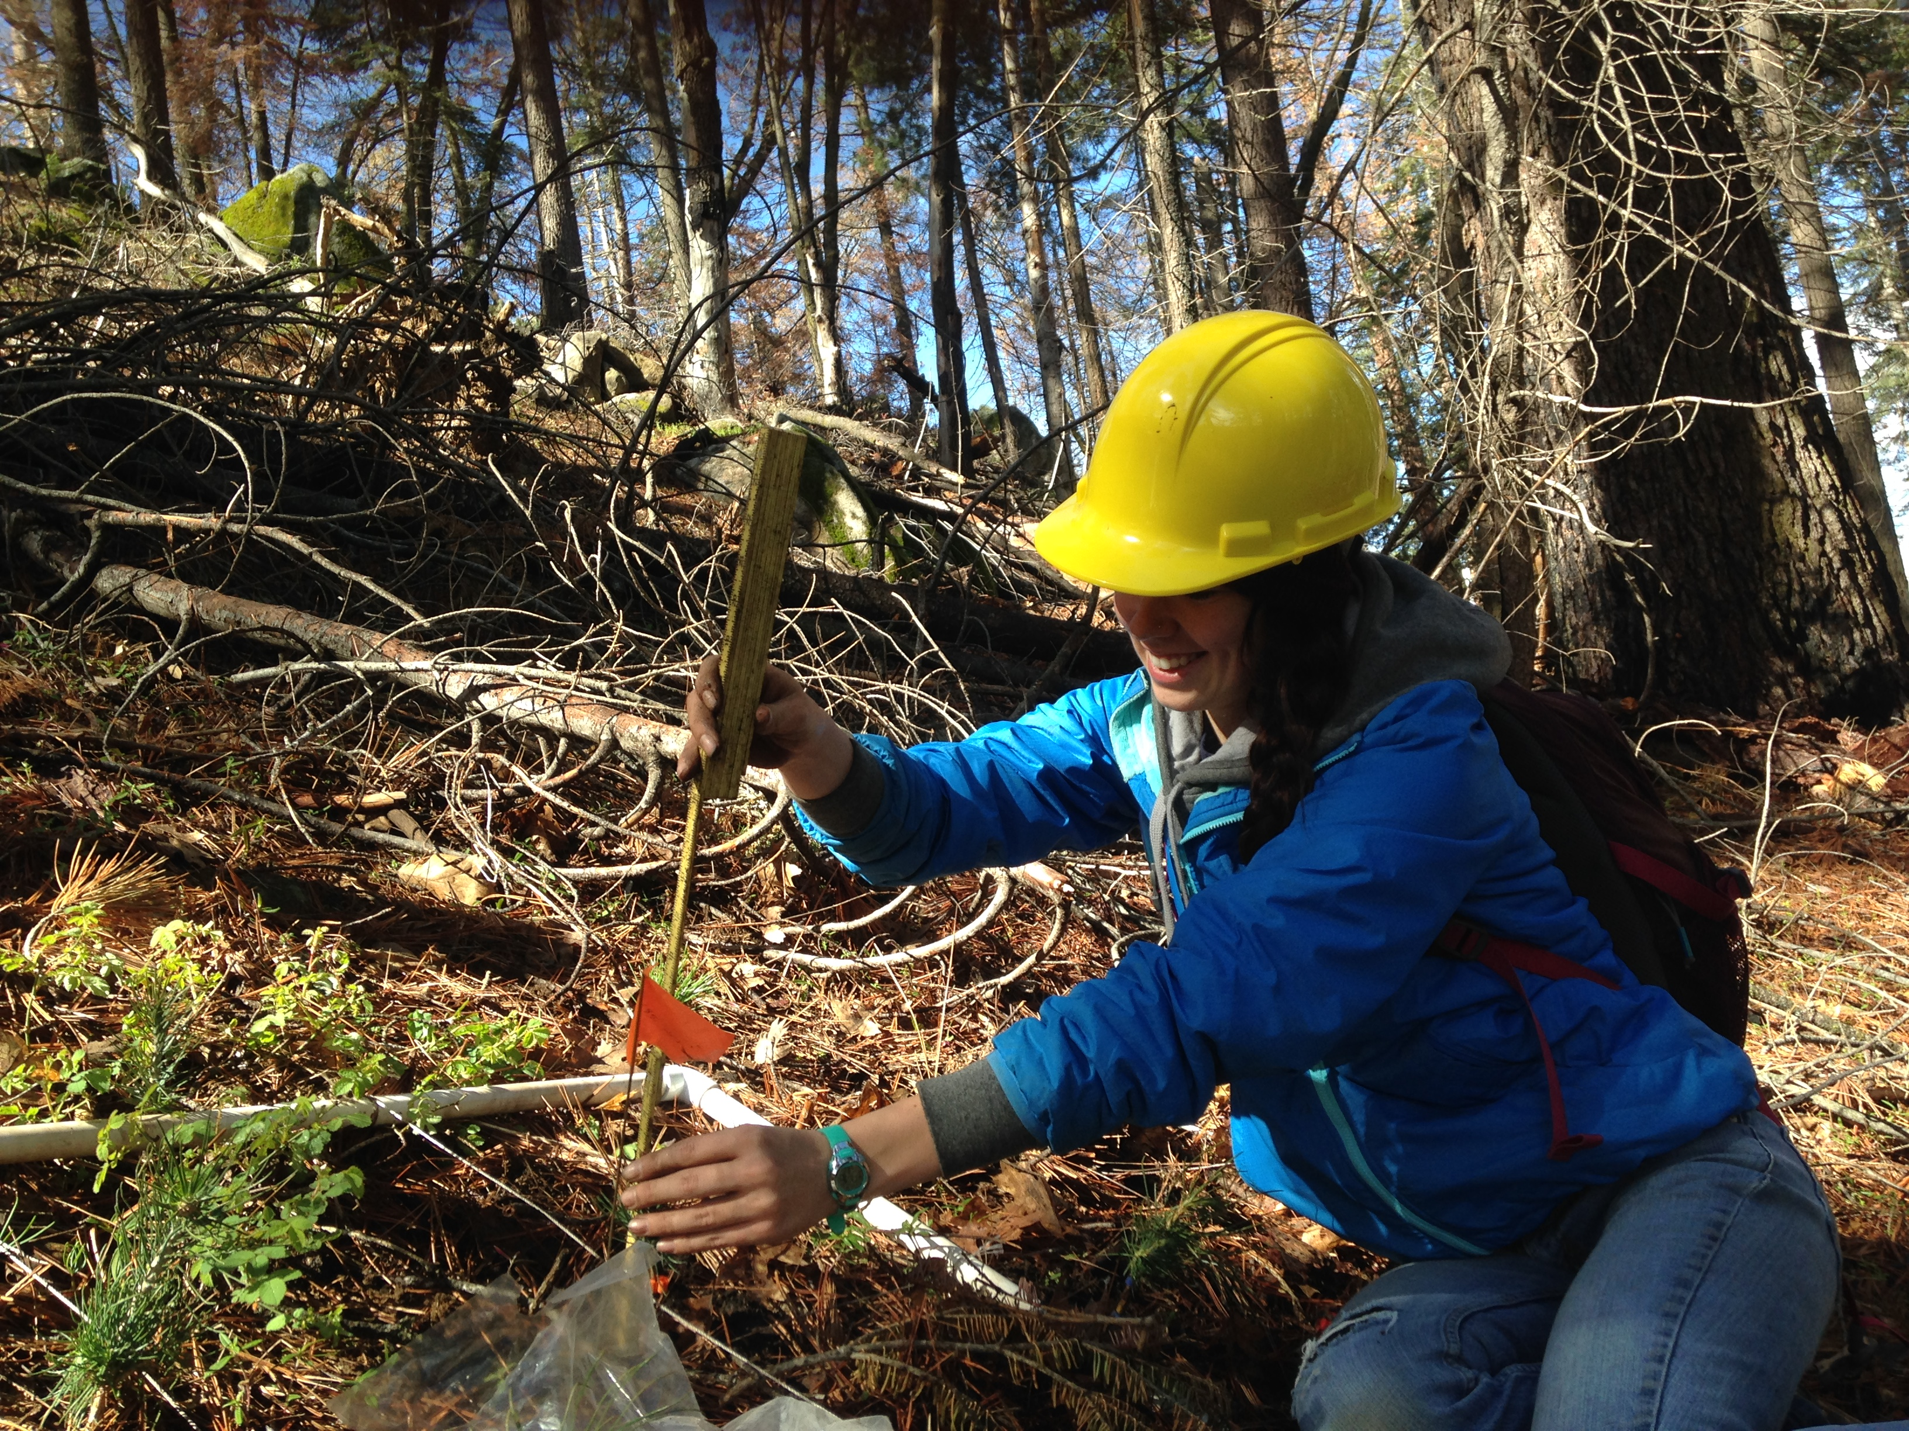

The Moran lab at UC Merced is looking for 2-3 undergraduate students to help with summer field research. Our research projects focus on growth and survival responses of forest trees to changes in their environment, including increasing heat and drought. https://sites.google.com/site/moranplantlab/

Between May 19 and July 15, students would work variable hours (average 16-18 hours/week; some weeks full time, some off) helping to measure seedlings and adult trees in permanent plots in Sequoia National Park and Sierra and Tahoe National Forests. Between July 16 and Aug 20, students would work full time measuring pine seedlings in a restoration planting in the area of the King Fire. Forest Service housing or camping facilities are available near the work site for this second period. Pay is $14.50/hour.
If necessary, qualified applicant could be hired for one time period or the other.

Required qualifications:
- Available to work full days (off campus) for at least 2 consecutive weekdays May 19-June 15 and/or full-time (40 hours/week) off campus for July 16 - Aug 20.
- Ability to do sometimes strenuous physical work outdoors where weather conditions can be hot and there is a potential for smoke in the air
- Some prior experience hiking or doing fieldwork
- Driver's license and clean driving record
Preferred qualifications:
- Ability to identify genera of trees (eg. distinguishing pines from firs, oaks, etc.) desirable; species-level knowledge highly desirable
- Camping experience

To apply:
Job is posted on Handshake (https://ucmerced.joinhandshake.com/login ), under Job ID number (4520298)
To ensure full consideration, please submit your application before April 1.

Upload
1) Cover letter detailing:
- Why you are interested in this position (eg. how does it fit into your long-term goals?)
- Why you think you would be a good fit to the position (addressing each of the qualifications above).
2) Your resume or CV
3) List of 2 references who may be contacted

