Spatial and Temporal Patterns of Diversity in Vernal Pool Annual Plant Communities
Daniel J. Toews, PhD Student
Environmental Systems Graduate Group, University of California, Merced, 5200 North Lake Road, Merced, CA 95343, USA

Background
The global rate of plant extinctions is increased relative to pre-human background rates (Vellend et. al, 2017). Understanding patterns of plant diversity and the processes that govern species distributions across environmental gradients are important for mitigating impacts of future environmental change (e.g., conservation and restoration; Vellend et. al, 2017). Global biodiversity hotspots contain >50% of Earths plant species and represent about 2.3% of earths land surface area (Baldwin, 2014). The California Floristic Province ranks among the top 35 global biodiversity hotspots and is comprised of over 6,500 native plant species (Baldwin, 2014). California vernal pools are ephemeral wetlands dominated by annual plant communities and represent centers of endemism’s and hotspots of biodiversity (Keeley & Zedler, 1998). Recent estimates show >95% of vernal pool habitat has been destroyed or degraded by land conversion to agriculture and urban development (Witham et al., 2014). Remaining vernal pool habitat is distributed across complex soil, hydrological and climatic gradients that harbor several rare and/or endemic plant species with specific edaphic and environmental associations (Holland, 1978; Holland and Dains, 1990; Barbour et al., 2003). Significant effort has been put forth to predict likely rare vernal pool species habitat, surveying for species presence, as well as, the development of vernal pool plant community classification schemes (Vollmar et al., 2013; Barbour et al., 2003). However, quantifying biological diversity and the processes that structure vernal pool plant communities across environmental gradients remains a central challenge for conservation biologists, ecologists and resource managers (Barbour et al., 2007; Ramp et al., 2008).
Quantifying biological diversity and individual species presence in plant communities is traditionally performed by visually based aboveground species surveys. Detecting species presence using traditional above ground survey methods for annual plant communities is, however, complicated by the phenological stages of species at the time surveys are taken (species presence may be missed due to spatial heterogeneity or temporal variance), a species’ ability to persist over time in the soil seed bank, lack of botanical expertise, and time or logistical issues (Hiiesalu et al., 2012; Elliott et al., 2014). Aboveground species surveys of California’s vernal pool plant communities show year-to-year fluctuation in both species diversity and individual species population sizes (Collinge & Ray, 2009; Emery et al., 2012). Temporal variance in precipitation and inundation regimes typically require repeated surveys within a single season to achieve a complete census of vernal pool plant community diversity (Barbour et al., 2003; Bauder, 1993). Recent advances in environmental DNA (eDNA) metabarcoding techniques enable detection of trace amounts of species DNA present in environmental samples (reviewed in Thomsen & Willerslev 2015). eDNA gives researchers the ability to detect species that may be present but missed by above-ground assessment methods. Combining vegetation survey data and eDNA metabarcoding assays provide novel ways to study the spatial and temporal patterns of species diversity and biogeography within plant communities (Kesanakurti et al., 2011, Yoccoz et al., 2012, Alsos et al., 2018).
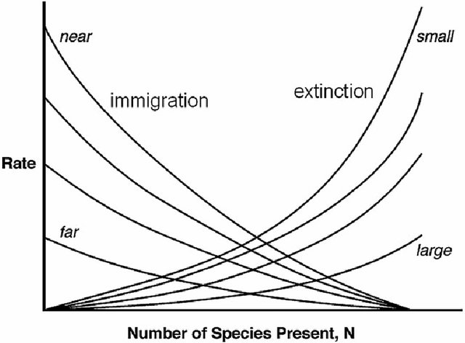
California vernal pools represent an ideal system for testing basic and applied theories that examine patterns of diversity and mechanisms that underlie species distributions in temporary wetlands (Ray & Collinge 2014; Emery et al., 2012; Carl et al., 2004). Vernal pools are island-like insular habitats analogous to island archipelagos within a matrix of unsuitable habitat, where the distribution of biodiversity might be governed by island biogeography or metacommunity like processes (Holland and Jain 1981; Ripley et al., 2009). Island biogeography theory predicts that species abundance and richness increase as a function of area, and that abundance and species richness decrease as a function of distance and isolation (Figure 1, McArthur & Wilson, 1967).
Figure 1. Equilibrium model of island biogeography. Far islands have lower immigration rates than near islands, resulting in fewer species on more distant islands (distance effect). Extinction rates are lower for large islands than small islands, resulting in more species on larger islands (area effect).
Patterns of diversity in plant communities are determined by climate, species eco-evolutionary interactions with the abiotic and biotic environment, and dispersal (Pulliam, 2000). The broad scale patterns of vernal pool plant diversity are structured by latitudinal differences in temperature and precipitation (Holland & Dains, 1990). However, on finer, landscape scales vernal pool plant communities are shown to be structured by edaphic (Holland & Dains, 1990), geologic (Holland, 1978) and hydrological gradients (Barbour et al., 2003; Emery et al., 2012). Additionally, unique plant-microorganism associations have been observed for few vernal pool plant species (Griggs, 1980; Keeley, 1988). Soil microorganisms help plants acquire nutrients, establish seedlings and compete with other plant species, and are recently suggested to be major drivers of plant diversity (reviewed in Van Der Heijden et al., 2008). In this study, I propose a novel eDNA metabarcoding approach to examine patterns and underlying processes of diversity and species richness within vernal pool plant communities across multiple spatial scales.

Questions and hypotheses
By combining eDNA metabarcoding techniques with traditional vegetation survey data and habitat models it might be possible to identify environmental characteristics important for structuring vernal pool plant communities. In addition, eDNA can identify soil microorganisms that may have significant biotic interactions with vernal pool plant species. Finally, it might be possible to explain the processes that shape spatial distributios of species diversity in this system by applying species-area and species-distribution concepts of Island Biogeography Theory to vernal pools. To investigate these possibilities, I will address the following research questions: What is the relationship between above- below-ground patterns of diversity and species richness in vernal pools, and how is it related to habitat characteristics? How are patterns of species richness consistent with concepts of basic Island Biogeography Theory? To answer these questions, I will test the following hypothesis:

H1. Below-ground patterns of diversity (plants/bacteria/fungi) are related to above ground patterns of plant diversity.
H2. Species richness is related to pool ‘types.’
H3. Species diversity and richness are different according to size and isolation of pools.

Research Approach
Study location and sampling design
Thirty-six vernal pools on the UC Merced Vernal Pools and Grassland Reserve were surveyed for above-ground plant species richness and sampled for soils over two consecutive years in 2017-2018. Study pools were semi-randomly selected to reflect the diversity of soil types, pool sizes and habit (shallow/deep), as well as presence of state or federally listed species. Three permanently marked 35 × 70 cm quadrats were located randomly along three transects established in each pool zone (e.g., 3 samples*3 pool zones: pool bottom, edge, upland). Botanical surveys were conducted in the spring of each year during peak bloom and after pools have dried (April—May, as in Marty (2005)). Each plant species within each quadrat was recorded for its cover class value (Barbour, 1987). Sterile soil samples were collected in fall of each year from the top 2 cm of soil directly adjacent to permanently vegetation plots. Three 2 ml replicate samples were collected at each plot following CALeDNA methodology (Ruiz et al., personal com.). The three samples per each zone (3 replicates*3 plots*3 zones) will be combined, totaling 3 soil samples/pool for subsequent extraction and metabarcode sequencing. Pools were monitored weekly after filling and each storm event to estimate the inundation period, maximum depth and seasonal depth fluctuations. Pool habitat area and neighborhood indices were determined from <1 m resolution aerial imagery and satellite data. Pool elevation profiles will be determined by collecting points from bottom to upland habitat with a high accuracy Real-Time Kinematic GPS system.

Metabarcoding
To quantify vernal pool plant community diversity and species presence from eDNA in soil, DNA from all 108 soil samples (3 samples*36 vernal pools) will be extracted using PowerSoil® DNA Isolation Kit (MO BIO Laboratories, Inc., Carlsbad, CA, USA) and amplified using PCR. PCR product will be sequenced for five genes (ITS1 plant, trnL plant, ITS2 fungi,16S bacteria) using universal primers on an Illumina MiSeq platform at UC Merced (648 samples total for sequencing). PCR products will be purified using a Promega Wizard clean-up kit and quantified using a Qubit and NanoDrop spectrophotometer. The ITS2, rbcL, genes were selected based on the available sequences for native listed species on or near the reserve by querying the NCBI (http://www.ncbi.nlm.nih.gov/nuccore) and BOLD (http://www.barcodinglife.org/) databases. Operational Taxonomic Units generated for plant species will be assigned to NCBI, BOLD, and our locally generated reference library sequence databases. Sequence reads will be processed through CALeDNA’s Anacapa pipeline and referenced to assign taxonomic units (see http://www.ucedna.com/software/).

Data synthesis
Metabarcoding-based species detections will be compared to visual surveys to determine rates of false positives and negatives using the Markov chain Monte Carlo (MCMC) algorithms implemented in the software package, JAGS (Just Another Gibbs Sampler, http://mcmc-jags.sourceforge.net). Multivariate analyses will be performed using the Vegan package in R (Oksanen et al., 2013) to relate habitat characteristics (inundation period, depth, area, and soil type) to differences in plant species metabarcoding-based species diversity measures (alpha, species richness within a single vernal pool; beta, variation in species composition among vernal pools; and gamma, species diversity over all surveyed vernal pools). PERMANOVA test with Jaccard distance (function adonis2 in Vegan) will be used to test for differences in community composition and to determine the amount of variation ascribed to pools, inundation zones and soil type.

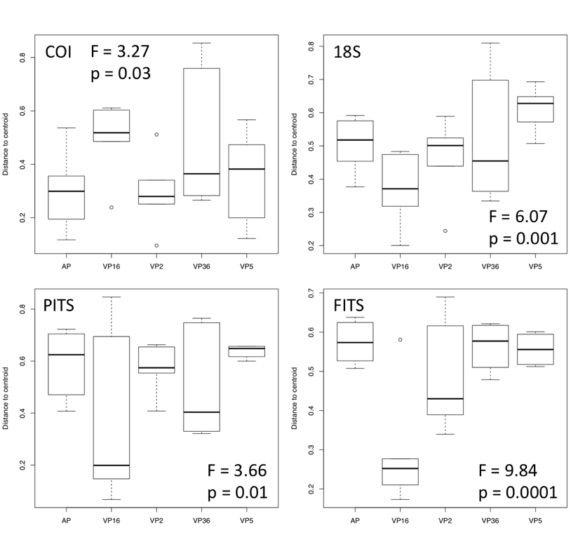
Preliminary Results
Preliminary results
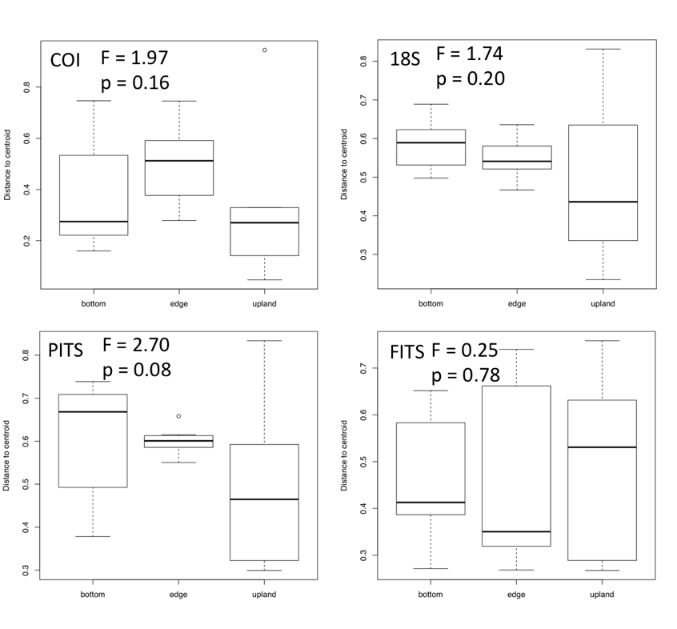
Four genetic barcodes (CO1 animal, ITS1 plant, ITS2 fungi and 18S bacteria) have been sequenced and beta diversity analyzed for five vernal pools. Jaccard distance of beta diversity among the five vernal pools shows significant separation between pools (animal, F = 3.27, p < 0.03; plant, F = 3.66, p < 0.01; fungi, F = 9.84, p < 0.0001; bacteria , F = 6.07, p < 0.001) (Figure 2). That is, these five vernal pools appear to be significantly different from one another when only comparing diversity between pools. Conversely, beta diversity for the same five vernal pool communities are not significantly different when comparing bottom, edge and upland pool zones (Figure 3) (animal, F = 1.97, p < 0.16; plant, F = 2.70, p < 0.08; fungi, F = 0.25, p < 0.78; bacteria , F = 1.74, p < 0.20).
Figure 2. Distance to the centroid of vernal pool community Beta diversity for COI, 18S, PITS and FITS metabarcodes of five vernal pools.

Discussion
Literature shows that vernal pool plant species are adapted to different inundation regimes along topographic moisture gradients that result in zonal segregation of vegetation within pools. Additionally, vernal pools can be categorized into distinct pool ‘types’ that are distinguished by physical and hydrological characteristics (soil type, depth, area, inundation period) which promote distinct community associations. Lastly, vernal pools represent island like habitats where species distributions could be determined by island biogeography processes. Overall, by combining eDNA metabarcoding techniques with traditional vegetation survey data I expect below-ground patterns of plant metabarcode diversity to be related to the degree of habitat specialization and zonation similar to above ground vegetation surveys. Alternatively, above-ground patterns of diversity may be different from patterns of diversity in eDNA samples, in one of several ways. First, species absent from vegetation surveys that are present in eDNA samples (false negative) might suggest the species is present in a dormant state in the soil seedbank or reflect ‘legacy effects’ of DNA in the soil sample (e.g. DNA detected is from past occurrences). Secondly, species present in vegetation surveys that are absent in eDNA samples (false positive) could be due to biases in sampling methods (e.g. survey location different than eDNA sample location), or because species with poor or no reference DNA might not be assigned taxonomic units in downstream data analyses resulting in “unknown’s” that cannot be matched with above-ground survey data.
Figure 3. Distance to the centroid of vernal pool community Beta diversity grouped by pool zones (bottom/edge/upland) for COI, 18S, PITS and FITS metabarcodes of five vernal pools.
Preliminary data show individual pools are significantly different. Considering pool characteristics and basic island theory, I expect diversity and species richness to: 1.) be lower within pools than among pools (beta diversity); 2.) be greater among pool types than within similar types of pools; 3.) be lower in smaller and more isolated pools than larger pools and pools within a neighborhood (pool complex). Conversely, species richness may not differ within and among pools. That is, processes like colonization-competition or neutral theory that govern community assembly in different -but similar pool ‘types’ might be more important than dispersal or selection. However, I expect these differences to be more significant considering the distribution of plant taxa within pools is shown to be controlled by species adaptations to specific inundation regimes along pool topographic gradients. Taken alone, preliminary eDNA data suggest each vernal pool community is different, and that overall species diversity is not determined by inundation zones (except possibly for plant species). I expect that a larger sample size and environmental correlates will produce different results (see above). To my knowledge, this is the first eDNA metabarcoding study applied to vernal pools soils and serves as a first pass in quantifying below-ground vernal pool community diversity.

Timeline
Fall 2016: Establish study design, and vegetation survey and eDNA sampling protocols. (completed)
Winter – Spring, 2017: Establish permanent vegetation survey plots for each study site. Collect hydrological data. Collect vegetation data and eDNA voucher specimens for all species and pools. Assign inundation rank to pools sampled (completed)
Summer – Fall, 2017: Collect year-one eDNA soil samples. Collect habitat/environmental data (completed)
Winter, 2017 – Spring, 2018: Collect hydrological data. Collect vegetation data and remaining voucher specimens for all species and pools. Began DNA extractions and building reference eDNA library. Begin data analyses of above-ground vegetation data (completed/in progress)
Summer – Fall, 2018: Collect year-two eDNA soil samples, and conclude environmental measurements. Start metabarcoding extractions and data analyses. (In progress)
Spring – Fall, 2019: Finish eDNA extractions and continue statistical analysis. Begin manuscript preparation on paper of vernal pool diversity. Present findings at two conferences.
Spring, 2020: Conclude statistical analyses and submit manuscript for publication by Spring 2020.

References
Alsos, I. G., Lammers, Y., Yoccoz, N. G., Jørgensen, T., Sjögren, P., Gielly, L., & Edwards, M. E. (2018). Plant DNA metabarcoding of lake sediments: How does it represent the contemporary vegetation. PloS one, 13(4), e0195403.
Baldwin, B. G. (2014). Origins of plant diversity in the California Floristic Province. Annual Review of Ecology, Evolution, and Systematics, 45, 347-369.
Barbour M, Solomeshch A, Witham C, Holland R, Macdonald R, Cilliers S, Molina JA, Buck J, Hillman J. (2003). Vernal pool vegetation of California: variation within pools. Madrono 50: 129–146.
Barbour M, Solomeshch A, Buck J (2007) Classification, ecological characterization, and presence of listed plant taxa of vernal pool associations in California. Final report to U.S. Fish and Wildlife Service, Agreement #814205g238. University of California, Davis. 146pp.
Bauder ET. (1987). Species assortment along a small‐scale gradient in san diego vernal pools. Ph.D. thesis. Davis and San Diego, CA, USA: University of California.
Carl, T., & Blumenshine, S. (2005). Relationships among vernal pool invertebrate assemblages with habitat morphology and distribution. Bios, 145-152.
Collinge, S. K., & Ray, C. (2009). Transient patterns in the assembly of vernal pool plant communities. Ecology, 90(12), 3313-3323.
Elliott TL, Davies TJ. Challenges to barcoding an entire flora. Mol Ecol Resour. (2014). Sep;14. (5):883–91. pmid:24813242
Emery, N. C., Stanton, M. L., & Rice, K. J. (2009). Factors driving distribution limits in an annual plant community. New Phytologist, 181(3), 734-747
Griggs, F. T. (1976). Life history strategies of the genus Orcuttia (Gramineae). In S. K. Jain [ed.], Vemal pools, their ecology and conservation, 57-63. Institute of Ecology Publication No. 9, University of California, Davis
Hiiesalu I, ÖPik M, Metsis M, Lilje L, Davison J, Vasar M. (2012). Plant species richness belowground: Higher richness and new patterns revealed by next-generation sequencing. Mol Ecol; 21(8):2004–16. Pmid:2216824
Holland, R. (1978). “The Geographic and Edaphic Distribution of Vernal Pools in the Great Central Valley, ….” Calwater.Ca.Gov 0: 53529–42. http://www.ncbi.nlm.nih.gov/entrez/query.fcgi?db=pubmed&cmd=Retrieve&dopt=AbstractPlus&list_uids=4950658073563451553related:oVArx0lFtEQJ.
Holland, Robert F., and Subodh K. Jain. (1981). “Insular Biogeography of Vernal Pools in the Central Valley of California.” The American Naturalist 117 (1): 24. doi:10.1086/283684.
Keeley, J. E. (1988). Anaerobiosis as a stimulus to germination in two vernal pool grasses. American Journal of Botany, 75(7), 1086-1089.
Keeley, J. E., & Zedler, P. H. (1998). Characterization and global distribution of vernal pools. In Ecology, conservation, and management of vernal pool ecosystems, proceedings from 1996 conference (Vol. 1, p. 14).
Kesanakurti, P. R., Fazekas, A. J., Burgess, K. S., Percy, D. M., Newmaster, S. G., Graham, S. W., & Husband, B. C. (2011). Spatial patterns of plant diversity below‐ground as revealed by DNA barcoding. Molecular Ecology, 20(6), 1289-1302.
Marty JT (2005). Effects of cattle grazing on diversity in ephemeral wetlands. Conservation Biology 19, 1626-1632.
Oksanen, J., Blanchet, F. G., Kindt, R., Legendre, P., Minchin, P. R., O’hara, R. B. & Oksanen, M. J. (2013). Package ‘vegan’. Community ecology package, version, 2(9).
Pulliam, H. R. (2000). On the relationship between niche and distribution. Ecology letters, 3(4), 349-361.
Ramp Neale, J. M., Ranker, T. A., & Collinge, S. K. (2008). Conservation of rare species with island‐like distributions: A case study of Lasthenia conjugens (Asteraceae) using population genetic structure and the distribution of rare markers. Plant Species Biology, 23(2), 97-110.
Ripley, B. J., & Simovich, M. A. (2009). Species richness on islands in time: variation in ephemeral pond crustacean communities in relation to habitat duration and size. Hydrobiologia, 617(1), 181-196.
Thomsen, P. F., & Willerslev, E. (2015). Environmental DNA - An emerging tool in conservation for monitoring past and present biodiversity. Biological Conservation, 183, 4–18. https://doi.org/10.1016/j.biocon.2014.11.019
Van Der Heijden, M. G., Bardgett, R. D., & Van Straalen, N. M. (2008). The unseen majority: soil microbes as drivers of plant diversity and productivity in terrestrial ecosystems. Ecology letters, 11(3), 296-310.
Vellend, M., Baeten, L., Becker-Scarpitta, A., Boucher-Lalonde, V., Mccune, J. L., Messier, J., Sax, D. F. (2017). Plant Biodiversity Change Across Scales During the Anthropocene. Annu. Rev. Plant Biol, 68, 563–586. https://doi.org/10.1146/annurev-arplant-042916
Vollmar J, Holland R, Witham C, Schweitzer J (2013) Predictive Habitat Analysis and Mapping of Four Rare Vernal Pool Species in Merced, Sacramento and Placer Counties. Report prepared for USFWS under a CVPIA/HRP grant; January 31, 2013. 81pp.
Witham, Carol, Robert Holland, and John Vollmar. (2014). “Changes in the Distribution of Great Valley Vernal Pool Habitats from 2005 to 2012.”
Yoccoz, N. G., Bråthen, K. A., Gielly, L., Haile, J., Edwards, M. E., Goslar, T., Taberlet, P. (2012). DNA from soil mirrors plant taxonomic and growth form diversity. Molecular Ecology, 21(15), 3647–3655. https://doi.org/10.1111/j.1365-294X.2012.05545.x

