Spatial and temporal distributions of microbial communities in vernal pools of California.

Introduction
Understanding diversity and geographical distribution has been a longstanding goal in science since Alfred Russel Wallace’s seminal work (Goldhor, 1964). To date, neither the biodiversity of microbes or its distributions and the drivers of distributions are well understood (Hanson et at, 2012, Zhou & Ning, 2017).

Theories developed for large organisms, versus the classical paradigms born in microbiology are center of hot debate (Finlay, 2002; Finlay & Fenchel, 2004, Martiny et al., 2006; Dolan, 2006; Zhou & Ning, 2017). In general, this debate challenge ideas trying to address whether microbes have distributional patterns (biogeographical patterns) similar to those of microorganisms; versus the premise that microorganisms, are ubiquitous organisms across landscapes, characterized by small size, fast colonization rates and efficient dispersal mechanisms (O’Malley, 2007; Incagnone et al. 2015).

Nowadays, molecular-tools are a powerful approach to distinguish between microbial groups and make possible to address their communities composition. In this vein, this proposed research aims to explore the microbial world (bacteria, fungi, protozoa, algae), and its spatial and temporal distributions, using vernal pools as a model eco-system.

Background and Questions
Vernal pools are scattered “islands” across the landscape, embedded in completely terrestrial ecosystems (Stebbins, 1976). They are considered temporal wetlands, characterized by cyclical phases of aquatic inundation to complete desiccation (Zedler, 1987). A vernal pool can be seen as a whole ecosystem, having well-defined boundaries and variability. Then, vernal pools hold the potential to study microbial diversity distributions: a) spatial, and b) temporal.

a) Spatial distribution
In natural communities, the dissimilarity (or community variation) between two locations, as a function of spatial distance is known as distance decay (Astorga et al., 2012) i.e. Closer islands in an archipelago complex should be more similar in species composition, in comparison with distant islands (Goldhor, 1964). Some vernal pools complexes are ‘archipelago-like’ islands, where the connectivity between vernal pools has to be taken into consideration for the spatial distribution of a given taxa. Some taxa might be present in a single pool or a specific group of vernal pools due to dispersal, different environmental conditions, and species composition drift (Hanson et al, 2012).

Question 1: Do vernal pool microbial communities vary spatially between pools? To what degree are different assembly mechanisms involved (environmental selection, dispersal, drift)?

To answer this question, I plan to select fifty vernal pools for water and soil sampling, at the UCM Vernal Pools and Grassland Reserve (figure 1). To obtain DNA of free-living microbial organisms from water, 100ml of water will be collected and filtered using 0.02 mm filters. The process will be made with two replicates, for a total of 300ml of water per vernal pool. Along with the water samples, three soil samples of 0.25g per pool will be collected from different places within margins of the pool.

-To reduce incidental capture of endangered aquatic crustaceans in juvenile to reproductive stage I will be using a common aquarium net, to create a space clear of this aquatic organisms within the boundaries of the net, and with a syringe I will pull out the water gently from inside the net.

b) Temporal distribution
Since vernal pools are fundamentally characterized by cyclical aquatic and terrestrial stages, organisms could be respond to the environmental conditions. i.e. for small crustaceans, they are present in vernal pools during the aquatic phase. in contrast, this is not the case of plants, which live during the aquatic stage and continue through the terrestrial phases.

In this vein, it is more likely to perceive different microbial communities across time, given the contrasting stages of the vernal pool, if we base our reasoning on “the classical paradigms born in microbiology” (Ragon et al., 2012). Is probable to detect specialized taxa that with live cycles encompassing aquatic and terrestrial, adapted to overcome the environmental change of the contrasting phases, and populate despite the environmental change.

Question 2: How does vernal pool microbial community vary across time? Do aquatic microbial communities differs from terrestrial microbial communities? Is there any overlap indicative of exchange? How vernal pools differ from other freshwater ecosystems (which always tend to be dominated by similar groups)?

To answer this question, I plan to sample 50 vernal pools five times (aprox.) in one year, using the protocol mentioned above in question number 1 to obtain DNA from the water column, and soil free living microorganisms. Additionally, physical and chemical properties will be examined, such as dissolved oxygen, CO₂ , pH, conductivity, Cation Interchange Capacity and nutrients (C, K, P, O, N).

DNA analysis
The quality and the quantity of DNA will be examined by Nano-Drop technology, final DNA aliquotes will contain a proportion of 2 ng /L. Amplification of barcoded DNA conserved regions and further sequencing will be perform on the Illumina MiSeq platform at UC Merced. After a quality control (demultiplexing), the sequence reads will be analyzed using Dada2 (Callahan et al., 2016) which infers the amplicon sequence variants (ASVs) in a fine resolution and reports less false positive sequences variants. Taxonomic affiliation of ASVs will be assigned using SILVA_123 database in QIIME v2. To complete the community analysis, species richness and diversity indexes will be used, and microbial communities will be compared.

Data analysis
I will test whether microbial communities differ between pools, using alfa and beta diversity metrics (Shannon, UniFrac, Sorensen, Jaccard, Bray-Curtis) and by what percentage they differ and what are the explanatory factors, using ordination models, and based on different statistical coefficients (Person correlations, Kruskal-wallis, Pearson, PERMANOVA).`

Figure 1. Proposed sampling locations (in blue ) at UCM vernal pool reserve.
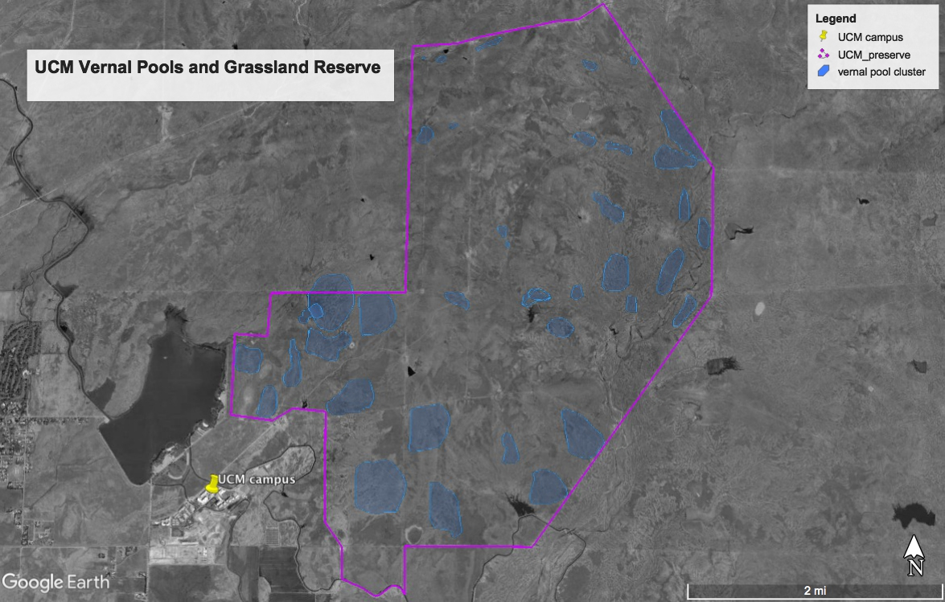
Literature
- Astorga, A., Oksanen, J., Luoto, M., Soininen, J., Virtanen, R., & Muotka, T. (2012). Distance decay of similarity in freshwater communities: Do macro- and microorganisms follow the same rules? Global Ecology and Biogeography, 21(3), 365–375. http://doi.org/10.1111/j.1466-8238.2011.00681.x
- Callahan, B. J., McMurdie, P. J., Rosen, M. J., Han, A. W., Johnson, A. J. A., & Holmes, S. P. (2016). DADA2: High-resolution sample inference from Illumina amplicon data. Nature Methods, 13(7), 581–583. http://doi.org/10.1038/nmeth.3869
- Dolan, J. R. (2006). Microbial biogeography? Journal of Biogeography, 33(2), 199–200. http://doi.org/10.1111/j.1365-2699.2005.01406.x
- Fierer, N., Schimel, J. P., & Holden, P. A. (2003). Variations in microbial community composition through two soil depth profiles. Soil Biology and Biochemistry, 35(1), 167–176. http://doi.org/10.1016/S0038-0717(02)00251-1
- Finlay BJ (2002) Global dispersal of free-living microbial eukaryote species. Science, 296, 1061–1063.
- Finlay BJ, Fenchel T (2004) Cosmopolitan metapopulations of free-living microbial eukaryotes. Protist, 155, 237–244.
- Hanson, C. A., Fuhrman, J. A., Horner-Devine, M. C., & Martiny, J. B. H. (2012). Beyond biogeographic patterns: processes shaping the microbial landscape. Nat Rev Micro, 10(7), 497–506. Retrieved from http://dx.doi.org/10.1038/nrmicro2795
- Incagnone, G., Marrone, F., Barone, R., Robba, L., & Naselli-Flores, L. (2015). How do freshwater organisms cross the dry ocean? A review on passive dispersal and colonization processes with a special focus on temporary ponds. Hydrobiologia, 750(1), 103–123. http://doi.org/10.1007/s10750-014-2110-3
- Martiny, J. B., Bohannan, B. J., Brown, J. H., Colwell, R. K., Fuhrman, J. A., Green, J. L., … Staley, J. T. (2006). Microbial1. J. B. Martiny et al., Microbial biogeography: putting microorganisms on the map, Nat Rev Microbiol 4, 102–112 (2006). biogeography: putting microorganisms on the map. Nat Rev Microbiol, 4(2), 102–112.
- O’Malley, M. A. (2007). The nineteenth century roots of “everything is everywhere.” Nature Reviews Microbiology, 5(8), 647–651. http://doi.org/10.1038/nrmicro1711
- Ragon, M., Fontaine, M. C., Moreira, D., & Lopez-Garcia, P. (2012). Different biogeographic patterns of prokaryotes and microbial eukaryotes in epilithic biofilms. Molecular Ecology, 21(15), 3852–3868.
- Stebbins, G.L. 1976. Ecological islands and vernal pools of California. pp. 1-4 in: S. Jain (Ed.). Vernal pools: their ecology and conservation. Institute of Ecology Publication 9, University of California, Davis, CA.Tilman, D. (1982). Resource competition and community structure. Princeton University Press, Princeton, NJ, 2058. http://doi.org/10.7861/clinmedicine.14-3-000
- Zedler, P.H. 1987. The ecology of southern California vernal pools: a community profile. U.S. Fish and Wildlife Service, Biology Report, pp 87.
- Zhou, J., & Ning, D. (2017). Stochastic Community Assembly: Does It Matter in Microbial Ecology? Microbiology and Molecular Biology Reviews, 81(4), e00002-17. http://doi.org/10.1128/MMBR.00002-17

