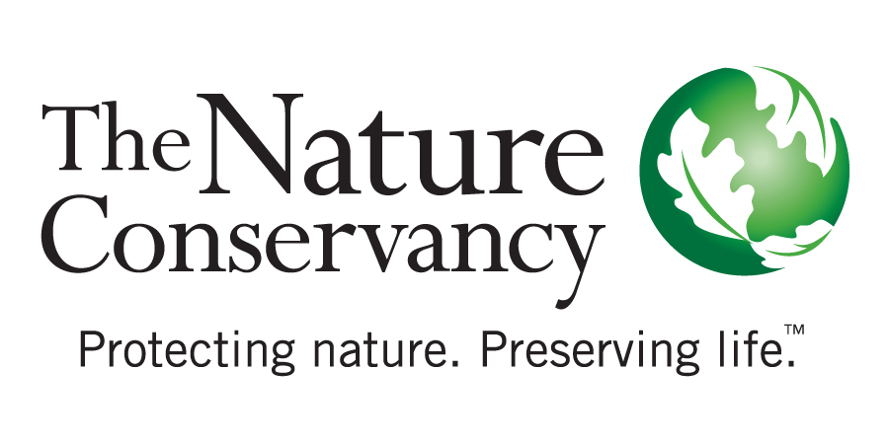

Sierra Nevada Program Manager
The Nature Conservancy, one of the world’s leading conservation organizations, seeks a Program Manager to help advance our Sierra Nevada conservation and restoration efforts. Working as part of an interdisciplinary team, and in collaboration with external partners, the Program Manager will help to advance place-specific and landscape-scale forest restoration projects and to develop and implement policy and budget measures to bring restoration to scale. The Program Manager will also pursue, develop, and manage public and private grants and contracts to support the Sierra program.

The California Chapter is among the largest and most innovative chapters within the organization, with approximately 200 employees across the state.

The position requires a BA/BS degree (advanced degree preferred) in environmental policy, natural resources, conservation planning and practice, or related field, and 5 years’ experience in conservation practice (or equivalent combination of education and experience). We are looking for candidates with excellent written, verbal, and analytical skills, experience managing complex and/or multiple projects under deadlines, and experience working with a broad range of partners such as NGOs, government agencies, academic researchers, and the private sector.

The position will be based in either our San Francisco or Sacramento office.

Please visit nature.org for a complete description and to apply before May 27, 2018.

The Nature Conservancy is an Equal Opportunity Employer.
Women, minorities, people with disabilities and veterans are encouraged to apply.

