EVOLUTION JOURNAL CLUB

Time: Wednesdays, 12-1pm (Lunch)
Starting 23-Oct-2019
Room: SE1 298

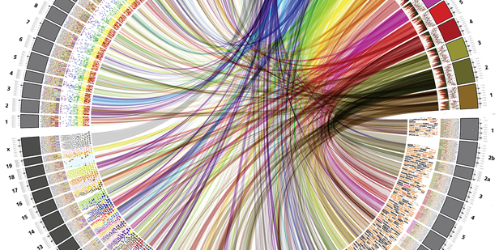

Details:

Students, postdocs, and faculty are welcome to participate. Presentations and discussion will be centered around the theme of evolution in the broadest sense, as it is a subject that intersects most fields. All areas of biology, all organisms, all methods, and etc., are welcome! So, whether you are interested in evolutionary theory, ecological and biological diversity, basic biology, development, molecular and ecological sciences and methods – or really anything – come share your perspective.

Presentation Format:

Folks are encouraged to drop-in and present on a volunteer basis. It’s simple: (i.) please select a recent paper that excites you, (ii.) prepare a 5-7 minute presentation with slides, (iii.) present and discuss. There will be no assigned reading, anyone can swing by to learn, share, and discuss science.

Slides should be short and succinct. They should present the broad question, necessary background, methods, and the main finding and its central importance. Use the figures in the paper to guide discussion. And, please restrict yourself to the timeframe.

This format has two goals. First, students are encouraged to practice their reading and synthesis skills to distill and present important details. Second, it is hoped folks will take advantage of the drop-in and relaxed format to present and discuss recent literature. More ground can be covered, and folks can share things with the community that excite them. (Plus, printing many copies of one paper and wasting resources is de facto discouraged!).

