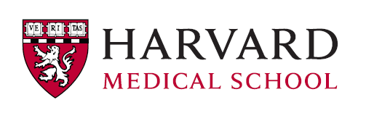
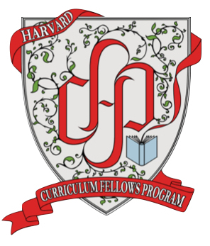
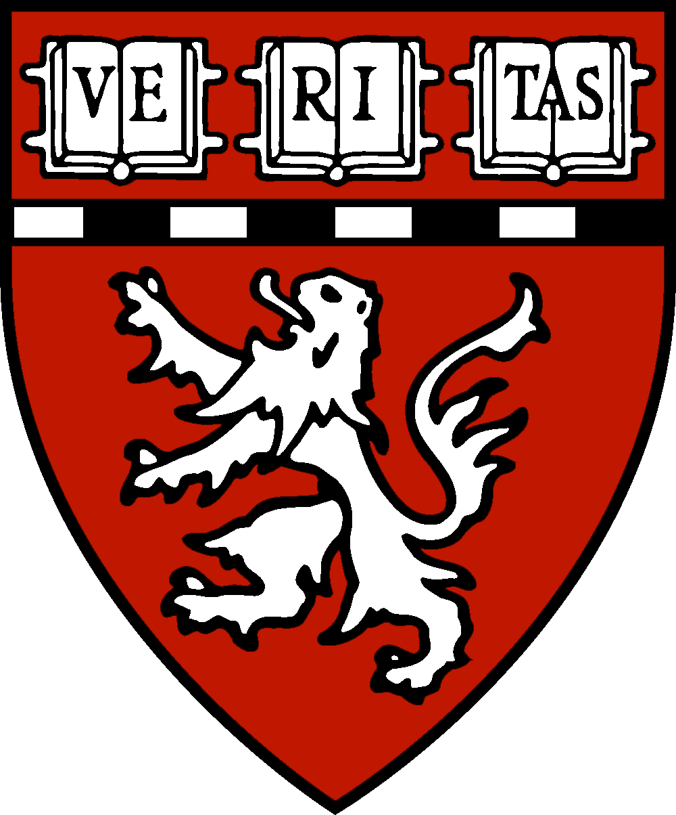

Curriculum Fellows Program
HMS Program in Graduate Education

Harvard Medical School (HMS) seeks applications from early-career science educators interested in a three-year fellowship within the HMS Curriculum Fellows Program (https://curriculumfellows.hms.harvard.edu). Curriculum Fellows work closely with committed members of the HMS faculty and administration to develop, deploy, and evaluate evidence-based improvements in graduate biomedical education. Fellows have gone on to careers as faculty at teaching-focused undergraduate institutions, leaders in centers for teaching and learning, discipline-based educational researchers, and administrators of higher education.

The fellowship period is spent in service of the curricular and programmatic goals of a specific sponsoring department or graduate training program, the details of which are determined in collaboration with the appropriate departmental/programmatic leadership. As part of the Curriculum Fellows Program, fellows are also provided with oversight and mentorship focused on the creation of aligned curricular and para-curricular programming for graduate training, the application of evidence-based teaching practices, and highly individualized professional development. Fellows are expected to contribute to the HMS community of graduate biomedical educators by attending and presenting at workshops, an education journal club, and pedagogy-focused seminars. Collaborations to improve training across the HMS Program in Graduate Education are encouraged and opportunities may exist to teach undergraduate courses and/or conduct discipline-based educational research (DBER) — in both cases either in- or outside the scope of the fellows’ primary service.

Suitable candidates will have a PhD in a scientific field relevant to the service mission of the hiring program or department (see below) or in science education. Demonstrated interest and experience in scientific teaching, preferably at the graduate or undergraduate level, is required. The fellowship is intended for early-career scientist-educators and therefore, applications from candidates with more than 5 years of postdoctoral research or teaching experience are discouraged. Fellows are appointed as research associates, with promotion to the rank of Lecturer possible based on experience and performance.

CURRENT OPEN CURRICULUM FELLOW POSITIONS

Curriculum Fellow in Translational and Biomedical Sciences
(Leder Human Biology Program - http://dms.hms.harvard.edu/lhb/Students.html)

Curriculum Fellow for the Master of Medical Sciences in Immunology
(http://mmscimmunology.hms.harvard.edu/)

We are an equal opportunity employer and all qualified applicants will receive consideration for employment without regard to race, color, religion, sex, national origin, disability status, protected veteran status, gender identity, sexual orientation, pregnancy and pregnancy-related conditions or any other characteristic protected by law.
Curriculum Fellow for the Master of Medical Sciences in Immunology

Institution: Harvard Medical School
Location: Boston, MA
Category: Faculty - Science
Type: Full Time

The Harvard Medical School (HMS) Program in Graduate Education invites applications for a Curriculum Fellow (CF) supporting the Master of Medical Sciences (MMSc) program in Immunology. For more information about this graduate program see http://mmscimmunology.hms.harvard.edu/. The primary focus of this position will be the development of graduate-level curriculum in immunology for the students in the MMSc program in immunology, with additional responsibilities overseeing TAs in the Harvard Immunology PhD program.

Responsibilities
- Collaborate with program faculty to develop and revise the curriculum for three graduate level courses in immunology:
  - An immunology methods course, with a primer in core molecular, cellular and quantitative biology concepts
  - A course focused on reading primary literature and science communication
  - A graduate-level introduction to immunology taken by both MMSc and PhD students.
- Serve as an instructor in courses 1 and 2 above.
- Serve on the admissions committee for the MMSc program and conduct interviews with applicants.
- Work with program leadership to oversee other aspects of the training program, including student advising and paracurricular programming.

Qualifications
- An earned doctorate in immunology or a closely related field
- Experience teaching graduate or undergraduate students
- Advanced knowledge of molecular biology and immunology research methods, such as flow cytometry (preferred)
- Postdoctoral research and/or teaching experience (preferred)

Job Skills and Competencies
- Ability to work collaboratively with multiple faculty and administrative partners to develop new courses and educational/training opportunities
- Experience applying pedagogical best practices to the classroom, including evidence-based teaching methods and technological innovations
- Ability to work independently to identify and implement optimal solutions to diverse problems
- Strong oral and written communication skills, strict attention to detail
- Strong organizational and administrative skills
- Effective mentorship skills

Interested candidates should email a single PDF document containing:
(1) a letter of application that identifies the specific program or programs to which you are applying, including your specific interest in and qualifications for the position, (2) a curriculum vitae, (3) a statement of teaching philosophy.
Address emails to cfp@hms.harvard.edu, attention Dr. Bradley Coleman, Co-Director of the HMS Curriculum Fellows Program. Include the names and contact information of three references, who will be contacted during the review process. Applications will be reviewed on a rolling basis, starting immediately. For full consideration, you must submit a complete set of materials no later than June 11th, 2018. 2018 fellows are expected to begin the program by early- to mid-summer in Boston, MA.

