Merced Vernal Pools and Grassland Reserve
Intern Position Open

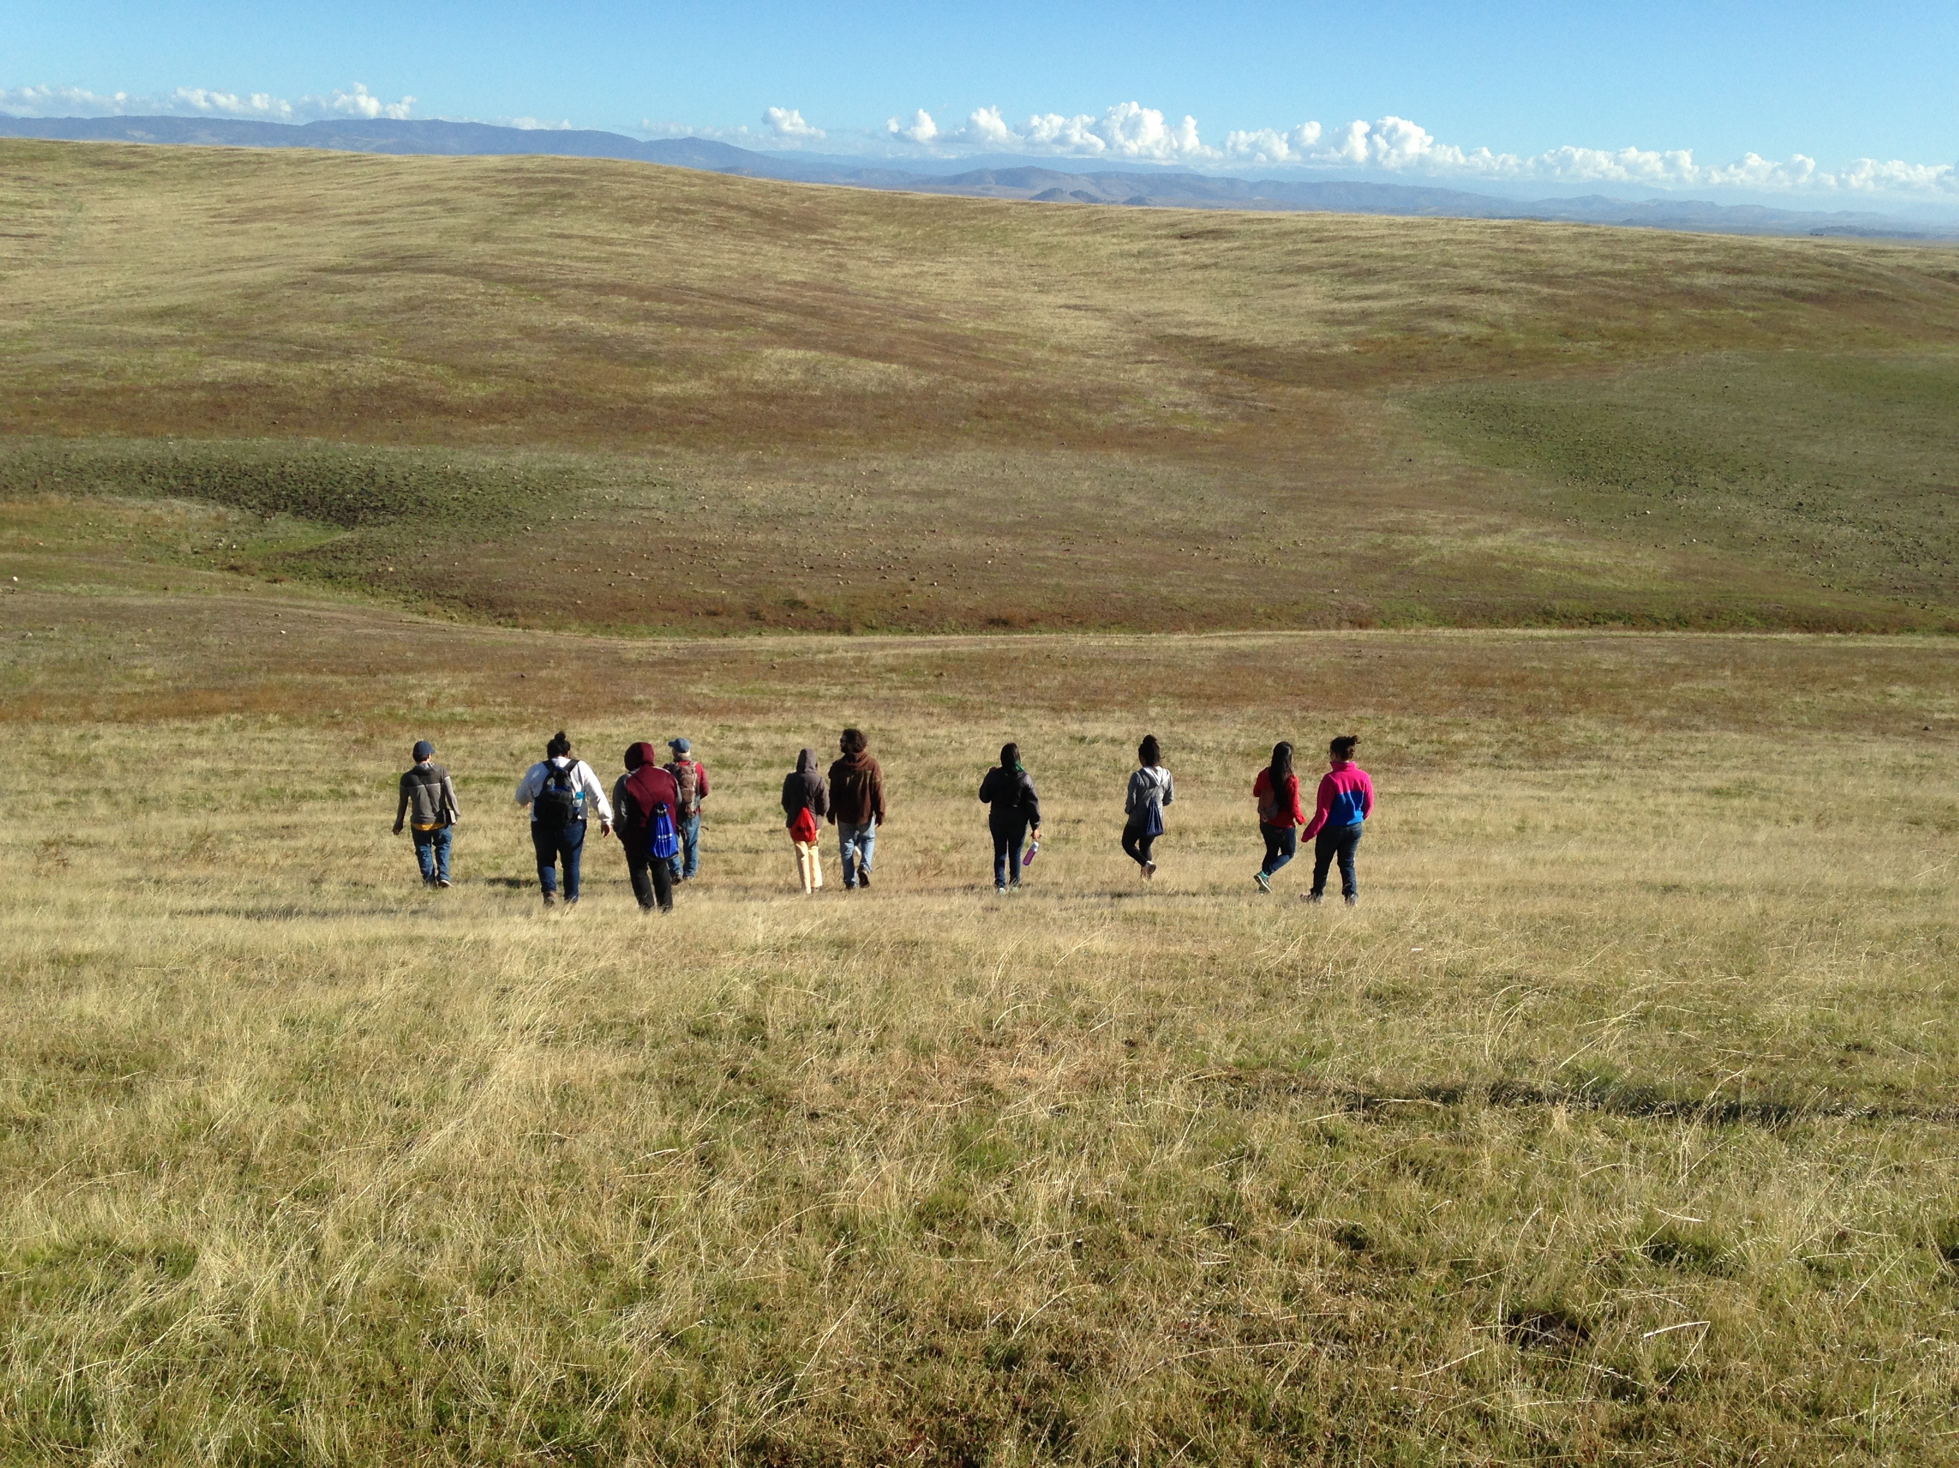

The UC Merced Vernal Pools-Grasslands Natural Reserve has an opening for an intern to assist the Reserve Director in implementing education, research and management programs.

Interns will:
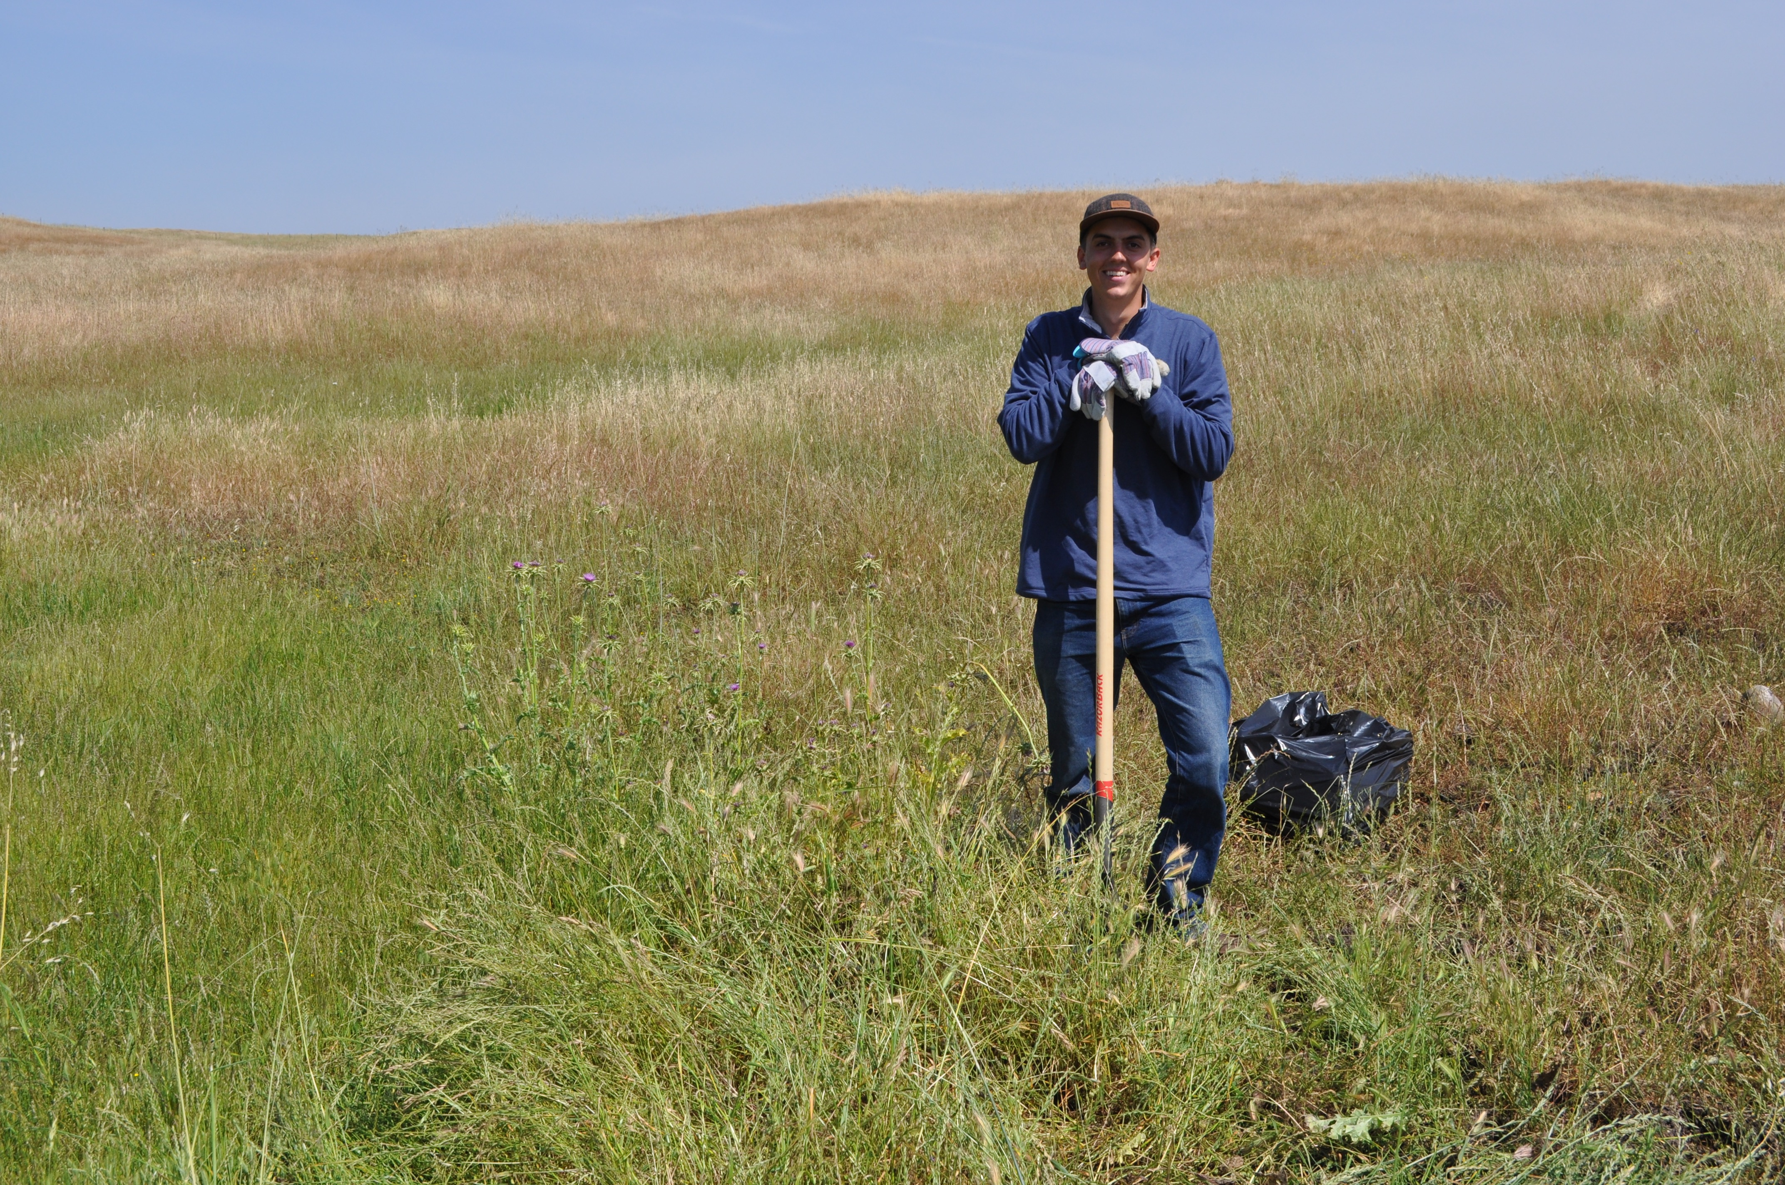
- Learn about the habitats, natural history, and organisms of the Reserve.
- Interpret and explain ecology, geology, cattle grazing and other aspects of the Reserve to faculty, students and the public
- Co-lead field trips
- Assist with environmental monitoring and research studies
- Assist with management programs
- Develop educational materials (including web site enhancement; maps; writing brochures; photography)
- Assist with outreach to the public and to schools.

Qualifications:
- Junior or senior majoring in the life, natural, or environmental sciences.
- Excellent writing and speaking skills.
- Well organized.
- Physically fit and able to hike several miles in the out of doors.
- Prior experience working in the out of doors is a plus.
- Experienced with gathering information from the internet.
- Must have a valid California driver's license.
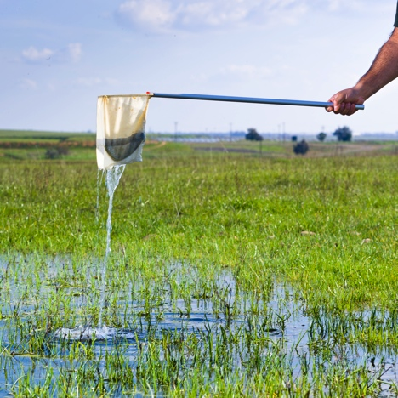
Application process:
Prepare a resume and cover letter
Work location: Academic Office Annex #125, in the reserve or at an independent location
Schedule: 15-20 hours per week (days of week TBD)
Salary: $10.50/hr.
For more info, contact Monique Kolster at mkolster@ucmerced.edu

