QSB Seminar : October 20, 2017, COB 2, Rm 170, 1:30 pm - 2:45 pm
Plant– Soil Microbe Interactions in Semi-arid systems: Who’s Driving the Bus?
Abstract: Interactions between plants and soil microorganisms may take many forms and are not limited to the close symbiotic relationships that we often associate with this topic. Plants may modify the soil physical environment, making it more or less favorable for microbial activity. Conversely, soil microbes may stimulate or inhibit plant growth by releasing or tying up plant available nutrients. In this seminar, I will discuss two of my recent research projects: One examines the effects of an exotic invasive grass (cheatgrass) on soil microbial activity and nutrient cycling, and the other examines the effects of “hydraulic lift” by sagebrush plant roots in stimulating nutrient release by soil microbes and increasing plant-nutrient acquisition during the dry summer months. Both of these projects have important implications regarding the effects of global change.
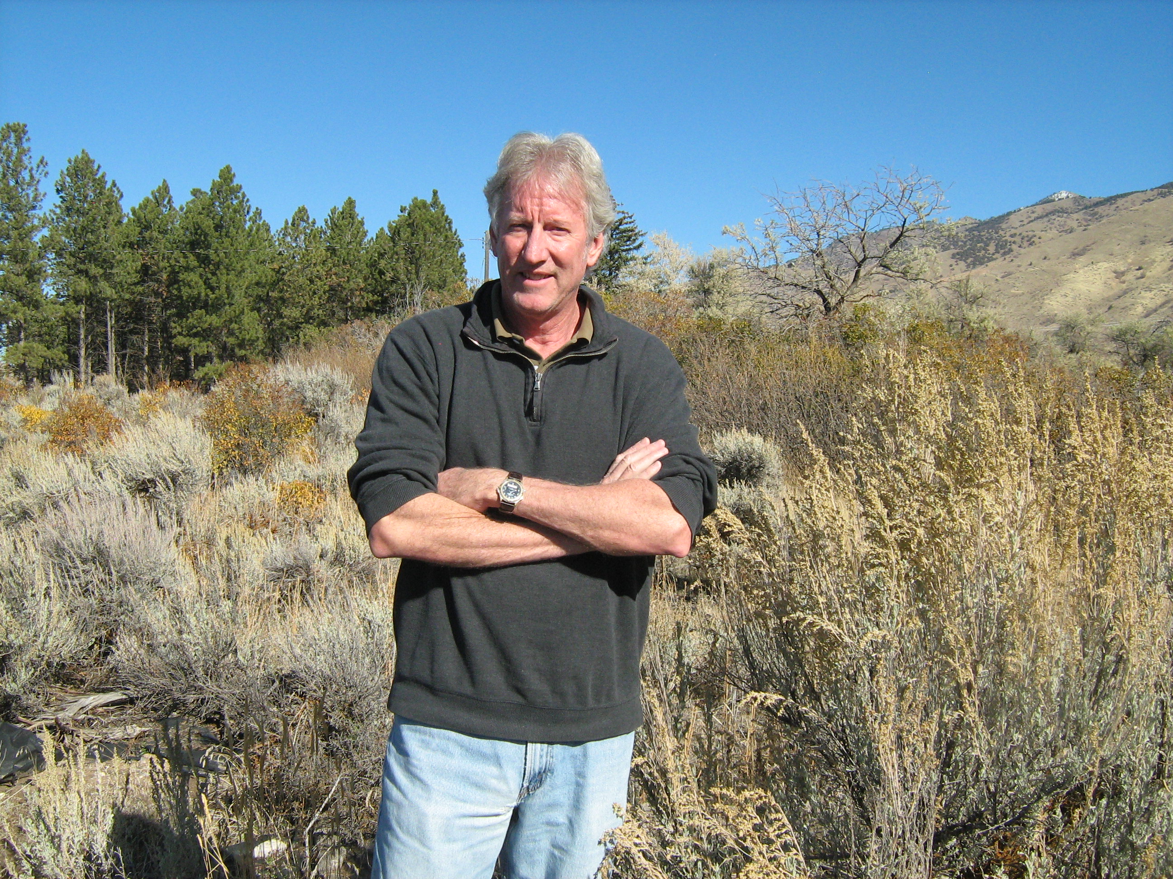
Bio: Dr. John M. Stark is a soil biogeochemist in the Department of Biology, and the Ecology Center at Utah State University. His research interests span scales from soil microsites to entire ecosystems. His research has examined topics such as how invasive grasses modify soil environments to promote their own success, what regulates trace greenhouse gas emission from soils, and what controls nitrogen retention in wildland soils. While his research has generally focused on C and N cycling forest and rangeland soils, his group is currently examining what regulates microbial sequestration in C in soils of agroecosystems.

