UC Merced Environmental Systems Seminar (ES 291)

Wednesday 26th October 2016

12.30-2.00 PM COB 105

Beyond Recalcitrance – Carbon Flow through the Mineral Soils of a Prokaryotic World

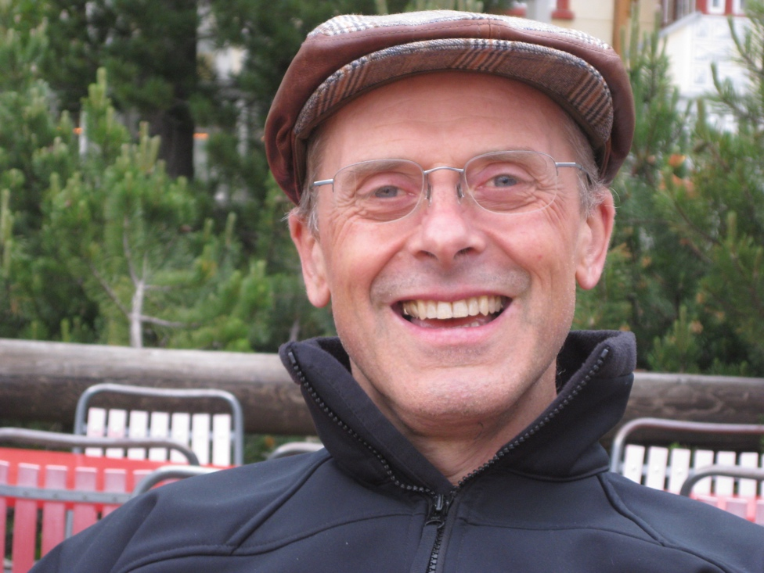

Prof. Markus Kleber
Oregon State University

Prof. Kleber started out as a sailor in the German Navy (1978 -1988), where he was trained as an antisubmarine helicopter pilot and participated in several cruises to the North Atlantic and Indian Ocean. He shifted gears in 1988 and enrolled at the University of Hohenheim to pursue a degree in Agricultural Biology. During his PhD, he developed an interest in soil carbon cycling, originally focusing on CO2 and CH4 emissions from soil. When he moved to the University of Halle-Wittenberg in 1998, this interest shifted towards mineral-organic associations. This has been his main field of interest ever since. Related interests have been the behavior of thermally altered carbon in soils and, most recently, the fate of proteins in contact with mineral surfaces.

