Long duration energy storage technologies

Abstract:
We review candidate long duration energy storage technologies that are commercially mature or under commercialization. We then compare their modularity, long-term energy storage capability and capital cost for large energy applications. These are valuable insights to guide the development of long duration energy storage projects and inspire future analysis in the relevant modeling and decision-making.

Key words: Long duration energy storage; electricity market; use case
Table of Contents
1. Introduction 1
2. Long Duration Energy Storage Technology Evaluation 3
2.1 Methodology 3
2.2 Technologies Overview 3
2.2.1 Pumped-Storage Hydropower 3
2.2.2 Other Gravity Based Solution 5
2.2.3 Compressed Air Energy Storage 7
2.2.4 Thermal Energy Storage 8
2.2.5 Flow Battery 10
2.2.6 Power-to-Gas (Noah) 11
3. Comparison in details 15
3.1 Land footprint 15
3.2 Equivalent efficiency 17
3.3 Average Capital cost 18
4. Conclusion 19
5. Reference 20

1. Introduction
To mitigate climate change, there is an urgent need to transition the energy sector toward low-carbon technologies [1,2] where electrical energy storage plays a key role to integrate more low carbon resources and ensure the reliability of the grid [3–5]. Previous papers have demonstrated that deep decarbonization of the electricity system would require long duration energy storage [6–8]. Planned outages in California and Texas draw more attention to the value of long duration energy storage. Although the value of long duration energy storage is widely discussed[6,7], a systematic review can provide an understanding of technological maturity relative to what is needed on the power grid to achieve deep decarbonization at a reasonable cost. The detailed description of technological maturity across different parameters helps identify roadblocks, challenges, and opportunities to accelerate deployment of long-duration storage technologies.

There are some reviews about the energy storage systems[9,10], but most of them, if not all, do not distinguish short and long duration energy storage technologies. Different durations would induce different applications, business model, and also different metrics of interest. Some metrics like idle loss may not be important in the discussion of short duration energy storage but might be important for long duration energy storage technologies. In this paper, we loosely define long duration energy storage technology as one that provides stable electricity at its rated power for more than 8 continuous hours. This duration is consistent with the definition in the integrated resource planning issued by California Public Utilities Commission and entities around the world who are pro-actively seeking long-duration storage implemented in existing power networks. Long-duration energy storage projects usually have large energy ratings, targeting different markets compared with many short duration energy storage projects. These characteristics differ from short duration technologies and thus demonstrate the need to review techno-economic performance of long duration energy storage technologies. Moreover, some characteristics such as energy losses during the storage or self-discharge rates are critical to evaluate long duration energy storage technologies, but are not widely discussed in previous reviews that focus more on comparisons of short duration storage technologies.

Different from the market for short-duration energy storage technologies, which is projected by 2030 to be dominated by the Li-ion batteries[11,12], the market for long duration energy storage technologies contains a broader set of competitive players, ranging from traditionally dominant storage technologies such as pumped storage hydropower and compressed air storage, to many emerging technologies from startups which are not usually included in the discussion. These long duration energy storage technologies differ not only in duration from the short duration energy storage technologies but also differ significantly from each other. Many of them are in the early stage of the development and could significant improve their performances in the near future. Omission of this diversity and advancement hinders a proper evaluation of the role of long duration energy storage technologies[13], framing them in the stereotype that long-duration storage is inefficient, geographically constrained and prohibitively capital intensive.

This paper reviews emerging long duration energy storage technologies, compares their techno-economic characteristics and discusses potential use cases based on innovative characteristics. The analysis provides valuable insights to economists, system modelers, policy makers and investors on the pathway to the deep decarbonization of the electricity system.

2. Long Duration Energy Storage Technology Evaluation

2.1 Methodology
In selecting which technologies to discuss, electricity-in-electricity-out technologies were prioritized. We chose to focus on technologies applicable to at least diurnal and cross-day storage with a discharging duration at rated power for more than 8 hours. We review the technologies that are either already commercially viable or during the commercialization process. Lithium ion has been provided as a benchmark of “standard” battery technology, which is already commonly used for short term storage; we select Powerpack, a utility scale product by Tesla, in our comparison.
Surveys were sent to companies identified as actively developing relevant technologies, asking for estimates of costs and performance metrics typical of a system being marketed to customers. We also requested minimum and maximum deliverable sizes and the associated marginal costs. Some agreed to meet and provide additional details through correspondence. These survey data were supplemented by a literature search that prioritized recent publications (2015 or later) to give a more complete view of the current state of technologies, and focused, where possible, on real-world examples of operational projects rather than theoretical simulations, specifying current costs and performance rather than future projections. Land footprint data were estimated for some locatable projects using Google Earth.
To compare different technologies, we compute the equivalent efficiency following Equation 1, useful for gauging the effectiveness of storage on the scale of days or weeks and which considers roundtrip efficiency and idle losses. Some companies also provided information about their reference systems which are either typical, nominal or useful configurations in demonstrating their technologies. Based on the reference system, we also calculate how the project average capital cost, C_{x}, ($/kWh), which evolves with different energy ratings for a power rating (Eq. 2).
Equation 1 $$Equivalent efficiency=Round trip efficiency×{(1-idle loss per hour)}^{x}$$
x is the storage time (hour)
Equation 2$$C_{x}=\frac{E_{r}× C_{r}+(E_{x}-E_{r})×C_{mar}}{E_{x}}$$
$C_{x}$ is the project average cost ($/kWh) of the estimated system and this system has the same power rating with the reference system
$E_{x}$ is the energy rating (kWh) of the estimated system
$E_{r}$ is the energy rating (kWh) of the reference system
$C_{r}$ is the average cost ($/kWh) of the reference system
$C_{mar}$ is the marginal cost ($/kWh) of the system

2.2 Technologies Overview

2.2.1 Pumped-Storage Hydropower
Pumped-storage hydropower (PSH) is composed of two reservoirs with elevation difference and at least one powerhouse, storing the energy in the form of gravity of the water. It occupies more than 90% of the US energy storage market [14] and its economical resource potential exceeds the global energy storage requirement based on recent studies [15,16].

Similar to many other long duration energy storage technologies, the cost can be separated into an energy part and a power part. The energy part includes the cost to construct the reservoir which determines how much energy it could store. The power part is mainly about the powerhouse. The capital cost varies significantly; the cheapest could be only one fifth of the most expensive one. If measured by $/kW, PSH is expensive compared to other technologies[17,18], but is among the cheapest if measured by $/kWh [12,18–20]. Some researchers believe it could be as low as 5$/kWh[21]. Several studies[12,18–20,22] state that PSH is one of the most cost attractive options for long duration energy storage in the near term. Such a low energy cost results from the large energy rating. Some projects are designed for seasonal storage or store energy over multiple years[23]. Additionally, it would be expensive to build a small PSH project due to project-level economics of scale.

Besides the low energy cost, PSH also has many other advantages[24]: The designed lifetime is usually longer than 30 years and sometimes more than 100 years. The round-trip efficiency is relatively high as 65%-85%; The depth of discharge could be as high as 100%. Another advantage, especially for long duration energy storage technologies, would be the low self-discharging rate [25]. Despite so many advantages, dependency on water availability and geographic conditions, large land area, huge upfront capital cost, and considerable environmental impact all limit the deployment of traditional PSH.

Many emerging PSH technologies address some of these limitations. Instead of constructing a reservoir, a team designed a vessel and deployed it under the water[26] (Figure 1 a). It would consume electricity to pump out the water from the vessel and generate electricity when water flows in. The concept has been proven to be technologically feasible with a pilot project[27]; a researcher estimated the cost around 400-500 €/kWh[28]. Researchers developed a similar concept in which a floating membrane would act as a storage reservoir rather than a vessel[29] (Figure 1 b).
Another approach to reduce the cost of the reservoir is to utilize existing reservoirs, like a decommissioned coal mine. A case study on an underground mine site in Kentucky found that the initial capital cost would be between 1700 $/kW and 2400 $/kW for a 5MW/50MWh PSH project[30]. Another assessment of a coal mine in Germany resulted in a capital cost of 253 €/kWh when the head was 1000-m[31]. Depending on the driving factors, the underground environment can increase or decrease the round trip efficiency compared with the traditional PSH projects[32,33]. Quidnet Energy, a geomechanical PSH provider had four projects under development in 2020 in New York, Texas, Ohio and Alberta.[34] (Figure 1 c).
The PSH technologies mentioned above still face geographic restrictions. People have conceptualized a system that combines pumped storage with a compressed air system through a pressurized water container[35]. A realized example is Ground-Level Integrated Diverse Energy Storage (GLIDES) developed in Oak Ridge National Laboratory [36] (Figure 1 d). The current prototype of GLIDES uses a steel pressure vessel, leading to high capital cost. It costs around $4500/kWh for a 300-MW, 6-hour system. If the vessel is made of high-pressure pipe segment, the cost of the same system can be reduced to $250/kWh[37]. Another company, Hydrostor, developed a similar technology combing CAES with pumped storage, but instead of using liquid to compress air, they use compressed air to drive water to and out the reservoir.
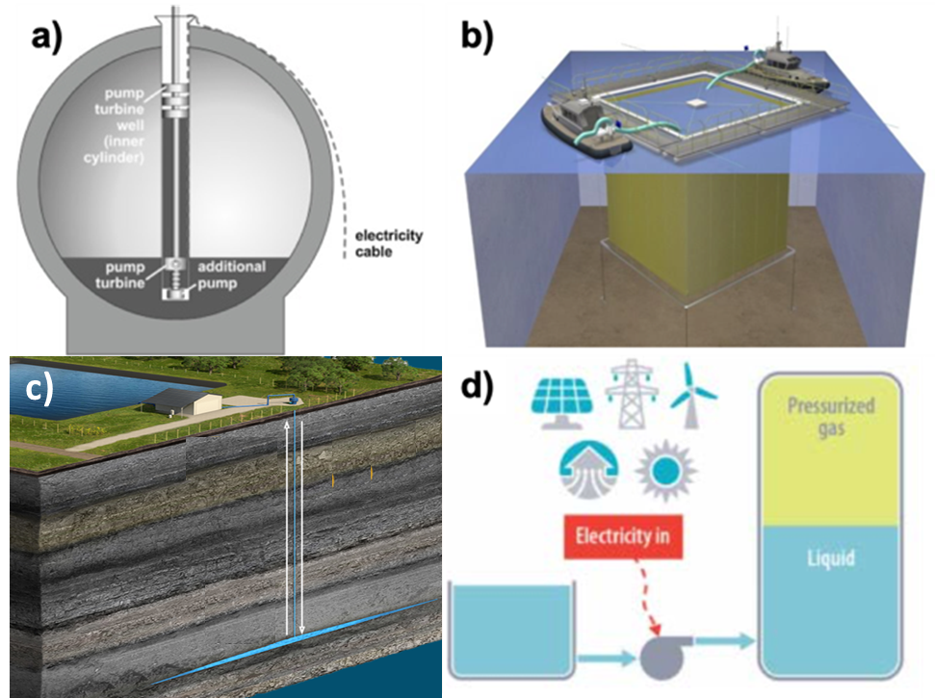

Figure 1 a) Schematic cross sectional view of the StEnSea system[28]; b) Schematic of prototype floating reservoir[29]; c) Scheme of Quidnet Energy; d) Schematic of GLIDES when charging[36]

2.2.2 Other Gravity Based Solution
One drawback of PSH is the low energy density as it is constrained by the density of water. The PSH essentially is a technology that stores the electricity in the form of gravity potential. With the same principle, some other gravity-based energy storage solutions are developed, increasing the energy density of storage media and also alleviating the water availability constraints.

In an underground PSH project, replacing part of the water with a heavy piston, we get the Gravity Power Module proposed by Gravity Power (Figure 2, a). A similar design is also under development by Heindl Energy. When the piston drops, it pushes the water through the penstock to move the turbine and generate electricity. Lifting the piston up through the hydraulic system consumes electricity. Gravity Power has begun their demonstration project in Germany. A Scottish company Gravitricity devised another underground gravity storage system, replacing the hydraulic system with winches (Figure 2, b). Their technology utilizes the existing mine shafts to raise and release the heavy weights up to 12,000 tons as the developer estimated[38]. Operation of a 250kW demonstration unit commenced in 2020 and a commercial scale project, 4MW is planned in 2021. Raising the mine shaft above ground, engineers from Energy Vault designed a tower, which uses a crane to lift blocks (Figure 2, c). Both the width and the height of the tower decide the energy capacity. The power would rely on the velocity and the mass of the block. Energy Vault began operation of a 5MW, 35MWh commercial demonstration unit in Switzerland in 2020 with an energy density as 6.3kWh/m²[39]. Also lifting blocks, a Russian company Energozapas(Figure 2 d) is developing a similar solution and has operated their prototype since 2017. Instead of vertical movement, Advanced Rail Energy Storage (ARES) uses a rail to move weight up and down a mountain (Figure 2, e).. ARES has already completed a demonstration project in California and a 50MW commercial project in Nevada is under development[40].
Figure 2 a) illustrative plot of Gravity Power Module from Gravity Power Inc.[41]; b) Schematic plot of the Gravitricity system[38]; c) Design from Energy Vault[39]; d) Lifted Weight Storage module constructed by Energozapas[42] e)ARES’s demonstration project in California[43]
Comparing with traditional PSH, these novel gravity based technologies have many advantages[44], for example, the modularity. Their size can range from 100-kWh to multi-GWh, resulting in lower foot prints and environmental impact. The faster response time is another advantage. Gravitricity claimed that their technology could go from zero to full power in less than a second[38]. ARES plans to actively participate in the frequency regulation market in CAISO[43], confident in their fast response time. Since there is no evaporation, as with PSH, the self-discharge rate or the energy loss during the storage is extremely low, making them ideal for long term energy storage.

Gravity Power system is estimated to have a capital cost around 1460 €/kWh[45] for a four-hour project. As for a similar eight-hour duration project, another researcher estimated the capital cost as 148$/kWh[46]. Both studies concluded a low levelized cost of storage 148$/MWh and 123 €/MWh, and Li-ion battery is around.132-250$/MWh[47]. The main cost component for these underground projects is the excavation cost, making more than 50% of the total capital cost[48]. Thus, if an ideal site is identified, such a technology would be highly cost-competitive. Capital cost of ARES is around 1200$/kW or 160$/kWh[43]. If the concrete is around 10$/ton, the marginal cost of energy for Energy Vault is 37$/kWh[39].

2.2.3 Compressed Air Energy Storage
Compressed Air Energy Storage (CAES) uses energy to compress into a large underground cavern. The air is later released into a recuperator and heated for re-expansion at a turbine for power generation. CAES can be categorized into diabatic and adiabatic. In diabatic, the heat released by compression is not captured, and the reheating of air must be accomplished via burning of natural gas or through electric heating. Adiabatic systems capture the compression heat reuse in a recuperator, increasing efficiency for higher build cost.

While diabatic CAES is the more mature technology, the number of commercial implementations remains limited. The world’s first CAES plant was the 1978 Huntorf plant, at 290 MW, 480 MWh. The second, was the 1991 McIntosh plant at 110 MW, 2000 MWh (later 3370 MWh with upgrades)[18,49]. These two remain the only physical examples in current commercial operation, and form the basis of test cases and projections throughout the literature, though Apex has a planned 324 MW, 16 GWh project under development in Texas with anticipated commercial operation date as fall 2022.[50].

Diabatic CAES favors large builds with long duration, taking advantage of large underground caverns for low per kWh costs of $94-$229[18], $90-$327[9]), with total per kW estimates of $1050-$2544[18] and $885-$1368[9]. Operation and maintenance costs for contemporary systems are estimated at $8-$18/kW and $5.1$×{10}^{-4}$/kWh respectively [9]. This comes at the expense of geographic dependence on large salt caverns, and only modest round trip efficiencies (50 – 54%)[9,18,49,51] when considering energy cost of reheating.

Adiabatic systems only reached commercial production recently. After completion of their Toronto Island Demonstration Facility in 2015, Hydrostor opened their Goderich A-CAES site (1.75 MW and 10 MWh) to commercial service in 2019 in Ontario. Augwind announced a 5 MW, 20 MWh pilot in Israel. Though early system sizes are small compared to diabatic systems, Hydrostor has a 500 MW, 6 GWh project under development in Rosamond that could start by 2024. [52,53].

Adiabatic CAES (A-CAES) similarly relies on underground caverns. The use of hard rock excavation techniques allows for significantly more flexibility compared to natural salt caverns[52] [Hydrostor correspondence]. These techniques could theoretically be applied to traditional CAES to improve siting flexibility, though no plans to do so have been announced. The reuse of compression heat results in efficiencies of up to 70-75%[9,18,51] (with Augwind claiming possible 75-81% for their pilot), at increased cost. Limited economic analysis of A-CAES has been done. Though current builds are significantly smaller than diabatic systems, it seems likely this is a result of low technological maturity, and larger projects are under development. Adiabatic systems should also favor large builds, though possibly limited by the ability of thermal storage components to keep pace with air storage

Response times for both systems is on the order of minutes. There appears to be no intrinsic limit on system lifetime aside from standard repair and maintenance of compressor, heat exchanger and generator systems.

There is a third category that can be considered an offshoot of CAES, or a hybrid with Thermal Storage, called Liquid Air Energy Storage (LAES), sometimes called cryo-storage. Air is cooled to cryogenic temperature using a cycle of compression, cooling and expansion with associated hot and cold storage tanks. Highview is currently the only company with any LAES plants in operation (Figure 3). A 350 kW, 2.5 MWh pilot underwent testing between 2011 and 2014 and has since been relocated to the University of Birmingham. The 5 MW, 15MWh Pillsworth Demonstration Plant in Bury, Greater Manchester began operation in April 2018. A number of plants are under development in the United States and Europe, the first of which is a 50 MW, 250 MWh project under construction in Carrington, UK[54].
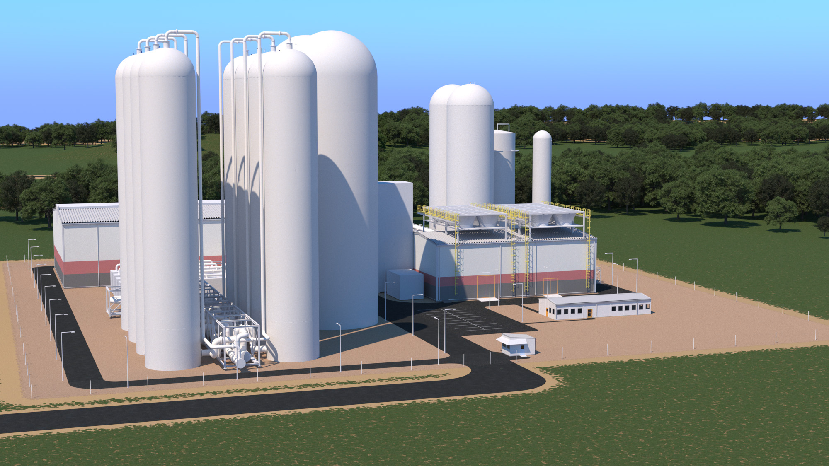
Figure 3 Schematic of a HighView plant

LAES allows for higher energy density (8-24 kWh/m³ [55], as opposed to 2-6 for diabatic and estimated 0.5-20 of adiabatic[51]), and removes the cavern restriction in favor of tank storage, for greater capital costs ($2000-$4000/kW based on projections from the pilot) and O&M costs comparable to conventional CAES[56]. Round trip efficiency is ~60%, though could climb to 70% with integration of waste heat recovery if built into existing power plants[56]

2.2.4 Thermal Energy Storage
Thermal storage can be sorted into three categories based on storage medium. Sensible Heat stores energy in the temperature of a material, later drawing it out through an exchanger to generate power via steam production or the expansion of another working gas/fluid. Latent Heat storage, frequently called Phase Change Materials (PCM), utilizes a phase transition of its storage medium, reverting it to release heat, and can be further manipulated by imposing pressure conditions. Thermochemical Storage drives an endothermic chemical reaction, splitting a molecular substance into products that are stored separately and reintroduces to reverse the reaction and release heat. Energy density of each of each storage type depends on the medium used, but ranges from 10 – 50 kWh/ton for sensible heat, 50 – 150 kWh/ton (50 – 200 kWh/m³) for PCM, and 120 – 250 kWh/ton (200 – 600 kWh/m³) for thermochemical.[57].

After analyzing the Global Energy Storage Database hosted at Sandia National Laboratory[58], we found that most thermal projects to date are not designed for electrical storage. PCMs feature heavily in construction materials for energy efficient buildings for temperature regulation [57]. Only a few commercial thermochemical storage technologies are in development at this time like HiT Nano and TEXEL Energy storage.

Thermal storage for electrical generation is dominated by sensible heat molten salt, accounting for 77% of all thermal energy stored[10]. This is almost entirely implemented as Concentrated Solar Power (CSP), with typical duration of 4 – 10 hours[58]. As CSP turns solar incidence directly into stored heat for conversion into electricity, this does not represent a true alternating current (AC) to AC system. Some storage technologies required auxiliary loads (AC-based) to operate (e.g., pumps, fans, controls), and hence to fully integrate the storage technology with the AC electric grid, a relevant efficiency metric to consider is its AC-to-AC roundtrip efficiency.

AC to AC thermal storage systems are relatively new. Systems in which a working gas/fluid is circulated between hot and cold tanks are referred to as Pumped Heat Electrical Storage (PHES). Isentropic finished their 600 kWh, 150 kW Newcastle University demonstrator facility in 2019. It pumps argon between two tanks of mineral gravel and achieved an AC to AC roundtrip efficiency of 60-65% (with theoretical 75-80%). Analysis and cost estimates for a theoretical commercial system of 16 MWh and 1.6 MW, based on data from the project then in progress[59], and using an assumed efficiency of 67% (with 52% and 72% as end case scenarios), predicted storage costs of $17/kWh ($13 – $21/kWh).

National Renewable Energy Laboratory (NREL) is working on their ENDURING project, in which sand storage medium is circulated between tanks and passed through a fluidized bed heat exchanger. The 405 MW and scalable 100 MW – 76 GW system claims energy densities of 450 kWh/m³, 10 – 100 hour duration, 50% roundtrip efficiency, and estimated storage cost of $10 - $40/kWh (less if built into a pre-existing thermal plant). The modular nature of heating elements allows for broad scalability of charge time.

Malta is constructing a 10 MW pre-production prototype of a molten salt based PHES system for 100 MW and 4-24 hour duration, with 10 hours as an initial design target. It will have a similar modularity of heating elements and variable charge rates.
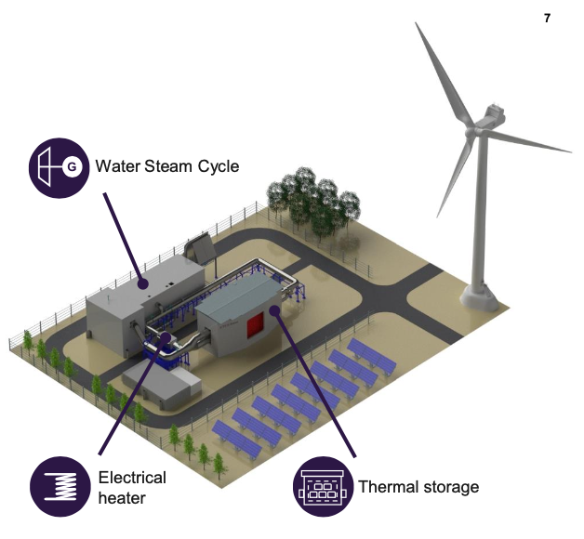
Figure 4 schematic of ETES system

Siemens developed Electric Thermal Energy Storage (ETES) system using volcanic rocks for both heat to heat storage and heat to electricity via steam generation (Figure 4). Having completed a 130 MWh demonstrator in Hamburg in 2019, they are currently working on the first series of commercial pilots.

Another sensible heat, but non-PHES system is being developed by Antora. Their thermophotovoltaic (TPV) system allows the medium to emit energy as light in the infrared and near-infrared frequencies to be absorbed by a photovoltaic cell, while other frequencies are reflected back. The 5 – 500 MWh, 10 MW system would have energy densities of 80 – 500 kWh/m³, 40% roundtrip efficiency, and ~$10/kWh storage cost.

A PCM AC to AC system is being pursued by Swedish company, Azelio. Their Thermal Energy Storage Pod uses phase changing aluminum and a Sterling engine to run a turbine. The first commercial installation of their system has started in Dubai as of February 2021.

Idle energy loss is a major challenge when discussing thermal storage, and depends on the effectiveness and cost of insulation technology. CSP systems rarely discuss heat loss, as they are typically built for duration times of 10 hours or less. Smallbone et al[59] use a daily value of 1% in their projected estimate of a PHES system, as does Siemens for their ETES, for a total 6.8% weekly value. Malta predicts <1% daily for a 10 MW system, and <0.5% daily at 100 MW. NREL’s ENDURING project claims weekly loss of ~3-5%. Anterra gives ~5-10% weekly. Theoretically, thermochemical storage would bypass the problem, but no projects appear to be under development.

2.2.5 Flow Battery
Flow batteries have the potential to provide flexible long-duration storage as they can be configured in different arrangements based on power and energy needs. Flow batteries have been under development for decades, yet renewed interest due to technological breakthroughs and cost reductions in solar and wind that have renewed interest. Compared to conventional stationary batteries, flow batteries separate power density from energy capacity and duration by design, meaning that flow batteries could discharge MW-scale power within seconds. However, unlike supercapacitors or other short-duration competitors, flow batteries can also serve the 8+ hour duration range with energy capacity a function of the electrolytic tank volume. The ability to substitute different electrolytic, membrane, and electrode materials make flow batteries an attractive technology for commercialization and deployment. Vanadium-redox flow batteries have demonstrated recent cost reductions and commercialization in the UK through companies such as Invinity Energy Systems. Zinc-based flow batteries such as zinc-air, zinc-cerium or zinc-bromine offer alternative options, though typically at lower efficiency compared to vanadium-redox flow batteries. Zinc8 as a leader in zinc-air technology has energy storage projects underway in New York State to showcase commercialized solutions. An Australian company RedFlow commercialized zinc-bromine flow battery and could provide as small as 10 kWh system. Additionally, lab breakthroughs identify future potential for organic, metals-free, quinone-based systems[60]. In Germany, Jena batteries in Germany offers organic commercial options with capacities up to 40 kWh. Iron-flow batteries such as those developed by ESS Inc, an American flow battery company, offer portability and transportability as key advantages for projects that require mobility- such as temporary micro-grids or other portable long-duration applications.

Power densities for vanadium-redox flow batteries (60-100 W/L) typically exceed that of other chemistries(50 W/L for zinc-based systems) and low power densities for metals-free options. Additionally, most flow batteries operate between 0-40° C. Vanadium is a highly persistent metal with a cycle-life that potentially can exceed more than 10,000 cycles of 100% Depth of Discharge, making it an attractive option due to its extended lifetime (20+ years) compared to other flow batteries – and roundtrip efficiencies are reported up to 85%[61,62]. Past studies indicate fewer GHG emissions per kWh from flow batteries storing solar and wind compared to CAES[61].
As a long-duration option, flow batteries present interesting advantages compared to stationary battery counterparts such as lithium-ion storage and sodium-sulfur batteries. Due to their fast response times, flow batteries typically could provide load balancing, peak shaving, frequency response, voltage regulation, and ancillary service provision on the grid – yet at the same time they could expand volumetrically to increase total duration. Therefore, they may add flexibility depending on their grid application. They may charge or discharge within seconds-to-minutes, and allow for black start capabilities for small micro-grid back-up – providing resilience during emergency outages or as a replacement for building generators. Conventional lead-acid or lithium-ion batteries that may cost less upfront capital than flow batteries, may degrade faster than vanadium- or zinc-based flow batteries on the market. Primus Power, a leading flow battery developer, often points to the lower total cost of ownership as a key advantage compared to lithium-ion, though the market for 8+ hour storage is only beginning to emerge. Therefore, durability and the ability to locate flow batteries in most geographic locations make them a viable long-duration storage candidate—although they typically operate on smaller scales and shorter durations than other options considered in this study.

2.2.6 Power-to-Gas (Noah)
Power-to-gas has emerged as a potential way to convert and store electricity into gas, such as hydrogen, for heat or transportation. The major advantages are the opportunities for large-scale and long-duration storage that gas provides – and the potential for sector coupling across electricity, gas, transportation, and heat networks.
Historically, major barriers to implementing Power-to-gas have been low conversion efficiencies and high costs that limit deployment. Power-to-gas technologies include the conversion of electricity into hydrogen using water electrolysis (Power-to-Hydrogen). Hydrogen can be used for industrial purposes as a chemical, injected and blended with natural gas in existing pipelines, or stored. It can be later reconverted to electricity using a fuel cell or remain as hydrogen gas. Synthetic natural gas such as methane can be produced when hydrogen reacts with CO₂. This synthetic natural gas can be injected into the natural gas pipeline or stored and used to produce power in a gas turbine.

Currently, only 4% of global hydrogen production comes from water electrolysis – and a small fraction of electrolyzer-produced hydrogen is from renewable sources [63]. Two main electrolysis technologies are commercially available: alkaline (AEL) and polymer electrolyte membrane (PEM)[64]. Solid-oxide electrolysis cells are under development, as some companies such as LG and FuelCell Energy have built demonstration projects[65].

The greenhouse gas footprint of hydrogen production depends heavily on the type of electricity sourced to produce hydrogen. Alkaline and PEM electrolysis with electricity from wind and/or solar PV plants lead to substantially lower life-cycle CO₂-equivalent emissions for a comparable amount of hydrogen produced by other electricity sources.

Globally, the largest Power-to-Gas installations exist in Europe, particularly Germany, Denmark, and Switzerland[66]. As of 2017, the largest installed industrial plant was ETOGAS- Audi e-gas plant in Werlte, Germany, using 14.4 MW of electricity from offshore wind to power a 6 MW AEL electrolyzer. The hydrogen in this application combines with CO₂ from a biomethane plant to generate synthetic natural gas. The waste heat from electrolysis and methanation can supply heat to neighboring customers and the plant is eligible and participates in ancillary service markets in Germany. German power and gas grid operators have announced larger projects, such as 100 MW facility in Lower Saxony. The plant aims at reducing curtailed wind electricity, stabilizing the electric grid, and reducing need for new generation.

AEL electrolyzers have lower installation cost compared to PEM electrolyzers. Because AEL electrolyzers have a lower minimum operating capacity of 20% and slow cold start times (30-60 minutes), AEL systems are advised to operate continuously. Another disadvantage of AEL is that the electrolytes are highly corrosive, necessitating frequent maintenance. PEM electrolyzers have faster cold start times and greater flexibility. The minimum load is reported to be 5%, but could reach 0% by 2025 [67]. PEM electrolyzers are largely viewed to have the most potential upside for commercial development and coupling with excess wind or solar PV-based electricity. Solid-oxide electrolysis cells are an emerging electrolyzer technology currently under development.

The European Commission undertook a forecast of technology development for PEM electrolyzers and found three future potential sizes, with most PEM electrolyzers operating at 1-5 MW and new electrolyzers expanding up to 20 MW.

 | AEL | PEM
Minimum capacity [%] | 20 | 5
Pressure output [bar] | 0 | 30
Power consumption [kWh/m³H₂] | 4.5-7 | 4.5-7.5
CAPEX [$/kW] | 900-1,500 | 1,400-1,800
Lifetime – system [years] | 20 | 20
Lifetime = stack [hours] | 80,000 | 40,000
Table 1 Summary of AEL and PEM technologies [68–71]

Company | Type | Discharging duration(hr) | Energy Density (kWh/m3) | Land Usage (m2/kW) | Land Usage (m2/kWh) | Energy capacity (MWh) | Discharging power capacity (MW) | Lifetime (years) | Self-discharge rate (%/day) | Roundtrip efficiency (%) | Response time(s) | Marginal Energy Capital cost ($/kWh) | Average capital cost ($/kW) | Average capital cost ($/kWh) | Fixed O&M ($/kW-yr)
Zinc8 | Flow Battery | 8-200 | 8-13 | 0.15-0.20 | 0.02-0.025 | 0.16~240 | 0.02~10 | 20 | 0.5~0.7 | 65 | ~1 | 45 | 3808 | 475 | 20-50
Renewell * | Gravity |  |  | 892.86 | 892.86 | 25~100 | 25~100 | 25 | 0 | 74 | ~1 |  | 8000 | 8000 | 50
Energy Vault | Gravity | 2-15 | NA | NA | ~0.15 | 50~10000 | 20~1000 | 35 | 0 | 83-85 | ~5 | ~100 | NA | 200-300 | ~20
Quident | Other Hydropower | ~10 |  |  |  | 160-3200 | 160~320 | 40 | 0.5 | 65~75 | 300-900 | 5-10 | 500-1000 | 50~100 | 10-20
Cat Creek^ | Pumped Hydropower | 120-725 | NA | 11 | ~0.1 | 3000000 | 120~720 | 100 | Evaporation | 83 | ~5 | NA | 2220 | 0.05 | 9.4
ETES*^ | Thermal | 6-48 |  |  | 0.007 | 240~1600 | 30-100 | 25 | 1 | 39 | ~300 | 1-2.5 | NA | 126-154
Antora* | Thermal | 10-250 | 250-500 | 50-100 | 10-20 | 5-50000 | 0.5-200 | 30 | 0.5-2 | 50 | ~5 | 5 | 400-750 | 10 | 10
HighView | Liquid CASE | 4-24 | NA |  | ~0.03 | 10-1000 | 10-200 | 30 | 0.5-1 | 55*^^ | ~600
Table 2 Summary of storage technologies from interviewed companies
*These companies have not built demonstration project yet
^ This company has only one project and the data is project specific and does not represent for the technology
*^ This data is only applicable to powerplant retrofit not other application. The MW/MWh should be MWe/MWhe to distinguish from the heat power/energy.
*^^This data does not consider heat integration to further increase the efficiency.

Type | Subtype | Discharging Duration (h) | Response time | Energy density (kWh/m3) | Land Usage (m2/kW) | Land Usage (m2/kWh) | Energy capacity (MWh) | Discharging power capacity (MW) | Lifetime (years) | Daily self-discharge rate (%/day) | Roundtrip efficiency (%) | Average capital cost ($/kW). | Average capital cost ($/kWh)
Compressed air energy storage | Adiabatic | 10-100 | 3-10min | 0.5~20 | ~15-17* | 0.27-0.3* | 10~10000 | 1~300 | 20~30 | 0.5~1 | 55~75 | 700~1000 | 40~80
Compressed air energy storage | Diabatic | 10-100 | 3-10min | 2~15 | ~13* | ~0.07 | 10~10000 | 1~300 | 20~40 | 0.003~0.03 | 40~60 | 400~2300 | 2~50
Compressed air energy storage | Liquid** | 4-24 | 5-10min | 8~24 |  |  | 10~1000 | 5~100 | 20~40 |  | 50~85 | 900~4000 | 260~530
Flow battery | Vanadium-based flow battery | 4~24 | Milliseconds | 15~70 |  |  | 0.1~100 | 0.01-10 | 5~20 | 0~1 | 65~85 | 600~1500 | 150~1050
Flow battery | Zinc-based flow battery | 4~24 | Milliseconds | 20~70 |  |  | 0.1~100 | 0.01-10 | 5~20 | 0.24~33 | 65~75 | 700~2500 | 150~1680
Gravity Storage | Rail-based gravity Storage** | 4-24 | Second |  | ~5 | ~20 | 100~20000 | 10~3000 | 40 |  | 75~80 | 1200
Gravity Storage | Block-based gravity storage** | 4-24 | Second |  |  | ~0.16 | 4~10000 | 1-1000 | 40 |  | 80~85
Innovative Hydropower | Ground level pumped storage** | 4-24 | Second-3min | 0.3~2.5 |  |  | 4~2000 | 1~300 |  |  | 75~85 |  | 250~5100
Innovative Hydropower | Underwater mechanical storage** | 4-24 | ~min | 1.5 | ~0.12 | ~0.03 | 20~4000 | 5~1000 | 5~20 |  | 70-75 | 1650~2200 | 470~600
Pumped storage hydropower | Pumped storage hydropower | 10-100 | Second-5min | <2 |  |  | 100-20000 | 10~3000 | 25~100 | 0~0.02 | 60-85 | 1700~3200 | 5~200
Thermal Storage | CSP^* | 4~24 |  |  | 0.13~2.3* | 0.03-1.2* | 0.1~2000 | 1~300 |  |  |  |  | 40~6250
Li-ion Battery | LFP^** | 0-4 | ~millisecond | 200-620 |  |  |  |  | 5-20 | 0.09-0.36 | 90-95 | 1500-2400 | 300-800

Table 3 Summary of Commercially Viable Long Duration Storage
*These data is estimated based on Google Earth
**These technologies are in their early stage and these parameters could change significantly depending on the technology advancement
^* CSP is generational technology and include a storage component, but different from other long duration storage technologies shown in the table.
^**Li-ion is not a long duration energy storage technology

To clarify several terms in the two tables, Energy Density refers to energy per volume of the storage medium, while Land Use/Footprint refers to the overall system, including support structures. Roundtrip Efficiency is overall efficiency of energy entering and immediately leaving the system such that idle losses are negligible. Idle losses are accounted for under Daily Self-Discharge Rate (%/day). Unless otherwise noted, Average Capital Cost ($/kWh or $/kW) reflects total inclusive cost of building a sample system divided by the energy or power of said system, not the costs specific to energy storage or power, which would be better represented by Marginal Capital Cost ($/kWh or $/kW). We describe the size of systems by Energy Capacity (MWh) and Power Capacity (MW). The Duration Discharge at Rated Discharge Power (h) is calculated from the ratio of the Energy Capacity and Power Capacity for a given system, but underrepresents the actual discharge time when the discharge power is less than the rated power. Source values for minimum and maximum Energy and Power Capacity could be constrained by the technical feasibility and/or economic feasibility if provided by companies.

3. Comparison in details

3.1 Land footprint
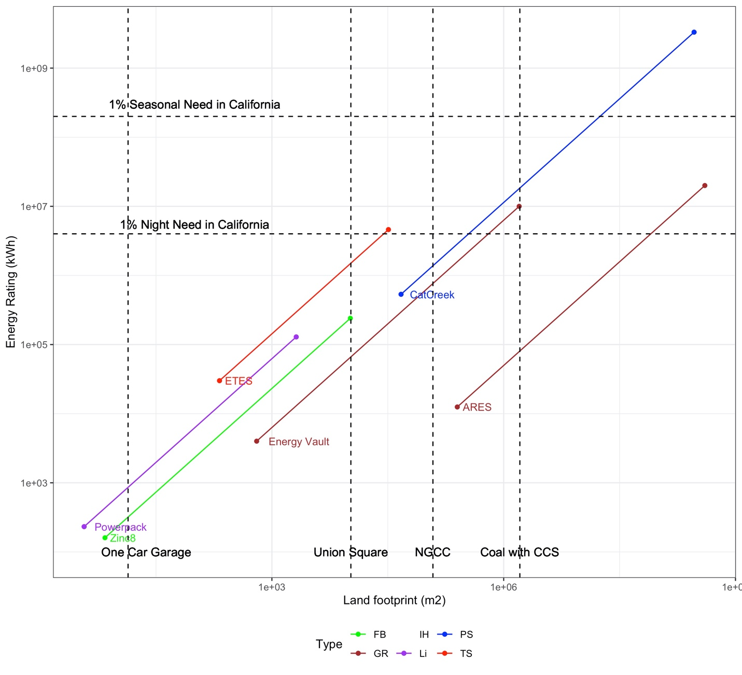
Figure 5 Land footprints of different technologies, FB: Flow battery; Li: Lithium-ion battery; PS: Pumped storage hydropower; GR: Gravity storage; IH: Innovative hydropower storage; TS: Thermal Storage The estimated footprints of thermal plants are from a report by Strata Policy[72]. Storage demand for California is based on Abido’s conference paper
Traditional long duration storage technologies, as represented by pumped hydropower storage and CAES, are characterized by their geographic limitations and environmental impacts. Figure 3 highlights the land use footprint of LDES -- ranging from several square meters to thousands square kilometers, depending on application and use. Smaller footprints for emerging technologies also inspire new business models (e.g., modular distributed storage) for LDES to enter the market. Small TPV storage options such as those developed by Antora Energy are likely to support more flexible sizing and siting, with smaller minimum footprints. Other storage options, such as small flow batteries could provide back-up power to commercial buildings or residences next to a single-car garage.
The location of storage technologies also varies depending on physical power plant infrastructure needed to complement installations. The smaller scale of thermal storage comparing with thermal plants provide a potentially profitable retrofit option – where carbon-intensive thermal generation that may be costly to operate can be phased-out by replacing silos and powering turbines with steam from particle thermal storage. These thermal technologies may offer relief to power plant owners who fear operating future stranded assets or could provide employment opportunities for workers trained in operating thermal power plants. Liquid-air energy storage can also utilize waste heat with a similar footprint. Liquid-air overcomes the geographic constraints of conventional compressed air technology, which needs underground caverns.
In addition to retrofits near power plants, tower gravity technology can also be deployed near demand centers as the manufacturing and operation is similar to building construction. A place like the Union Square plaza in San Francisco (~10,000m²) could hold a 70MWh Energy Vault project. The underwater PSH technology seems fit the size of a farm pond but it has additional requirement related to water depth. Yet, the modularity of underwater PSH adds flexibility in the location and installed capacity of new projects. For example, it is possible to deploy in larger water bodies such as Lake Tahoe. When comparing technologies, one can identify both the advantages for economies-of-scale with larger energy footprint plants such as PSH or advanced rail storage and the disadvantages related to limitations in the available land-area for deployment. Even some technologies with smaller footprints need additional complementary technologies to scale up– such as space for chillers to meet larger cooling requirements for some large batteries.
The land footprint uniquely describes a less-commonly discussed aspect of the energy transition. Geographic requirements, especially in states or countries with limited land availability and protected natural and cultural territories, present constraints and opportunities for long-duration storage technologies. The co-location flexibility and modularity in arrangements could be an advantage for siting new projects and reducing overall system costs due to land, while simultaneously reducing area-related environmental impacts. Alternatively, the footprint graph also presents market entry opportunities at different scales in the power grid, whether in the distribution system, transmission system, or as a replacement/complement to existing generation.

3.2 Equivalent efficiency
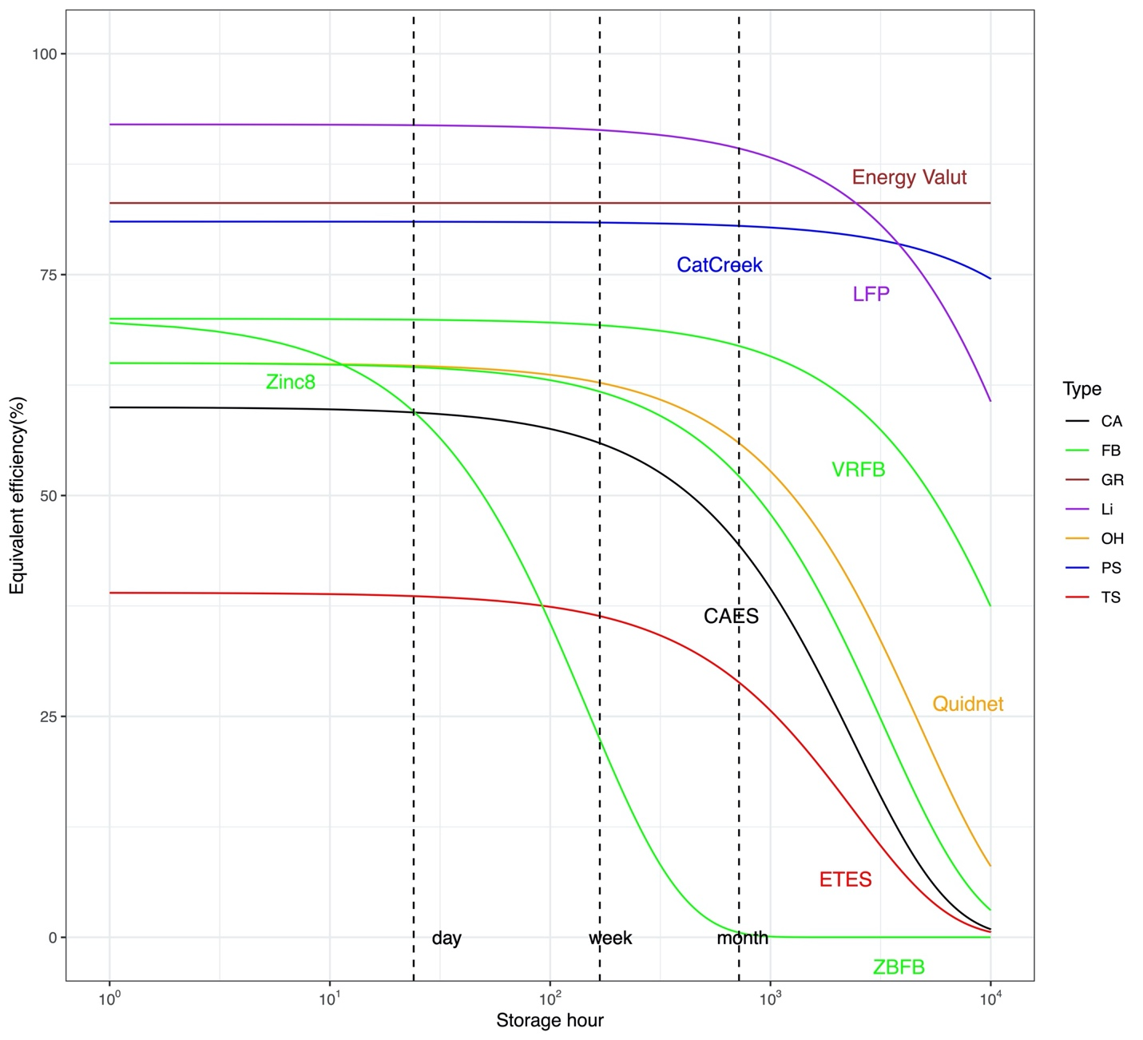
Figure 6 Equivalent efficiency of different storage technologies
Equivalent efficiency also presents a critical aspect of long-duration storage technologies, represented in Figure 4. The equivalent efficiency here is defined as the roundtrip efficiency (RTE) multiplied by the hourly idle losses from storage – which demonstrates how storage technology efficiencies change as a function of application from hourly demand arbitrage to seasonal applications.
Li-ion batteries have almost the highest RTE and relatively low idle losses, but cannot easily decouple energy and power. The mechanical based storage technologies (gravity and PSH) have a relatively high RTE and low idle loss and can outcompete with Li-ion battery at seasonal scale. Its footprint and economies of scale lead it to large energy rating. As it can efficiently store a large amount of energy over a year, it becomes ideal for provision of seasonal storage, resilience and emergency response. Flow batteries are among the second tier of technologies in terms of RTE, performing well for weeks with significant decline after a month. Conventional CAES and geomechanical storage both need underground infrastructure and the equivalent efficiency declines similarly to flow batteries. Considering the deliverable size and footprint, flow batteries and underground storage both operate at weeks scale but could enter the market in different ways. Flow batteries could start from residential and commercial customers while underground storage at a much larger scale. The thermal and power-to-power (hydrogen) technologies have the lowest RTE. The low equivalent efficiency curves impose a great challenge for them to make profit from energy arbitrage. Thus, we would expect them to rely on revenue from selling the heat or the gas directly and possible ancillary services in the electricity market.

3.3 Average Capital cost

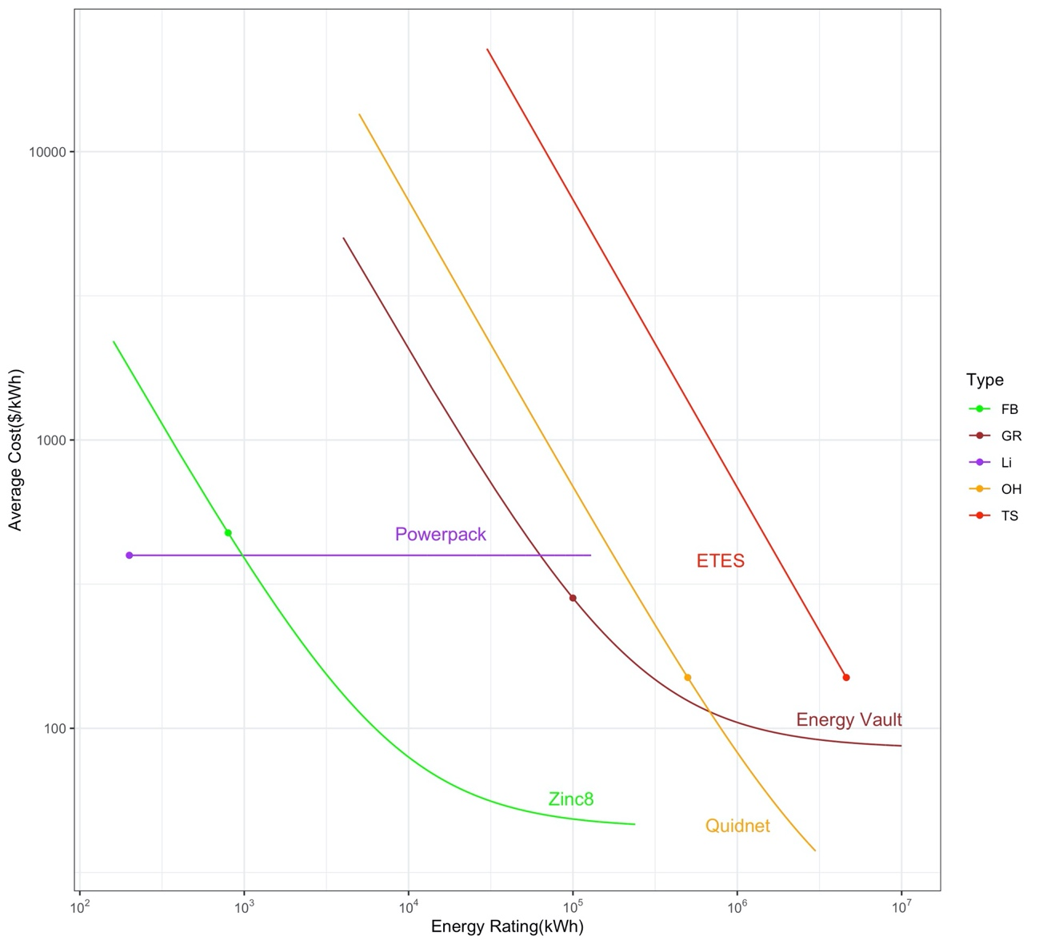
Figure 7 Average capital cost of different energy storage technologies

The cost of long-duration storage technologies also creates a variety of trade-offs and major considerations in addition to the footprint and equivalent efficiency of a candidate technology. For instance, the cost reduction as a function of energy rating (Figure 5) demonstrates that as duration increases, some of the larger-scale and larger-footprint technologies compete more directly on a cost basis with smaller projects and particularly could outcompete Li-ion storage. When taken together with applications (such as the equivalent efficiency for seasonal or weekly storage) and including information related to the footprint of projects, one may estimate that though flow battery technologies appear to offer capital cost advantages for smaller projects, future innovations that focus on extending the efficiency for longer durations would make flow batteries more competitive with other long-duration storage technologies. At a larger energy rating or discharging duration, technology like hydropower storage gradually outcompete gravity storage like Energy Vault which has advantages in both efficiency and footprint. However, despite the large footprint and geological constraint, hydropower storage project could be much cheaper if an ideal site appears, for example, two reservoirs already exist. Thermal storage and power-to-gas-to-power technology still burden a relatively high capital cost and would be difficult to compete with other long-duration storage technologies, given their land footprint and equivalent efficiency. Acting as an electric storage system may not be their main business model, but participating in the electric market might increase project profitability besides the revenue from selling heat or hydrogen.

4. Conclusion
In this paper, we present various long duration energy storage technologies, from conventional PSH and compressed air energy storage technologies, to innovative gravity storage and TPV technologies. The survey with technology developers, in addition to literature review provide a review on cost, land footprint, and electric performance of deployed pilots and prototypes of LDES technologies. By comparing their capital cost, deliverable size, land footprint, and equivalent efficiency, we identify possible market entry strategies and innovation paths that may enhance their competitiveness.
Flow batteries, despite their diverse subtypes, have advantages in the footprint and cost, making them suitable for the residential and commercial sectors, but their high idle loss constrains their charge-discharge cycle to several weeks. Improvements in their idle losses or RTE can increase their competitiveness with other technologies in the monthly or seasonal storage market. Vertical designed gravity storage technology, like Energy Vault, with a medium land footprint to be placed near demand centers, could be cost-competitive at a larger energy rating and longer discharge duration to support city level storage demand, even for seasonal storage due to their minimum idle loss. Liquid air energy storage and innovative CAES-hydro combined technologies like GLIDES share similar land footprint and deliverable size with Energy Vault, and thus could also support regional level inter-day storage demand but not seasonal. In the similar inter-day storage space, we also find conventional CASE and underground storage technology like Quidnet categorized as such due to their equivalent efficiency. These technologies are constrained by underground infrastructure, but they also have opportunities to achieve low cost with existing underground infrastructure. To economically meet an even larger energy storage demand in a single project, we have to turn back to PSH which with its low idle loss can also support seasonal-level needs. The thermal storage and power-to-gas technologies are not currently competitive in terms of equivalent efficiency, footprint, nor capital cost and thus we would expect them not only rely on the revenue from electricity market and not start from a green field. Thermal storage technologies could start from retrofitting thermal plants to revitalize strand assets and then sell both heat and electricity. Power-to-gas project should locate where pipeline and other gas related infrastructure are already in place, because it would sell both the electricity and the gas.

5. Reference

[1] Masson-Delmotte V, Zhai P, Pörtner H-O, Roberts D, Skea J, Shukla PR, et al. Global Warming of 1.5 °C: An IPCC Special Report on the Impacts of Global Warming of 1.5° C Above Pre-industrial Levels and Related Global Greenhouse Gas Emission Pathways, in the Context of Strengthening the Global Response to the Threat of Climate Chang. World Meteorological Organization Geneva, Switzerland; 2018.
[2] Edenhofer O, Pichs-Madruga R, Sokona Y, Seyboth K, Matschoss P, Kadner S, et al. Summary for Policymakers. In: IPCC Special Report on Renewable Energy Sources and Climate Change Mitigation. Cambridge, United Kingdom and New York, NY, USA.: 2011.
[3] Few S, Schmidt O, Gambhir A. Electrical energy storage for mitigating climate change. Grantham Institute-Climate Change and the Environment 2016.
[4] De Sisternes FJ, Jenkins JD, Botterud A. The value of energy storage in decarbonizing the electricity sector. Applied Energy 2016;175:368–79.
[5] Balducci PJ, Alam MJE, Hardy TD, Wu D. Assigning value to energy storage systems at multiple points in an electrical grid. Energy & Environmental Science 2018.
[6] Albertus P, Manser JS, Litzelman S. Long-duration electricity storage applications, economics, and technologies. Joule 2020;4:21–32.
[7] Dowling JA, Rinaldi KZ, Ruggles TH, Davis SJ, Yuan M, Tong F, et al. Role of Long-Duration Energy Storage in Variable Renewable Electricity Systems. Joule 2020;4:1907–28.
[8] Blanco H, Faaij A. A review at the role of storage in energy systems with a focus on Power to Gas and long-term storage. Renewable and Sustainable Energy Reviews 2018;81:1049–86.
[9] Mongird K, Viswanathan V, Alam J, Vartanian C, Sprenkle V, Baxter R. 2020 Grid Energy Storage Technology Cost and Performance Assessment. Energy 2020;2020.
[10] Aneke M, Wang M. Energy storage technologies and real life applications–A state of the art review. Applied Energy 2016;179:350–77.
[11] Beuse M, Steffen B, Schmidt TS. Projecting the Competition between Energy-Storage Technologies in the Electricity Sector. Joule 2020;4:2162–84.
[12] Schmidt O, Melchior S, Hawkes A, Staffell I. Projecting the future levelized cost of electricity storage technologies. Joule 2019;3:81–100.
[13] Sepulveda NA, Jenkins JD, Edington A, Mallapragada DS, Lester RK. The design space for long-duration energy storage in decarbonized power systems. Nature Energy 2021:1–11.
[14] Uria Martinez R, Johnson M, Shan R. US Hydropower Market Report (January 2021 edition). Oak Ridge National Lab.(ORNL), Oak Ridge, TN (United States); 2021.
[15] Hunt JD, Byers E, Wada Y, Parkinson S, Gernaat DEHJ, Langan S, et al. Global resource potential of seasonal pumped hydropower storage for energy and water storage. Nature Communications 2020;11:1–8.
[16] Stocks M, Stocks R, Lu B, Cheng C, Blakers A. Global Atlas of Closed-Loop Pumped Hydro Energy Storage. Joule 2021;5:270–84.
[17] IRENA. Innovation landscape brief: Innovative operation of pumped hydropower storage. Abu Dhabi: 2020.
[18] Mongird K, Viswanathan V V, Balducci PJ, Alam MJE, Fotedar V, Koritarov VS, et al. Energy Storage Technology and Cost Characterization Report. Pacific Northwest National Lab.(PNNL), Richland, WA (United States); 2019.
[19] Giovinetto A, Eller A. Comparing the costs of long duration energy storage technologies. National Grid Ventures and Navigant Research See Www Slenergystorage Com/Documents/20190626_Long_ Duration% 20Storage_Costs Pdf 2019.
[20] Klumpp F. Comparison of pumped hydro, hydrogen storage and compressed air energy storage for integrating high shares of renewable energies—potential, cost-comparison and ranking. Journal of Energy Storage 2016;8:119–28.
[21] Krishan O, Suhag S. An updated review of energy storage systems: Classification and applications in distributed generation power systems incorporating renewable energy resources. International Journal of Energy Research 2019;43:6171–210.
[22] Jülch V. Comparison of electricity storage options using levelized cost of storage (LCOS) method. Applied Energy 2016;183:1594–606.
[23] Hunt JD, Zakeri B, Lopes R, Barbosa PSF, Nascimento A, de Castro NJ, et al. Existing and new arrangements of pumped-hydro storage plants. Renewable and Sustainable Energy Reviews 2020;129:109914.
[24] Argyrou MC, Christodoulides P, Kalogirou SA. Energy storage for electricity generation and related processes: Technologies appraisal and grid scale applications. Renewable and Sustainable Energy Reviews 2018;94:804–21.
[25] Ralon P, Taylor M, Ilas A, Diaz-Bone H, Kairies K. Electricity storage and renewables: Costs and markets to 2030. International Renewable Energy Agency: Abu Dhabi, UAE 2017.
[26] Slocum AH, Fennell GE, Dundar G, Hodder BG, Meredith JDC, Sager MA. Ocean renewable energy storage (ORES) system: Analysis of an undersea energy storage concept. Proceedings of the IEEE 2013;101:906–24.
[27] Puchta M, Bard J, Dick C, Hau D, Krautkremer B, Thalemann F, et al. Development and testing of a novel offshore pumped storage concept for storing energy at sea− Stensea. Journal of Energy Storage 2017;14:271–5.
[28] Hahn H, Hau D, Dick C, Puchta M. Techno-economic assessment of a subsea energy storage technology for power balancing services. Energy 2017;133:121–7.
[29] Hadjerioua B, Eldredge T, Medina H, DeNeale S. Hydrodynamic and structural response modeling of a prototype floating membrane reservoir system for pumped storage hydropower. Journal of Hydraulic Engineering 2019;145:4019032.
[30] Witt A, Hadjerioua B, Uría-Martínez R, Bishop Jr NA. Evaluation of the feasibility and viability of modular pumped storage hydro (m-PSH) in the United States. ORNL/TM-2015/559, Oak Ridge National Laboratory, Oak Ridge, Tennessee 2015.
[31] Madlener R, Specht JM. An Exploratory Economic Analysis of Underground Pumped-Storage Hydro Power Plants in Abandoned Deep Coal Mines. Energies 2020;13:5634.
[32] Menéndez J, Fernández-Oro JM, Galdo M, Loredo J. Efficiency analysis of underground pumped storage hydropower plants. Journal of Energy Storage 2020;28:101234.
[33] Pujades E, Orban P, Bodeux S, Archambeau P, Erpicum S, Dassargues A. Underground pumped storage hydropower plants using open pit mines: How do groundwater exchanges influence the efficiency? Applied Energy 2017;190:135–46.
[34] Quidnet Energy. Quidnet Energy - About Us 2020.
[35] Wang H, Wang L, Wang X, Yao E. A novel pumped hydro combined with compressed air energy storage system. Energies 2013;6:1554–67.
[36] Odukomaiya A, Abu-Heiba A, Graham S, Momen AM. Experimental and analytical evaluation of a hydro-pneumatic compressed-air Ground-Level Integrated Diverse Energy Storage (GLIDES) system. Applied Energy 2018;221:75–85.
[37] Kassaee S, Abu-Heiba A, Ally MR, Mench MM, Liu X, Odukomaiya A, et al. PART 1-techno-economic analysis of a grid scale Ground-Level Integrated Diverse Energy Storage (GLIDES) technology. Journal of Energy Storage 2019;25:100792.
[38] Gravitricity. Fast, long-life energy storage - Gravity energy storage system | Gravitricity technology 2020. https://gravitricity.com/technology/ (accessed March 12, 2021).
[39] Fyke A. The fall and rise of gravity storage technologies. Joule 2019;3:625–30.
[40] ARES. ARES Nevada Project. ARES 2019. https://aresnorthamerica.com/nevada-project/ (accessed June 12, 2021).
[41] Gravity Power Inc. Technology - Gravity Power Energy Storage. Official Website 2017. http://www.gravitypower.net/technology-gravity-power-energy-storage/ (accessed March 12, 2021).
[42] Energozapas. News-Energozapas 2017. http://energozapas.com/#decision (accessed March 16, 2021).
[43] Cava F, Kelly J, Peitzke W, Brown M, Sullivan S. Advanced rail energy storage: green energy storage for green energy. Storing Energy, Elsevier; 2016, p. 69–86.
[44] Moore SK. The Ups and Downs of Gravity Energy Storage: Startups are pioneering a radical new alternative to batteries for grid storage. IEEE Spectrum 2020;58:38–9.
[45] Berrada A, Loudiyi K, Zorkani I. Sizing and economic analysis of gravity storage. Journal of Renewable and Sustainable Energy 2016;8:24101.
[46] Schmidt O. Levelized Cost of Storage Gravity Storage. 2018.
[47] LAZARD. levelized cost of storage analysis–version 6.0, Oct 2020. n.d.
[48] Berrada A, Loudiyi K, Zorkani I. System design and economic performance of gravity energy storage. Journal of Cleaner Production 2017;156:317–26.
[49] Venkataramani G, Parankusam P, Ramalingam V, Wang J. A review on compressed air energy storage–A pathway for smart grid and polygeneration. Renewable and Sustainable Energy Reviews 2016;62:895–907.
[50] APEX CAES. Technology Overview | APEX CAES. APEX 2021. http://www.apexcaes.com/technology-overview.
[51] Budt M, Wolf D, Span R, Yan J. A review on compressed air energy storage: Basic principles, past milestones and recent developments. Applied Energy 2016;170:250–68.
[52] Hydrostor Inc. Projects – Hydrostor. Hydrostor Inc 2021.
[53] WILLUHN M. Compressed air storage to be more than just hot air in Israel. PV Magazine 2021.
[54] Highview Power. Plants | Highview Power. Highview Power 2021. https://highviewpower.com/plants/.
[55] Wang J, Lu K, Ma L, Wang J, Dooner M, Miao S, et al. Overview of compressed air energy storage and technology development. Energies 2017;10:991.
[56] Aquino T, Zuelch C, Koss C. Energy storage technology assessment-prepared for public service company of new Mexico. HDR, Revision C Brentwood, TN, USA, Tech Rep 2017.
[57] Sarbu I, Sebarchievici C. A comprehensive review of thermal energy storage. Sustainability 2018;10:191.
[58] Huff G. DOE Global Energy Storage Database. Sandia National Lab.(SNL-NM), Albuquerque, NM (United States); 2020.
[59] Smallbone A, Jülch V, Wardle R, Roskilly AP. Levelised Cost of Storage for Pumped Heat Energy Storage in comparison with other energy storage technologies. Energy Conversion and Management 2017;152:221–8.
[60] Huskinson B, Marshak MP, Suh C, Er S, Gerhardt MR, Galvin CJ, et al. A metal-free organic–inorganic aqueous flow battery. Nature 2014;505:195–8.
[61] Barnhart CJ, Benson SM. On the importance of reducing the energetic and material demands of electrical energy storage. Energy & Environmental Science 2013;6:1083–92.
[62] Divya KC, Østergaard J. Battery energy storage technology for power systems—An overview. Electric Power Systems Research 2009;79:511–20.
[63] Gielen D, Taibi E, Miranda R. Hydrogen: A renewable energy perspective. International Renewable Energy Agency (IRENA) 2019.
[64] Zhang X, Bauer C, Mutel CL, Volkart K. Life Cycle Assessment of Power-to-Gas: Approaches, system variations and their environmental implications. Applied Energy 2017;190:326–38.
[65] Vora SD, Jesionowski G, Williams MC. Overview of U.S. Department of Energy Office of Fossil Energy’s Solid Oxide Fuel Cell Program for FY2019. ECS Transactions 2019;91:27–39. https://doi.org/10.1149/09101.0027ecst.
[66] Bailera M, Lisbona P, Romeo LM, Espatolero S. Power to Gas projects review: Lab, pilot and demo plants for storing renewable energy and CO2. Renewable and Sustainable Energy Reviews 2017;69:292–312.
[67] Cell F, Undertaking HJ. Study on early business cases for H2 in energy storage and more broadly power to H2 applications 2017.
[68] Götz M, Lefebvre J, Mörs F, Koch AM, Graf F, Bajohr S, et al. Renewable Power-to-Gas: A technological and economic review. Renewable Energy 2016;85:1371–90.
[69] Schiebahn S, Grube T, Robinius M, Tietze V, Kumar B, Stolten D. Power to gas: Technological overview, systems analysis and economic assessment for a case study in Germany. International Journal of Hydrogen Energy 2015;40:4285–94.
[70] Ruf Y, Baum M, Zorn T, Menzel A, Rehberger J. FUEL CELLS AND HYDROGEN 2 JOINT UNDERTAKING n.d.
[71] Siemens. Siemens Sylizer 300 2019.
[72] Stevens L, Anderson B, Cowan C, Colton K, Johnson D. The footprint of energy: Land use of US Electricity production. STRATA: Logan, UT, USA 2017.

2019-2020 Electric Resource Portfolios to Inform Integrated Resource Plans and Transmission Planning, Rulemaking 16-02-007 R.16-02-007 ALJ/JF2/avs https://docs.cpuc.ca.gov/PublishedDocs/Published/G000/M331/K772/331772681.PDF

