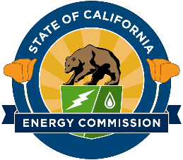

**California Energy Commission**

**Modeling of Long-Duration Storage for Decarbonization of California Energy System**

**Contract # EPC-19-060 with The Regents of the University of California, Merced**

**CPR #1 Meeting Agenda**

**March 25, 2021**

**10:00 AM – 12:00 PM**

1. Introductions (5 min)
   1. Presenters and Attendees
   2. Team Members and Project Partners
2. Project Overview & Status (30 min)
   1. Project Timeline and Goals
   2. Results from the Introductory Public Workshop and the Baseline Development (Task 2)
3. Project Approach (25 min)
   1. Approach to Storage and Energy Technology Summaries
   2. Plans for the Scenario Selection Public Workshop
   3. Challenges and Opportunities
4. Questions (30+ min)
5. CPR Determination April 8, 2021