**Long duration energy storage technologies: candidates and use cases**

**Abstract**:

We review candidate long duration energy storage technologies that are relatively mature and ready to deploy into the market in the near future. We then analyze their techno-economic performance in different use cases and propose potential business models. These are valuable insights to guide the development of long duration energy storage projects and inspire future analysis in the relevant modeling and decision-making.

**Key words**: Long duration energy storage; electricity market; use case

Table of Contents

1. Introduction 1

2. Long Duration Energy Storage Technology 2

2.1 Methodology 2

2.1.1 Literature review 2

2.1.2 Survey and interview 2

2.2 Technology 2

2.2.1 Pumped Storage Hydropower 2

2.2.2 Other Gravity Based Solution 2

2.2.3 Compressed Air Energy Storage 2

2.2.4 Thermal Energy Storage 2

2.2.5 Flow Battery 2

2.2.6 Power to Gas 2

3. Use Cases 2

3.1 Wholesale market 2

3.2 Transmission and Distribution 2

3.3 Behind Meter and microgrid 2

3.4 Other value creation 2

4. Conclusion 2

5. Reference 2

# 1. Introduction

To mitigate the climate change, we need a low-carbon transition in the energy sector[1,2] where the electrical energy storage technology would be a key to integrate more low carbon resources and ensure the reliability of the grid[3–5]. Previous papers have shown that a deep decarbonization in electricity system would require the long duration energy storage[6–8]. The planned outages in California and Texas draw more attention to the value of long duration energy storage. Although the value of long duration energy storage is widely discussed[6,7], we are not clear how to translate these values into practical business models, which would require a systematic review of their use cases for different long duration energy storage technologies.

There are some reviews about the use cases and business models for the energy storage system[9–12], but most of them, if not all, does not distinguish the short and long duration energy storage technologies. In this paper, we loosely define the long duration energy storage technology as the one can provide stable electricity at its rated power for more than 8 hours which is consistent with the definition in the integrated resource planning issued by California Public Utilities Commission [1]. The long duration energy storage projects usually have large energy ratings, targeting different markets comparing to many short duration energy storage projects. These characteristics differ them with the short duration applications and thus it would be essential to review the techno-economic performance of the long duration energy storage technologies. Moreover, some characteristics like energy loss during the storage or self-discharge rate would be critical to long duration energy storage applications but not widely discussed in previous reviews that focus more on the short duration applications.

Different from the market for short-duration energy storage technologies, which is projected to be dominated by the Li-ion battery[13,14], the market for long duration energy storage technologies still have many competitive players, ranging from the traditional pumped storage hydropower and compressed air storage, to many emerging technologies from startups which are not usually included in the discussion. These long duration energy storage technologies differ not only from the short duration energy storage technologies but also differ significantly from each other.

In this paper, we will review some long duration energy storage technologies, compare their different techno-economic characteristics and derive the potential use cases based on their characteristics. It will provide valuable insights to economists, system modelers, policy makers and investors on the pathway to the deep decarbonization of the electricity system.

# 2. Long Duration Energy Storage Technology

## 2.1 Methodology

### 2.1.1 Literature review

Paper within 5yrs

Reports from top consulting companies or national labs

News from company websites

Database: Sandia’s storage database,

Google Earth (Jeremiah)

Tables by sources, projects, technologies, some may be in SI

### 2.1.2 Survey and interview (Rui)

Paused for now

## 2.2 Technology

1.Basic mechanism with a plot

2. provide key characteristics, advantage and disadvantage

3. present new technologies or some advancement to be different from previous review papers (need to include the cost and technical capabilities)

### 2.2.1 Pumped Storage Hydropower

Pumped storage hydropower(PSH) is a traditional energy storage technologies and now it compose most of the energy storage market if measured by energy rating. In United States, 99% of the stored electricity (GWh) is in pumped storage hydropower projects and if measured by power (GW), pumped storage hydropower contributes to more than 93% of energy storage capacity[15]. This technology stores the electricity in the form of gravity of the water. As shown in Figure 1, a classic pumped storage hydropower project has two reservoirs with some elevation differences and at least one powerhouse. If any of the reservoirs connect with a river system, this project is called open-loop otherwise close-loop. The open-loop system usually not only serves for electricity purpose but also facilitate the water management. Hunt et al[16]. estimated that the global resource potential for open-loop pumped storage system could be at least 17.3 PWh, limiting the sites with a fixed capacity as 1 GW and levelized cost of storage lower than 50$/MWh. As for the close-loop system, Stocks et al[17] estimated more than 3.1PWh potential globally with cost lower than 40$/MWh.

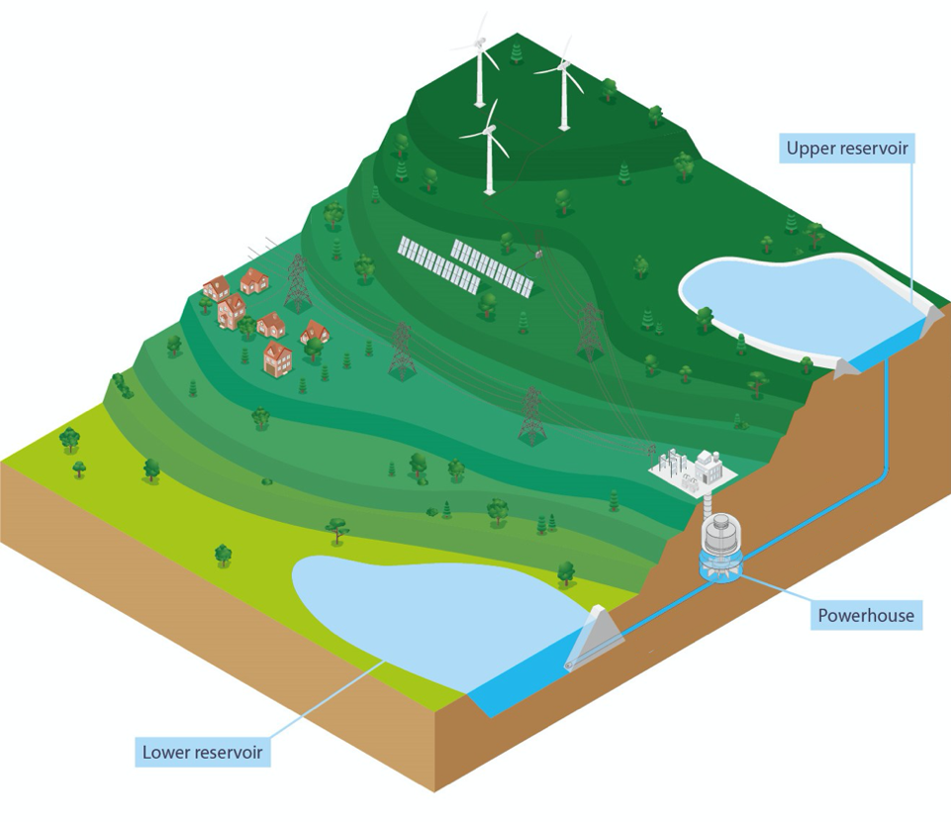

Figure 1 Illustration of a closed-loop PHS project, from reference [18]

The cost of the pumped storage hydropower varies a lot. Based on a IRENA report[19], the lowest capital cost is 617$/kW while the high end,2465$/kW, could be four times as high as the lowest one. Another review[20] which pays more attention in the United States finds that the capital cost for pumped hydropower project ranges from 1700$/kW to 3200$/kW. Such a huge uncertainty is mainly caused by the site dependency, leading to different labor and construction cost[19]. Similar to many other long duration energy storage technologies, the cost can be separated into energy part and power part. The energy part include the cost to construct the reservoir which determines how much energy it could store. The power part is mainly about the powerhouse. The equipment like turbines would cost about 30%~40% capital cost. The cost of reservoirs and water conveyances can ranges from less than 20% capital cost to more than 50% capital cost[21]. When the measurement transfer from the cost per power to cost per energy, the capital cost of pumped storage become pretty competitive, within the range 57-200 $/kWh [14,20,22,23] and some researchers believe it could be as low as 5$/kWh[24]. Several studies[14,20,22,23,25] state that the pumped storage hydropower is one of the most cost attractive options for long duration energy storage in the near term. Such a low energy cost is the result of the large energy rating which also contribute to the long duration of discharging. Some projects are designed for seasonal or even pluri-annual purpose[26].

Besides the low energy cost and long discharging duration, pumped storage hydropower also have many other advantages[27]: The designed lifetime for pumped storage hydropower projects is usually longer than 30 years and sometimes more than 100 years. The round trip efficiency is relatively high as 65%-85%; The depth of discharge could be as high as 100%. Another advantage, especially for long duration energy storage technologies, would be the low self-discharging rate (0.01% per day[28]). Despite so many advantages, dependency in water availability, large land area, huge upfront capital cost, considerable environmental impact, and geographic constraints limit the deployment of traditional pumped storage technologies.

Scientists and engineers are aware these constraints and develop many novel pumped storage technologies that are not often seen in the reviews about energy storage technologies. To reduce the cost related with reservoir, a research team proposed underwater pumped hydro energy storage [29]. Instead of constructing a reservoir, they designed a vessel and deployed it under the water. It would consume electricity to pump out the water from the vessel and generate electricity when water flows in. The concept has been proven technological feasible with a pilot project[30] and researcher estimated the cost around 400-500 euro/kWh[31]. Researchers developed a similar concept that a floating membrane would act as a storage reservoir rather than a vessel[32]. This concept is still under field testing and no techno-economic estimation data available, but they believe it would be low cost and easy to replicate at many locations due to its modularity.

Previous two examples replace the upper reservoir with the open water. Another approach to reduce the cost for reservoir construction is to utilize some existing lower reservoir, like a decommissioned coal mine. Researcher conduct a case study on an underground mine site in Kentucky, which shows the initial capital cost would between 1700 $/kW and 2400 $/kW for a 5MW/50MWh pumped storage project[33]. Another assessment about coal mine in Germany results in a capital cost as 360.5 Euro/kWh when the head as 500m and when the head increases to 1000m, the capital cost would reduce to 253 Euro/kWh[34]. Depending on the driving factors, the underground environment can increase or decrease the round trip efficiency comparing with the traditional pumped storage hydropower projects[35,36]. When replace the lower reservoir with the sea, we get the seawater pumped storage. The first seawater project was implemented in Japan and operated in 1999[37] and other real world case is rare. The seawater pumped storage avoid the cost for lower reservoir construction but increases the cost for corrosion protection[38] and thus would be more suitable for places difficult to access to the freshwater system[39] or coupled with other renewable resources like offshore wind[40].

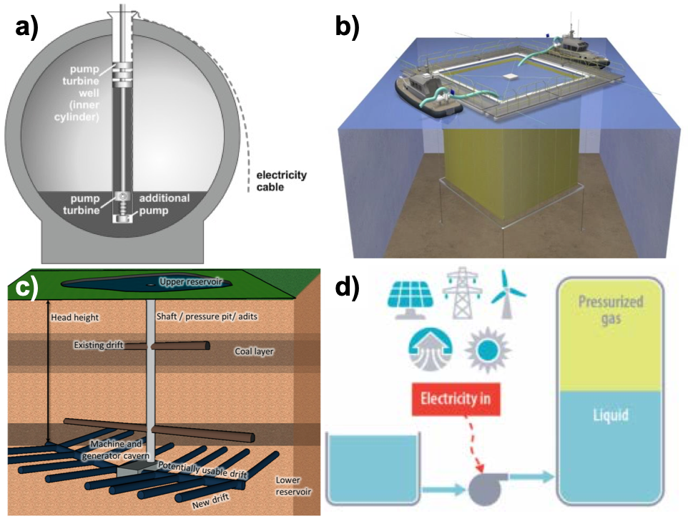

Figure 2 a) Schematic cross sectional view of the StEnSea system[31]; b) Schematic of prototype floating reservoir[32]; c) Scheme of underground pumped storage in a coal mine[34]; d) Schematic of GLIDES when charging[41]

The novel pumped storage technologies mentioned above still face geographic restrictions, either close to water or existing reservoir. People have conceptualized a system that combines pumped storage with compressed air system through a pressurized water container[42]. A realized example is Ground-Level Integrated Diverse Energy Storage (GLIDES) developed in Oak Ridge National Laboratory [41]. The current prototype of GLIDES use steel pressure vessel, leading to high capital cost. It costs around $4500/kWh for a 300MW and 6 hours system. If the vessel is made of high-pressure pipe segment, the cost of the same system can reduce to $250/kWh[43].

### 2.2.2 Other Gravity Based Solution (Rui)

### 2.2.3 Compressed Air Energy Storage (Jeremiah)

### 2.2.4 Thermal Energy Storage (Jeremiah)

### 2.2.5 Flow Battery (Noah)

### 2.2.6 Power to Gas (Noah)

One large summary table

# 3. Use Cases

Still need to explain the framework and methodology

## 3.1 Wholesale market

## 3.2 Transmission and Distribution

## 3.3 Behind Meter and microgrid

## 3.4 Other value creation

# 4. Conclusion

# 5. Reference

[1] Masson-Delmotte V, Zhai P, Pörtner H-O, Roberts D, Skea J, Shukla PR, et al. Global Warming of 1.5 °C: An IPCC Special Report on the Impacts of Global Warming of 1.5° C Above Pre-industrial Levels and Related Global Greenhouse Gas Emission Pathways, in the Context of Strengthening the Global Response to the Threat of Climate Chang. World Meteorological Organization Geneva, Switzerland; 2018.

[2] Edenhofer O, Pichs-Madruga R, Sokona Y, Seyboth K, Matschoss P, Kadner S, et al. Summary for Policymakers. In: IPCC Special Report on Renewable Energy Sources and Climate Change Mitigation. Cambridge, United Kingdom and New York, NY, USA.: 2011.

[3] Few S, Schmidt O, Gambhir A. Electrical energy storage for mitigating climate change. Grantham Institute-Climate Chang Environ 2016.

[4] De Sisternes FJ, Jenkins JD, Botterud A. The value of energy storage in decarbonizing the electricity sector. Appl Energy 2016;175:368–79.

[5] Balducci PJ, Alam MJE, Hardy TD, Wu D. Assigning value to energy storage systems at multiple points in an electrical grid. Energy Environ Sci 2018.

[6] Albertus P, Manser JS, Litzelman S. Long-duration electricity storage applications, economics, and technologies. Joule 2020;4:21–32.

[7] Dowling JA, Rinaldi KZ, Ruggles TH, Davis SJ, Yuan M, Tong F, et al. Role of Long-Duration Energy Storage in Variable Renewable Electricity Systems. Joule 2020;4:1907–28.

[8] Blanco H, Faaij A. A review at the role of storage in energy systems with a focus on Power to Gas and long-term storage. Renew Sustain Energy Rev 2018;81:1049–86.

[9] Malhotra A, Battke B, Beuse M, Stephan A, Schmidt T. Use cases for stationary battery technologies: A review of the literature and existing projects. Renew Sustain Energy Rev 2016;56:705–21.

[10] Baumgarte F, Glenk G, Rieger A. Business Models and Profitability of Energy Storage. Iscience 2020:101554.

[11] Anaya KL, Pollitt MG. Storage Business Models: Lessons for Electricity from Cloud Data, Frozen Food and Natural Gas. Energy J 2019;40.

[12] Aneke M, Wang M. Energy storage technologies and real life applications–A state of the art review. Appl Energy 2016;179:350–77.

[13] Beuse M, Steffen B, Schmidt TS. Projecting the Competition between Energy-Storage Technologies in the Electricity Sector. Joule 2020;4:2162–84.

[14] Schmidt O, Melchior S, Hawkes A, Staffell I. Projecting the future levelized cost of electricity storage technologies. Joule 2019;3:81–100.

[15] Uria Martinez R, Johnson M, Shan R. US Hydropower Market Report (January 2021 edition). Oak Ridge National Lab.(ORNL), Oak Ridge, TN (United States); 2021.

[16] Hunt JD, Byers E, Wada Y, Parkinson S, Gernaat DEHJ, Langan S, et al. Global resource potential of seasonal pumped hydropower storage for energy and water storage. Nat Commun 2020;11:1–8.

[17] Stocks M, Stocks R, Lu B, Cheng C, Blakers A. Global Atlas of Closed-Loop Pumped Hydro Energy Storage. Joule 2021;5:270–84.

[18] Rogner M, Troja N. The world’s water battery: Pumped hydropower storage and the clean energy transition. IHA London, UK 2018.

[19] IRENA. Innovation landscape brief: Innovative operation of pumped hydropower storage. Abu Dhabi: 2020.

[20] Mongird K, Viswanathan V V, Balducci PJ, Alam MJE, Fotedar V, Koritarov VS, et al. Energy Storage Technology and Cost Characterization Report. Pacific Northwest National Lab.(PNNL), Richland, WA (United States); 2019.

[21] Hadjerioua B, Stewart K, DeNeale S, Tingen W, Curd S, Smith B, et al. Pumped Storage Hydropower FAST Commissioning Technical Analysis. Pacific Northwest National Lab.(PNNL), Richland, WA (United States); 2020.

[22] Giovinetto A, Eller A. Comparing the costs of long duration energy storage technologies. Natl Grid Ventur Navig Res See Www Slenergystorage Com/Documents/20190626_Long_ Duration% 20Storage_Costs Pdf 2019.

[23] Klumpp F. Comparison of pumped hydro, hydrogen storage and compressed air energy storage for integrating high shares of renewable energies—potential, cost-comparison and ranking. J Energy Storage 2016;8:119–28.

[24] Krishan O, Suhag S. An updated review of energy storage systems: Classification and applications in distributed generation power systems incorporating renewable energy resources. Int J Energy Res 2019;43:6171–210.

[25] Jülch V. Comparison of electricity storage options using levelized cost of storage (LCOS) method. Appl Energy 2016;183:1594–606.

[26] Hunt JD, Zakeri B, Lopes R, Barbosa PSF, Nascimento A, de Castro NJ, et al. Existing and new arrangements of pumped-hydro storage plants. Renew Sustain Energy Rev 2020;129:109914.

[27] Argyrou MC, Christodoulides P, Kalogirou SA. Energy storage for electricity generation and related processes: Technologies appraisal and grid scale applications. Renew Sustain Energy Rev 2018;94:804–21.

[28] Ralon P, Taylor M, Ilas A, Diaz-Bone H, Kairies K. Electricity storage and renewables: Costs and markets to 2030. Int Renew Energy Agency Abu Dhabi, UAE 2017.

[29] Slocum AH, Fennell GE, Dundar G, Hodder BG, Meredith JDC, Sager MA. Ocean renewable energy storage (ORES) system: Analysis of an undersea energy storage concept. Proc IEEE 2013;101:906–24.

[30] Puchta M, Bard J, Dick C, Hau D, Krautkremer B, Thalemann F, et al. Development and testing of a novel offshore pumped storage concept for storing energy at sea− Stensea. J Energy Storage 2017;14:271–5.

[31] Hahn H, Hau D, Dick C, Puchta M. Techno-economic assessment of a subsea energy storage technology for power balancing services. Energy 2017;133:121–7.

[32] Hadjerioua B, Eldredge T, Medina H, DeNeale S. Hydrodynamic and structural response modeling of a prototype floating membrane reservoir system for pumped storage hydropower. J Hydraul Eng 2019;145:4019032.

[33] Witt A, Hadjerioua B, Uría-Martínez R, Bishop Jr NA. Evaluation of the feasibility and viability of modular pumped storage hydro (m-PSH) in the United States. ORNL/TM-2015/559, Oak Ridge Natl Lab Oak Ridge, Tennessee 2015.

[34] Madlener R, Specht JM. An Exploratory Economic Analysis of Underground Pumped-Storage Hydro Power Plants in Abandoned Deep Coal Mines. Energies 2020;13:5634.

[35] Menéndez J, Fernández-Oro JM, Galdo M, Loredo J. Efficiency analysis of underground pumped storage hydropower plants. J Energy Storage 2020;28:101234.

[36] Pujades E, Orban P, Bodeux S, Archambeau P, Erpicum S, Dassargues A. Underground pumped storage hydropower plants using open pit mines: How do groundwater exchanges influence the efficiency? Appl Energy 2017;190:135–46.

[37] Hiratsuka A, Arai T, Yoshimura T. Seawater pumped-storage power plant in Okinawa island, Japan. Eng Geol 1993;35:237–46.

[38] Katsaprakakis D Al, Christakis DG, Stefanakis I, Spanos P, Stefanakis N. Technical details regarding the design, the construction and the operation of seawater pumped storage systems. Energy 2013;55:619–30.

[39] Ioakimidis CS, Genikomsakis KN. Integration of seawater pumped-storage in the energy system of the Island of São Miguel (Azores). Sustainability 2018;10:3438.

[40] Yao W, Deng C, Li D, Chen M, Peng P, Zhang H. Optimal sizing of seawater pumped storage plant with variable-speed units considering offshore wind power accommodation. Sustainability 2019;11:1939.

[41] Odukomaiya A, Abu-Heiba A, Graham S, Momen AM. Experimental and analytical evaluation of a hydro-pneumatic compressed-air Ground-Level Integrated Diverse Energy Storage (GLIDES) system. Appl Energy 2018;221:75–85.

[42] Wang H, Wang L, Wang X, Yao E. A novel pumped hydro combined with compressed air energy storage system. Energies 2013;6:1554–67.

[43] Kassaee S, Abu-Heiba A, Ally MR, Mench MM, Liu X, Odukomaiya A, et al. PART 1-techno-economic analysis of a grid scale Ground-Level Integrated Diverse Energy Storage (GLIDES) technology. J Energy Storage 2019;25:100792.

1. 2019-2020 Electric Resource Portfolios to Inform Integrated Resource Plans and Transmission Planning, Rulemaking 16-02-007 R.16-02-007 ALJ/JF2/avs <https://docs.cpuc.ca.gov/PublishedDocs/Published/G000/M331/K772/331772681.PDF>