Long duration energy storage technologies: candidates and use cases

Abstract:
We review candidate long duration energy storage technologies that are relatively mature and ready to deploy into the market in the near future. We then analyze their techno-economic performance in different use cases and propose potential business models. These are valuable insights to guide the development of long duration energy storage projects and inspire future analysis in the relevant modeling and decision-making.

1.Introduction and Background

Long duration energy storage technologies have their unique values. They are important for deep decarbonization and grid resilience.

2. Potential candidates and their techno-economic data
2.1 Data collection methodology
Interview and literature review

2.2 Thermal
2.3 Mechanical
2.4 Electrochemical
2.5 Hydro
2.6 Hydrogen
Describe basic mechanism and recent development of the candidates;
Introduce their efficiency, geographic flexibility, response time, cost and many others;
Emphasize the innovation from a few companies we contacted, bringing these new technologies into the discussion.

Summarize the data collection with tables or plots

3. Use cases similar to short duration energy storage: compete with short duration
3.1 Wholesale market:
Some technical parameters will screen some long duration technologies out of markets like frequency regulation, but some markets will be more competitive than short duration technologies like resource adequacy.
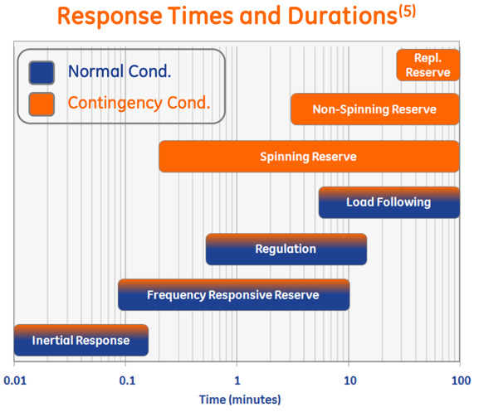
Replace the label with the technology, the color code shows the cost or performance level, overlay with different services

Or a table like 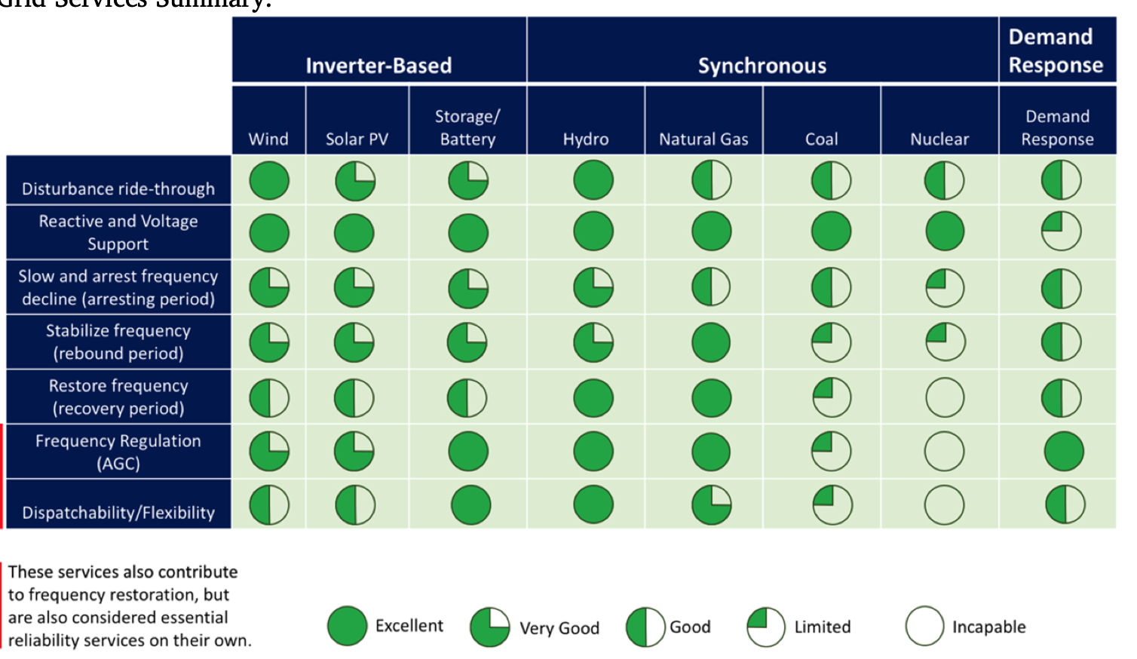

As for the energy arbitrage, the RTE will determine the feasible price range (Peak/Off-peak price > RTE). Vidhi’s efficiency plot might be used. Despite the lower RTE, the long duration energy storage can still earn the profit. We conjecture 1. inter-day or longer period energy arbitrage opportunities (give an example with historical price curve) and it will not be flattened by short duration technologies; 2. sufficient market size of intraday arbitrage but it will diminish.
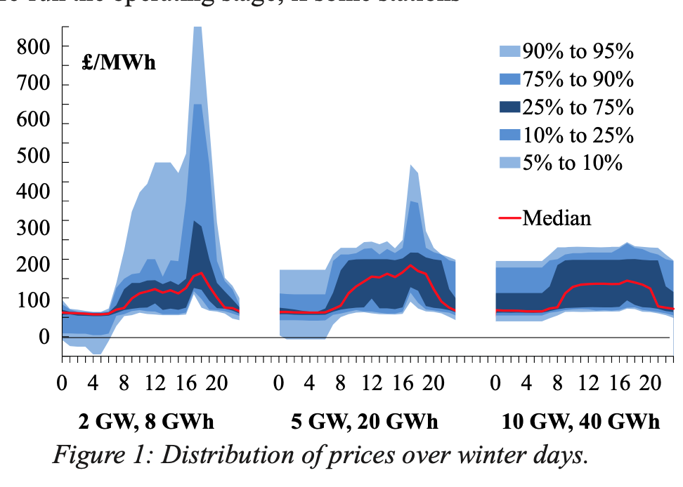
Show the historical price curve and a counterfactual one with flat intra-day curve

3.2 Behind meter:
Can add Jeremiah’s plot about land usage, energy density and cost. Better also add the land available for different cases, like an average area of the backyard.
Discuss it application in residential and commercial cases from several dimension: cost, safety risk, installation and maintenance.
Discuss industrial applications, like utilizing waste heat, (producing cheap hydrogen)

3.3 Resilience

3.4 Transmission and Distribution market

4. Use cases may be unique: collaboration with large thermal plants
The collaboration with thermal plants lies in two ways:
1) Increase flexibility of the thermal plant and nuclear plant
2) Replace the thermal power plant to a thermal storage plant
For baseload plant or large capacity one, long duration ones should be more competitive than short duration one in these two applications. (Need reference or some calculation)
For both, we conduct an envelope calculation comparing the saving with decommission the plant or flexibility retrofit. We also consider the savings from a)time saved and revenue during the retrofit, b) BOP cost, c) potential transmission infrastructure.

We got some job related data from companies and can also discuss here as it reduces the job loss if not create new ones.

Decommissioned plant can also contribute to the gravity storage ? Could these bricks be reused?

Another additional calculation is the potential for such retrofit/replacement in U.S. These deployment need to be added in the modeling.

5. Use cases that are not finically viable in the near future or more policy driven cases
Resiliency under extreme weather
Similar to the reserve of coal and oil
Energy security (strategical reserve of oil)

6. Conclusion

