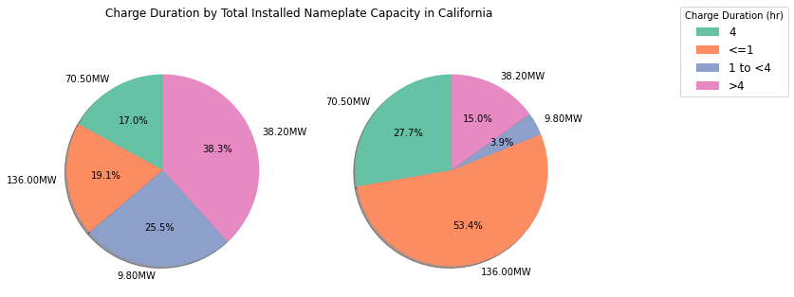
Figure 2
Figure 1

These figures were calculated using the EIA 860 dataset. Figure 1 is proportionate to the number of batteries within California that fall under the different charge duration categories (as specified in the legend). Figure 2 is proportionate to the total installed nameplate capacity in California for the different charge duration categories (as specified in the legend).
Example calculation:
- Batteries with 4 hr charge duration
  - Figure 1: Count of batteries with 4 hr charge /Count of all batteries
    - 8/47 = 17%
  - Figure 2: Sum of Nameplate capacity of batteries with 4 hr charge/Sum of nameplate capacity of all batteries
    - 70.5MW/254.5MW = 27.7%

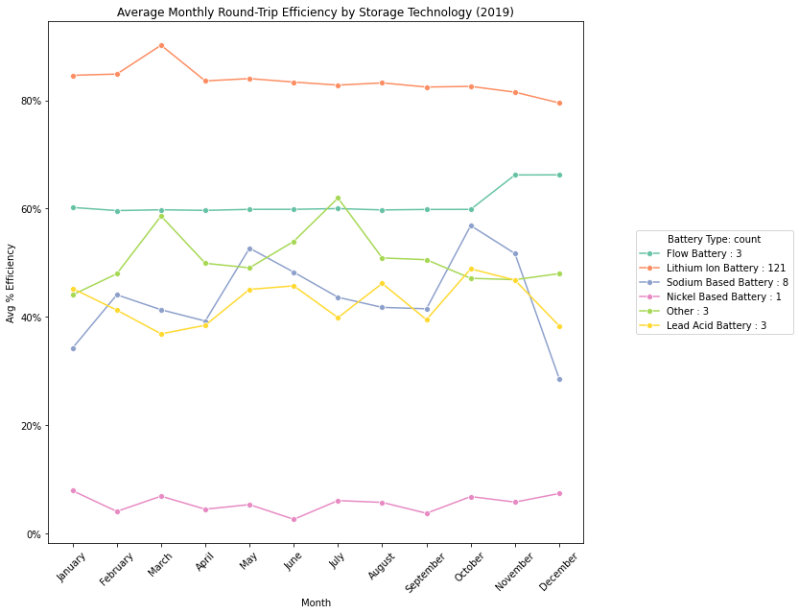
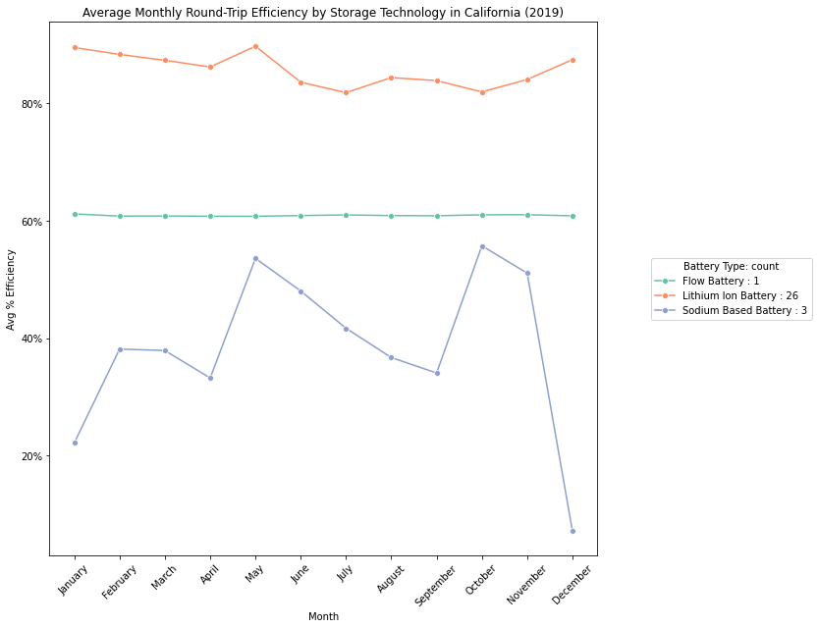
Figure 4
Figure 3
These figures were derived by combining the EIA 923 and 860 datasets. Average monthly round trip efficiency was calculated by dividing the mean gross generation by the mean electricity quantity for each month for each battery technology.
Example calculation:
- Jan Flow Battery (Figure 3):
  - mean gross generation (MWh)/mean electricity quant (MWh)
  - = 157.767000/ 258.0 = 61% Average Round Trip Efficiency

