Talking about Long-duration Energy Storage

As countries, companies, and utilities set targets to decarbonize the grid, it is clear that it will be useful to have a range of storage options to provide power when solar and wind electricity is not available. Most agree that long-duration storage will be a useful element of a decarbonized grid, but questions often arise about what is meant by “long-duration storage.” While pumped hydroelectricity is clearly a long-duration storage technology, is biogas an electricity-generation technology or a storage technology? Here we suggest clarification of terminology that may help us communicate better as well as to encourage innovation in directions that will be useful:
- “Minimum-discharge-duration time” vs “Duration”
- “Short-duration“ vs “Long-duration storage
- “Self-contained” vs “Cross-sector” long-duration storage
We address these and then use that better understanding to gain perspective on the roles of energy storage in creating a reliable decarbonized grid.

“Minimum-discharge-duration time” vs “duration”

Electricity storage is accomplished by converting electricity to a form of energy that is stored in an energy reservoir and then later converted back to electricity as shown in Fig. 1. In the case of a pumped hydroelectric system, the stored energy (assumed to be x MWh) is a function of the size of the reservoir and the head, and the rate of discharge depends on the size of the turbines (assumed to be y MW). If the discharge (conversion of the stored energy to electricity) is done at the maximum rate allowed by the hardware (y MW), then the minimum-discharge-duration time is calculated from the ratio of the energy in the reservoir (x MWh) to the rated power of the discharge system (y MW) or x/y hours. If the storage is discharged at a power that is less than the rated power, the time of discharge will be longer. While the ratio of the size of the energy reservoir to the discharge power should be called the “minimum-discharge-duration time,” it is often referred to as the “duration” for simplicity, leading to confusion when the simplification is not well communicated.

Fig. 1. Defining the “minimum-discharge-duration time,” which is often referred to as “duration”

Here’s an alternative figure trying to focus on the “minimum duration” for consideration:
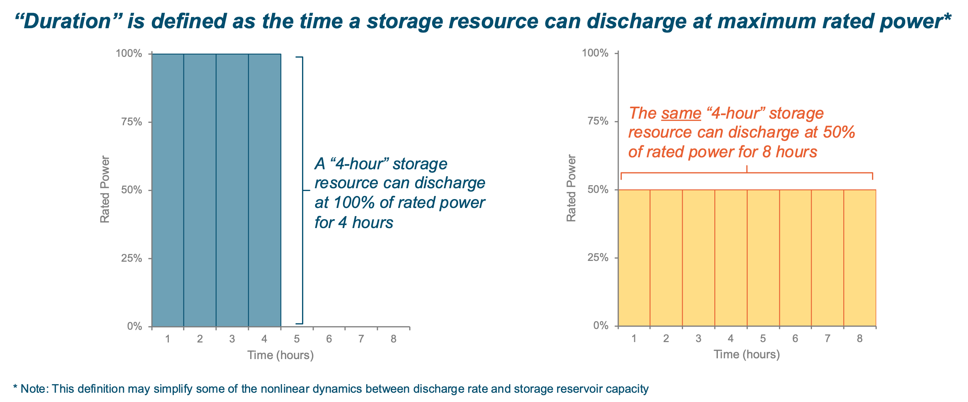

Instead of saying “long-duration storage” it would be more precise to say, “long-minimum-discharge-duration-time storage.” Preferred use for the shorter phrase is understandable, but can be a point of confusion especially when discussion of the actual discharge time is mixed with discussion of the minimum-discharge-duration time. For example, a 1 kWh/1 kW battery may be discharged over 1 hour, or over 10 hours, or even over 100 hours if the rate of discharge is slowed enough. This leads to the common question of whether we can use a large number of 1-hour batteries to meet our long-duration storage needs, discussed next.

“Short-duration” vs “Long-duration storage

The total cost of an energy-storage system includes the cost of both the energy reservoir and energy-conversion hardware. As an example, for a pumped hydro plant, the upfront cost can be estimated by the sum of the costs of the water reservoir ($/kWh) and the turbines ($/kW). The size of the reservoir and the number of turbines may be adjusted independently (within a reasonable range). In Fig. 2 we plot the total cost (left) for a 1-kW storage system estimated as a function of the minimum-discharge-duration time, Duration, as calculated by equation (1),

$Total cost= 1 kW*\left(\frac{\$}{kW}\right)+Duration*\left(\frac{\$}{kWh}\right)$ (1)

where the values for $/kW and $/kWh are labeled on each curve. The graph on the right plots the same calculation, but divided by the size of the reservoir. If the needed duration is less than about 2 hours, it is cheaper to use the $25/kW-$40/kWh storage system. If a longer duration is needed, then the $100/kW-$10/kWh storage system will be less expensive. In practice, the needed duration for the storage varies and a mix of resources may be optimal. In general, the costs of energy storage systems may be compared in this way with good candidates for short-duration storage having smaller $/kW costs and good candidates for long-duration storage having smaller $/kWh costs.

Fig. 2. Comparison of upfront cost of a 1-kW storage system as a function of the minimum-discharge-duration time for storage that costs more for the reservoir or more for the power conversion. Both the total cost (left) and cost relative to the reservoir size (right) are shown.

Commonly, the transition from short- to long-duration applications is considered to be between 4- and 10-hours minimum-discharge-duration time. In practice, good candidates for long-duration storage are likely to have a scalable energy reservoir with < $10/kWh cost, though this will likely change over time as costs on the electric grid change as well. The distinction between short- and long-duration storage is useful for studying the system’s needs and identifying the best technologies to meet those needs, but it should be kept in mind that a large set of short-duration storage resources may provide storage over a long duration and that any long-duration storage resource may also be used for short-duration applications.

We think that a more durable definition of “short-” and “long-duration” storage can be found by thinking about the economic behavior of the systems rather than the specific costs or chemistries. To help develop the vocabulary around these economic behaviors, we are studying whether there are distinct operating regimes that can be decomposed to identify:
- Intra-day or diurnal balancing
- Inter-day balancing (days to weeks)
- Seasonal balancing (weeks to months)
- Inter-annual balancing

“Self-contained” vs “Cross-sector” long-duration storage

We propose two categories of long-duration storage: “self-contained” and “cross-sector” long-duration storage, as shown in Fig. 3. The self-contained category of long-duration storage is easiest to understand and has been described above. These systems use surplus electricity to store energy in a reservoir. The system later converts the stored energy back to electricity.

Fig. 3. Schematic describing “self-contained” and “cross-sector” long-duration storage. For the self-contained system, the minimum-discharge-duration time can be calculated from the ratio of the size of the stored energy reservoir (MWh) to the rated power of the discharge system (MW). For the cross-sector long-duration storage technologies the size of the stored energy reservoir may not be defined, so the minimum-discharge-duration time is undefined.

The cross-sector category of long-duration storage may be implemented in two primary types of ways. The first uses surplus electricity to make a useful product. The useful product could take many forms and may supply other sectors as in the cases of making hydrogen for fuel-cell vehicles or heat for canning tomatoes. In these cases, the energy reservoir is usually not defined and may take a different form. For example, storing fertilizer or canned tomatoes can take the place of storing the energy needed to manufacture those products, essentially avoiding the energy storage cost altogether. The second type of cross-sector long-duration storage uses stored energy from other sectors. For example, biogas made in digesters from various waste streams may be stored for a variety of applications. While the biogas might be used for heating, it can also be used for power generation. Large quantities of natural gas are already stored at very low cost. For both types of cross-sector long-duration storage the effective storage reservoir can be quite large, potentially enabling almost limitless storage.

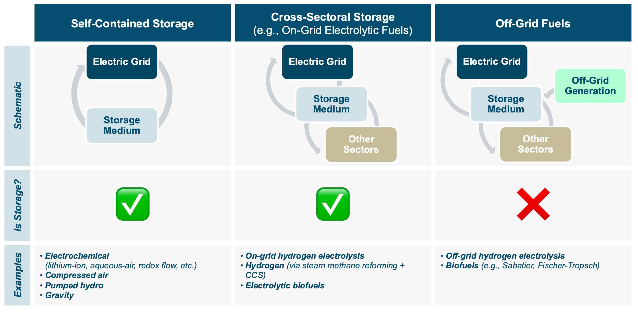

Understanding the big picture for long-duration storage

This ability to access almost limitless storage positions cross-sector long-duration storage assets to be essential elements of reliable grids. Self-contained long-duration storage systems will compete with short-duration storage for short-duration applications and with cross-sector long-duration systems for long-duration applications as shown schematically in Fig. 4. The value of each storage system will depend on how successfully it competes for each application. Ultimately, we may find that short-duration, or one of the long-duration storage approaches may be the best at meeting all of the needs, but it is more likely that the optimal solution will include all three.

Fig. 4. Comparison of how short- and long-duration storage (blue shapes) are well suited to meet storage needs of different hours of duration (x-axis and green strip at bottom).

Others have proposed terms similar to those we’ve discussed here. For example, Duke Energy suggested the term “zero-emitting, load-following resources” (ZELFR) while Jesse Jenkins uses “firm low carbon” resources for the types of technologies well suited to address the seasonal challenge. While there is clear agreement that we will need a solution to the seasonal challenge of grid reliability, there is uncertainty about the identity of the solution(s). Duke Energy’s definition of ZELFRs identifies “Long-duration energy storage” as one of several technologies. The two most commonly cited technologies for “firm low carbon” resources are natural gas with carbon sequestration or nuclear power. Cross-sector inspires many other options as well.

Why is the term cross-sector long-duration storage useful?

Self-contained long-duration storage technologies can usually be classified as being contained within the power sector. However, carbon emissions in California are currently greatest for the transportation sector. Energy is used and carbon emissions generated across many sectors. It’s obvious that reaching zero-carbon emissions will require addressing energy needs in all sectors. What may be less obvious is that the solutions we identify for the other sectors may be enabling for the power sector. In particular, as we explore the need for ZELFRs or “firm low carbon” resources as seasonal solutions it is useful to consider how energy use in the other sectors may be part of the solution. We may tackle decarbonization of the transportation sector, of chemical processing sector and of the heating sector individually, or we may consider how we might decarbonize those sectors in a way that will provide additional tools for balancing supply and demand for the electrical grid. The terms ZELFR and firm low carbon are useful terms, but they may not be optimal for inspiring creativity for coupling with other sectors. For example, on a day when the grid is facing a potential shortfall, fuel-cell trucks could provide vehicle-to-grid electricity using hydrogen that was generated from low-cost renewable electricity, then stored underground with the intention of powering trucks to drive across the country. If trucks end up using hydrogen-electric powertrains, the trucks would need very little additional hardware to provide electricity to the grid while the driver sleeps, effectively providing a zero-carbon peaker plant on wheels. Would such a solution be best labeled a ZELFR, firm low-carbon resource, or cross-sector long-duration storage? We propose the term “cross-sector long-duration storage” as an all-encompassing term that includes both ZELFR and firm low carbon resources while emphasizing the benefit of “cross-sector” coupling, motivating innovation as the decarbonization technologies are developed for all sectors. A fully decarbonized grid may eventually intertwine electricity generation and storage with many other types of infrastructure. We hope our proposal for the term “cross-sector long-duration storage” will inspire much creativity toward using infrastructure from other sectors to meet grid reliability requirements for a cost-effective zero-carbon grid.

“Duration” may also specify the time the energy is stored. Storage systems that can hold many hours of stored energy are more likely to also retain that energy for longer. Energy loss during storage may limit the time the energy may be stored.
Ric O’Connell did a Twitter poll in May 2020 and found that 65% of the > 250 votes preferred “Firm Low Carbon” over “ZELFR.” https://twitter.com/ricoconnell8/status/1265786256589418497?lang=en
https://www.duke-energy.com/_/media/PDFs/our-company/Climate-Report-2020.pdf, accessed Dec. 28, 2020.

