Example table

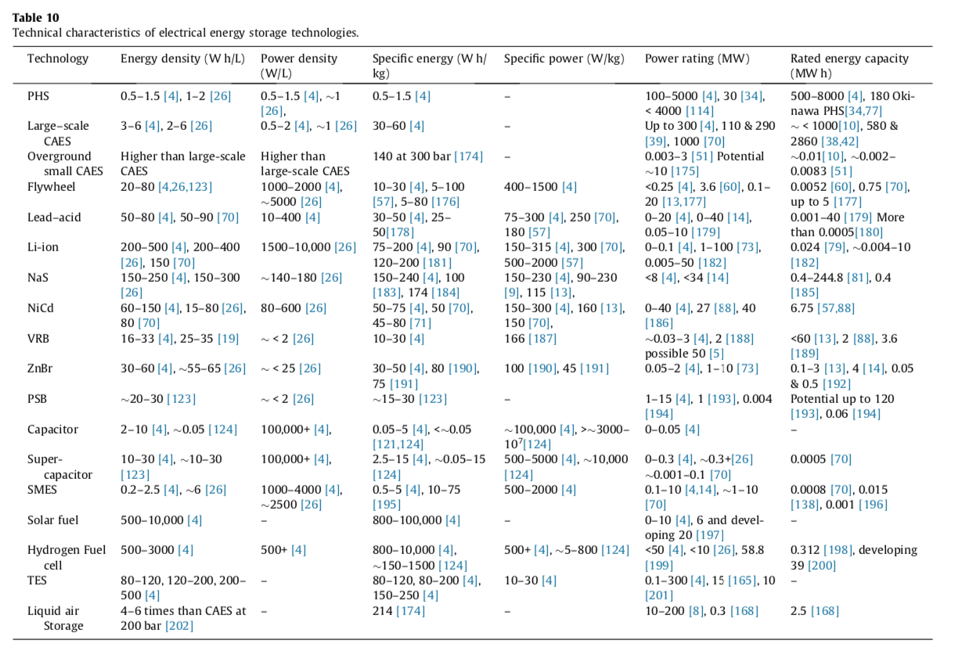
Parameter
Minimum Deliverable Size
Minimum Incremental Size
Maximum Deliverable Size
Power factor
Rated Power for charging of reference system (kW)
Rated Power for discharging of reference system (kW)
Associated energy (kWh) at Rated power
AC or DC power?
Power Conversion System Rated Power of the reference system (kW or kVA)
Maximum charging power

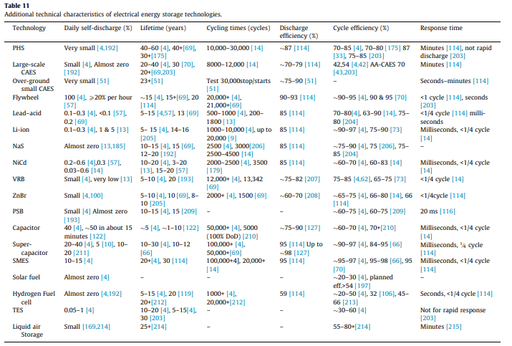
Survey Parameters
1:
Degradation losses (max power), Degradation losses (max energy)
(% per year and % per 1000 cycles)
Energy loss during storage (% stored /day, kWh/day)
2, 3:
Nominal Cycles per year (#)
+ Nominal Depth of Cycles (%)
+ Cycle Life at Depth of Discharge (# cycles at 20%, 50%, 80%, and 100% discharge)
Average System Life Expectancy (years)
- Keep life expectancy in cycles rather than years? Fewer assumptions baked in regarding nominal cycles per year.
4, 5:
Charging, Discharging, and Roundtrip Efficiency at Rated Power (%)
-Discharging seems most important unless you are purchasing energy to charge.

6:
Ramp up rate (% rated power/s, kW/s)
Response time to/from discharge/charge (s)
- How important are these two? Do we really care as long as it’s not hours?
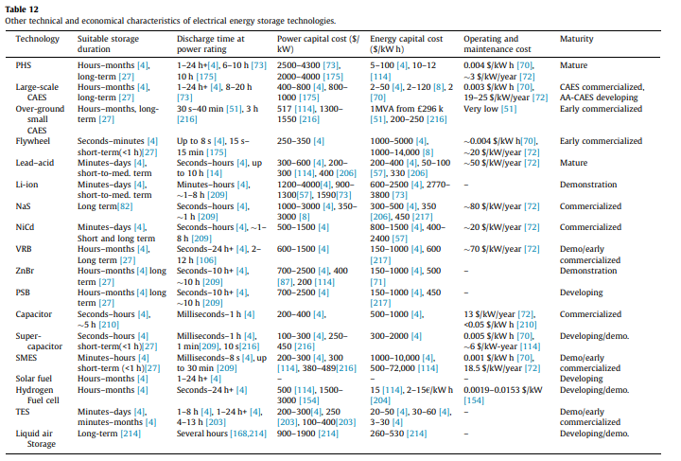
Survey Parameters
1: Not part of survey
2:
Associated energy at Rated power (kWh) Discharge time
- Would think this would depend on chosen size of build.

3, 4:
Total Capital cost of reference system ($/kW, $/kWh)

5:
Fixed Operation and Maintenance cost ($/kW-yr)
Variable Operation and Maintenance cost ($/kWh-yr)

6: Not part of survey.
-Should we include column for maturity? More a qualitative measure and does not look like it would contribute much to the comparison other than maybe an asterisk to suggest possible reduction of future capital cost estimates.

