Example table

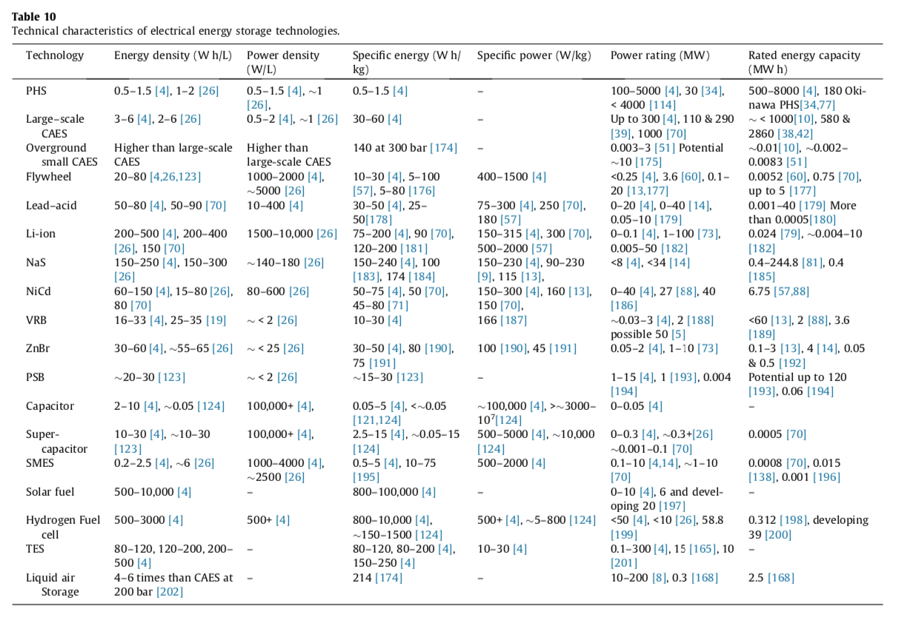
Parameter
Minimum Deliverable Size
Minimum Incremental Size
Maximum Deliverable Size
Power factor
Rated Power for charging of reference system (kW)
Rated Power for discharging of reference system (kW)
Associated energy (kWh) at Rated power
AC or DC power?
Power Conversion System Rated Power of the reference system (kW or kVA)
Maximum charging power

