FINAL PROJECT REPORT
Evaluating the Value of Long Duration Energy Storage in California

Month 2024 | CEC-500-XXXX-XXX

PREPARED BY:

Primary Author(s):
Sarah Kurtz, University of California Merced
Patricia Hidalgo-Gonzalez, University of California San Diego
Noah Kittner, University of North Carolina, Chapel Hill
Mariela Colombo, University of California Merced
Farzan ZareAfifi, University of California Merced
Zabir Mahmud, University of California Merced
Mahmoud Abido, University of California Merced
Paul Serna-Torre, University of California San Diego
Martin Staadecker, University of California San Diego

California Energy Commission Project Manager:
Jeffrey Sunquist

Agreement Number: EPC-19-060
Jonah Steinbuck, Ph.D.
Director
ENERGY RESEARCH AND DEVELOPMENT DIVISION

Drew Bohan
Executive Director
DISCLAIMER
This report was prepared as the result of work sponsored by the California Energy Commission. It does not necessarily represent the views of the Energy Commission, its employees or the State of California. The Energy Commission, the State of California, its employees, contractors, and subcontractors make no warranty, express or implied, and assume no legal liability for the information in this report; nor does any party represent that the uses of this information will not infringe upon privately owned rights. This report has not been approved or disapproved by the California Energy Commission nor has the California Energy Commission passed upon the accuracy or adequacy of the information in this report.

Acknowledgements
Special thanks to Roderick Go, of Energy and Environmental Economics, Inc., for support with RESOLVE, especially while it was being modified. Additionally, special thanks to the Technical Advisory Committee:
- Priya Sreedharan, Gridlab
- Erin Childs, Strategen
- Jennifer Dowdell, TURN
- Shucheng Liu, CAISO
- Ron Sinton, Sinton Instruments
- Julia Prochnik, LDES Council
- Paul Denholm, NREL
- David Williams, Dissigno
- Keith Parks, Xcel Energy
- Jeffrey Reed, UC Irvine

And, special thanks to the many people who were kind enough to support the project by answering questions, etc. A partial listing of these can be found in Appendix A.

PREFACE
The California Energy Commission’s (CEC) Energy Research and Development Division supports energy research and development programs to spur innovation in energy efficiency, renewable energy and advanced clean generation, energy-related environmental protection, energy transmission, and distribution and transportation.

In 2012, the Electric Program Investment Charge (EPIC) was established by the California Public Utilities Commission to fund public investments in research to create and advance new energy solutions, foster regional innovation, and bring ideas from the lab to the marketplace. The CEC and the state’s three largest investor-owned utilities—Pacific Gas and Electric Company, San Diego Gas and Electric Company, and Southern California Edison Company—were selected to administer the EPIC funds and advance novel technologies, tools, and strategies that provide benefits to their electric ratepayers.

The CEC is committed to ensuring public participation in its research and development programs that promote greater reliability, lower costs, and increase safety for the California electric ratepayer and include:

- Providing societal benefits.
- Reducing greenhouse gas emission in the electricity sector at the lowest possible cost.
- Supporting California’s loading order to meet energy needs first with energy efficiency and demand response, next with renewable energy (distributed generation and utility scale), and finally with clean, conventional electricity supply.
- Supporting low-emission vehicles and transportation.
- Providing economic development.
- Using ratepayer funds efficiently.

For more information about the Energy Research and Development Division, please visit the CEC’s research website (www.energy.ca.gov/research/) or contact the CEC at ERDD@energy.ca.gov.

ABSTRACT
As California transitions its energy system, energy storage will play a critical role. This project explored the duration, cost, and other attributes needed for the energy storage system. Long-duration storage will play especially important roles during the night and during cloudy days, especially during the winter. However, the need for storage also depends on the choice of generation technologies, availability of transmission, ability to shift load, and many other details of the grid. This study explores a wide range of scenarios to elucidate the value of long-duration energy storage in meeting California’s zero-emissions for retail sales target in 2045. California already has more than 6 GW of lithium battery storage and is planning on more storage. This report shows that California’s solar-driven grid will benefit from 8-h-duration storage installed with a power rating that can meet peak demand, which typically occurs just after sunset. Longer duration storage will also be useful. The cost target that a new storage technology needs to reach to displace today’s common 4-h Li batteries (less than about twice the lithium battery price when compared in $/kW) is found to change very little in the future. However, a small amount (in terms of power rating) of 100-h storage will become increasingly valuable especially as the energy transition matures, as expected in the 2045 timeframe. High round-trip efficiency is also an important attribute, with lithium batteries setting the system-level efficiency target at about 85%. Low efficiencies are more acceptable for storage that is used infrequently. The results are strongly dependent on both the cost assumptions and the estimated potential. The selection of more wind and geothermal could increase greatly, for example, if low-cost potential for these resources increased. Thus, the report focuses on identifying trends rather than concluding on specific targets and cautions the reader to use the results in this context.

Keywords: Long-duration energy storage, solar energy, wind energy, flexible load,

Please use the following citation for this report:
Garfield-Jones, Susanne, Lana McAllister, and Carol E. Robinson. 2024. Style Manual: Fourth Edition. California Energy Commission. Publication Number: CEC-180-2020-XXX.

Table of Contents
Executive Summary 1
Background 1
Project Purpose and Approach 1
Key Results 1
Knowledge Transfer and Next Steps 11
CHAPTER 1: Introduction 12
CHAPTER 2: Project Approach 14
2.1. Project Timeline and Approach 14
2.2 Project Partners 14
2.3 Research Objectives 15
2.4 LDES Technology Background and Summary 15
2.5 Core Scenario Description used for RESOLVE Modeling 17
2.6 Core Scenario Description used for SWITCH Modeling 19
2.7 Sensitivity Analysis 19
CHAPTER 3: Results 20
3.1 Core Scenario 20
3.2 Core Scenario - Optimal Duration 20
3.3 Core Scenario - Competitive Cost 21
3.4 Core scenario – Adding Multiple Types of LDES Simultaneously 25
3.5 Core Scenario - Optimal Efficiency and Duration 26
3.6 Pumped Hydropower Storage 26
3.7 Impact of EV Charging Profiles on Selected Storage 27
3.8 Impact of Solar and Wind Generation Profiles on Storage 29
3.9. Impact of Oxy-combustion on the Selected Storage 35
3.10 Impact of Electrolyzers on Selected Storage 38
3.11 Storage-Cost Impacts on WECC and California Transmission 41
3.12 Impact of Increasing LDES Deployment in the WECC 54
3.13 Critical Factors Determining Sensitivity of Results 56
CHAPTER 4: Conclusion 58
Glossary and List of Acronyms 60
References 61
Project Deliverables 62
APPENDIX A: Acknowledgment of Contributors Supplementary information 63
APPENDIX B: Summary of Input Assumptions Supplementary information 66
APPENDIX C: Build Fractions Supplementary information 67

List of Figures
Figure Exec. 1: Power and Energy Capacity Selected for RESOLVE Baseline Scenario 2
Figure Exec. 2: Average Storage Duration in California vs Transmission Buildout 3
Figure Exec. 3: Capacity Expansion Selected for Example Scenarios 3
Figure Exec. 4: Selection of 4-h Li Batteries vs LDES 4
Figure Exec. 5: Cost Target for LDES vs Efficiency for 3 Penetration Levels 4
Figure Exec. 6: Cost Targets for LDES as a Function of Modeled Year 5
Figure Exec. 7: Fraction of Annual California Load met by California Generation 6
Figure Exec. 8: Annual Electricity Generation by State and Transmission Capacities 7
Figure Exec. 9: Impact of LDES Mandates on the Marginal Price of Electricity 8
Figure Exec. 10: Added Storage to Meet EV Loads for Three EV Charging Profiles 9
Figure Exec. 11: 2045 Electrolyzer Capacity Factor 10
Figure Exec. 12: Annual Solar Curtailment for Three Solar Configurations 10

Figure 2. 1: Revised 4-h Li Battery Capital Cost from 2022-2023 IRP 17

Figure 3. 1: Capacity Expansion Selected for RESOLVE Core Scenario Without LDES 20
Figure 3. 2: Power and Energy Capacity Selected for RESOLVE Baseline Scenario 21
Figure 3. 3: Selection of 4-h Li Batteries vs LDES 21
Figure 3. 4: Cost Target for 50% Market Share as a Function of LDES Duration 22
Figure 3. 5: Cost Target for LDES vs Efficiency for 3 Market Share Levels 23
Figure 3. 6: Cost Targets for LDES as a Function of Efficiency 24
Figure 3. 7: Cost Targets for LDES as a Function of Modeled Year 25
Figure 3. 8: Capacity Expansion Selected for Table 2.4 Scenarios 26
Figure 3. 9: Selected Operational Power Capacities, as a Function of LDES Efficiency 26
Figure 3. 10: Capacity Expansion for Baseline (left) and High Pumped Hydro 27
Figure 3. 11: Light-duty Electric Vehicles Load (GW) Profiles 28
Figure 3. 12: Added Storage to Meet EV Loads for Three EV Charging Profiles 28
Figure 3. 13: Storage Capital Costs for the Cases in Figure 3.12 29
Figure 3. 14: Daily and Monthly Solar Generation Profiles for 3 Solar Configurations 29
Figure 3. 15: Annual Solar Curtailment for Three Solar Configurations 30
Figure 3. 16: Cost Targets for LDES as a Function of Duration 31
Figure 3. 17: LDES Cost Target as Function of LDES Efficiency for 3 Configurations 31
Figure 3. 18: Selected Capacity Expansion for 3 Solar Mounting Configurations 32
Figure 3. 19: Monthly Wind Generation Profiles 33
Figure 3. 20: Annual Solar Curtailment Comparing Wind Profiles 34
Figure 3. 21: New-Build Capacities for Added Wind Scenarios 35
Figure 3. 22: LDES Power Capacity Selected vs LDES Duration for Wind Scenarios 35
Figure 3. 23: Operational Capacity of Oxy-combustion as Function of Capital Cost 36
Figure 3. 24: 2045 Operational Capacities Without & With (right) Oxy-combustion 37
Figure 3. 25: 2045 Oxy-combustion Dispatched Power 38
Figure 3. 26: Operational Capacities, Without and With Electrolyzer 39
Figure 3. 27: Solar Energy Curtailment with Electrolyzer 39
Figure 3. 28: 2045 Electrolyzer Capacity Factor 40
Figure 3. 29: 2045 Solar Power Profile, with Electrolyzer Load 40
Figure 3. 30: 2045 Solar and Storage Power Profiles, with Electrolyzer Load 41
Figure 3. 31: 2045 Solar and Storage Power Profiles 41
Figure 3. 32: Transmission Line Capacities Between the Modeled WECC Load Zones 43
Figure 3. 33: Annual Electricity Generation by State and Transmission Capacities 43
Figure 3. 34: Annual Electricity Generation by State and Loading of Transmission 44
Figure 3. 35: Electricity Generation and Transmission Loading for 85-GW Demand 45
Figure 3. 36: Electricity Generation and Transmission Loading for High Imports 45
Figure 3. 37: Solar Capacity in California vs Transmission Build-out. 46
Figure 3. 38: Storage Power Capacity Deployed in California vs Transmission Build 47
Figure 3. 39: Storage Energy Capacity Deployed in California vs Transmission Build 48
Figure 3. 40: Average Storage Duration in California vs Transmission Buildout 49
Figure 3. 41: Wind Capacity Deployed in California vs Transmission Buildout 50
Figure 3. 42: Installed Generation Capacity in California for 2050 51
Figure 3. 43: Fraction of Annual California Load met by California Generation 52
Figure 3. 44: Fraction of Monthly California Load met by California Generation 53
Figure 3. 45: Impact of LDES Mandates on the Marginal Price of Electricity 55
Figure 3. 46: Capacity Expansion for Two Emissions Scenarios 57

List of Tables
Table 2. 1: Project Timeline 14
Table 2. 2: Long-Duration Energy Storage (LDES) Summary 15
Table 2. 3: LDES Assumptions for Adoption of a Single LDES Type 18
Table 2. 4: Scenarios Offering 4 types of LDES Simultaneously 18

Table 3. 1: Model Inputs for Operational Capacity for Oxy-combustion 36
Table 3. 2: Scenarios Analyzed for 2050 WECC Grid Expansion 42

Executive Summary

Background
Senate Bill 100 sets the goal of zero-carbon retail sales of electricity by 2045. Long-duration energy storage (LDES) can help to reach that goal by storing electricity for use after the sun sets and for other times when solar and wind are inadequate. The California Energy Commission is funding development of LDES; this study was designed to inform the development and implementation of LDES.

Project Purpose and Approach
The project’s goal is to understand the role and cost targets of LDES to reach zero-carbon and related goals by 2045. This understanding is explored for multiple scenarios to understand how actions by the state may affect the need, benefit, and desired attributes of LDES.

Key Results
As California transitions to a renewable energy driven grid with zero carbon emissions for retail electricity by 2045, energy storage will be critical. Today’s 4-h Li batteries (about 7 GW in California) are providing very useful service to the grid, but the 4-h duration will not be adequate for getting through each night as the state transitions away from natural gas. This project found that an 8-h battery (Figure Exec.1) minimizes the need to overbuild the power capacity (and associated power electronics, etc.) of the storage (left axis) simultaneously with minimizing the need to overbuild the energy capacity (right axis) which would be infrequently used. The 8-h LDES is well suited for California in 2045 because solar electricity is likely to dominate the renewable energy build out. The 8-h LDES will be charged while the sun is up, discharge quickly during peak demand in the early evening, and then discharge more slowly for the lower demand experienced during the night. This result assumes that 8-h LDES is amply available at a cost similar to the $/kWh capital cost expected for 4-h Li batteries.

Figure Exec. 1: Power and Energy Capacity Selected for RESOLVE Baseline Scenario
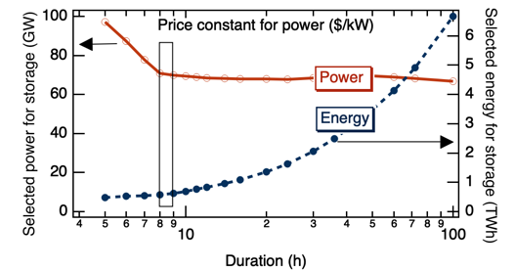

Approximately 70 GW of 8-h storage will be beneficial and may be cycled more than 300 times per year. The optimal duration for the most common type of storage may be as low as 7 hours when the entire Western Electricity Coordinating Council (WECC) is considered or may increase to 10 to 12 hours when A) transmission is limited (Figure Exec.2), B) more wind generators are built, or C) the added cost of longer duration is quite small.

Figure Exec. 2: Average Storage Duration in California vs Transmission Buildout
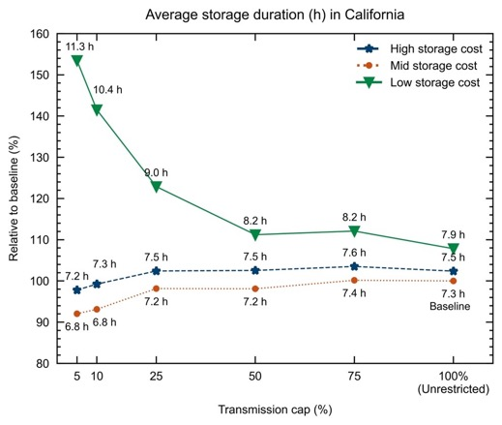

In addition to the 8-h storage, the models found that a small amount of 100-h storage may be beneficial. For the scenarios modeled, the 100-h storage typically displaced a few percent of the 8-h storage, especially in 2045 (Figure Exec.3).

Figure Exec. 3: Capacity Expansion Selected for Example Scenarios
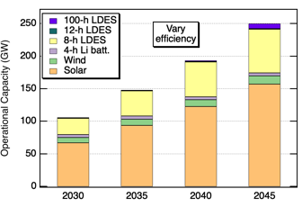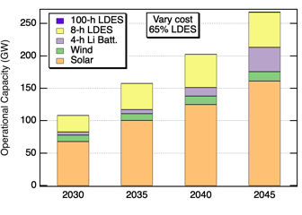

The results shown in Figure Exec.3 are highly dependent on the exact assumptions made for each LDES candidate. Recognizing that any new storage technology will need to compete with 4-h Li batteries, the cost of each LDES candidate was varied to identify the competitive price, as shown for an 8-h LDES in Figure Exec.4. From such graphs, the cost target to displace 4-h Li batteries was derived. The determination of the cost target for each LDES candidate is dependent on the fraction of the market that is targeted. For example, in Figure Exec.4, the LDES cost target to displace 100% of 4-h Li batteries is 0.6 of the 4-h Li battery energy cost, while the cost target to displace 50% is closer to 0.95 of the 4-h Li battery energy cost. Given that the uncertainty in Li battery prices is a factor of 2, the calculated cost targets are presented here relative to the assumed 4-h Li battery cost.

Figure Exec. 4: Selection of 4-h Li Batteries vs LDES
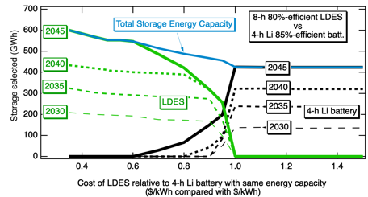

The cost target for LDES to capture market share from lithium batteries is strongly dependent on the LDES efficiency (Figure Exec. 5). The dependence on efficiency is less important if only 1% of the 4-h Li batteries are displaced, reflecting the likelihood that these LDES are cycled less frequently.

Figure Exec. 5: Cost Target for LDES vs Efficiency for 3 Penetration Levels
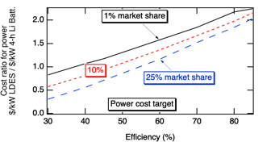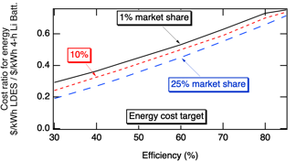

The relative cost target may change in the future depending on whether the grid will value 4-h or longer duration storage more. Figure Exec.6 shows that for a LDES product to displace 50% of 4-h Li batteries the cost target decreases in the future, suggesting that, while 8 hours of storage is still needed to get through the night, reduced use of peaker plants to meet zero emissions targets may require an increased part of the storage fleet to function like peaker plants in 2045, increasing the market share of 4-h storage. The opposite dependence on years into the future was found when considering displacement of 1% of 4-h Li batteries (Figure Exec. 6 for 50%-efficient LDES), demonstrating that the value of 100-h LDES relative to 4-h storage will increase in the future, but at approximately 1-GW scale rather than at tens of GW scale. In terms of energy storage: 1-GW 100-h LDES would provide 100 GWh, while 50 GW of 4-h storage would provide 200 GWh, suggesting that 100-h LDES will be a substantial part of the market when energy capacity is considered.

Figure Exec. 6: Cost Targets for LDES as a Function of Modeled Year

All modeled scenarios found that California will continue to be a net importer of electricity, though California will export electricity during the day when solar electricity is abundant. If additional transmission is built, the electricity generated in California may decrease even more with California net importing more than 10% of its electricity on an annual basis (Figure Exec. 7).

Figure Exec. 7: Fraction of Annual California Load met by California Generation
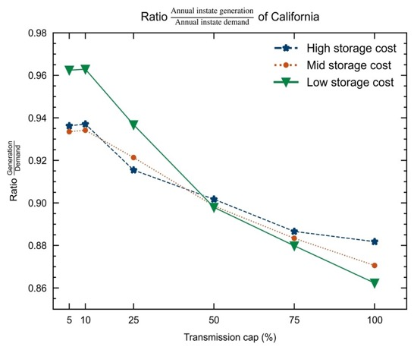

As storage costs were decreased, the model chose to build fewer transmission lines, though some lines connecting California to its neighbors were built to larger capacity when storage costs were decreased (Figure Exec. 8). Wider deployment of storage was found to both decrease the price of electricity and decrease the variability of the price of electricity (Figure Exec. 9) with an initial large benefit with the deployment of the first 3 TWh and large benefit for up to 20 TWh storage deployment. Note that wider deployment of storage will result in larger investment costs that are not captured in the figure.

Figure Exec. 8: Annual Electricity Generation by State and Transmission Capacities
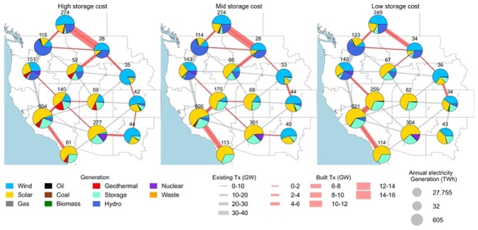
Figure Exec. 9: Impact of LDES Mandates on the Marginal Price of Electricity
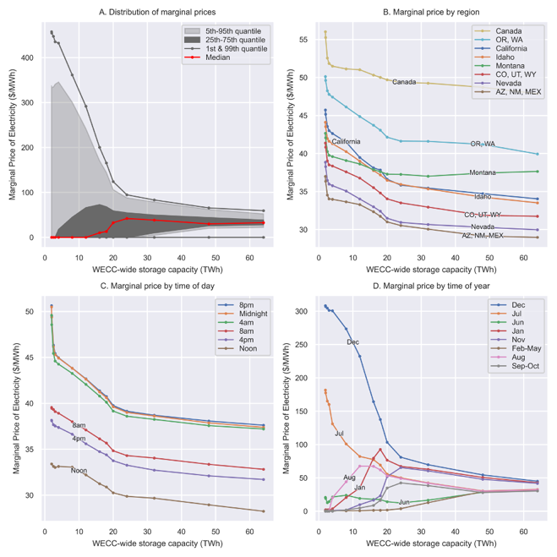

Today’s flexible loads are too small (with batteries sometimes being less expensive than installing load-shifting equipment) to balance supply and demand of electricity, but tomorrow will bring two very large flexible loads: electric vehicle charging and electrolyzers for hydrogen generation. If one considers that roughly 1/3 of energy is used for transportation (which may be largely met by electricity or hydrogen from electrolysis) and 1/3 for industrial processes (which may be met by electricity-driven heat pumps and/or with hydrogen), the potential flexible loads in the future may be comparable to today’s total electrical load. The use of daytime charging of electric vehicles in 2045 was found to reduce the selected storage (Figure Exec. 10), saving on order of $1 billion and motivating investment in daytime charging infrastructure. Electrolyzers were found to contribute to seasonal load balancing by turning off during the winter. Surprisingly, the electrolyzers were found to operate at a capacity factor of 40% (Figure Exec. 11), exceeding the capacity factor of the solar plants that provided power for them, suggesting that batteries supply the electrolyzers with electricity sometimes. Thus, the availability of under-used assets (curtailed electricity combined with ample storage) may be enabling for green hydrogen.

Figure Exec. 10: Added Storage to Meet EV Loads for Three EV Charging Profiles
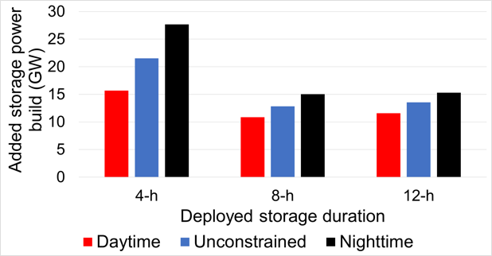

Figure Exec. 11: 2045 Electrolyzer Capacity Factor
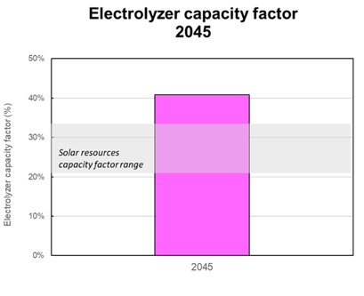

The use of solar and wind generation profiles (by changing the solar mounting configuration (Figure Exec. 12) or selecting wind locations with stronger winter-time wind) with better seasonal match to the load profiles, reduced curtailment. However, the reduction in curtailment must be balanced with the potential increase in cost of the system.

Figure Exec. 12: Annual Solar Curtailment for Three Solar Configurations
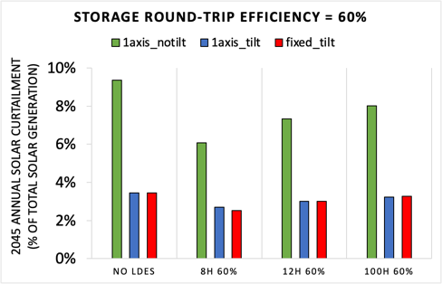

The use of oxy-combustion could help to reduce the need for storage, but questions remain about the rate of scale up of both the oxy-combustion generators and the infrastructure for sequestration of the generated carbon dioxide.

Knowledge Transfer and Next Steps
Results have been shared directly with CEC, with publications, presentations at conferences and through webinars, as documented in the Knowledge Transfer Report.
A more complete summary of the results of this study may be found online.

CHAPTER 1:
Introduction
This project’s goal is to understand the role and cost targets of long-duration energy storage (LDES) to reach zero-carbon emissions and related goals by 2045. While, clearly, low-cost, efficient LDES is desirable, it is less clear what duration (hours of discharge that can be sustained at the LDES’ rated power) will be most beneficial.

The optimal solution for California is likely to include some LDES with durations suitable to provide power through the night, longer durations that will provide power during a few cloudy days, and even longer durations that provide power during the most difficult seasons. The efficiencies of the LDES and other details of the system will affect the optimal mix.

Understanding the combinations of attributes that will enable solar and wind to provide electricity round the clock will guide investments in the many promising LDES technologies. A critical attribute will be the cost each type of LDES will need to reach to be able to capture market share.

California has a unique mixture of energy resources, including abundant solar energy and a wind resource that is stronger in summer than in winter, while most locations have stronger wind during winter. Thus, studies describing how LDES broadly complements solar and wind generation for other locations may not provide the optimal solutions for California.

Additionally, California is exploring investment in offshore wind, has the largest geothermal generation in the country, and could benefit from using wood from the forests for electricity generation as a means for reducing wildfires. If any of these were installed at a multi-GW scale, the need for LDES would change. Electric vehicle (EV) charging, electrolysis, and heat pumps are examples of three loads that are anticipated to increase. These loads are significant because they are more flexible than today’s loads, so may be more significantly influenced by state policy and actions that guide design of demand management programs such as creation of time-of-use rates as well as design of incentive programs that motivate investment in technologies and infrastructure that will enable load shifting. For example, investments for EV charging could incentivize use of on-site storage to enable fast charging (increasing the use of LDES), installation and use of infrastructure for daytime charging in parking lots (reducing the need for LDES), and/or installation of residential charging infrastructure that would be used primarily at night (increasing the need for LDES).

This study focuses on longer-term questions and a wide range of scenarios, differentiating it from the CEC’s Integrated Energy Policy Report (IEPR) which focuses more on near-term energy needs and issues. Complementing the related study by the Energy & Environmental Economics, Inc, this study considers how solar and wind generation profiles may be designed to more closely match the load profiles, how loads may be shifted to reduce the need for storage, and how the WECC resources may interact with California’s resources.

Thus, this study explores a wide variety of scenarios to understand how actions by the state may affect the need for and benefit of LDES in the future, aiding both policy makers and companies that are developing long-duration storage projects.

CHAPTER 2:
Project Approach

Project Timeline and Approach
The project timeline is shown in Table 2.1. An initial survey of the currently available LDES technologies identified the technology options and their attributes and later was used to refine the implementation of storage in the modeling. The model was modified to enable consecutive 365-day modeling to ensure LDES benefits could be fully appreciated by the model. Finally, in discussion with the CEC, the scenarios were developed and analyzed.

Table 2. 1: Project Timeline
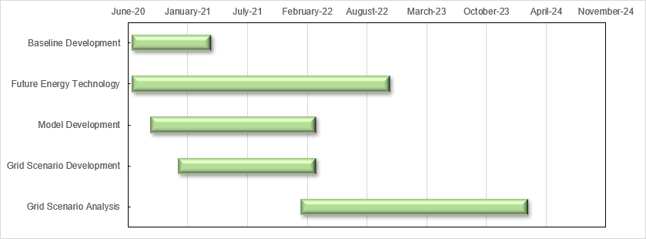

Project Partners
The project was led by UC Merced (Sarah Kurtz) with subcontracts to UC Berkeley (Dan Kammen), UC San Diego (Patricia Hidalgo-Gonzalez), and the University of North Carolina Chapel Hill (Noah Kittner). Sergio Castellanos initially participated at UC Berkeley, then continued the collaboration after moving to the University of Texas Austin. The Technical Advisory Committee is identified at the beginning of this report.

Dozens of individuals and companies provided input as identified in Appendix A.
Students and researchers who contributed in addition to those listed as authors include:
- Pedro Sanchez
- Kenji Shiraishi
- Jeremiah Reagan
- Julia Szinai
- Natalia Gonzalez
- Tyler Lis
- Aashika Nair
- Jerry Potts
- Rajni Kant Bansal

2.3 Research Objectives
The project’s primary objectives were to understand the roles and cost targets of long-duration energy storage to reach zero-carbon emissions and related goals by 2045, considering a broad context of the generation technologies that will be installed and the use of transmission to connect to the rest of the WECC.

LDES Technology Background and Summary
This project’s assessment, of many LDES technologies provided the basis for the capacity expansion modeling. The Shan, et al. assessment⁷ provides an overview of standardized metrics comparing LDES technologies with lithium-ion based counterparts. That assessment developed innovative storage metrics for comparing technologies, such as a standardized average capital cost of different storage technology as a function of discharge duration at rated power, equivalent efficiency considering idle loss rates, and land footprints as a function of energy rating.⁷ The project also analyzed current shortcomings in storage modeling with opportunities for cross-sector applications as explored in Section 3.10. Table 2.2 provides an abbreviated overview of the available LDES technologies.

Table 2. 2: Long-Duration Energy Storage (LDES) Summary
Storage type | Discharge duration | Lifetime | Roundtrip efficiency (%) | Capital cost ($/kW) | Capital cost ($/kWh)
Compressed air, adiabatic | 10-100 | 20-30 | 55-75 | 700-1100 | 40-90
Flow battery, Vanadium | 4-24 | 5-20 | 65-85 | 600-1650 | 160-1150
Flow battery, Zinc | 4-24 | 5-20 | 65-75 | 700-2700 | 160-1800
Pumped hydropower | 10-100 | 25-100 | 60-85 | 1800-3400 | 5-200
Thermal | 4-24 |  |  |  | < 10
Li-ion battery | 1-4 | 5-20 | 85-90 | 1600-2500 | 300-900

Real project cost estimates for gravity storage have increased from $200-300/kWh to ~$880/kWh based on pilot projects developed in China; however, there is potential for further cost reduction.

The dynamic LDES market offers a wide range of technology options, each catering to specific applications. It is critical to consider factors like self-discharge rates, modularity (smallest deliverable capacity), heat management, cost-effectiveness, land footprint, and depth of discharge when determining the most suitable solution for specific applications.

Proton exchange membrane (PEM) electrolyzers provide flexibility in their operation, enabling them to better complement variable renewable energy sources than alkaline electrolyzers. Thus, they act as a type of storage. Electrolyzers are rapidly coming down in price.

Based on feedback and the observation that the attributes of the storage technologies are not yet well defined, the capacity expansion modeling used a matrix of attributes as defined in Section 2.6 rather than specifically modeling each technology. However, the information in Table 2.2 can be used to relate specific technologies to the modeling results.

Community feedback encouraged studies covering the entire range of durations, efficiencies, and costs, reflecting the uncertainty of which technologies will succeed. In response to this feedback, the project explored the full range of durations, efficiencies, and cost, defining a large matrix to survey in competition with 4-h Li batteries that were modeled after today’s Li-ion batteries, though another short-duration storage technology could still displace Li-ion batteries. Efficiencies as low as 30% were explored but were not selected by the model in the price ranges that were explored.

The model’s selection of the lowest cost solution can result in highly variable results when the costs of two candidate resources are similar. This report, therefore, emphasizes how the selected solution depends on the input costs while still considering how the other inputs affect the solutions.

To underscore the challenge of predicting the future costs of energy storage technologies, Figure 2.1 highlights how the 2022-2023 Integrated Resource Planning (IRP) noted the decision to essentially double the modeled cost of Li batteries. The cost of Li batteries is the basis for the modeled 4-h storage, so is a critical input to the model because the selection of LDES to displace the current trend of using GWs of 4-h Li batteries is dependent on their relative cost. While the uncertainty in Li battery costs is high, the uncertainty in LDES costs is even greater.

On the other hand, Bloomberg recently reported that Li battery prices are now falling again with battery pack prices in Nov. 2023 averaging $139/kWh and the cells averaging $89/kWh.

Figure 2. 1: Revised 4-h Li Battery Capital Cost from 2022-2023 IRP
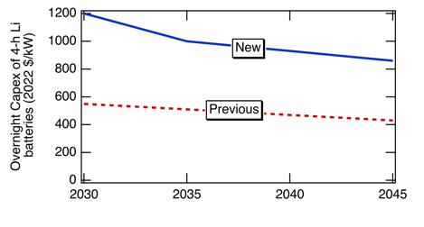

2.5 Core Scenario Description used for RESOLVE Modeling
RESOLVE was developed by Energy and Environmental Economics (E3) and models expansion of the CAISO grid, while retaining generation and load for surrounding states. The limitation of only building new resources within CAISO introduces uncertainty, but modeling of resources outside of CAISO was included in the studies using SWITCH (see section 2.6).

The Final Core Scenario using the RESOLVE software includes baseline assumptions to reflect the 2021 CPUC IRP PSP and the 2020 PATHWAYS High Electrification analysis for the growth of EV loads.

Additional characteristics of the Final Core Scenario:
- Use fixed hydropower profiles for dry year
- Offer 85%-efficient, 4-h Li batteries as short-duration storage (model does not adjust the duration)
- Vary the duration and efficiency of candidate LDES resources without assigning to specific technologies
- Use the Critical-time-steps approach that shortens the computation time, enabling many calculations while allowing 365-day continuous simulations (Some calculations used 8760 time points to confirm the accuracy of the Critical-time-steps calculations)
- Exclude the constraint of a planning reserve margin (meeting the reserve was considered for every hour of the year rather than identifying whether the installed generation capacities had adequate electrical load carrying capacity)

Using RESOLVE, LDES was modeled with a predefined duration using four methods:
- Fixed efficiency and cost ($/kW) with varied (defined) duration for a single storage type ranging from durations of 4 h to 100 h,
- Fixed duration and efficiency of a single LDES type with cost varied to identify the cost target that would result in selection of the LDES at a target penetration level,
- Fixed duration, efficiency, and cost for a single LDES type selected from Table 2.3 in competition with 4-h Li batteries from the baseline to quantify the selected adoption for the least-cost solution, and
- Four LDES types with duration, efficiency and cost defined as in Table 2.4 in competition with each other and with 4-h Li batteries. The “Vary cost” scenario defined in Table 2.4 can be implemented with a range of efficiencies, denoted as “Y” in the Table, where the same “Y” efficiency is used for all LDES types.

Table 2. 3: LDES Assumptions for Adoption of a Single LDES Type
Duration | 60% Efficient | 80% Efficient
8 h | 1.2 X 4-h Li battery power cost;  0.6 X 4-h Li battery energy cost | 1.2 X 4-h Li power cost;  0.6 X 4-h Li energy cost
12 h | 1.4 X 4-h Li battery power cost;  0.47 X 4-h Li battery energy cost | 1.4 X 4-h Li power cost;  0.47 X 4-h Li energy cost
100 h | 1.8 X 4-h Li battery power cost;  0.072 X 4-h Li battery energy cost | 1.8 X 4-h Li power cost;  0.072 X 4-h Li Energy cost

Table 2. 4: Scenarios Offering 4 types of LDES Simultaneously
Duration | Vary efficiency,  constant power cost | Vary cost,  constant “Y” efficiency
4 h | 1 X 4-h Li power cost or  1 X 4-h Li energy cost; 85% | 1 X 4-h Li power cost or  1 X 4-h Li energy cost; 85%
8 h | 1 X 4-h Li power cost or  0.5 X 4-h Li energy cost; 75% | 1.2 X 4-h Li power cost or  0.6 X 4-h Li energy cost; Y%
12 h | 1 X 4-h Li power cost or  0.33 X 4-h Li energy cost; 70% | 1.4 X 4-h Li power cost or  0.47 X 4-h Li energy cost; Y%
24 h | 1 X 4-h Li power cost or  0.17 X 4-h Li energy cost; 60% | 1.6 X 4-h Li power cost or  0.27 X 4-h Li energy cost; Y%
100 h | 1 X 4-h Li power cost or  0.04 X 4-h Li energy cost; 50% | 1.8 X 4-h Li power cost or  0.072 X 4-h Li energy cost; Y%

Core Scenario Description used for SWITCH Modeling
SWITCH-WECC models the WECC with 50 load zones featuring a high geographic and temporal resolution for renewable resources in the WECC.

In the case of the Western Electricity Coordinating Council (WECC) the model includes all 365 days in 2050, sampling every four hours and imposes a zero-emissions carbon cap constraint. The model considers 7,000+ possible candidate projects geolocated for deployment of solar, wind, geothermal, etc. (considering land and environmental constraints). The optimization model is free to choose power capacity and energy capacity for the installed storage assets, i.e., duration is not predetermined: it is an output.

Within SWITCH, LDES was modeled by providing a cost for $/kW and a separate cost for $/kWh with the duration selected by the model to provide the lowest cost outcome. The two cost inputs were varied to explore a wide parameter space. The efficiency was fixed at 75%, the efficiency used for the 8-h LDES in the left side of Table 2.4, reflecting an efficiency that is achievable for several LDES technologies.

Sensitivity Analysis
Modifications to the core scenarios include testing the impacts of:
  - EV charging profiles on the need of storage
  - Solar and wind generation profiles on the need of storage
  - Oxy-combustion on the need of storage
  - Use of electrolyzers as a flexible load
  - Storage costs and transmission deployment caps in the WECC
  - Storage implementation in the WECC

CHAPTER 3:
Results

Core Scenario
The capacity expansion for the core scenario before introduction of LDES is shown in Figure 3.1. Subsequent graphs omit hydro, biomass, geothermal, CCGT and other (mainly non-CCGT fossil and nuclear) as they are usually unchanged with the introduction of LDES.

Figure 3. 1: Capacity Expansion Selected for RESOLVE Core Scenario Without LDES
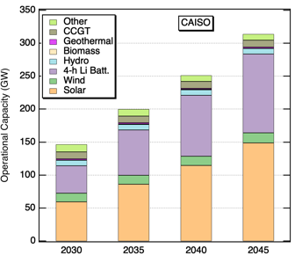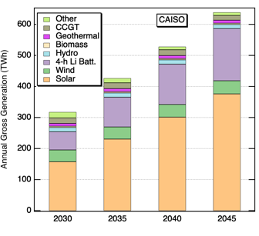

Core Scenario - Optimal Duration
A capacity expansion model is designed to select the lowest cost solution. However, there is large uncertainty in future costs. As discussed above, even the cost of Li-ion batteries currently has an uncertainty of a factor of two. A strategy for evaluating the grid’s need for LDES when the costs are not clear is to document the needed power capacity and needed energy capacity as a function of LDES duration when only one storage option is offered to the model (method “a” in section 2.6). For shorter duration storage, the energy capacity can be sized to meet the most stressful time, while the power capacity must be overbuilt. On the other hand, as shown in Figure 3.2, for the longest duration storage, the power rating (solid red curve plotted on left y axis) is lower, but the energy capacity (dotted blue curve plotted on right y axis) is overbuilt. Although the ideal duration depends on the cost(s) and efficiencies, if a duration between 8 and 9 h is selected (rectangle in Figure 3.2), the power overbuild will be < 2% and the energy capacity overbuild < 15%. This straightforward assessment can be repeated for each scenario to identify how the need for storage changes. However, the ideal solution includes multiple storage types.

Figure 3. 2: Power and Energy Capacity Selected for RESOLVE Baseline Scenario

Core Scenario - Competitive Cost
The competition between LDES and 4-h Li batteries can be probed directly by fixing the 4-h Li battery cost and varying the LDES cost (Figure 3.3). In this case, 8-h 80%-efficient LDES needs to be lower in cost than a 4-h Li 85%-efficient battery when considering the cost of the energy capacity.

Figure 3. 3: Selection of 4-h Li Batteries vs LDES
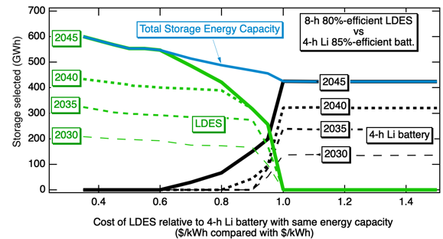
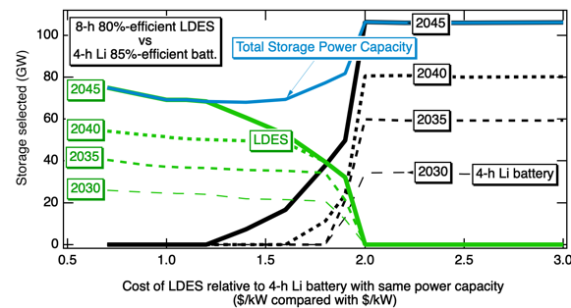

- The target price for 50% adoption of an LDES product can be derived from Figure 3.3 by identifying the cost ratio at which the LDES and 4-h Li battery selections are equal (about 0.95 when comparing the energy costs or 1.8 when comparing power costs in Figure 3.3). Figure 3.4 shows this target price as a function of the 80% LDES duration, with the relative cost per installed kWh on the left and the relative cost per installed kW on the right. Up to about 8-h duration, the competitive cost in $/kWh for the LDES approximately equals the $/kWh for the 4-h Li batteries. For durations > 8 h, the LDES $/kWh target cost drops quickly.

Figure 3. 4: Cost Target for 50% Market Share as a Function of LDES Duration
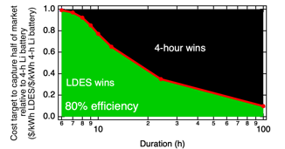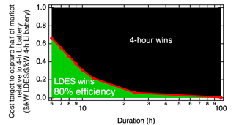

Longer duration LDES that may be needed to cycle only a few times per year may provide higher value, justifying a higher cost target, if the adoption level is taken to be small. Figure 3.5 shows higher cost targets for lower efficiency 12-h LDES that is adopted for a small fraction of the market (e.g. 1%).

Figure 3. 5: Cost Target for LDES vs Efficiency for 3 Market Share Levels

The cost target to capture 1% or 50% of the market in 2030 or 2045 is shown as a function of LDES efficiency in Figure 3. 6 for 8-h and 100-h LDES. As anticipated, efficiency is a very important metric, with cost targets changing about a factor of 2 as the efficiency increases from 50% to 80%. The effect of efficiency is less critical for early adoption (1% of market share) (Figure 3.5 or 3. 6).

Figure 3. 6: Cost Targets for LDES as a Function of Efficiency
2030 2045

As restrictions on emissions are tightened, the need for LDES is likely to increase and the market will be willing to pay more for LDES relative to a 4-h Li battery in 2045 than in 2030. Indeed, this appears to be true for the adoption of a small amount of 100-h LDES as shown in Figure 3. 6 in the top graphs (1% market share). However, surprisingly, for 50% market share adoption in 2045, the model shows that the LDES will have to drop in price faster than the 4-h Li batteries, suggesting that the best time to launch LDES products for wide adoption may be before 2030 rather than waiting until closer to 2045. This effect is seen more clearly in Figure 3.7 for the 50% and 80% efficiency cases where the cost targets are plotted as a function of adoption year.

Figure 3. 7: Cost Targets for LDES as a Function of Modeled Year
50% 80%

Core scenario – Adding Multiple Types of LDES Simultaneously
The capacity expansion results for the core scenario are shown in Figure 3.8 for LDES scenarios simultaneously offering 4 types of LDES as described in Table 2.4. No 24-h LDES was selected. For the selected scenarios, the model had difficulty differentiating between 4-h Li, 8-h, and 12-h storage. As shown in Figure 3.3, a very small change in the assumed cost can change the conclusion about which storage dominates. Nevertheless, the conclusions for this set of storage options in Table 2.4 shows that 4-h Li and 8-h storage dominate with 100-h becoming more attractive in 2045. When higher efficiency and lower cost were assumed, LDES gained market share.

Figure 3. 8: Capacity Expansion Selected for Table 2.4 Scenarios

Core Scenario - Optimal Efficiency and Duration
For the LDES scenario “Vary cost” in Table 2.4, the efficiency (Y% in the table) has a profound effect on the LDES’ competition with 4-h Li batteries, with LDES benefiting from at least 60% to 70% efficiency as shown in Figure 3.9. The calculation in Fig. 3.9 was only for 2045, using an hourly calculation to differentiate between the types of storage more accurately.

Figure 3. 9: Selected Operational Power Capacities, as a Function of LDES Efficiency
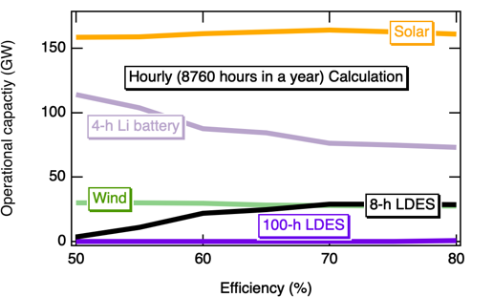

Pumped Hydropower Storage

Historically, pumped hydropower storage (PHS) has been the largest LDES technology. As storage is becoming more critical, several additional PHS projects have been proposed (see report for Task 3.2). The results for the anticipated capacity expansion are shown in Figure 3.10 on the right showing how the additional pumped hydropower primarily replaces 100-h LDES. As a well-proven technology, if PHS sites can be identified that are both economical and with minimal environmental impact (as may be the case for closed-loop systems), PHS could serve as a primary asset for the storage with the longest durations.

Figure 3. 10: Capacity Expansion for Baseline (left) and High Pumped Hydro
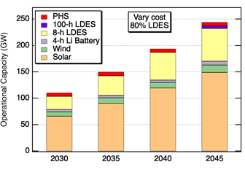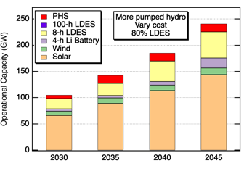

3.7 Impact of EV Charging Profiles on Selected Storage
The project studied the effects of three light-duty electric vehicle (EV) charging profiles on the need for storage. The profiles were taken from a recent study funded by the California Energy Commission (CEC). As illustrated in Figure 3.11, the first case, called 'Nighttime charging,' pictures a situation where 95% of EV owners have access to home charging, and these EVs commence charging at midnight, reflecting existing time-of-use pricing. Consequently, in this case, EV charging demand peaks at midnight, followed by a gradual decrease. The second scenario, referred to as 'Unconstrained' in Figure 3.11, assumes a spontaneous charging pattern without controlled schedules or economic incentives. Here, the peak charging is projected to occur in the evening when individuals return home from work and plug in. Finally, the 'Daytime charging' case incorporates two distinct periods of high demand: one during the middle of the day and another at midnight. This load profile assumes that daytime charging is common, probably using workplace charging stations.

Figure 3. 11: Light-duty Electric Vehicles Load (GW) Profiles
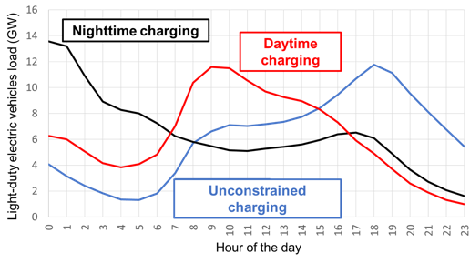

Figure 3.12 exhibits the effect of the three charging cases on the additional storage that is needed to provide charging for 15 million vehicles, assuming 40 miles/day, resulting in total load of 55 TWh/y. The LDES technologies analyzed here are 4-, 8- and 12-hour storage with 85% efficiency and the baseline power costs $/kW for 4-h Li batteries. As Figure 3.12 indicates and as expected, daytime charging shows the smallest need for storage. The smaller storage needed when deploying daytime charging could correspond to cost differences of up to $1 billion, according to Figure 3.13. This result motivates investment in daytime (e.g. workplace) charging infrastructure.

Figure 3. 12: Added Storage to Meet EV Loads for Three EV Charging Profiles
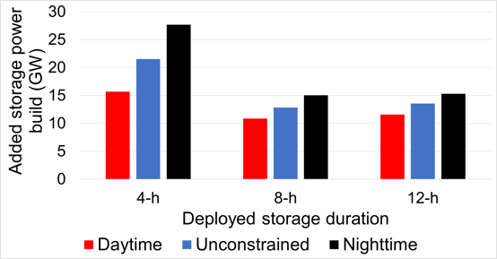

Figure 3. 13: Storage Capital Costs for the Cases in Figure 3.12
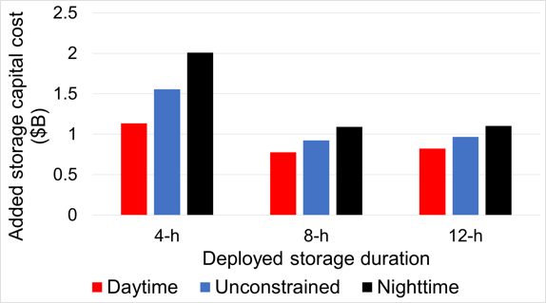

3.8 Impact of Solar and Wind Generation Profiles on Storage
The need for storage is driven by the mismatch between the generation and demand profiles. The study included three solar mounting configurations: 1) 1-axis tracked with no tilt (most common today), 2) 1-axis tracked with south-facing tilt, and 3) fixed mounting with south-facing tilt. The solar generation profiles are characterized in Figure 3.14.

Figure 3. 14: Daily and Monthly Solar Generation Profiles for 3 Solar Configurations
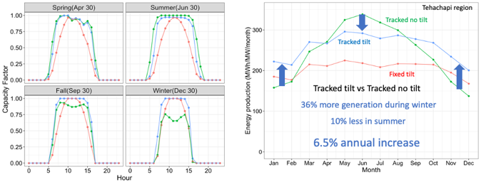

The effect of the mounting configurations is most apparent when comparing the curtailment, as shown in Figure 3.15 for the baseline and LDES described in Table 2.3. The strongly reduced curtailment for the south-facing tilt configurations reflects the better seasonal match between generation and demand profiles, but the effect may be too small to motivate using a higher cost design.

Figure 3. 15: Annual Solar Curtailment for Three Solar Configurations
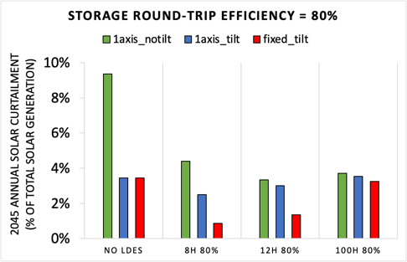

For 50% market adoption, the mounting configuration has little effect on the cost target as shown in Figure 3.16 for a competition between 80% LDES and 4-h Li 85% storage. When the fixed-tilt mounting is used, the LDES needs to reach a slightly lower cost.

Figure 3. 16: Cost Targets for LDES as a Function of Duration
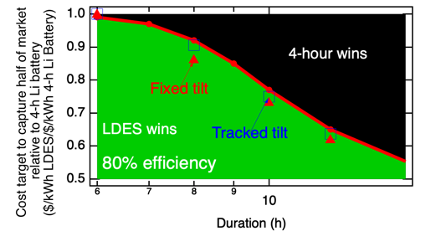

Similarly, the effect of efficiency on the cost target does not change substantially when using the 3 mounting configurations, as shown in Figure 3.17. The capacity expansion results shown in Figure 3.18 show less solar built when south-facing tilt is added to the one-axis tracking and more solar built when south-facing tilt is used in a fixed configuration, reflecting the yields of these solar configurations. When 80% 8-h LDES is added to the core scenario (using cost shown in Table 2.3), the 4-h Li batteries are replaced by the 8-h LDES with 49.5 GW of 8-h LDES adopted for the two south-facing configurations, compared with 47 GW for the 1-axis-tracked configuration with no tilt. This larger adoption of LDES is correlated with reduced use of wind, reflecting the added value of the south-facing tilt to the system. When 60% 8-h LDES is added, 4-h Li batteries are retained, with, again, more storage being built for the two south-facing tilt configurations, though, in this case, the connection to the reduced use of wind is less clear.

Figure 3. 17: LDES Cost Target as Function of LDES Efficiency for 3 Configurations
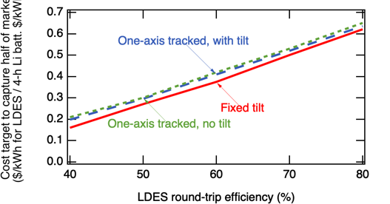

Figure 3. 18: Selected Capacity Expansion for 3 Solar Mounting Configurations

Like solar, wind generation profiles can affect the modeling results. Figure 3.19 shows a winter-dominant wind generation profile and an offshore wind-generation profile in comparison with the core scenario’s generation profile. Notably, the winter-dominant profile can provide generation during the winter when both solar and today’s onshore wind have reduced generation.

Figure 3. 19: Monthly Wind Generation Profiles

By providing better seasonal balance, the winter-dominant wind is effective at reducing curtailment of solar generation, as shown in Figure. 3.20 for 60% efficient LDES. This optimization used the same LDES assumptions as Figure 3.15. When 80% LDES was used, the curtailment was relatively low in all cases.

Figure 3. 20: Annual Solar Curtailment Comparing Wind Profiles

Adding winter-dominant wind or offshore wind reduces the storage needed as shown in Figure 3.21 and shifts the optimal duration to slightly longer, as shown in Figure 3.22

Figure 3. 21: New-Build Capacities for Added Wind Scenarios

Figure 3. 22: LDES Power Capacity Selected vs LDES Duration for Wind Scenarios
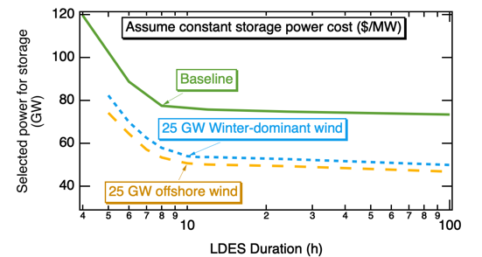

3.9. Impact of Oxy-combustion on the Selected Storage
Oxy-fuel combustion, or oxy-combustion, is carbon capture and storage (CCS) technology that involves burning fuel with nearly pure oxygen (instead of air), resulting in combustion gases primarily composed of CO₂ and water vapor, simplifying carbon dioxide capture in power plant applications. The Allam cycle employs oxy-combustion technology in a closed-loop cycle, with high-pressure supercritical CO₂ as the working fluid and retaining all emissions by design.
Allam cycle oxy-combustion was modeled to evaluate its impact on the need for LDES.
This technology with natural gas as a fuel has an efficiency comparable to a combined cycle gas turbine (CCGT). For that reason, it was modeled as a CCGT with no associated emissions.
The maximum operational capacity in California was limited to the values in Table 3.1 as an estimate of potential for deployment of additional infrastructure for CO₂ transportation and storage.

Table 3. 1: Model Inputs for Operational Capacity for Oxy-combustion
Year | Maximum operational capacity (GW)
2030 | 0.5
2035 | 1
2040 | 2
2045 | 4

The cost range considered was from 1 to 2.5 times the cost of CCGT. The model selected to build oxy-combustion to the maximum capacity offered only for the case of equal cost. Moreover, when the cost exceeded two times the cost of CCGT, oxy-combustion was not selected at all (Figure 3.23).

Figure 3. 23: Operational Capacity of Oxy-combustion as Function of Capital Cost
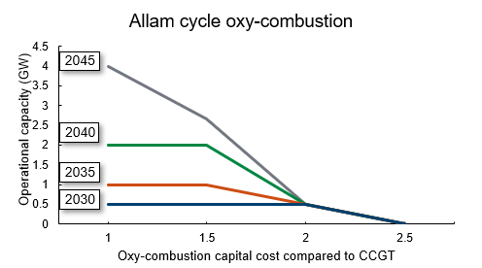

In this study, 100-h LDES was considered, with two round-trip efficiencies (60% and 80%) at a power cost equal to 1.8 times the corresponding cost for 4-h Li batteries. Figure 3.24 shows the operational capacities obtained in 2045 for the case without oxy-combustion (left) and with oxy-combustion (right). Without oxy-combustion, the selection of 100-h 60% efficiency LDES is limited. However, 80% efficiency LDES is adopted at a higher level, reducing the capacities of solar PV and 4-h Li batteries. When the oxy-combustion resource is offered at a cost equal to conventional CCGT (Figure 3.24, right), in all scenarios it is being built to the maximum operational capacity offered (4 GW in 2045). Moreover, solar PV and 4-h Li batteries capacities are further reduced, while LDES capacities remain practically unchanged.

These results show that the combination of LDES and closed-loop oxy-combustion allows for a reduction in the capacity expansion needed by 2045, as well as the total system cost.

Figure 3. 24: 2045 Operational Capacities Without & With (right) Oxy-combustion
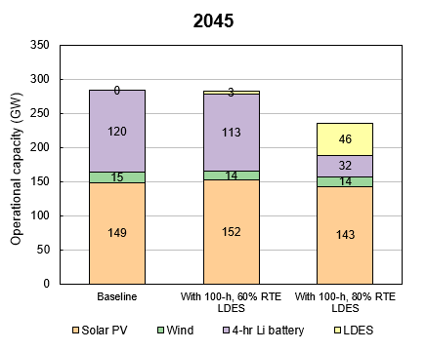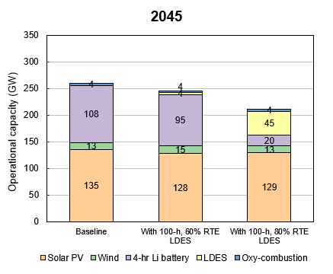

Figure 3.25 shows the selected operation of the Allam cycle resource for 2045 and the scenario with 100-h, 80%-efficient LDES. Oxy-combustion is providing power during winter months, while being mainly off during spring and summer months. The rest of the months oxy-combustion operates as a dispatchable resource, being on/off depending on the net load.

Figure 3. 25: 2045 Oxy-combustion Dispatched Power
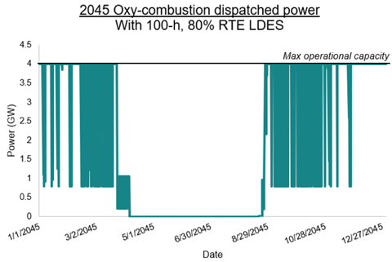

3.10 Impact of Electrolyzers on Selected Storage
Electrolyzers for hydrogen production were modeled as a flexible load, to help address demand-supply imbalances in the grid as the share of variable renewable energy increases.
The hydrogen produced was considered to be sold at a selected price, for an unspecified use.
For defining the hydrogen selling price, a production cost was calculated based on the best available resource for electricity generation in the grid, which was solar PV. In this calculation, an isolated solar PV + electrolyzer system was defined, where the production cost was defined by the total all-in cost of the solar and electrolyzer, divided by the total hydrogen production. The hydrogen production was set by the capacity factor of the electrolyzer, which, in the isolated system, is equal to the solar resource capacity factor, and by the electrolyzer electricity-to-hydrogen conversion (50 kWh/kg). For the best solar resource, in 2030, this production cost was $2/kg H₂.

For this study, multiple LDES were offered, at the same power cost but different efficiencies (Table 2.4).

The H₂ selling price selected for this study was 99% of the modeled production cost. In these conditions, an isolated solar PV-electrolyzer system would not be selected by the model. However, when the electrolyzers were offered to the grid, the model selected to build up to 17 GW in 2045, as shown in Figure 3.26:

Figure 3. 26: Operational Capacities, Without and With Electrolyzer
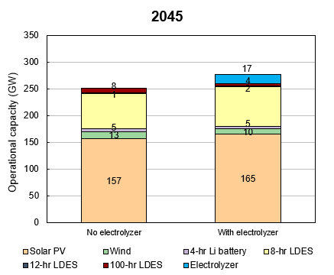

Figure 3.27 shows that electrolyzers effectively use excess solar generation that would otherwise be curtailed, resulting in a reduction in the total solar energy curtailment in 2045. Moreover, as seen in Figure 3.28 the capacity factor of the electrolyzers is around 40%, above the capacity factors of the solar resources, which are between 21 and 33%.

Figure 3. 27: Solar Energy Curtailment with Electrolyzer
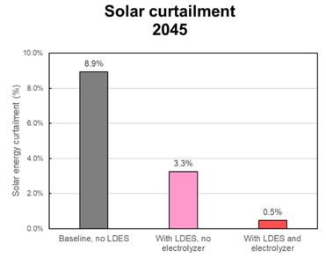

Figure 3. 28: 2045 Electrolyzer Capacity Factor
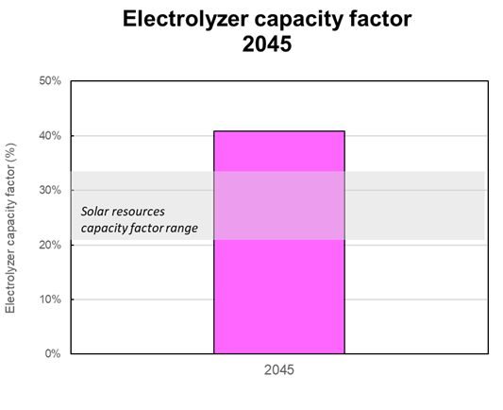

These electrolyzers effectively work as a flexible load as they are OFF during winter months and ON during summer and full sun days (Figure 3.29). In general, electrolyzer loads follow solar generation profiles. However, during some spring days they also operate at night (Figure 3.30). When evaluating the load together with the storage provided power (Figure 3.31), it can be seen when the energy stored exceeds the demand, it is used for hydrogen generation increasing the value of the installed storage.

Figure 3. 29: 2045 Solar Power Profile, with Electrolyzer Load
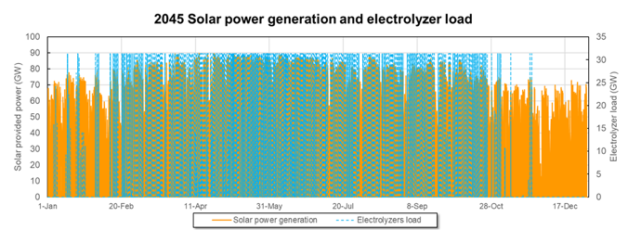

Figure 3. 30: 2045 Solar and Storage Power Profiles, with Electrolyzer Load
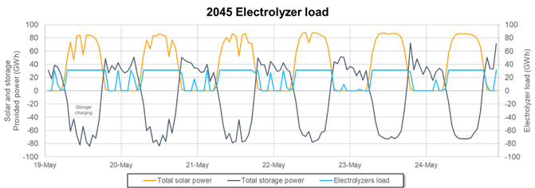

Figure 3. 31: 2045 Solar and Storage Power Profiles
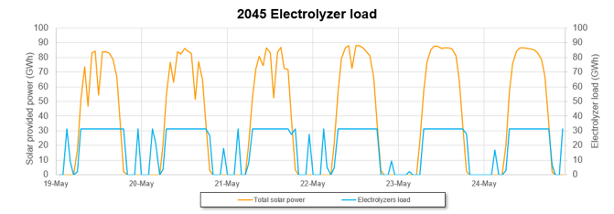

In the future, as the demand for green hydrogen grows, the addition of this large, flexible load will help to stabilize the grid, possibly reducing the need for storage, while making the installed storage more valuable.

3.11 Storage-Cost Impacts on WECC and California Transmission
This work investigates the least-cost grid expansion for the WECC and California in 2050 under zero carbon emissions considering declining storage costs and diminishing transmission capacity expansion, which could be the result of regulatory or political challenges (Table 3.2).

Lower storage costs and unrestricted transmission capacity expansion result in building up to 31% less WECC-wide transmission capacity and 19% less transmission capacity in California (Figures 3.32-3.33). However, the transmission system becomes more loaded as less transmission capacity is built in lieu of storage deployment (the loading is shown as arrows in Figure 3.34). This is because lower storage costs lead to more solar capacity and more storage energy and power capacity deployed throughout the WECC (Figure 3.33). That high solar and storage generation with the high utilization of the existing transmission capacity reduce the need for more transmission capacity.

However, high storage and solar installed capacities caused by low storage costs increase California’s electricity imports up to 14% of its demand, requiring up to 7.8 GW more transmission capacity between California and its neighbors. (Figure 3.32).

Table 3. 2: Scenarios Analyzed for 2050 WECC Grid Expansion
Scenario | Storage power capacity cost¹ ($/kW) | Storage energy capacity cost² ($/kWh) | Transmission  capacity cap³ | Inputs  Results | Solar capacity (GW) | Wind capacity (GW) | Storage energy capacity (GWh) | Duration (h)
1 | 325 | 275 | 100% |  | 151 | 15.9 | 469 | 7.5
2 | 325 | 275 | 75% |  | 153 | 15.9 | 469 | 7.6
3 | 325 | 275 | 50% |  | 160 | 16.6 | 490 | 7.5
4 | 325 | 275 | 25% |  | 171 | 16.8 | 515 | 7.5
5 | 325 | 275 | 10% |  | 184 | 17.4 | 544 | 7.3
6 | 325 | 275 | 5% |  | 184 | 17.4 | 547 | 7.2
7 | 140 | 170 | 100% |  | 156 | 15.1 | 487 | 7.3
8 | 140 | 170 | 75% |  | 160 | 15.3 | 508 | 7.4
9 | 140 | 170 | 50% |  | 169 | 15.6 | 522 | 7.2
10 | 140 | 170 | 25% |  | 182 | 16.6 | 559 | 7.2
11 | 140 | 170 | 10% |  | 189 | 16.7 | 571 | 6.8
12 | 140 | 170 | 5% |  | 189 | 16.7 | 567 | 6.8
13 | 10 | 10 | 100% |  | 159 | 7.4 | 612 | 7.9
14 | 10 | 10 | 75% |  | 165 | 8.2 | 666 | 8.2
15 | 10 | 10 | 50% |  | 173 | 8.5 | 722 | 8.2
16 | 10 | 10 | 25% |  | 190 | 9.8 | 848 | 9.0
17 | 10 | 10 | 10% |  | 205 | 10.1 | 1051 | 10.4
18 | 10 | 10 | 5% |  | 205 | 10.3 | 1157 | 11.3
¹Power-related costs ($/kW) of the candidate storage projects.
²Energy-related costs ($/kWh) of the candidate storage projects.
³Upper bound on total built transmission capacity in the WECC.

Figure 3. 32: Transmission Line Capacities Between the Modeled WECC Load Zones
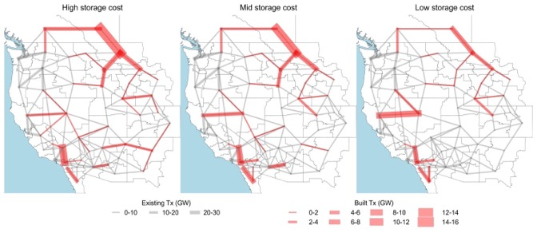
Figure 3. 33: Annual Electricity Generation by State and Transmission Capacities
Figure 3. 34: Annual Electricity Generation by State and Loading of Transmission
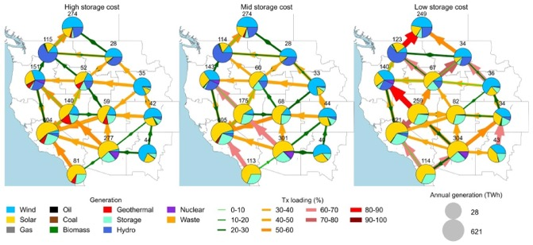

Declines in the cost of storage can lead to congestion in the transmission corridors, especially from Oregon to California and from California to Arizona. For instance, during California’s peak demand of 85 GW (July 25, 2050, 8:00 p.m.), lower storage costs result in higher loading levels of the transmission corridors to supply California’s demand. The affected corridors go from Nevada to California, from Oregon to California, and from Arizona to California (Figure 3.35). The loading levels during California’s highest imports ratio (April 4, 2050, 3:00 a.m.) in the transmission corridors from Nevada to California and from Oregon to California were observed to be 90-100%, regardless of the storage costs (Figure 3.36).

Figure 3. 35: Electricity Generation and Transmission Loading for 85-GW Demand
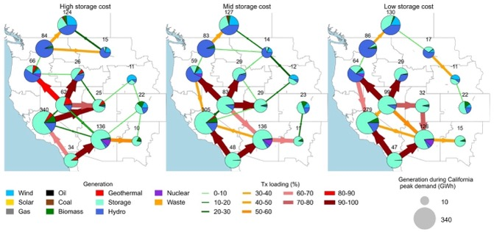

Figure 3. 36: Electricity Generation and Transmission Loading for High Imports
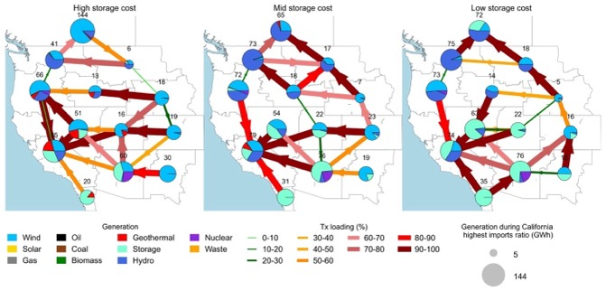

Investigating California’s situation amid the WECC grid expansion, lower storage costs lead California to increase its solar capacity up to 205 GW (15% increase) (Figure 3.37), its storage power capacity up to 104 MW (50% increase) (Figure 3.38), and its storage energy capacity up to 1157 GWh (150% increase) (Figure 3.39). Moreover, lower storage costs result in longer average storage duration in California, increasing from 6.8 h to 11.3 h (Figure 3.40). In contrast, lower storage costs lead to up to 60% slower deployment rates of wind capacity in California (Figure 3.41). This reveals that lower-cost wind would better compete with low-cost storage plus solar. In this manner, R&D efforts are required to advance cost reductions and flexible deployments of wind resources.

Figure 3. 37: Solar Capacity in California vs Transmission Build-out.
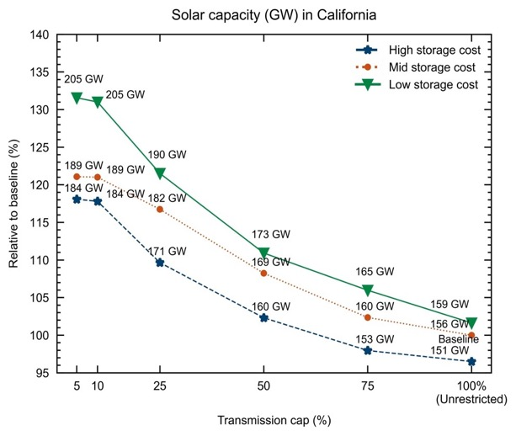

Figure 3. 38: Storage Power Capacity Deployed in California vs Transmission Build
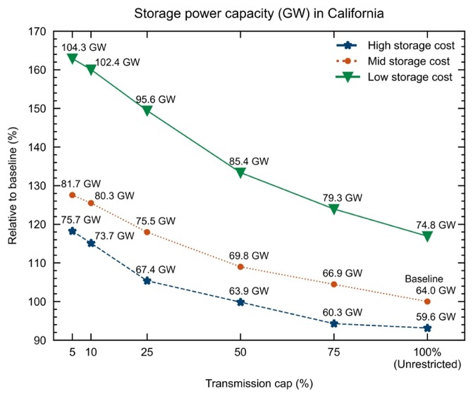

Figure 3. 39: Storage Energy Capacity Deployed in California vs Transmission Build
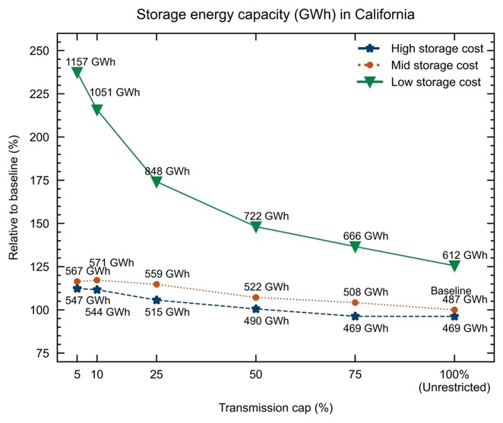

Figure 3. 40: Average Storage Duration in California vs Transmission Buildout
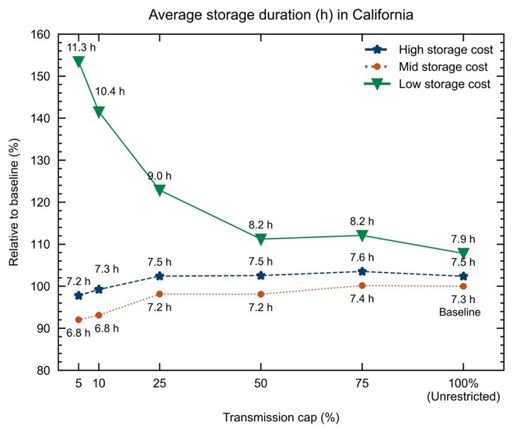

Figure 3. 41: Wind Capacity Deployed in California vs Transmission Buildout
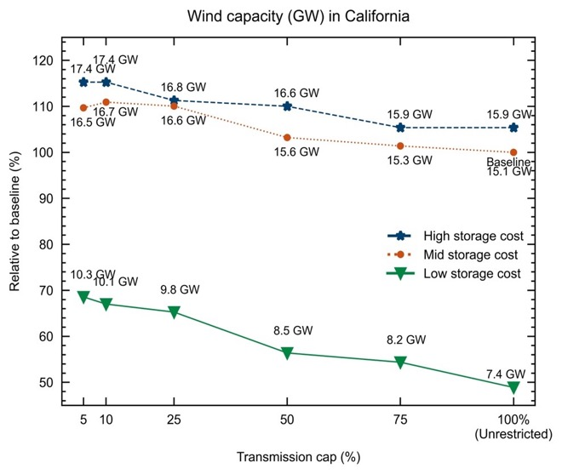

Furthermore, regardless of storage costs declining, when almost no transmission expansion is allowed across the WECC, California requires up to 34% more in-state generation capacity for 2050 (Figure 3.42). In fact, up to 30% more solar capacity (Figure 3.37), up to 50% more storage power capacity (Figure 3.38) and up to 20% more wind capacity (Figure 3.41) is deployed in California in response to restricting the expansion of transmission capacity across the WECC (Figure 3.41).

Figure 3. 42: Installed Generation Capacity in California for 2050
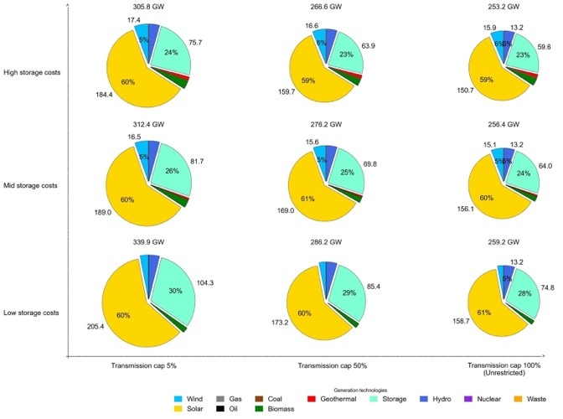

Finally, despite lower storage costs and reduced transmission capacity across the WECC, California will continue being a net importer in 2050 (Figure 3.43). However, in the scenario when the expansion of transmission is highly restricted (capacity cap of 5%) and storage costs are the lowest, California’s monthly generation exceeds its monthly demand in July, August, and September. Hence, in 2050 it becomes a summer net exporter – when the rest of the WECC would benefit the most (Figure 3.44).

Figure 3. 43: Fraction of Annual California Load met by California Generation
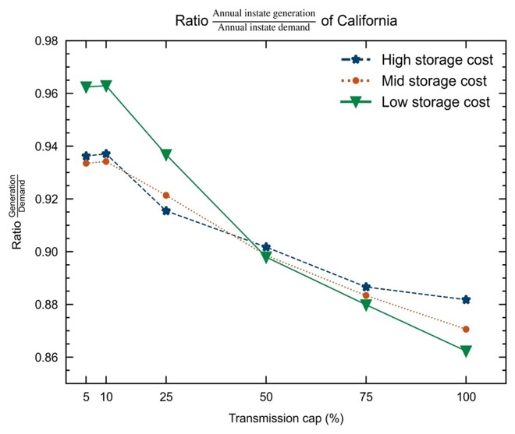

Figure 3. 44: Fraction of Monthly California Load met by California Generation
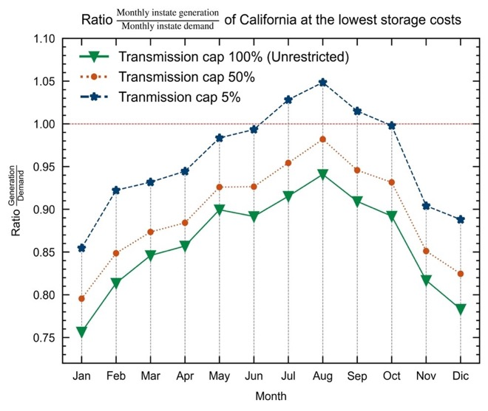

In conclusion:

- As storage costs decline, the WECC deploys more solar capacity and more storage energy capacity.

- Storage cost declines result in:
- building less transmission in the WECC,
- higher loading for existing transmission lines,
- building less transmission within California, and
- building more transmission between California and its neighbors.

- When transmission buildout is constrained to 5% of that selected for the baseline and storage costs are the lowest that was modeled, California’s storage duration increases up to 11.3 h (compared to 7 h in the baseline).

3.12 Impact of Increasing LDES Deployment in the WECC

Looking to the day when LDES may be deployed broadly, analyzing the marginal electricity price reduction as a function of the LDES deployment helps to quantify the amount of LDES that can be expected in future years. An increase in energy storage could be achieved through policy, such as the implementation of LDES mandates, or R&D resulting in LDES cost decrease, etc. The baseline containing 1.94 TWh of energy storage (no storage energy capacity forced) was modified to study 13 scenarios where the amount of energy storage is forced to be anywhere from 2 to 64 TWh. As the deployment of LDES increases, electricity prices change. Based on a study of 13 scenarios in which the energy storage was forced to be between 2 and 64 TWh, Figure 3.45a shows how the adoption of LDES reduces variability in electricity prices, especially for the first 20 TWh of installed LDES. Larger deployment of LDES results in higher investment costs that are not reflected in the electricity prices plotted in Figure 3.45.

In a zero-emissions 2050, marginal electricity prices are highest at night and the deployment of energy storage reduces marginal prices for all times of day (Figure 3.45c). The average marginal price of electricity is 29% to 52% higher at night (8 pm, midnight, and 4 am) than at noon since cheap solar generation is not available during the night. In the baseline scenario, July and December marginal electricity prices are highest at 180 $/MWh and 310 $/MWh, respectively, due to high demand during these months (Figure 3.45d). As energy storage is added to the grid, the high July and December prices are reduced but prices in neighbouring months increase. In the 20-TWh scenario, average marginal prices for July, August, November, December, and January range from 52 to 100 $/MWh while other months average 35 $/MWh or less.

Figure 3. 45: Impact of LDES Mandates on the Marginal Price of Electricity

In summary, this work shows that a 2050 decarbonized grid with greater storage energy capacity would reduce daily and seasonal variability in the marginal price of electricity while also reducing the marginal price of electricity across all regions and times of the day. As such, policies, subsidies, mandates, technology development or other events that would increase the penetration of storage resources in the WECC would likely result in lower prices in the wholesale electricity market while reducing price surges in July, December, and night-time hours.

3.13 Critical Factors Determining Sensitivity of Results
This project has quantified the optimal capacity expansion and hourly dispatch for many sets of input parameters, finding that some results are very clear, and some results are highly uncertain. Just as a two-pan scale may shift from finding one side is heavier than the other when a small weight is transferred, the selection of the model of one set of solutions can change to a very different set if input values are shifted by an amount that is small if the two components have almost equal value. Often this difference is small compared with our knowledge of that value.

The study is limited by uncertainties in the technologies that will be available tomorrow in terms of:
• Cost
• Potential (In many cases the model chose to implement the resource to the limit offered. Appendix C summarizes the fraction of the offered potentials selected for the baseline scenario. In particular, wind and geothermal are often limited by the cap that has been applied.)
• Performance (e.g. efficiency)

Additionally, the requirements for tomorrow’s grid may vary substantially depending on the rate of electrification and population growth.

As shown in the studies of the WECC, transmission is a critical element in defining a robust grid. Timelines for investment in transmission are often very long and modeling the cost and timelines of specific transmission expansion projects was outside of this project’s scope. Also, this project did not attempt to consider the importance of distribution as local generation and demand may not be adequately balanced.

The study assumed that emissions would meet the SB100 goals as modeled to reach 38 MMT by 2030. Requiring zero emissions by 2045 results in substantially more solar and storage being selected, but the largest relative increase in the 100-h LDES in the example shown in Figure 3.46.

Figure 3. 46: Capacity Expansion for Two Emissions Scenarios
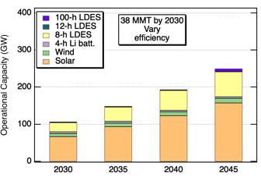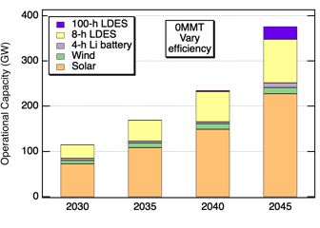
Despite the many uncertainties in the analysis, there are clear conclusions that fall outside of the uncertainty limits as described in the Conclusion.

CHAPTER 4:
Conclusion
As California transitions to a renewable energy driven grid with zero carbon emissions for retail electricity by 2045, energy storage will be critical. Today’s lithium batteries (about 7 GW) are providing very useful service to the grid, but the 4-h duration will not be adequate for getting through each night as the state transitions away from natural gas. This project found that an 8-h battery is well suited for supporting California as solar electricity becomes dominant. The 8-h batteries will be charged while the sun is up, discharge quickly during peak demand in the early evening, and then discharge more slowly for the lower demand experienced during the night.

Approximately 70 GW of 8-h storage will be beneficial and may be cycled more than 300 times per year. The optimal duration for the most common type of storage may be as low as 7 hours when the entire WECC is considered or may increase to 10 to 12 hours when more wind generators are built or if the added cost of longer duration is quite small. However, it will be beneficial having storage that is of short duration to play a role that is more like the role of peaker plants today alongside of the 8-h storage used most nights. Additionally, the models found that a small amount of 100-h storage may be beneficial. For the scenarios modeled, the 100-h storage typically displaced a few percent of the 8-h storage, especially in 2045.

The relative cost that enabled an LDES product to displace 50% of 4-h Li batteries decreased into the future, suggesting that, while 8 hours of storage is still needed to get through the night, reduced use of peaker plants to meet zero emissions targets may require an increased part of the storage fleet to function like peaker plants in 2045, increasing the attractiveness of 4-h storage. The opposite dependence on years into the future was found when considering displacement of 1% of Li batteries, demonstrating that the value of 8-h or 100-h LDES relative to 4-h storage will increase in the future, but at approximately 1-GW scale rather than at tens of GW scale.

While high efficiency increases the value of LDES that is cycled daily, the LDES that is adopted at the 1% level is cycled less frequently, reducing the importance of efficiency.

All modeled scenarios found that California will continue to be a net importer of electricity, though California will export electricity during the day when solar electricity is abundant. If additional transmission is built, the electricity generated in California may decrease even more with California net importing more than 10% of its electricity on an annual basis.

For decreasing storage costs, the model chose to build fewer transmission lines, though some lines connecting California to its neighbors were selected for build to larger capacity when storage costs were decreased. Wider deployment of storage was found to both decrease the price of electricity and decrease the variability of the price of electricity.

Today’s flexible loads are too small to be very helpful in balancing supply and demand of electricity, but tomorrow will bring two very large flexible loads: electric vehicle charging and electrolyzers for hydrogen generation. The use of daytime charging of electric vehicles was found to reduce the selected storage by about 10%, saving on order of $1 billion. Electrolyzers were found to contribute to seasonal load balancing by turning off during the winter. Surprisingly, the electrolyzers were found to operate at a capacity factor of 40%, exceeding the capacity factor of the solar plants that provided power for them, suggesting that batteries supply the electrolyzers with electricity at some hours. Thus, the availability of under-used assets (curtailed electricity combined with ample storage) may be enabling for green hydrogen.

The use of solar and wind generation profiles (by changing the solar mounting configuration and selecting wind locations with stronger winter-time wind) that had better seasonal match to the load profiles reduced curtailment, but the reduction in curtailment must be balanced with the higher cost for solar electricity for non-optimal solar mounting.

The use of oxy-combustion could help to reduce the need for storage, but questions remain about the rate of scale up of both the oxy-combustion generators and the infrastructure for sequestration of the generated carbon dioxide.

More complete summary of the results of this study may be found online.

Glossary and List of Acronyms
Term | Definition
CAISO | California independent system operator
CCGT | Combined cycle gas turbine
CEC | California Energy Commission
CPUC IRP PSP | California Public Utility Commission Integrated resource planning, Preferred system plan
E3 | Energy and Environmental Economics
EV | Electric vehicle
IEPR | Integrated Energy Policy Report
IRP | Integrated resource planning
LDES | Long duration energy storage
R&D | Research and development
RESOLVE | Software package for capacity expansion modeling
SWITCH | Software package for capacity expansion modeling
UC | University of California
WECC | Western Electricity Coordinating Council

References
Allam R. et al., Energy Procedia, 2017.

Gerke, Brian, et al. "The California demand response potential study, phase 3: final report on the shift resource through 2030." (2020). DOI: 10.20357/B7MS40

Kittner, N., S. Castellanos, P. Hidalgo-Gonzalez, D. Kammen, & S. Kurtz, (2021). “Cross-sector storage and modeling needed for deep decarbonization.” Joule, 5(10), 2529-2534.

Lindogan, P., Shan, R., Kittner, N. Projecting PEM Electrolyzer Costs Under Different Deployment Scenarios. In prep for International Journal of Hydrogen Energy.

Mahmud, Z. S. Kurtz, “Effect of Solar Mounting Configuration on California Zero-Carbon Grid” Photovoltaic Specialists’ Conference, 2023.

Mahmud, Z., Kenji Shiraishi, Mahmoud Y. Abido, Pedro Andres Sanchez-Perez, and Sarah R Kurtz, “Hierarchical approach to evaluating storage requirements for renewable-energy-driven grids" iScience, Vol. 26(1), 105900, Jan. 2023. Open access

Mahmud, Z., K. Shiraishi, M. Abido, D. Millstein, P. Sanchez, and S. Kurtz, “Geographical variability of summer- and winter-dominant onshore wind" Journal of Renewable and Sustainable Energy, Volume 14, 023303, 2022. Open access

Shan, R., J. Reagan, S. Castellanos, S. Kurtz, and N. Kittner. "Evaluating emerging long-duration energy storage technologies" Renewable and Sustainable Energy Reviews,
Volume 159, 2022. Article

Staadecker, Martin, Julia Szinai, Pedro A. Sánchez-Pérez, Sarah Kurtz and Patricia Hidalgo-Gonzalez. The Value of Long-Duration Energy Storage under Various Grid Conditions in a Zero-Emissions Future, 16 October 2023, PREPRINT (Version 1) available at Research Square [https://doi.org/10.21203/rs.3.rs-3422677/v1]

ZareAfifi, F., and S. Kurtz, (2023, October). “Powering the future: electric vehicle charging profile impact on California’s future energy storage needs.” North American Power Symposium (NAPS-2023)

ZareAfifi, Farzan, Zabir Mahmud and Sarah Kurtz, “Diurnal, physics-based strategy for computationally efficient capacity-expansion optimizations for solar-dominated grids", Energy, Vol. 279, 128206, 2023. On line

Project Deliverables
Project deliverables are available upon request by submitting an email to pubs@energy.ca.gov. Some of them can be found at: https://sites.ucmerced.edu/ldstorage/downloadable-reports.
The project deliverables include:
- Baseline Description
- Modeling Approach Description
- Summary of Baseline Model Results
- Electricity Generation Technology Summary
- Storage Technology Summary
- Grid Scenario Summary
- Final Analysis Summary

APPENDIX A: Acknowledgment of Contributors
Supplementary information
The following people are acknowledged for the time they took to provide information for this study. This list is intended as an acknowledgment and to document the scope of the effort; it is not an exhaustive list. Some individuals have now moved to other companies. TAC members are included here if they participated in meetings outside of formal TAC meetings.
Company | Individual
Malta, Inc | Bao Truong, Mert Geveci
Harvard University | Roy Gordon
NREL | Zhiwen Ma, Caroline Draxl
Antora Energy | David Bierman, Jordan Kearns
Energy Vault | Marco Terruzzin, Brendan Shaffer
Strategen | Erin Childs, Sergio Duenas, Maria Roumpani, Devin Gaby, Nina Hebel, Dhruv Bhatnagar
E3 | Roderick Go
GridLab | Priya Sreedharan
CEC | Robin Goodhand
Rondo Energy | John O’Donnell
Quidnet | Joe Zhou, Richard Brody, Chad Dixon
HighView | Bonnie Lamond, Jamie Hussman, Richard Riley
Cat Creek | Peggy Beltrone, others
Renewell | Kemp Gregory
Long Duration Energy Storage Association of California | Julia Prochnik
Lawrence Berkeley National Lab | Curtis Moldenburg, Dev Millstein, Brian Gerke, Alexandre Moreira da Silva, Patricia de Sousa Oliveira Silva
TURN | Jennifer Dowdell
Zinc8 Energy | Roberto Orendain, Mark Baggio
Solar Turbines | David Voss
Gridworks | Arthur Haubenstock
H2B2 | Jim Corboy
EDF | Sonika Choudhary, Thomas Bladier, Neha Nandakumar
Heliogen | Paul Gauche
GE Renewables | Debbie Mursch
California Council on Science and Technology | Teresa Feo, Geoff Hollett
Dissigno | David Williams
SGRE COG IS EST TE SI | Daniel Huck
Plus Energy Storage | Polly Shaw
Sinton Instruments | Ron Sinton
Hydrostor | Tri Luu
Reascend | Conrad Eustis
EDF | Jane Long
GKN | Clark Crawford
Lawrence Livermore National Lab | Roger Aines, Simon Pang, Jean-Paul Watson
Invinity | Bruce Herzer, Colin Boone, Matt Harper, Johnson Chiang
Blue Marble | Ana Mileva
CESA | Sergio Duenas
University of California Irvine | Jeff Reed
Bakersfield College | Liz Rozell
Consultant | Alan Lamont
Augwind | Greg Rosen, Eshhar Chetsrony
Form Energy | Sophie Meyer, Annie Baldwin, Natalie Bodington, Justin Adamson, Rachel Orsini
Kainos Consulting | Bret Adams
Southern California Gas | Sean Soni, Priscilla Hamilton, Kevin Barker, Paul Lin, Jason Egan, Hilary Petrizzo, Hugo Mejia, Vijay
CAISO | Shucheng Liu, Peter Klauer
UC Davis | Lewis Fulton
Indian Energy | Michael Firenze
StorEdgeAI | Ranjan Gupta
PolyJoule | Andrew Hartshorn
Darcy Partners | Lindsay Motlow, Mora
WECC | Stan Holland
SMUD | Joshua Rasin, Dave Tamayo
LDES Council | Julia Souder
SPRI Group, Basque | Cristina Oyon
Gravity Power | Jim Fiske
Longitude 122 West | Susan Schoenung
Sandia | Daniel Borneo, Qing Tian
Alliance | John Flory
SDGE | Victor Cervates
Baker Botts | Dino Barajas
Bloomenergy | Kendal Asuncion
International Longshore and Warehouse Union | Sal Dicostanzo
Department of Water & Power, LA | Aaron Guthrey
Leighty Foundation | Bill Leighty
8 Rivers | Adam Goff, Jennifer Diggins
Electric Hydrogen | Alex Panchula, Soufien Taamallah
JAS Energies | Julia Prochnik
Sierra Club | Theresa Cheng, Katherine Ramsey
LUT University | Christian Breyer
SB Energy | Michael Bolen
Solar Power Consulting | Terry Peterson
ENGIE North America | Roma Notani
Retired from Southern California Edison | Bob Ferguson
Guidehouse | Warren Wang
RedFlow | Paul Kelleher
NREL | Omar Guerra
Sean Anayah | Hybrid EV
UC Davis | Lukas Wernert

APPENDIX B: Summary of Input Assumptions
Supplementary information

To be added by Jan. 31

APPENDIX C: Build Fractions
Supplementary information
To be added by Jan. 31

Gerke, Brian, et al. "The California demand response potential study, phase 3: final report on the shift resource through 2030." (2020). DOI: 10.20357/B7MS40
https://sites.ucmerced.edu/ldstorage/publications%20version%202
Mahmud, Z., K. Shiraishi, M. Abido, D. Millstein, P. Sanchez, and S. Kurtz, “Geographical variability of summer- and winter-dominant onshore wind" Journal of Renewable and Sustainable Energy, Volume 14, 023303, 2022. Open access
https://www.energy.ca.gov/data-reports/reports/integrated-energy-policy-report
https://efiling.energy.ca.gov/Lists/DocketLog.aspx?docketnumber=20-MISC-01
Shan, R., J. Reagan, S. Castellanos, S. Kurtz, and N. Kittner. "Evaluating emerging long-duration energy storage technologies" Renewable and Sustainable Energy Reviews, Volume 159, 2022. Article
Shan, R., J. Reagan, S. Castellanos, S. Kurtz, & N. Kittner. (2022). “Evaluating emerging long-duration energy storage technologies.” Renewable and Sustainable Energy Reviews, 159, 112240.
https://sites.ucmerced.edu/files/ldstorage/files/epc-19-060-storage_technology_summary_task_3.1.pdf and https://sites.ucmerced.edu/files/ldstorage/files/epc-19-060_storage_scenarios_summary_task_3.2.pdf
Kittner, N., S. Castellanos, P. Hidalgo-Gonzalez, D. Kammen, & S. Kurtz, (2021). “Cross-sector storage and modeling needed for deep decarbonization.” Joule, 5(10), 2529-2534.
https://www.smart-energy.com/storage/first-grid-scale-gravity-energy-storage-system-commissioned-to-chinese-grid/. 650 million RMB total investment for a 100MWh project (~880 USD/kWh) while in the previous table, it was $200-300 USD/kWh
Lindogan, P., Shan, R., Kittner, N. Projecting PEM Electrolyzer Costs Under Different Deployment Scenarios. In prep for International Journal of Hydrogen Energy.
https://www.cpuc.ca.gov/-/media/cpuc-website/divisions/energy-division/documents/integrated-resource-plan-and-long-term-procurement-plan-irp-ltpp/2023-irp-cycle-events-and-materials/draft_2023_i_and_a.pdf See Fig. 9 on p. 81.
https://about.bnef.com/blog/lithium-ion-battery-pack-prices-hit-record-low-of-139-kwh/
https://files.cpuc.ca.gov/energy/modeling/2021%20PSP%20RESOLVE%20Package.zip
ZareAfifi, Farzan, Zabir Mahmud and Sarah Kurtz, “Diurnal, physics-based strategy for computationally efficient capacity-expansion optimizations for solar-dominated grids", Energy, Vol. 279, 128206, 2023. On line
https://github.com/REAM-lab/switch
For 2045, assuming LDES with 85% efficiency and cost of $66/(kW-y) which translates to about $950/kW.
https://sites.ucmerced.edu/files/ldstorage/files/epc-19-060_storage_scenarios_summary_task_3.2.pdf
https://www.energy.ca.gov/programs-and-topics/programs/electric-vehicle-charging-infrastructure-assessment-ab-2127
In the CEC study, this case is called the “High Residential Access” alternative future.
In the CEC study, this case is called the “Happy Hour” alternative future.
ZareAfifi, F., and S. Kurtz, (2023, October). “Powering the future: electric vehicle charging profile impact on California’s future energy storage needs.” North American Power Symposium (NAPS-2023).
Mahmud, Z. S. Kurtz, “Effect of Solar Mounting Configuration on California Zero-Carbon Grid” Photovoltaic Specialists’ Conference, 2023.
Z. Mahmud, K. Shiraishi, M. Abido, D. Millstein, P. Sanchez, and S. Kurtz, “Geographical variability of summer- and winter-dominant onshore wind"Journal of Renewable and Sustainable Energy, Volume 14, 023303, 2022. Open access
Mahmud, Z., S. Kurtz, in preparation.
Zabir Mahmud, Kenji Shiraishi, Mahmoud Y. Abido, Pedro Andres Sanchez-Perez, and Sarah R Kurtz, “Hierarchical approach to evaluating storage requirements for renewable-energy-driven grids" iScience, Vol. 26(1), 105900, Jan. 2023. Open access
Allam R. et al., Energy Procedia, 2017.
Martin Staadecker, Julia Szinai, Pedro A. Sánchez-Pérez, Sarah Kurtz and Patricia Hidalgo-Gonzalez. The Value of Long-Duration Energy Storage under Various Grid Conditions in a Zero-Emissions Future, 16 October 2023, PREPRINT (Version 1) available at Research Square [https://doi.org/10.21203/rs.3.rs-3422677/v1]
Here, the market share is described based on the power ratings rather than the energy ratings. Note that a 100-h LDES asset that captures 1% of the market share calculated according to the power ratings would be 50% of the market share when calculated according to the energy ratings.
https://sites.ucmerced.edu/ldstorage/publications%20version%202

