FINAL PROJECT REPORT
Evaluating the Value of Long Duration Energy Storage in California

Month 2023 | CEC-500-XXXX-XXX

PREPARED BY:

Primary Author(s):
Sarah Kurtz, University of California Merced
Patricia Hidalgo-Gonzalez, University of California San Diego
Noah Kittner, University of North Carolina, Chapel Hill
Mariela Colombo, University of California Merced
Farzan ZareAfifi, University of California Merced
Zabir Mahmud, University of California Merced
Mahmoud Abido, University of California Merced
Paul Serna-Torre, University of California San Diego
Martin Staadecker, University of California San Diego

California Energy Commission Project Manager:
Jeffrey Sunquist

Agreement Number: EPC-19-060
Jonah Steinbuck, Ph.D.
Director
ENERGY RESEARCH AND DEVELOPMENT DIVISION

Drew Bohan
Executive Director
DISCLAIMER
This report was prepared as the result of work sponsored by the California Energy Commission. It does not necessarily represent the views of the Energy Commission, its employees or the State of California. The Energy Commission, the State of California, its employees, contractors, and subcontractors make no warranty, express or implied, and assume no legal liability for the information in this report; nor does any party represent that the uses of this information will not infringe upon privately owned rights. This report has not been approved or disapproved by the California Energy Commission nor has the California Energy Commission passed upon the accuracy or adequacy of the information in this report.

Acknowledgements
Special thanks to Roderick Go, of Energy and Environmental Economics, Inc., for support with RESOLVE, especially while it was being modified. Additionally, special thanks to the Technical Advisory Committee:
- Priya Sreedharan, Gridlab
- Erin Childs, Strategen
- Jennifer Dowdell, TURN
- Shucheng Liu, CAISO
- Ron Sinton, Sinton Instruments
- Julia Prochnik, LDES Council
- Paul Denholm, NREL
- David Williams, Dissigno
- Keith Parks, Xcel Energy
- Jeffrey Reed, UC Irvine

PREFACE
The California Energy Commission’s (CEC) Energy Research and Development Division supports energy research and development programs to spur innovation in energy efficiency, renewable energy and advanced clean generation, energy-related environmental protection, energy transmission, and distribution and transportation.

In 2012, the Electric Program Investment Charge (EPIC) was established by the California Public Utilities Commission to fund public investments in research to create and advance new energy solutions, foster regional innovation, and bring ideas from the lab to the marketplace. The CEC and the state’s three largest investor-owned utilities—Pacific Gas and Electric Company, San Diego Gas and Electric Company, and Southern California Edison Company—were selected to administer the EPIC funds and advance novel technologies, tools, and strategies that provide benefits to their electric ratepayers.

The CEC is committed to ensuring public participation in its research and development programs that promote greater reliability, lower costs, and increase safety for the California electric ratepayer and include:

- Providing societal benefits.
- Reducing greenhouse gas emission in the electricity sector at the lowest possible cost.
- Supporting California’s loading order to meet energy needs first with energy efficiency and demand response, next with renewable energy (distributed generation and utility scale), and finally with clean, conventional electricity supply.
- Supporting low-emission vehicles and transportation.
- Providing economic development.
- Using ratepayer funds efficiently.

For more information about the Energy Research and Development Division, please visit the CEC’s research website (www.energy.ca.gov/research/) or contact the CEC at ERDD@energy.ca.gov.

ABSTRACT
As California transitions its energy system, energy storage will play a critical role. This project explored the duration, cost, and other attributes needed for the energy storage system. Long-duration storage will play especially important roles during the night and during cloudy days, especially during the winter. However, the need for storage also depends on the choice of the generation technologies, availability of transmission, the ability to shift load, and many other details of the grid. This study explores a wide range of scenarios to elucidate the value of long-duration energy storage in meeting California’s zero-emissions for retail sales target in 2045.
Keywords: Long-duration energy storage, Plain language, acronyms, formatting, usage, accessibility

Please use the following citation for this report:
Garfield-Jones, Susanne, Lana McAllister, and Carol E. Robinson. 2020. Style Manual: Fourth Edition. California Energy Commission. Publication Number: CEC-180-2020-XXX.

Table of Contents
Executive Summary 1
Background 1
Project Purpose and Approach 1
Key Results 1
Knowledge Transfer and Next Steps 10
CHAPTER 1: Introduction 11
CHAPTER 2: Project Approach 13
2.1. Project Timeline and Approach 13
2.2 Project Partners and Advisors 13
2.3 LDES Technology Background 14
2.4 Research Objectives 15
2.5 Core Scenario Description 15
2.6 California and the Western Interconnect Grid Modeling 15
RESOLVE (UC Merced) 15
SWITCH-WECC (UC San Diego) 17
2.7 Sensitivity Analysis 17
2.8 Long-Duration Energy Storage Technology Summary 17
CHAPTER 3: Results 20
3.1 Core Scenario 20
3.2 Core Scenario - Optimal Duration 20
3.3 Core Scenario - Competitive Cost 21
3.4 Core scenario – Adding Multiple Types of LDES Simultaneously 24
3.5 Core Scenario - Optimal Efficiency and Duration 25
3.6 Pumped Hydropower Storage 25
3.7 Impact of EV Charging Profiles on Selected Storage 26
3.8 Impact of Solar and Wind Generation Profiles on Storage 29
3.9. Impact of Oxy-combustion on the Selected Storage 35
3.10 Impact of Electrolyzers on Selected Storage 38
3.11 Storage-Cost Impacts on WECC and California Transmission 41
3.12 Impact of Increasing LDES Deployment in the WECC⁴ 54
CHAPTER 4: Conclusion 56
References 2
Project Deliverables 1

List of Figures
Figure Exec. 1: Power and Energy Capacity Selected for RESOLVE Baseline Scenario 1
Figure Exec. 2: Average Storage Duration in California vs Transmission Buildout 2
Figure Exec. 3: Capacity Expansion Selected for Example Scenarios 3
Figure Exec. 4: Selection of 4-h Li Batteries vs LDES 3
Figure Exec. 5: Cost Target for LDES vs Efficiency for 3 Penetration Levels 4
Figure Exec. 6: Cost Targets for LDES as a Function of Modeled Year 4
Figure Exec. 7: Fraction of Annual California Load met by California Generation 5
Figure Exec. 8: Annual Electricity Generation by State and Transmission Capacities 6
Figure Exec. 9: Impact of LDES Mandates on the Marginal Price of Electricity 7
Figure Exec. 10: Selected Operational Capacities for Three EV Charging Profiles 8
Figure Exec. 11: 2045 Electrolyzer Capacity Factor 9
Figure Exec. 12: Annual Solar Curtailment for 3 Solar Configurations 9

Figure 2. 1: Revised 4-h Li Capital Cost from 2022-2023 IRP 14

Figure 3. 1: Capacity Expansion Selected for RESOLVE Core Scenario Without LDES 20
Figure 3. 2: Power and Energy Capacity Selected for RESOLVE Baseline Scenario 21
Figure 3. 3: Selection of 4-h Li Batteries vs LDES 22
Figure 3. 4: Cost Target for 50% Market Share as a Function of LDES Duration 22
Figure 3. 5: Cost Target for LDES vs Efficiency for 3 Penetration Levels 23
Figure 3. 6: Cost Targets for LDES as a Function of Efficiency 23
Figure 3. 7: Cost Targets for LDES as a Function of Modeled Year 24
Figure 3. 8: Capacity Expansion Selected for Table 2.3 Scenarios 25
Figure 3. 9: Selected Operational Power Capacities, as a Function of LDES Efficiency 25
Figure 3. 10: Capacity Expansion for Baseline (left) and High Pumped Hydro 26
Figure 3. 11: Light-duty Electric Vehicles Load (GW) Profiles 27
Figure 3. 12: Selected Operational Capacities for Three EV Charging Profiles 28
Figure 3. 13: Storage Capital Costs for the Cases in Figure 3.12 28
Figure 3. 14: Daily and Monthly Solar Generation Profiles for 3 Solar Configurations 29
Figure 3. 15: Annual Solar Curtailment for Three Solar Configurations 30
Figure 3. 16: Cost Targets for LDES as a Function of Duration 31
Figure 3. 17: LDES Cost Target as Function of LDES Efficiency for 3 Configurations 31
Figure 3. 18: Selected Capacity Expansion for 3 Solar Mounting Configurations 32
Figure 3. 19: Monthly Wind Generation Profiles 33
Figure 3. 20: Annual Solar Curtailment Comparing Wind Profiles 34
Figure 3. 21: New-Build Capacities for Added Wind Scenarios 35
Figure 3. 22: LDES Power Capacity Selected vs LDES Duration for Wind Scenarios 35
Figure 3. 23: Operational Capacity of Oxy-combustion as Function of Capital Cost 36
Figure 3. 24: 2045 Operational Capacities Without & With (right) Oxy-combustion 37
Figure 3. 25: 2045 Oxy-combustion Dispatched Power 38
Figure 3. 26: Operational Capacities, Without and With Electrolyzer. 39
Figure 3. 27: Solar Energy Curtailment with Electrolyzer 39
Figure 3. 28: 2045 Electrolyzer Capacity Factor 40
Figure 3. 29: 2045 Solar Power Profile, with Electrolyzer Load 40
Figure 3. 30: 2045 Solar and Storage Power Profiles, with Electrolyzer Load 41
Figure 3. 31: 2045 Solar and Storage Power Profiles 41
Figure 3. 32: Transmission Line Capacities Between the Modeled WECC Load Zones 43
Figure 3. 33: Annual Electricity Generation by State and Transmission Capacities 43
Figure 3. 34: Annual Electricity Generation by State and Loading of Transmission 44
Figure 3. 35: Electricity Generation and Transmission Loading for 85-GW Demand 45
Figure 3. 36: Electricity Generation and Transmission Loading for High Imports 45
Figure 3. 37: Solar Capacity in California vs Transmission Build-out. 46
Figure 3. 38: Storage Power Capacity Deployed in California vs Transmission Build 47
Figure 3. 39: Storage Energy Capacity Deployed in California vs Transmission Build 48
Figure 3. 40: Average Storage Duration in California vs Transmission Build out 49
Figure 3. 41: Wind Capacity Deployed in California vs Transmission Build out 50
Figure 3. 42: Installed Generation Capacity in California for 2050 51
Figure 3. 43: Fraction of Annual California Load met by California Generation 52
Figure 3. 44: Fraction of Monthly California Load met by California Generation 53
Figure 3. 45: Impact of LDES Mandates on the Marginal Price of Electricity 55

List of Tables
Table 2. 1: Project Timeline and Primary Tasks 13
Table 2. 2: LDES Assumptions for Adoption of a Single LDES Type 16
Table 2. 3: Scenarios Offering 4 types of LDES Simultaneously 16
Table 2. 4: Long-Duration Energy Storage Summary 18

Table 3. 1: Model Inputs for Operational Capacity for Oxy-combustion 36
Table 3. 2: Scenarios Analyzed for 2050 WECC Grid Expansion 42

Executive Summary

Background
Senate Bill 100 sets the goal of zero-carbon retail sales of electricity by 2045. Long-duration energy storage (LDES) can help to reach that goal by storing electricity for use after the sun sets and for other times when solar and wind are inadequate. The California Energy Commission is funding development of LDES; this study was designed to inform the development effort.

Project Purpose and Approach
The project’s goal is to understand the role and cost targets of LDES to reach zero-carbon and related goals by 2045. This understanding is explored for multiple scenarios to understand how actions by the state may affect the need, benefit, and desired attributes of LDES.

Key Results
As California transitions to a renewable energy driven grid with zero carbon emissions for retail electricity by 2045, energy storage will be critical. Today’s 4-h lithium batteries (about 7 GW) are providing very useful service to the grid, but the 4-h duration will not be adequate for getting through each night as the state transitions away from natural gas. This project found that an 8-h battery (Figure Exec.1) minimizes the need to overbuild the power capacity of the storage (left axis) simultaneously with minimizing the energy capacity (right axis). The 8-h LDES is well suited for California in 2045 because solar electricity is likely to dominate the renewable energy build out. The 8-h LDES will be charged while the sun is up, discharge quickly during peak demand in the early evening, and then discharge more slowly for the lower demand experienced during the night.

Figure Exec. 1: Power and Energy Capacity Selected for RESOLVE Baseline Scenario
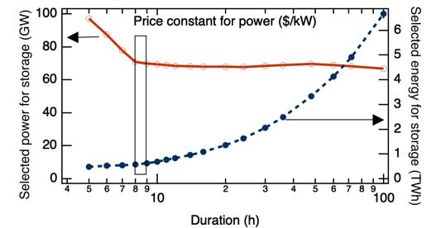

Approximately 70 GW of 8-h storage will be beneficial and may be cycled more than 300 times per year. The optimal duration for the most common type of storage may be as low as 7 hours when the entire WECC is considered or may increase to 10 to 12 hours when more wind generators are built or if the added cost of longer duration is quite small (Figure Exec.2).

Figure Exec. 2: Average Storage Duration in California vs Transmission Buildout
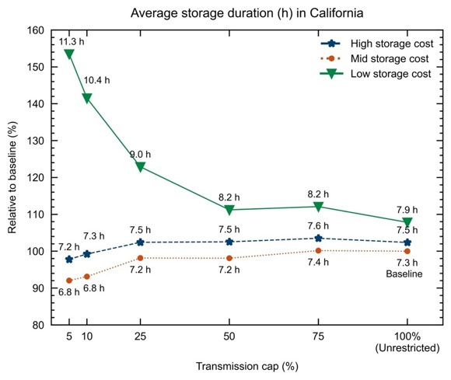

In addition to the 8-h storage, the models found that a small amount of 100-h storage may be beneficial. For the scenarios modeled, the 100-h storage typically displaced a few percent of the 8-h storage, especially in 2045 (Figure Exec.3).

Figure Exec. 3: Capacity Expansion Selected for Example Scenarios
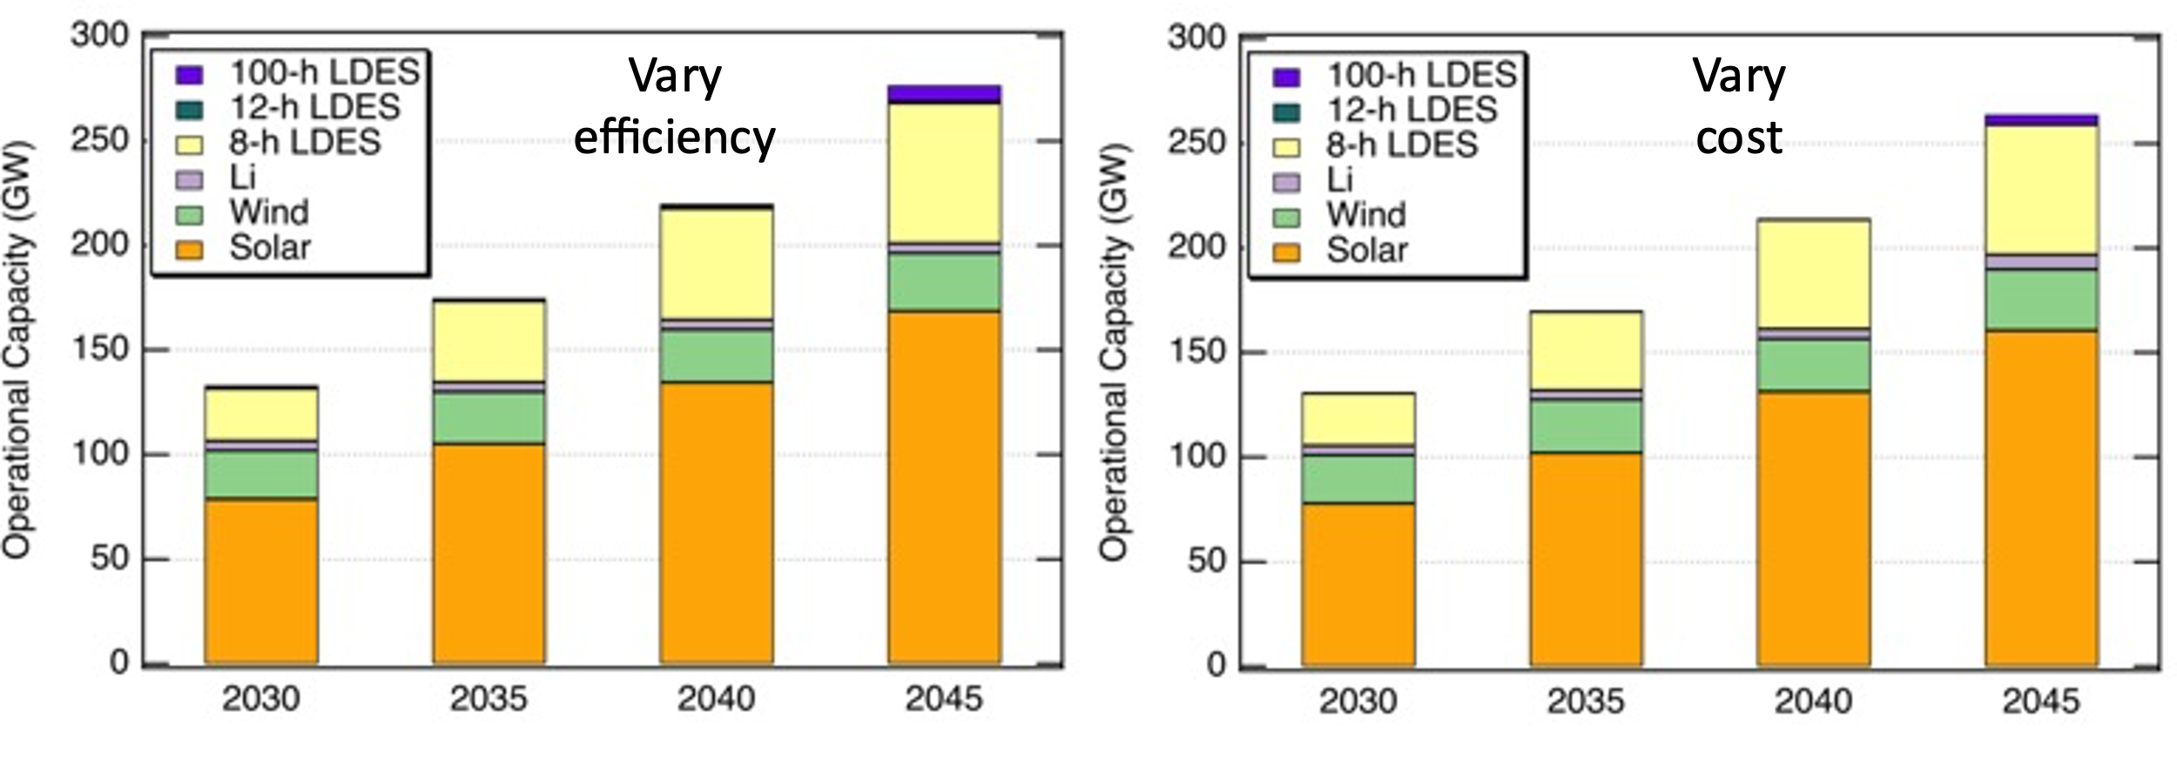

The results shown in Figure Exec.3 are highly dependent on the exact assumptions made for each LDES candidate. Recognizing that any new storage technology will need to compete with 4-h Li batteries, the cost of each LDES candidate was varied to identify the competitive price, as shown for an 8-h LDES in Figure Exec.4. From such graphs, the cost target to displace 4-h Li batteries was derived. The determination of the cost target for each LDES candidate is dependent on the fraction of the market that is targeted. For example, in Figure Exec.4, the LDES cost target to displace 100% of 4-h Li batteries is 0.6 of the 4-h Li battery energy cost, while the cost target to displace 50% is closer to 0.95 of the 4-h Li battery energy cost. Given that the uncertainty in Li battery prices is a factor of 2, the calculated cost targets are presented here relative to the assumed Li battery cost.

Figure Exec. 4: Selection of 4-h Li Batteries vs LDES
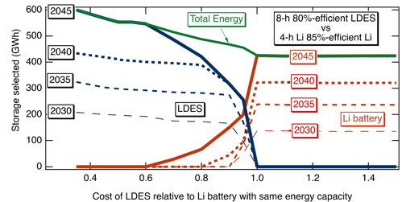

The cost target for LDES to capture market share from lithium batteries is strongly dependent on the LDES efficiency (Figure Exec.5). The dependence on efficiency is less important if only 1% of the 4-h Li batteries are displaced, reflecting the likelihood that these LDES are cycled less frequently.

Figure Exec. 5: Cost Target for LDES vs Efficiency for 3 Penetration Levels
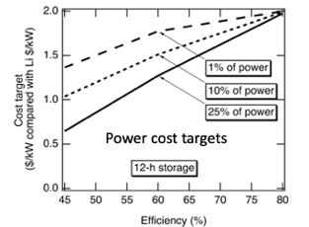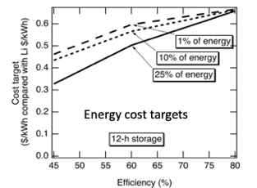

The relative cost target may change in the future. Figure Exec.6 shows that for a LDES product to displace 50% of 4-h Li batteries the cost target decreases in the future, suggesting that, while 8 hours of storage is still needed to get through the night, reduced use of peaker plants to meet zero emissions targets may require an increased part of the storage fleet to function like peaker plants in 2045, increasing the attractiveness of 4-h storage. The opposite dependence on years into the future was found when considering displacement of 1% of Li batteries (Figure Exec.6), demonstrating that the value of LDES relative to 4-h storage will increase in the future, but at approximately 1-GW scale rather than at tens of GW scale.

Figure Exec. 6: Cost Targets for LDES as a Function of Modeled Year
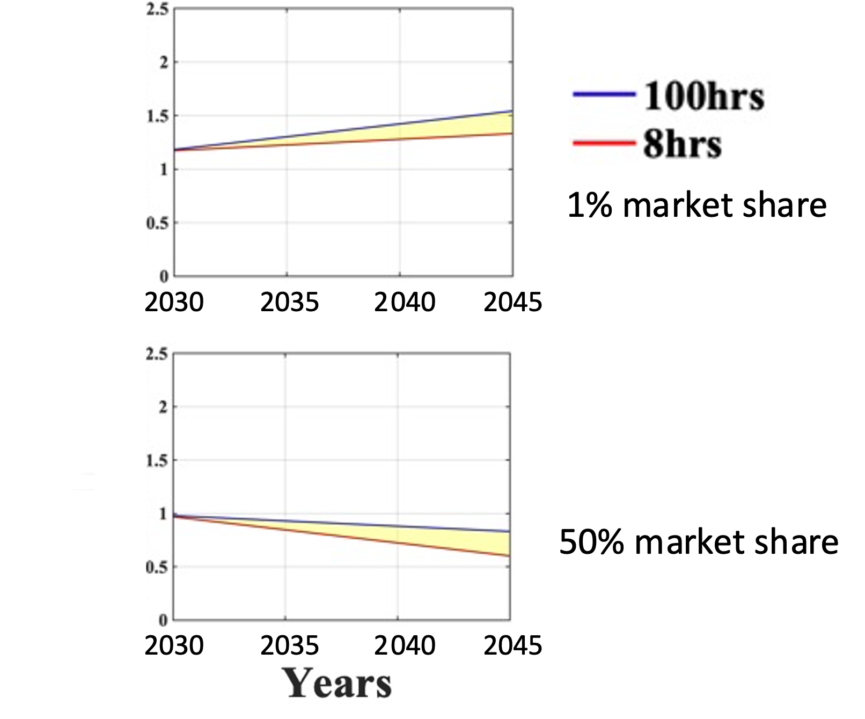

All modeled scenarios found that California will continue to be a net importer of electricity, though California will export electricity during the day when solar electricity is abundant. If additional transmission is built, the electricity generated in California may decrease even more with California net importing more than 10% of its electricity on an annual basis (Figure Exec.7).

Figure Exec. 7: Fraction of Annual California Load met by California Generation
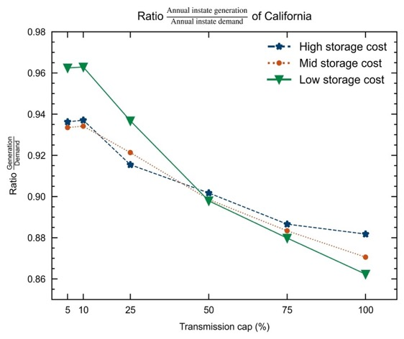

For decreasing storage costs, the model chose to build fewer transmission lines, though some lines connecting California to its neighbors were selected for build to larger capacity when storage costs were decreased (Figure Exec.8). Wider deployment of storage was found to both decrease the cost of electricity and decrease the variability of the cost of electricity. (Figure Exec.9)

Figure Exec. 8: Annual Electricity Generation by State and Transmission Capacities
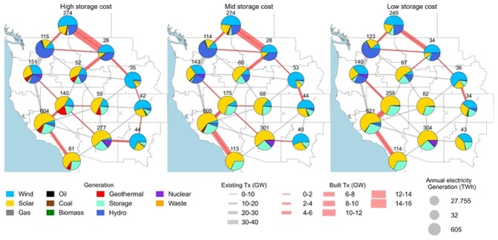
Figure Exec. 9: Impact of LDES Mandates on the Marginal Price of Electricity
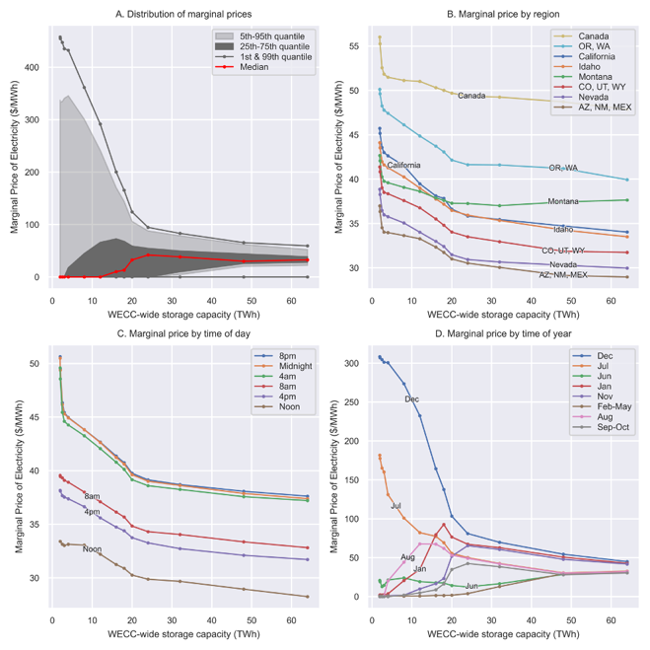

Today’s flexible loads are too small (with batteries sometime less expensive than installing load shifting equipment) to balance supply and demand of electricity, but tomorrow will bring two very large flexible loads: electric vehicle charging and electrolyzers for hydrogen generation. If one considers that roughly 1/3 of energy is used for transportation (which may be largely met by electricity or hydrogen from electrolysis) and 1/3 for industrial processes (which may also be met with hydrogen), the potential flexible loads in the future may be comparable to today’s total electrical load. The use of daytime charging of electric vehicles in 2045 was found to reduce the selected storage by about 10% (Figure Exec.10), saving on order of $1 billion and motivating investment in daytime charging infrastructure. Electrolyzers were found to contribute to seasonal load balancing by turning off during the winter. Surprisingly, the electrolyzers were found to operate at a capacity factor of 40% (Figure Exec.11), exceeding the capacity factor of the solar plants that provided power for them, suggesting that batteries supply the electrolyzers with electricity at some hours. Thus, the availability of under-used assets (curtailed electricity combined with ample storage) may be enabling for green hydrogen.

Figure Exec. 10: Selected Operational Capacities for Three EV Charging Profiles
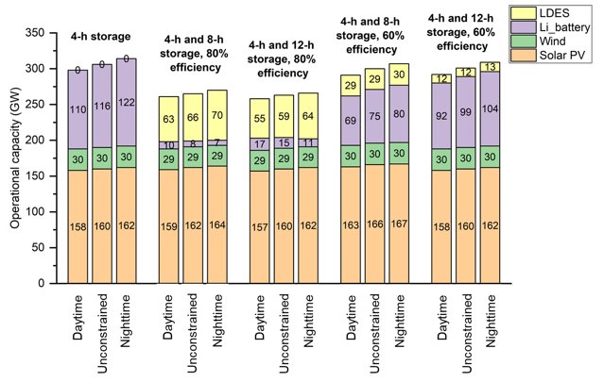

Figure Exec. 11: 2045 Electrolyzer Capacity Factor
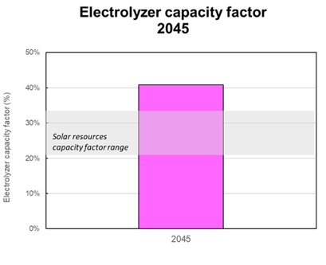

The use of solar and wind generation profiles (by changing the solar mounting configuration (Figure Exec.12) and selecting wind locations with stronger winter-time wind) with better seasonal match to the load profiles, reduced curtailment, but the reduction in curtailment must be balanced with the potential increase in cost of the system.

Figure Exec. 12: Annual Solar Curtailment for Three Solar Configurations

The use of oxy-combustion could help to reduce the need for storage, but questions remain about the rate of scale up of both the oxy-combustion generators and the infrastructure for sequestration of the generated carbon dioxide.

Knowledge Transfer and Next Steps
Results have been shared directly with CEC, with publications, presentations at conferences and through webinars, as documented in the Knowledge Transfer Report.
A more complete summary of the results of this study may be found on line.

CHAPTER 1:
Introduction
This project’s goal is to understand the role and cost targets of long-duration energy storage (LDES) to reach zero-carbon emissions and related goals by 2045. While, clearly, low-cost, efficient LDES is desirable, it is less clear what duration (hours of discharge that can be sustained at the LDES’ rated power) will be most beneficial.

The optimal solution for California is likely to include some LDES with durations suitable to provide power through the night and longer durations that will provide power during a few cloudy days and even longer durations that provide power during the most difficult seasons. The efficiencies of the LDES and other details of the system will affect this optimal mix.

Understanding the combinations of attributes that will enable solar and wind to provide electricity round the clock will guide investments in the many promising LDES technologies. A critical attribute will be the cost each type of LDES will need to reach to be able to capture market share.

California is uniquely blessed with abundant solar energy and with a wind resource that is stronger in summer than in winter. Thus, conclusions of literature studies elucidating how LDES attributes complement solar and wind generation may not elucidate the optimal solutions for California.

Additionally, California is exploring investment in offshore wind, has the largest geothermal generation in the country, and could benefit from using wood from the forests for electricity generation as a means for reducing wildfires. If any of these were installed at a multi-GW scale, the need for LDES would change. Electric vehicle (EV) charging, electrolysis, and heat pumps are examples of three loads that are anticipated to increase. These loads are significant because they are more flexible than today’s loads, so may be more significantly influenced by state policy and actions.

This study focuses on longer-term questions and a wide range of scenarios, differentiating it from the CEC’s Integrated Energy Policy Report (IEPR) which focuses more on pressing energy needs and issues. Complementing the related study by the Energy & Environmental Economics, Inc this study considers how solar and wind generation profiles may be designed to more closely match the load profiles, how loads may be shifted to reduce the need for storage, and how the Western Electricity Coordinating Council (WECC) resources may interact with California’s resources.

Thus, this study explores a wide variety of scenarios to understand how actions by the state may affect the need for and benefit of LDES in the future, aiding both policy makers and companies that are developing long-duration storage projects.

CHAPTER 2:
Project Approach

Project Timeline and Approach
The project was executed in two phases, as shown in Table 2.1. An initial survey of the currently available LDES technologies identified the technology options and their attributes and later was used to refine the implementation of storage in the modeling. In discussion with the CEC, the scenarios were developed and analyzed.

Table 2. 1: Project Timeline and Primary Tasks
Task | Phase 1 | Phase 2
Baseline | Assemble data
Technology assessment | Assess technology options | Refine technology implementation in model
Scenario development | Assess data implications on scenario selection | Define scenarios
Scenario analysis |  | Analyze scenarios

Project Partners and Advisors
The project was led by UC Merced (Sarah Kurtz) with subcontracts to UC Berkeley (Dan Kammen), UC San Diego (Patricia Hidalgo-Gonzalez), and the University of North Carolina Chapel Hill (Noah Kittner). Sergio Castellanos was initially involved at UC Berkeley, then continued the collaboration after moving to University of Texas Austin.

The Technical Advisory Committee included:
- Priya Sreedharan, Gridlab
- Erin Childs, Strategen
- Jennifer Dowdell, TURN
- Shucheng Liu, CAISO
- Ron Sinton, Sinton Instruments
- Julia Prochnik, LDES Council
- Paul Denholm, National Renewable Energy Laboratory
- David Williams, Dissigno
- Keith Parks, Xcel Energy
- Jeffrey Reed, UC Irvine

Dozens of individuals and companies provided input. Space limitations prevent us from listing all individuals. Key contributors have been acknowledged in individual reports.
Students who contributed in addition to those listed as authors include:
Pedro Sanchez
Kenji Shiraishi
Jeremiah Reagan
Julia Szinai
Natalia Gonzalez
Tyler Lis
Aashika Nair
Jerry Potts

LDES Technology Background

Community feedback encouraged studies covering the entire range of parameter space, reflecting the uncertainty of which technologies will succeed. In response to this feedback, the project explored the full range of durations, efficiencies, and cost, defining a large matrix to survey in competition with Li-ion batteries.

To underscore the challenge of predicting the future costs of energy storage technologies, Figure 2.1 highlights how the 2022-2023 Integrated Resource Planning (IRP) noted the decision to essentially double the modeled cost of Li batteries. The uncertainty in LDES costs is even greater.

Figure 2. 1: Revised 4-h Li Capital Cost from 2022-2023 IRP
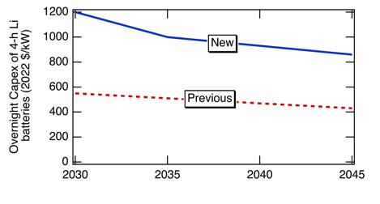

2.4 Research Objectives

Understand the role and cost targets of long-duration energy storage to reach zero-carbon emissions and related goals by 2045, considering a broad context of the generation technologies that will be installed and the use of transmission to connect to the rest of the WECC.

2.5 Core Scenario Description

The Final Core Scenario includes baseline assumptions to reflect the 2021 CPUC IRP PSP and the 2020 PATHWAYS High Electrification analysis for the growth of EV loads.

Additionally:
- Use fixed hydropower profiles for dry year
- Offer 85%-efficient lithium batteries with specified 4-hour duration (model does not adjust the duration)
- Vary the duration and efficiency of candidate storage resources without assigning to specific technology
- Use the Critical-time-steps approach that enables many calculations
- No planning reserve margin

In the case of the Western Electricity Coordinating Council (WECC) the model includes all 365 days in 2050, sampling every four hours and imposes a zero-emissions carbon cap constraint. The model considers 7,000+ possible candidate projects geolocated for deployment of solar, wind, geothermal, etc. (considering land and environmental constraints). The optimization model is free to choose power capacity and energy capacity for the installed storage assets, i.e., duration is not predetermined but it is an optimal output.

California and the Western Interconnect Grid Modeling

Two capacity expansion models optimize investment and dispatch decisions to minimize the cost of meeting decarbonization targets and other system goals required by grids with high penetration levels of renewable energy:

RESOLVE (UC Merced)

RESOLVE was developed by Energy and Environmental Economics and models expansion of the CAISO grid, while retaining generation and load for surrounding states.

For the RESOLVE scenarios the LDES was modeled with a predefined duration using three approaches:
- Fixed duration and efficiency of a single LDES type with cost varied to identify the cost target that would result in selection of the LDES at a target penetration level,
- Fixed duration, efficiency and cost for a single LDES type selected from Table 2.2 in competition with 4-h lithium batteries from the baseline to quantify the selected adoption for the least-cost solution, and
- Four LDES types with duration, efficiency and cost defined as in Table 2.3 in competition with each other and with 4-h Li batteries. The “Vary cost” scenario defined in Table 2.3 can be implemented with a range of efficiencies, denoted as “X” in the Table, where the same “X” efficiency is used for all 4 LDES types.

Table 2. 2: LDES Assumptions for Adoption of a Single LDES Type
Duration | 60% Efficient | 80% Efficient
8 h | 1.2 X Li power cost;  0.6 X Li energy cost | 1.2 X Li power cost;  0.6 X Li energy cost
12 h | 1.4 X Li power cost;  0.47 X Li energy cost | 1.4 X Li power cost;  0.47 X Li energy cost
100 h | 1.8 X Li power cost;  0.072 X Li energy cost | 1.8 X Li power cost;  0.072 X Li Energy cost

Table 2. 3: Scenarios Offering 4 types of LDES Simultaneously
Duration | Vary efficiency,  constant power cost | Vary cost,  constant “X” efficiency
4 h Li | 1 X Li power cost or  1 X Li energy cost; 85% | 1 X Li power cost or  1 X Li energy cost; 85%
8 h | 1 X Li power cost or  0.5 X Li energy cost; 75% | 1.2 X Li power cost or  0.6 X Li energy cost; X%
12 h | 1 X Li power cost or  0.33 X Li energy cost; 70% | 1.4 X Li power cost or  0.47 X Li energy cost; X%
24 h | 1 X Li power cost or  0.17 X Li energy cost; 60% | 1.6 X Li power cost or  0.27 X Li energy cost; X%
100 h | 1 X Li power cost or  0.04 X Li energy cost; 50% | 1.8 X Li power cost or  0.072 X Li energy cost; X%

SWITCH-WECC (UC San Diego)

SWITCH-WECC models the WECC with 50 load zones featuring a high geographic and temporal resolution for renewable resources in the WECC.

Within SWITCH, LDES was modeled by providing a cost for $/kW and a separate cost for $/kWh with the duration selected by the model to provide the lowest cost outcome. The two cost inputs were varied to explore a wide parameter space. The efficiency was fixed at 75%.

Sensitivity Analysis
Modifications to the core scenarios will include testing sensitivities to the following:

  - Impact of EV charging profiles on the need of storage
  - Impact of solar and wind generation profiles on the need of storage
  - Impact of oxy-combustion on the need of storage
  - Impact of storage costs and transmission deployment caps in the WECC
  - Impact of storage mandates in the WECC

Long-Duration Energy Storage Technology Summary

This project’s assessment, of many long-duration energy storage technologies provided the basis for the capacity expansion modeling. The Shan, et al. assessment¹ provides an overview of standardized metrics comparing long-duration energy storage technologies with lithium-ion based counterparts. That assessment developed innovative storage metrics for comparing technologies, such as a standardized average capital cost of different storage technology as a function of discharge duration at rated power, equivalent efficiency considering idle loss rates, and land footprints as a function of energy rating.¹ The project also analyzed current shortcomings in storage modeling with opportunities for cross-sector applications as explored in Section 10 in the Results section. Table 2.4 provides an abbreviated overview of the available long-duration energy storage technologies.

Table 2. 4: Long-Duration Energy Storage Summary
Storage type | Discharge duration | Lifetime | Roundtrip efficiency (%) | Capital cost ($/kW) | Capital cost ($/kWh)
Compressed air, adiabatic | 10-100 | 20-30 | 55-75 | 700-1100 | 40-90
Flow battery, Vanadium | 4-24 | 5-20 | 65-85 | 600-1650 | 160-1150
Flow battery, Zinc | 4-24 | 5-20 | 65-75 | 700-2700 | 160-1800
Pumped hydropower | 10-100 | 25-100 | 60-85 | 1800-3400 | 5-200
Thermal | 4-24 |  |  |  | < 10
Li-ion battery | 1-4 | 5-20 | 85-90 | 1600-2500 | 300-900

The modular design of flow batteries makes them suitable for deployment in small communities or even individual households. Although flow batteries were previously critiqued for their high self-discharge rate (estimated around 0-1% per day), recent insights from manufacturers such as RedFlow suggest that this issue can be minimized through proper cell design. In certain scenarios, flow batteries may even outperform Li-ion batteries in terms of self-discharge, particularly when considering auxiliary cooling loads.

While thermal storage can also take advantage of modular configurations, high self-discharge rates remain a challenge. Still, thermal storage often could be cost-effective, measured in terms of $/kWh, especially when the energy-to-power ratio is high. Antora Energy boasts a recent pilot project less than $10/kWh with a material cost less than $1/kWh. However, depth of discharge for thermal energy storage, overlooked in prior analyses, varies. Flow batteries, gravity storage, advanced compressed air, and advanced pumped storage hydropower can achieve 100% depth of discharge. This high depth of discharge contrasts with thermal, Li-ion, and other conventional alternatives, which are substantially lower.

Thermal and compressed air storage systems can be enhanced through insulation optimization and the utilization of waste heat from other processes or geothermal sources, bolstering their appeal for decarbonizing heavy industries reliant on waste heat as a valuable resource or for use of inactive oil wells.

Real project cost estimates for gravity storage have increased from $200-300/kWh to ~$880/kWh based on pilot projects developed in China; however, there is potential for further cost reduction.

The dynamic long-duration energy storage market offers a wide range of technology options, each catering to specific applications. It is critical to consider factors like self-discharge rates, modularity (smallest deliverable capacity), heat management, cost-effectiveness, land footprint, and depth of discharge when determining the most suitable solution for specific applications.

Proton exchange membrane (PEM) electrolyzers provide more flexibility in their operation, enabling them to better complement variable renewable energy sources, and, therefore, act as a type of storage. Electrolyzers are rapidly coming down in price.

Based on feedback from advisors and the observation that the attributes of the storage technologies are not yet well defined, the capacity expansion modeling used a matrix of attributes as defined in Section 6 rather than specifically modeling each technology. However, the information in Table 8.1 can be used to relate specific technologies to the modeling results.

CHAPTER 3:
Results

Core Scenario
The capacity expansion for the core scenario before introduction of LDES is shown in Figure 3.1. Subsequent graphs omit hydro, biomass, geothermal, CCGT and other as they are unchanged.

Figure 3. 1: Capacity Expansion Selected for RESOLVE Core Scenario Without LDES
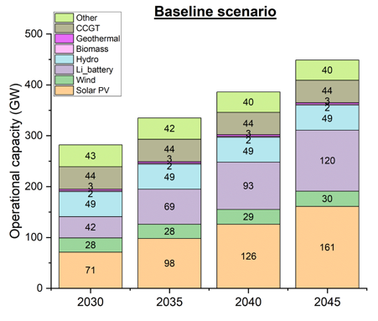

Core Scenario - Optimal Duration
A capacity expansion model is designed to select the lowest cost solution. However, there is large uncertainty in future costs. As discussed above, even the cost of Li-ion batteries currently has an uncertainty of a factor of two. A strategy for evaluating the grid’s need for LDES when the costs are not clear is to document the needed power capacity and needed energy capacity as a function of LDES duration when only one storage option is offered to the model. For shorter duration storage, the energy capacity can be sized to meet the most stressful time, while the power capacity must be overbuilt. On the other hand, as shown in Figure 3.2, for the longest duration storage, the power rating (red curve plotted on left y axis) will be lower, but the energy capacity (blue curve plotted on right y axis) will be overbuilt. Although the ideal duration depends on the cost(s) and efficiencies, if a duration in the range of 8 to 12 h is selected (rectangle in Figure 3.2), the power overbuild will be < 3% and the energy capacity overbuild < 50%. This straightforward assessment can be repeated for each scenario to identify how the need for storage changes. However, the ideal solution will include a collection of storage types.

Figure 3. 2: Power and Energy Capacity Selected for RESOLVE Baseline Scenario
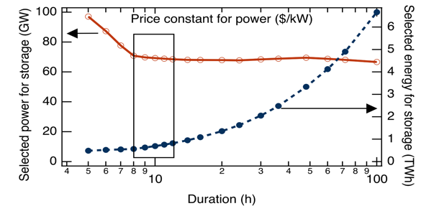

Core Scenario - Competitive Cost
The competition between LDES and lithium-ion batteries can be probed directly by fixing the 4-h Li battery cost and varying the LDES cost as shown in Figure 3.3. In this case, 8-h 80%-efficient LDES asset needs to be lower in cost than a 4-h 85%-efficient lithium-ion battery when considering the cost of the energy capacity.

Figure 3. 3: Selection of 4-h Li Batteries vs LDES

The target price for 50% adoption of an LDES product can be derived from Figure 3.3 by identifying the cost at which the LDES and Li battery selections are equal (about 0.95 in Figure 3.3). Figure 3.4 shows this target price as a function of the LDES duration, with the relative cost per installed kWh on the left and the relative cost per installed kW on the right. Up to about 8-h duration, the competitive cost in $/kWh for the LDES approximately equals the $/kWh for the Li batteries. For durations > 8 h, the LDES $/kWh cost drops quickly.

Figure 3. 4: Cost Target for 50% Market Share as a Function of LDES Duration
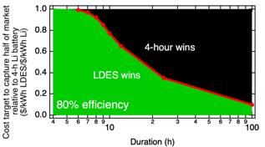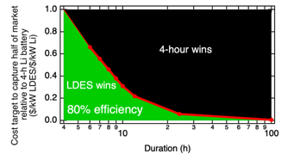

Longer duration storage that may be needed to cycle only a few times per year may provide higher value, justifying a higher cost target if the adoption level is taken to be small. Figure 3.5 shows higher cost targets for lower efficiency 12-h LDES that is adopted for a small fraction of the market (e.g. 1%).

Figure 3. 5: Cost Target for LDES vs Efficiency for 3 Penetration Levels

The cost target to capture 1% or 50% of the market in 2030 or 2045 is shown as a function of LDES efficiency in Figure 3. 6. As anticipated, efficiency is a very important metric, with cost targets changing about a factor of 2 as the efficiency increases from 50% to 80%. The effect of efficiency is less critical for early adoption (1% of market share), but efficiency is slightly more critical for 100-h duration than 8-h duration (Figure 3. 6).

Figure 3. 6: Cost Targets for LDES as a Function of Efficiency
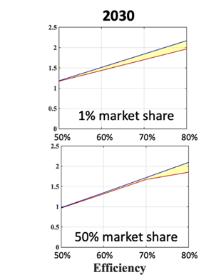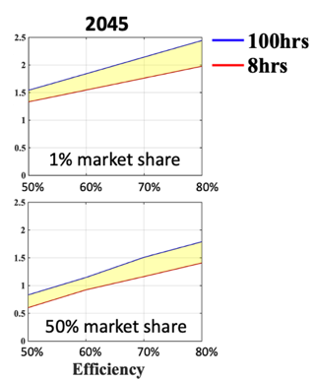

As restrictions on emissions are tightened, the need for LDES is likely to increase and the market will be willing to pay more for an LDES asset relative to a 4-h Li battery in 2045 than in 2030. Indeed, this appears to be true for the adoption of a small amount of 100-h LDES as shown in Figure 3. 6. However, surprisingly, for 50% market share adoption in 2045, the model shows that 4-h Li batteries become more, rather than less, attractive, relative to LDES, suggesting that the best time to launch LDES products for wide adoption may be before 2030 rather than waiting until closer to 2045. This effect is seen more clearly in Figure 3.7 for the 50% case where the cost targets are plotted as a function of adoption year.

Figure 3. 7: Cost Targets for LDES as a Function of Modeled Year
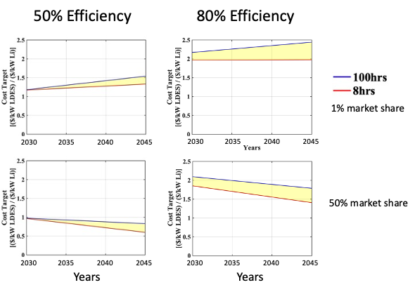

Core scenario – Adding Multiple Types of LDES Simultaneously
The capacity expansion results for the core scenario are shown in Figure 3.8 for LDES scenarios simultaneously offering 4 types of LDES as described in Table 2.3. No 24-h LDES was selected. For the selected scenarios, the model had difficulty differentiating between 4-h, 8-h, and 12-h storage. As shown in Figure 3.3, a very small change in the assumed cost can change the conclusion about which storage dominates. Nevertheless, the conclusions for this set of storage options in Table 2.3 shows that 4-h and 8-h storage dominate with 100-h becoming more attractive in 2045. When higher efficiency and lower cost were assumed, storage gained market share.

Figure 3. 8: Capacity Expansion Selected for Table 2.3 Scenarios

Core Scenario - Optimal Efficiency and Duration
For the LDES scenario “Vary cost” in Table 2.3, the efficiency (X% in the table) has a profound effect on the LDES’ competition with 4-h Li batteries, as shown in Figure 3.9.

Figure 3. 9: Selected Operational Power Capacities, as a Function of LDES Efficiency
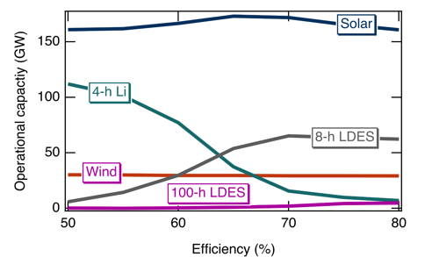

Pumped Hydropower Storage

Historically, pumped hydropower has been the largest LDES technology. As LDES is becoming more important, a number of additional pumped hydropower projects have been proposed as enumerated in the report for Task 3.2. The results for the anticipated capacity expansion are shown in Figure 3.10 on the right showing how the additional pumped hydropower primarily reduces the need for other LDES with the longest durations.

Figure 3. 10: Capacity Expansion for Baseline (left) and High Pumped Hydro
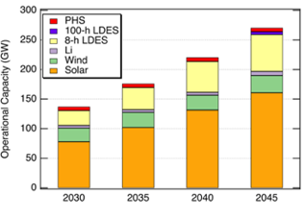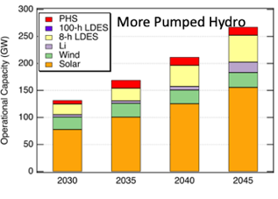

3.7 Impact of EV Charging Profiles on Selected Storage
The project studied the effects of three light-duty electric vehicle (EV) charging profiles on the need for storage. The profiles were taken from a recent study funded by the California Energy Commission (CEC). As illustrated in Figure 3.11, the first case, called 'Nighttime charging,' pictures a situation where 95% of EV owners have access to home charging, and these EVs commence charging at midnight, reflecting existing time-of-use pricing, where electricity costs less during nighttime hours. Consequently, in this case, EV charging demand peaks at midnight, followed by a gradual decrease. The second scenario, referred to as 'Unconstrained' in Figure 3.11, assumes a spontaneous charging pattern without controlled schedules or economic incentives. Here, the peak charging is projected to occur in the evening when individuals return home from work and plug in. Finally, the 'Daytime charging' case incorporates two distinct periods of high demand: one during the middle of the day and another at midnight. This load profile assumes that daytime charging is common, probably using workplace charging stations.

Figure 3. 11: Light-duty Electric Vehicles Load (GW) Profiles
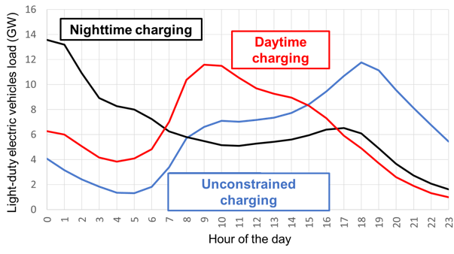

Figure 3.12 exhibits the effect of the three charging cases on the operational capacity of solar PV, wind, and storage systems. The LDES technologies analyzed here are 8- and 12-hour storage as described in Table 2.2. As Figure 3.12 indicates, in the presence of LDES, the total storage operational power capacity decreases. For each group of LDES, daytime charging shows the smallest need for storage. The smaller storage needed when deploying daytime charging could correspond to cost differences of around $ billion, according to Figure 3.13. The result motivates investment in daytime (e.g. workplace) charging infrastructure.

Figure 3. 12: Selected Operational Capacities for Three EV Charging Profiles

Figure 3. 13: Storage Capital Costs for the Cases in Figure 3.12
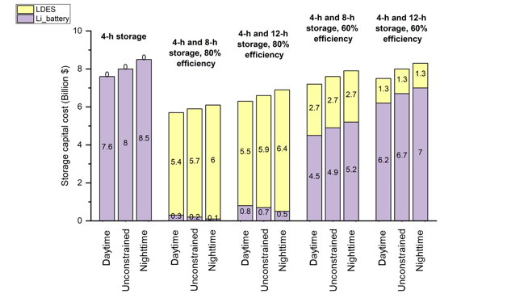

3.8 Impact of Solar and Wind Generation Profiles on Storage
The need for storage is driven by the mismatch between the generation and demand profiles. The study included three solar mounting configurations: 1) 1-axis tracked with no tilt (most common today), 2) 1-axis tracked with south-facing tilt, and 3) fixed with south-facing tilt and three wind scenarios. The solar generation profiles are characterized in Figure 3.14.

Figure 3. 14: Daily and Monthly Solar Generation Profiles for 3 Solar Configurations
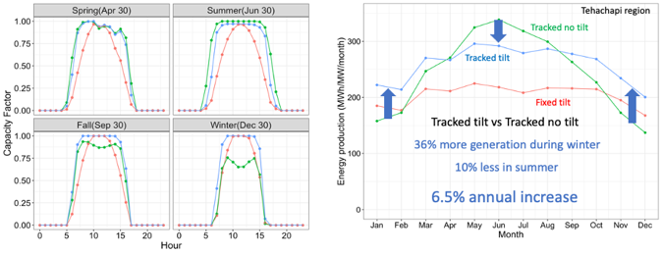

The effect of the mounting configurations is most apparent when comparing the curtailment, as shown in Figure 3.15 for the baseline and LDES described in Table 2.2. The strongly reduced curtailment for the south-facing tilt configurations reflects the better seasonal match between generation and demand profiles, but the effect may be too small to motivate using a higher cost design.

Figure 3. 15: Annual Solar Curtailment for Three Solar Configurations

For 50% market adoption, the mounting configuration has little effect on the cost target as shown in Figure 3.16 for a competition between 80% LDES and 4-h 85% storage.

Figure 3. 16: Cost Targets for LDES as a Function of Duration
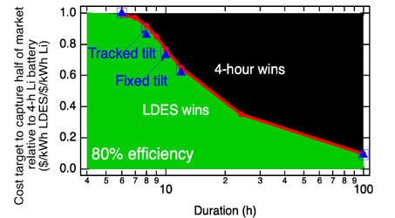

Similarly, the effect of efficiency on the cost target does not change substantially when using the 3 mounting configurations, as shown in Figure 3.17. The capacity expansion results shown in Figure 3.18 show less solar built when south-facing tilt is added to the one-axis tracking and more solar built when south-facing tilt is used in a fixed configuration, reflecting the yields of these solar configurations. When 80% 8-h LDES is added to the core scenario (using cost shown in Table 2.2), the 4-h Li batteries are replaced by the 8-h LDES with 49.5 GW of 8-h LDES adopted for the two south-facing configurations, compared with 47 GW for the 1-axis-tracked configuration with no tilt. This larger adoption of LDES is correlated with reduced use of wind, reflecting the added value of the south-facing tilt to the system. When 60% 8-h LDES is added, 4-h Li batteries are retained, with, again, more storage being built for the two south-facing tilt configurations, though, in this case, the connection to the reduced use of wind is less clear.

Figure 3. 17: LDES Cost Target as Function of LDES Efficiency for 3 Configurations
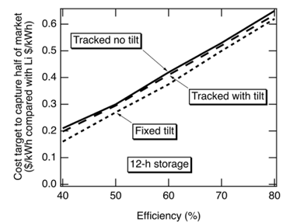

Figure 3. 18: Selected Capacity Expansion for 3 Solar Mounting Configurations

Like solar, wind generation profiles can affect the modeling results. Figure 3.19 shows a winter-dominant wind generation profile and an offshore wind-generation profile in comparison with the core scenario’s generation profile. Notably, the winter-dominant profile can provide generation during the winter when both solar and today’s onshore wind have reduced generation.

Figure 3. 19: Monthly Wind Generation Profiles

By providing better seasonal balance, the winter-dominant wind is effective at reducing curtailment of solar generation, as shown in Figure. 3.20 for 60% efficient LDES. This optimization used the same LDES assumptions as Figure 3.15. When 80% LDES was used, the curtailment is relatively low in all cases.

Figure 3. 20: Annual Solar Curtailment Comparing Wind Profiles
Adding winter-dominant wind or offshore wind reduces the storage needed as shown in Figure 3.21 and shifts the optimal duration to slightly longer, as shown in Figure 3.22

Figure 3. 21: New-Build Capacities for Added Wind Scenarios

Figure 3. 22: LDES Power Capacity Selected vs LDES Duration for Wind Scenarios
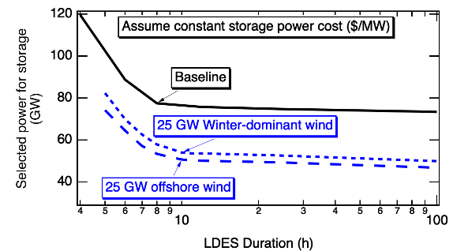

3.9. Impact of Oxy-combustion on the Selected Storage
Oxy-fuel combustion, or oxy-combustion, is carbon capture and storage (CCS) technology that involves burning fuel with nearly pure oxygen (instead of air), resulting in combustion gases primarily composed of CO₂ and water vapor, simplifying carbon dioxide capture in power plant applications. The Allam cycle employs oxy-combustion technology in a closed-loop cycle, with high-pressure supercritical CO₂ as the working fluid and retaining all emissions by design.
Allam cycle oxy-combustion was modeled to evaluate its impact on the need for long-duration energy storage.
This technology with natural gas as a fuel has an efficiency comparable to a combined cycle gas turbine (CCGT)³. For that reason it was modeled as a CCGT with no associated emissions.
The maximum operational capacity in California was considered limited due to the lack of announced projects for this technology in the state and the requirement of additional infrastructure for CO₂ transportation and storage, Table 3.1.

Table 3. 1: Model Inputs for Operational Capacity for Oxy-combustion
Year | Maximum operational capacity (GW)
2030 | 0.5
2035 | 1
2040 | 2
2045 | 4

The cost range considered was from 1 to 2.5 times the cost of CCGT. The model selected to build oxy-combustion to the maximum capacity offered only for the case of equal cost. Moreover, when the cost exceeded two times the cost of CCGT, oxy-combustion was not selected at all (Figure 3.23).

Figure 3. 23: Operational Capacity of Oxy-combustion as Function of Capital Cost
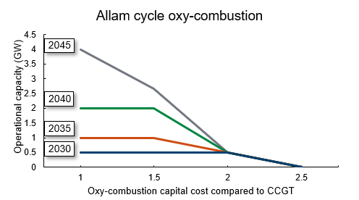

In this study, 100-h LDES is considered, with two round-trip efficiencies (60% and 80%) at a power cost equal to 1.8 times the corresponding cost for 4-h Lithium-ion batteries. Figure 3.24 shows the operational capacities obtained in 2045 for the case without oxy-combustion (a) and with oxy-combustion (b). Without oxy-combustion, the selection of 100-h 60% efficiency LDES is limited. However, 80% efficiency LDES is adopted at a higher level, reducing the capacities of solar PV and Li-ion batteries. When the oxy-combustion resource is offered at a cost equal to conventional CCGT (Figure 3.24, right), in all scenarios it is being built to the maximum operational capacity offered (4GW in 2045). Moreover, solar PV and Li-ion batteries capacities are further reduced, while LDES capacities remain practically unchanged.

These results show that the combination of LDES and closed-loop oxy-combustion allows for a reduction in the capacity expansion needed by 2045, as well as the total system cost.

Figure 3. 24: 2045 Operational Capacities Without & With (right) Oxy-combustion
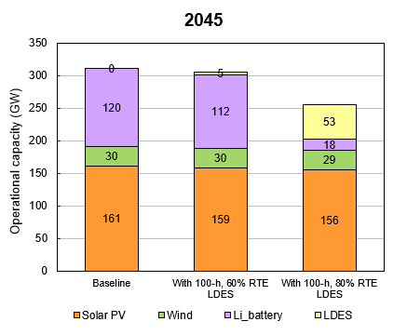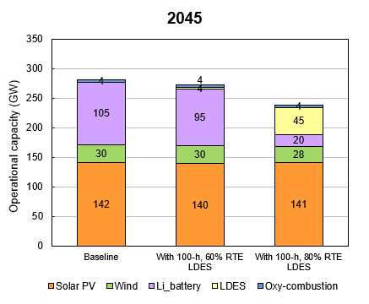

Figure 3.25 shows the selected operation of the Allam cycle resource for 2045 and the scenario with 100-h, 80%-efficient LDES. Oxy-combustion is providing power during winter months, while being mainly off during spring and summer months. The rest of the months oxy-combustion operates as a dispatchable resource, being on/off depending on the net load.

Figure 3. 25: 2045 Oxy-combustion Dispatched Power
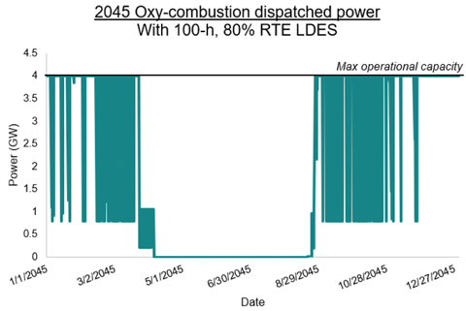

3.10 Impact of Electrolyzers on Selected Storage
Electrolyzers for hydrogen production were modeled as a flexible load, to help address demand-supply imbalances in the grid as the share of variable renewable energy increases.
The hydrogen produced is considered to be sold at a selected price, for an unspecified use.
For defining the hydrogen selling price, a production cost was calculated based on the best available resource for electricity generation in the grid, which is solar PV. In this calculation, an isolated solar PV + electrolyzer system was defined, where the production cost was defined by the total all-in cost of the solar and electrolyzer, divided by the total hydrogen production. The hydrogen production is set by the capacity factor of the electrolyzer, which, in the isolated system, is equal to the solar resource capacity factor, and by the electrolyzer electricity-to-hydrogen conversion (50 kWh/kg). For the best solar resource, in 2030, this production cost was $2/kg H₂.

For this study, multiple LDES were offered, at the same power cost but different efficiencies (Table 2.3).

The H₂ selling price selected for this study was 99% of the modeled production cost. In these conditions, an isolated solar PV-electrolyzer system would not be profitable. However, when the electrolyzers were offered to the grid, the model selected to build up to 17 GW in 2045, as shown in Figure 3.26:

Figure 3. 26: Operational Capacities, Without and With Electrolyzer.
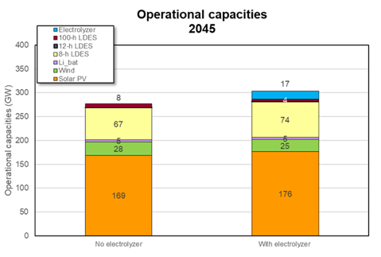

Figure 3.27 shows that electrolyzers effectively use excess solar generation, that would otherwise be curtailed, resulting in a reduction in the total solar energy curtailment in 2045. Moreover, as seen in Figure 3.28 the capacity factor of the electrolyzers is around 40%, above the capacity factors of the solar resources, which are between 21 and 33%.

Figure 3. 27: Solar Energy Curtailment with Electrolyzer
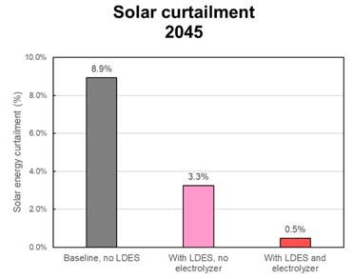

Figure 3. 28: 2045 Electrolyzer Capacity Factor

These electrolyzers effectively work as a flexible load as they are OFF during winter months and on during summer and full sun days (Figure 3.29). In general, electrolyzers loads follow solar generation profiles. However, during some spring days they also operate at night (Figure 3.30). When evaluating the load together with the storage provided power (Figure 3.31), it can be seen when the energy stored exceeds the demand, it is used for hydrogen generation increasing the value of the installed storage.

Figure 3. 29: 2045 Solar Power Profile, with Electrolyzer Load
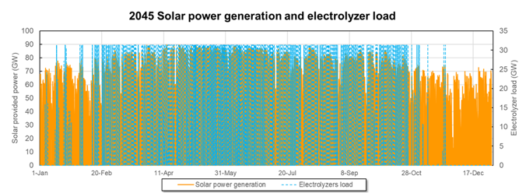

Figure 3. 30: 2045 Solar and Storage Power Profiles, with Electrolyzer Load
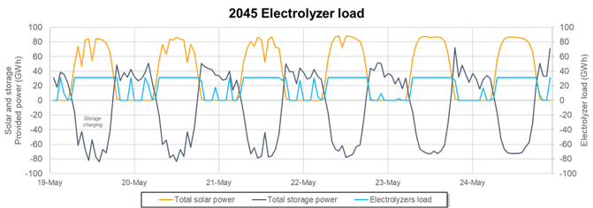

Figure 3. 31: 2045 Solar and Storage Power Profiles
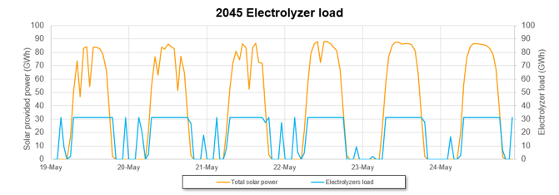

In the future, as the demand for green hydrogen grows, the addition of this large, flexible load will help to stabilize the grid, possibly reducing the need for storage, while making the installed storage more valuable.

3.11 Storage-Cost Impacts on WECC and California Transmission
This work investigates the least-cost grid expansion for the WECC and California in 2050 under zero carbon emissions considering declining storage costs and diminishing transmission capacity expansion, which could be the result of regulatory or political challenges (Table 3.2).

We find that lower storage costs and unrestricted transmission capacity expansion result in building up to 31% less WECC-wide transmission capacity and 19% less transmission capacity in California (Figures 3.32-3.33). However, the transmission system becomes more loaded as less transmission capacity is built in lieu of storage deployment (the loading is shown as arrows in Figure 3.34). This is because lower storage costs lead to more solar capacity and more storage energy and power capacity deployed throughout the WECC (Figure 3.33). That high solar and storage generation with the high utilization of the existing transmission capacity reduce the need for more transmission capacity.

However, high storage and solar installed capacities caused by low storage costs increase California’s electricity imports up to 14% of its demand, requiring up to 7.8 GW more transmission capacity between California and its neighbors. (Figure 3.32).

Table 3. 2: Scenarios Analyzed for 2050 WECC Grid Expansion
Scenario | Storage power capacity cost¹ ($/kW) | Storage energy capacity cost² ($/kWh) | Transmission  capacity cap³ | Inputs  Results | Solar capacity (GW) | Wind capacity (GW) | Storage energy capacity (GWh) | Duration (h)
1 | 325 | 275 | 100% |  | 151 | 15.9 | 469 | 7.5
2 | 325 | 275 | 75% |  | 153 | 15.9 | 469 | 7.6
3 | 325 | 275 | 50% |  | 160 | 16.6 | 490 | 7.5
4 | 325 | 275 | 25% |  | 171 | 16.8 | 515 | 7.5
5 | 325 | 275 | 10% |  | 184 | 17.4 | 544 | 7.3
6 | 325 | 275 | 5% |  | 184 | 17.4 | 547 | 7.2
7 | 140 | 170 | 100% |  | 156 | 15.1 | 487 | 7.3
8 | 140 | 170 | 75% |  | 160 | 15.3 | 508 | 7.4
9 | 140 | 170 | 50% |  | 169 | 15.6 | 522 | 7.2
10 | 140 | 170 | 25% |  | 182 | 16.6 | 559 | 7.2
11 | 140 | 170 | 10% |  | 189 | 16.7 | 571 | 6.8
12 | 140 | 170 | 5% |  | 189 | 16.7 | 567 | 6.8
13 | 10 | 10 | 100% |  | 159 | 7.4 | 612 | 7.9
14 | 10 | 10 | 75% |  | 165 | 8.2 | 666 | 8.2
15 | 10 | 10 | 50% |  | 173 | 8.5 | 722 | 8.2
16 | 10 | 10 | 25% |  | 190 | 9.8 | 848 | 9.0
17 | 10 | 10 | 10% |  | 205 | 10.1 | 1051 | 10.4
18 | 10 | 10 | 5% |  | 205 | 10.3 | 1157 | 11.3
¹Power-related costs ($/kW) of the candidate storage projects.
²Energy-related costs ($/kWh) of the candidate storage projects.
³Upper bound on total built transmission capacity in the WECC.

Figure 3. 32: Transmission Line Capacities Between the Modeled WECC Load Zones
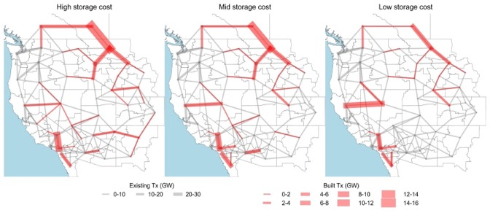
Figure 3. 33: Annual Electricity Generation by State and Transmission Capacities
Figure 3. 34: Annual Electricity Generation by State and Loading of Transmission
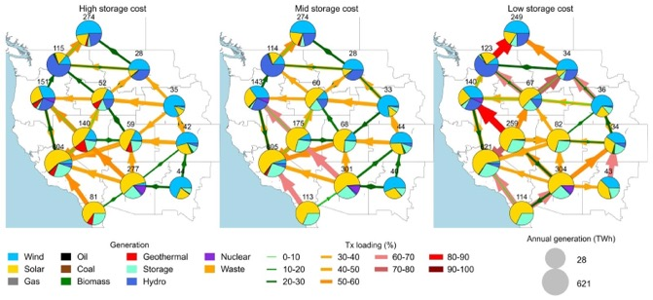

Declines in the cost of storage can lead to congestion in the transmission corridors, especially from Oregon to California and from California to Arizona. For instance, during California’s peak demand of 85 GW (July 25, 2050, 8:00 p.m.), lower storage costs result in higher loading levels of the transmission corridors to supply California’s demand. The affected corridors go from Nevada to California, from Oregon to California, and from Arizona to California (Figure 3.35). We observe 90-100% loading levels during California’s highest imports ratio (April 4, 2050, 3:00 a.m.) in the transmission corridors from Nevada to California and from Oregon to California, regardless of the storage costs (Figure 3.36).

Figure 3. 35: Electricity Generation and Transmission Loading for 85-GW Demand
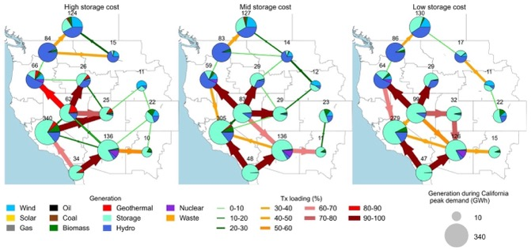

Figure 3. 36: Electricity Generation and Transmission Loading for High Imports
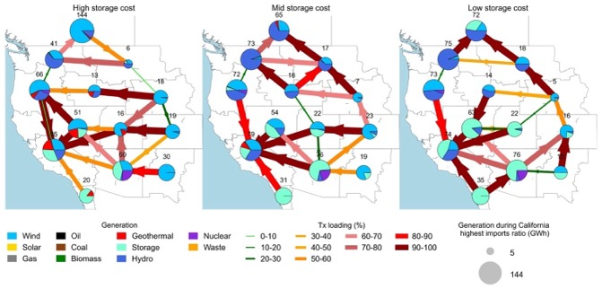

Investigating California’s situation amid the WECC grid expansion, lower storage costs lead California to increase its solar capacity up to 205 GW (15% increase) (Figure 3.37), its storage power capacity up to 104 MW (50% increase) (Figure 3.38), and its storage energy capacity up to 1157 GWh (150% increase) (Figure 3.39). Moreover, lower storage costs result in longer average storage duration in California, increasing from 6.8 h to 11.3 h (Figure 3.40). In contrast, lower storage costs lead to up to 60% slower deployment rates of wind capacity in California (Figure 3.41). This reveals that lower-cost wind would better compete with low-cost storage plus solar. In this manner, R&D efforts are required to advance cost reductions and flexible deployments of wind resources.

Figure 3. 37: Solar Capacity in California vs Transmission Build-out.
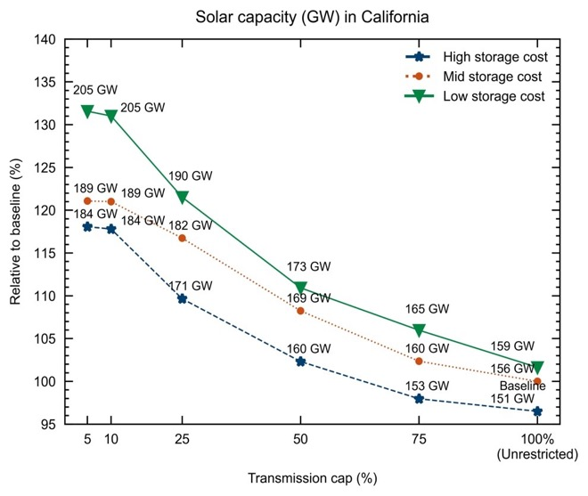

Figure 3. 38: Storage Power Capacity Deployed in California vs Transmission Build
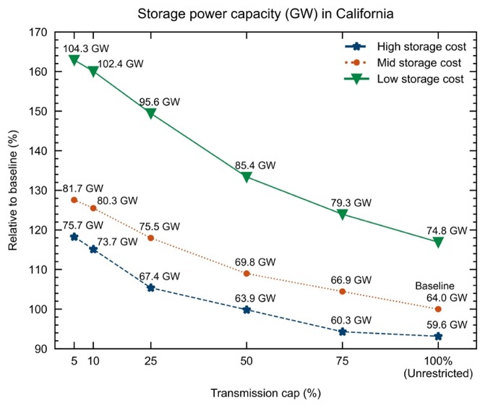

Figure 3. 39: Storage Energy Capacity Deployed in California vs Transmission Build
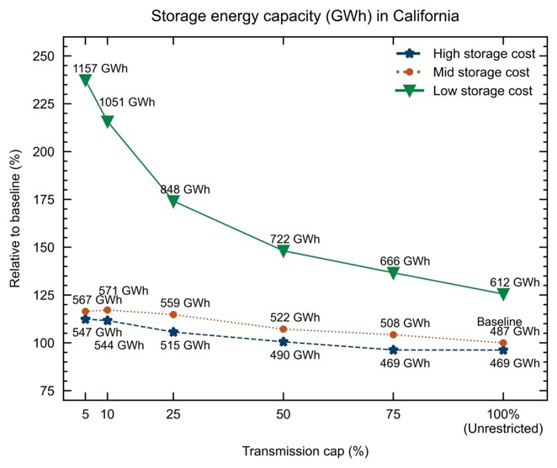

Figure 3. 40: Average Storage Duration in California vs Transmission Build out
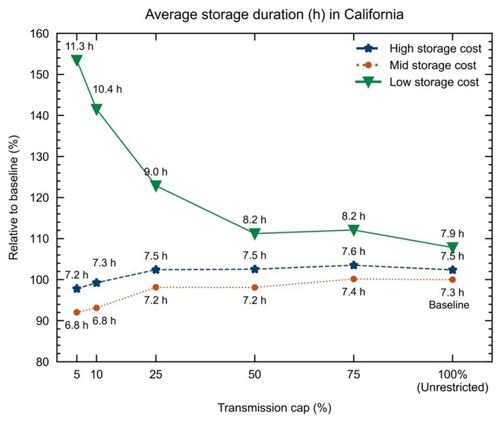

Figure 3. 41: Wind Capacity Deployed in California vs Transmission Build out
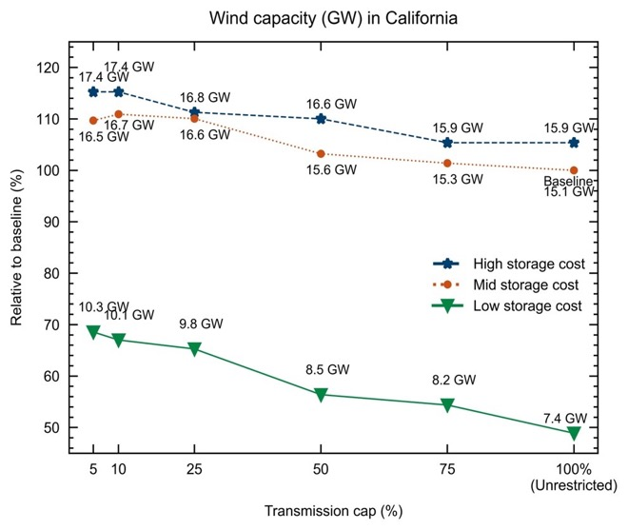

Furthermore, we find that regardless of storage costs declining, when almost no transmission expansion is allowed across the WECC, California requires up to 34% more in-state generation capacity for 2050 (Figure 3.42). In fact, up to 30% more solar capacity (Figure 3.37), up to 50% more storage power capacity (Figure 3.38) and up to 20% more wind capacity (Figure 3.41) is deployed in California in response to restricting the expansion of transmission capacity across the WECC (Figure 3.41).

Figure 3. 42: Installed Generation Capacity in California for 2050
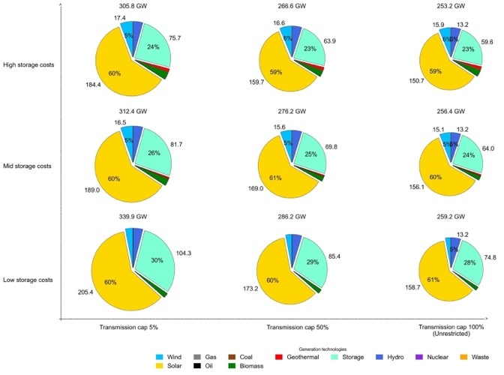

Finally, we find that despite lower storage costs and reduced transmission capacity across the WECC, California will continue being a net importer in 2050 (Figure 3.43). However, in the scenario when the expansion of transmission is highly restricted (capacity cap of 5%) and storage costs are the lowest, California’s monthly generation exceeds its monthly demand in July, August, and September. Hence, in 2050 it becomes a summer net exporter –when the rest of the WECC would benefit the most (Figure 3.44).

Figure 3. 43: Fraction of Annual California Load met by California Generation
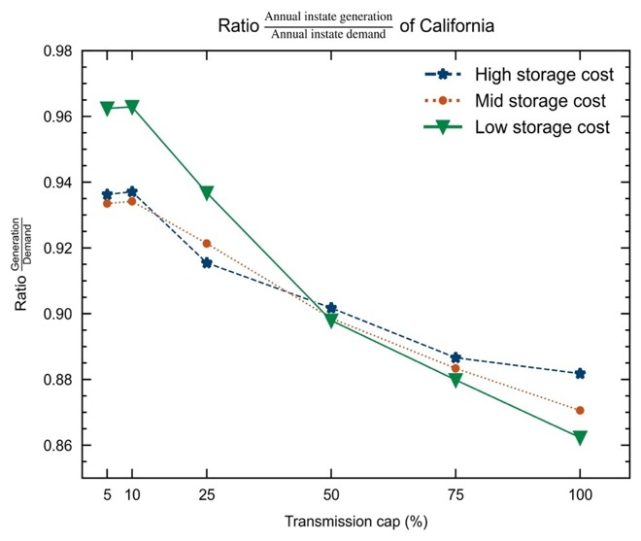

Figure 3. 44: Fraction of Monthly California Load met by California Generation
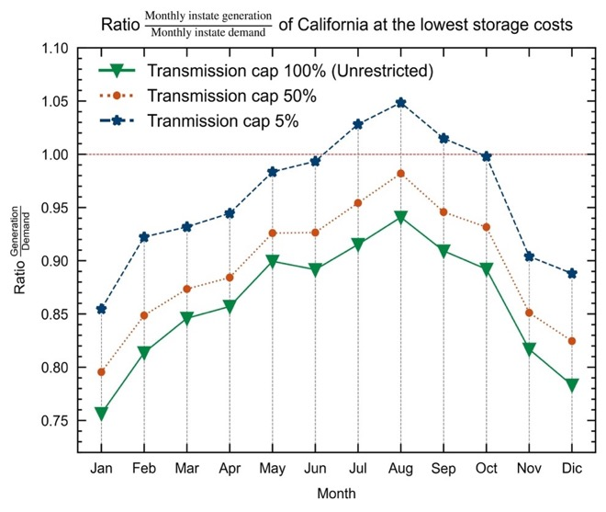

In conclusion:

- As storage costs decline, the WECC deploys more solar capacity and more storage energy capacity.

- Storage cost declines result in:
- building less transmission in the WECC,
- higher loading for existing transmission lines,
- building less transmission within California, and
- building more transmission between California and its neighbors.

- When transmission buildout is constrained to 5% of that selected for the baseline and storage costs are the lowest that was modeled, California’s storage duration increases up to 11.3 h (compared to 7 h in the baseline).

3.12 Impact of Increasing LDES Deployment in the WECC⁴

An increase in energy storage could be achieved through policy, such as the implementation of LDES mandates, or R&D resulting in LDES cost decrease, etc. The baseline containing 1.94 TWh of energy storage (no storage energy capacity forced) was modified to study 13 scenarios where the amount of energy storage is forced to be anywhere from 2 to 64 TWh. As the deployment of LDES increases, electricity prices will change. Based on a study of 13 scenarios in which the energy storage was forced to be between 2 and 64 TWh, Figure 3.45a shows how the adoption of LDES reduces variability in electricity prices, especially for the first 20 TWh of installed LDES.

In a zero-emissions 2050, marginal electricity prices are highest at night and the deployment of energy storage reduces marginal prices for all times of day (Figure 3.45c). The average marginal price of electricity is 29% to 52% higher at night (8 pm, midnight, and 4 am) than at noon since cheap solar generation is not available during the night. In the baseline scenario, July and December marginal electricity prices are highest at 180 $/MWh and 310 $/MWh respectively due to high demand during these months (Figure 3.45d). As energy storage is added to the grid, the high July and December prices are reduced but prices in neighbouring months increase. In the 20 TWh scenario, average marginal prices for July, August, November, December and January range from 52 to 100 $/MWh while other months average 35 $/MWh or less.

Figure 3. 45: Impact of LDES Mandates on the Marginal Price of Electricity

In summary, our results show that a 2050 decarbonized grid with greater storage energy capacity would reduce daily and seasonal variability in the marginal price of electricity while also reducing the marginal price of electricity across all regions and times of the day. As such, policies, subsidies, mandates, technology development or other events that would increase the penetration of storage resources in the WECC would likely result in lower prices in the wholesale electricity market while reducing price surges in July, December and night-time hours.

CHAPTER 4:
Conclusion
As California transitions to a renewable energy driven grid with zero carbon emissions for retail electricity by 2045, energy storage will be critical. Today’s 4-h lithium batteries (about 7 GW) are providing very useful service to the grid, but the 4-h duration will not be adequate for getting through each night as the state transitions away from natural gas. This project found that an 8-h battery is well suited for supporting California in 2045 because solar electricity is likely to dominate the renewable energy build out. The 8-h batteries will be charged while the sun is up, discharge quickly during peak demand in the early evening, and then discharge more slowly for the lower demand experienced during the night.

Approximately 70 GW of 8-h storage will be beneficial and may be cycled more than 300 times per year. The optimal duration for the most common type of storage may be as low as 7 hours when the entire WECC is considered or may increase to 10 to 12 hours when more wind generators are built or if the added cost of longer duration is quite small.

In addition to the 8-h storage, the models found that a small amount of 100-h storage may be beneficial. For the scenarios modeled, the 100-h storage typically displaced a few percent of the 8-h storage, especially in 2045.

The relative cost that enabled a LDES product to displace 50% of 4-h Li batteries decreased into the future, suggesting that, while 8 hours of storage is still needed to get through the night, reduced use of peaker plants to meet zero emissions targets may require an increased part of the storage fleet to function like peaker plants in 2045, increasing the attractiveness of 4-h storage. The opposite dependence on years into the future was found when considering displacement of 1% of Li batteries, demonstrating that the value of LDES relative to 4-h storage will increase in the future, but at approximately 1-GW scale rather than at tens of GW scale.

While high efficiency increases the value of LDES that is cycled daily, the LDES that is adopted at the 1% level is cycled less frequently, reducing the importance of efficiency.

All modeled scenarios found that California will continue to be a net importer of electricity, though California will export electricity during the day when solar electricity is abundant. If additional transmission is built, the electricity generated in California may decrease even more with California net importing more than 10% of its electricity on an annual basis.

For decreasing storage costs, the model chose to build fewer transmission lines, though some lines connecting California to its neighbors were selected for build to larger capacity when storage costs were decreased. Wider deployment of storage was found to both decrease the cost of electricity and decrease the variability of the cost of electricity.

Today’s flexible loads are too small to be very helpful in balancing supply and demand of electricity, but tomorrow will bring two very large flexible loads: electric vehicle charging and electrolyzers for hydrogen generation. The use of day-time charging of electric vehicles was found to reduce the selected storage by about 10%, saving on order of $1 billion. Electrolyzers were found to contribute to seasonal load balancing by turning off during the winter. Surprisingly, the electrolyzers were found to operate at a capacity factor of 40%, exceeding the capacity factor of the solar plants that provided power for them, suggesting that batteries supply the electrolyzers with electricity at some hours. Thus, the availability of under-used assets (curtailed electricity combined with ample storage) may be enabling for green hydrogen.

The use of solar and wind generation profiles (by changing the solar mounting configuration and selecting wind locations with stronger winter-time wind) that had better seasonal match to the load profiles reduced curtailment, but the reduction in curtailment must be balanced with the potential increase in cost of the system.

The use of oxy-combustion could help to reduce the need for storage, but questions remain about the rate of scale up of both the oxy-combustion generators and the infrastructure for sequestration of the generated carbon dioxide.

More complete summary of the results of this study may be found on line.

Glossary and List of Acronyms

Term | Definition
CAISO
CCGT
CEC
CPUC IRP PSP
EV
IEPR
IRP
LDES | Long duration energy storage
R&D
RESOLVE
SWITCH
UC
WECC

References
Allam R. et al., Energy Procedia, 2017.

Gerke, Brian, et al. "The California demand response potential study, phase 3: final report on the shift resource through 2030." (2020). DOI: 10.20357/B7MS40

Kittner, N., S. Castellanos, P. Hidalgo-Gonzalez, D. Kammen, & S. Kurtz, (2021). “Cross-sector storage and modeling needed for deep decarbonization.” Joule, 5(10), 2529-2534.

Lindogan, P., Shan, R., Kittner, N. Projecting PEM Electrolyzer Costs Under Different Deployment Scenarios. In prep for International Journal of Hydrogen Energy.

Mahmud, Z. S. Kurtz, “Effect of Solar Mounting Configuration on California Zero-Carbon Grid” Photovoltaic Specialists’ Conference, 2023.

Mahmud, Z., Kenji Shiraishi, Mahmoud Y. Abido, Pedro Andres Sanchez-Perez, and Sarah R Kurtz, “Hierarchical approach to evaluating storage requirements for renewable-energy-driven grids" iScience, Vol. 26(1), 105900, Jan. 2023. Open access

Mahmud, Z., K. Shiraishi, M. Abido, D. Millstein, P. Sanchez, and S. Kurtz, “Geographical variability of summer- and winter-dominant onshore wind" Journal of Renewable and Sustainable Energy, Volume 14, 023303, 2022. Open access

Shan, R., J. Reagan, S. Castellanos, S. Kurtz, and N. Kittner. "Evaluating emerging long-duration energy storage technologies" Renewable and Sustainable Energy Reviews,
Volume 159, 2022. Article

Staadecker, Martin, Julia Szinai, Pedro A. Sánchez-Pérez, Sarah Kurtz and Patricia Hidalgo-Gonzalez. The Value of Long-Duration Energy Storage under Various Grid Conditions in a Zero-Emissions Future, 16 October 2023, PREPRINT (Version 1) available at Research Square [https://doi.org/10.21203/rs.3.rs-3422677/v1]

ZareAfifi, F., and S. Kurtz, (2023, October). “Powering the future: electric vehicle charging profile impact on California’s future energy storage needs.” North American Power Symposium (NAPS-2023)

ZareAfifi, Farzan, Zabir Mahmud and Sarah Kurtz, “Diurnal, physics-based strategy for computationally efficient capacity-expansion optimizations for solar-dominated grids", Energy, Vol. 279, 128206, 2023. On line

Project Deliverables
To be discussed:
The Project Deliverables include a bulleted list of the products produced — primarily the deliverables noted in the key technical tasks — as identified in the Agreement and Scope of Work, and where they can be accessed.
- Products can include reports, surveys, questionnaires, analyses, workshops, etc.
- The Commission Agreement Manager may have suggestions on appropriate, high-value interim deliverables to include.
- Indicate that project deliverables, including interim project reports, are available upon request by submitting an email to pubs@energy.ca.gov.
- If appropriate, indicate that project deliverables can also be found on the research team’s website (include URL).

APPENDIX A:
Appendix Title [Example Title: Installation and Field Service Details]
Length of 15 pages or fewer.
Each appendix, if more than one, contains both a letter and a title

The Appendices will be created in response to CEC feedback.

Gerke, Brian, et al. "The California demand response potential study, phase 3: final report on the shift resource through 2030." (2020). DOI: 10.20357/B7MS40
https://sites.ucmerced.edu/ldstorage/publications%20version%202
Mahmud, Z., K. Shiraishi, M. Abido, D. Millstein, P. Sanchez, and S. Kurtz, “Geographical variability of summer- and winter-dominant onshore wind" Journal of Renewable and Sustainable Energy, Volume 14, 023303, 2022. Open access
https://www.energy.ca.gov/data-reports/reports/integrated-energy-policy-report
https://efiling.energy.ca.gov/Lists/DocketLog.aspx?docketnumber=20-MISC-01
Shan, R., J. Reagan, S. Castellanos, S. Kurtz, and N. Kittner. "Evaluating emerging long-duration energy storage technologies" Renewable and Sustainable Energy Reviews, Volume 159, 2022. Article
https://www.cpuc.ca.gov/-/media/cpuc-website/divisions/energy-division/documents/integrated-resource-plan-and-long-term-procurement-plan-irp-ltpp/2023-irp-cycle-events-and-materials/draft_2023_i_and_a.pdf See Fig. 9 on p. 81.
ZareAfifi, Farzan, Zabir Mahmud and Sarah Kurtz, “Diurnal, physics-based strategy for computationally efficient capacity-expansion optimizations for solar-dominated grids", Energy, Vol. 279, 128206, 2023. On line
https://files.cpuc.ca.gov/energy/modeling/2021%20PSP%20RESOLVE%20Package.zip
https://github.com/REAM-lab/switch
Shan, R., J. Reagan, S. Castellanos, S. Kurtz, & N. Kittner. (2022). “Evaluating emerging long-duration energy storage technologies.” Renewable and Sustainable Energy Reviews, 159, 112240.
https://sites.ucmerced.edu/files/ldstorage/files/epc-19-060-storage_technology_summary_task_3.1.pdf and https://sites.ucmerced.edu/files/ldstorage/files/epc-19-060_storage_scenarios_summary_task_3.2.pdf
Kittner, N., S. Castellanos, P. Hidalgo-Gonzalez, D. Kammen, & S. Kurtz, (2021). “Cross-sector storage and modeling needed for deep decarbonization.” Joule, 5(10), 2529-2534.
https://www.smart-energy.com/storage/first-grid-scale-gravity-energy-storage-system-commissioned-to-chinese-grid/. 650 million RMB total investment for a 100MWh project (~880 USD/kWh) while in the previous table, it was $200-300 USD/kWh
Lindogan, P., Shan, R., Kittner, N. Projecting PEM Electrolyzer Costs Under Different Deployment Scenarios. In prep for International Journal of Hydrogen Energy.
For 2045, assuming LDES with 85% efficiency and cost of $66/(kW-y) which translates to about $950/kW.
https://sites.ucmerced.edu/files/ldstorage/files/epc-19-060_storage_scenarios_summary_task_3.2.pdf
https://www.energy.ca.gov/programs-and-topics/programs/electric-vehicle-charging-infrastructure-assessment-ab-2127
In the CEC study, this case is called the “High Residential Access” alternative future.
In the CEC study, this case is called the “Happy Hour” alternative future.
ZareAfifi, F., and S. Kurtz, (2023, October). “Powering the future: electric vehicle charging profile impact on California’s future energy storage needs.” North American Power Symposium (NAPS-2023).
Mahmud, Z. S. Kurtz, “Effect of Solar Mounting Configuration on California Zero-Carbon Grid” Photovoltaic Specialists’ Conference, 2023.
Z. Mahmud, K. Shiraishi, M. Abido, D. Millstein, P. Sanchez, and S. Kurtz, “Geographical variability of summer- and winter-dominant onshore wind"Journal of Renewable and Sustainable Energy, Volume 14, 023303, 2022. Open access
Mahmud, Z., S. Kurtz, in preparation.
Zabir Mahmud, Kenji Shiraishi, Mahmoud Y. Abido, Pedro Andres Sanchez-Perez, and Sarah R Kurtz, “Hierarchical approach to evaluating storage requirements for renewable-energy-driven grids" iScience, Vol. 26(1), 105900, Jan. 2023. Open access
Allam R. et al., Energy Procedia, 2017.
Martin Staadecker, Julia Szinai, Pedro A. Sánchez-Pérez, Sarah Kurtz and Patricia Hidalgo-Gonzalez. The Value of Long-Duration Energy Storage under Various Grid Conditions in a Zero-Emissions Future, 16 October 2023, PREPRINT (Version 1) available at Research Square [https://doi.org/10.21203/rs.3.rs-3422677/v1]
https://sites.ucmerced.edu/ldstorage/publications%20version%202

