Demand Programs Should Drive – Not Lag – the Transition to Renewable Generation
Masoumeh Amirifard,ª Ronald A. Sinton ^{b}, Sarah Kurtz ^{c}
ª University of Tehran, Tehran, Iran, m.amirifard@ut.ac.ir
^{b} Sinton Instruments, Boulder, CO, USA, ron@sintoninstruments.com
^{c} University of California Merced, Merced, CA, USA, skurtz@ucmerced.edu

Abstract— Forward-looking strategies for demand management for future electricity systems have the potential to profoundly accelerate the adoption of renewable electricity. Time-varying rates are increasingly used to motivate load shifting, capitalizing on the increasing size of loads that can be easily shifted, such as electric vehicle charging and electric heat pumps. This study analyzes the time-of-day availability of renewable electricity seen today and anticipated for tomorrow for two representative grids that are moving toward high penetration of renewable electricity. While many demand management programs currently are designed to shift load to nighttime when demand is low, we show that shifting load to daytime will provide the lowest cost solution in the future for grids with significant solar penetration. Given that investments in electricity generation capacity shape the grid for decades to come, capacity expansion planning should anticipate how demand management programs (and associated load shapes) will change in the future and that the simple guideline of shifting loads to times when the sun is up will give the best results for most locations, both for cost and cleanliness of the grid.

Index Terms—EV charging, demand response, load management, renewable energy.

Introduction
With growing demand for electricity, including soaring investment in electric vehicles (EVs) [1], heat pumps [2], and electrolyzers, most utilities are planning to expand their available electricity generating capacity. Interconnection queues are considering projects that could more than double the electricity generating capacity in the United States [3] and elsewhere [4]. As these capacity expansion projects are selected, utilities must evaluate whether the new generating capacity will reliably meet future load profiles. This quickly raises the question of whether tomorrow’s load profiles will take the same shape as today’s profiles, especially as the new loads have different requirements than existing loads.
Many of the new electrical loads have more flexibility than existing loads. For these, demand-side-management programs are already being implemented to encourage electricity use when it’s most convenient for the grid. Demand response that shifts load is possible when loads are flexible – an electric vehicle is usually a flexible load because a vehicle can be charged whenever it’s parked, while most of today’s loads (e.g. lighting) are usually inflexible. In the US, interests in demand-response and load-management programs programs started rising in the 1970s with the emergence of home air-conditioning systems and associated load peaks. Subsequently, various management policies, including price-based and direct-control programs, were implemented to reduce load peaks. Incentives for time-based pricing such as time-of-use pricing, real-time pricing, critical-peak pricing, and emergency demand response can be used to manage demand response. Customers can choose when to use electricity and when not based on the time-varying price of electricity [5].
While utility policies for demand management have traditionally been designed to reduce grid operating costs and share the savings with the customers who enabled the savings, interest has been developing to use demand management to also reduce carbon emissions by reducing electricity usage when the most polluting power plants are active. Design of a demand management system can be quite complicated. Barbero et al., for example, compared two demand aggregator strategies using energy market and weather forecasts as inputs and found that both were successful in reducing CO₂ emissions as well as cost, but differed in their ease of implementation [6]. Albertsen et al. [7] compared three dynamic electricity taxation schemes in Denmark using six metrics and found that it was not possible to select a single optimal solution, though some schemes were more effective than others.
As Albertsen, et al. found, even agreeing upon the metrics used to evaluate a demand-management program’s success can be challenging. Two common metrics for evaluating CO₂ emissions reduction are the average carbon-emissions rate and marginal carbon-emissions rate. Marginal emissions rates are of special interest to those attempting to reduce today’s emissions by shifting today’s demand (which the customer can do) as a complement to focusing on which generator is chosen to serve that demand (which is most commonly controlled by a balancing authority). The “marginal emissions factor” can be calculated in multiple ways [8]. Thind et al. [9] compared average and marginal emissions factors and found that the two metrics often differ by a factor of five. Huber et al. [10] also calculated marginal emissions factors and defined “smart charging” that reduced CO₂ emissions from electric vehicle charging by 1% to 10%, though the “smart charging” sometimes increased peak loads.
While it’s not clear whether average or marginal emissions is a better metric for identifying success of a demand-management system, one could argue that the most important metric is the emissions over multiple years. Gagnon and Cole [11] evaluated a “long-run marginal emissions rate” metric, which includes both operational and structural effects, and found that the “long-run marginal emissions” metric correlated better with the observed emissions than either the average or short-run marginal emissions. Specifically, they modeled the adoption of new electricity generators across all of the U.S. between 2022 and 2050 for various load shapes and concluded that the long-run emissions factor was best at tracking the observed results of the model. While Gagnon and Cole focused their discussion on the best metric for guiding design of demand-management programs, their analysis elucidated how the demand profiles that were added for the new loads determined which generators were added in the capacity expansion.
This paper discusses and further elucidates why Gagnon and Cole found a strong correlation between the shapes of the load profiles they added and the emissions of the associated expanded grid. We start by reviewing how adoption of solar electricity is predicted to be important almost everywhere in the world. We then present planned solar growth Colorado’s grid, based on official documents. We evaluate both historical and projected data to identify the cleanliness of the grid for every hour of the year. We compare this result for Colorado (which is preparing to expand use of solar electricity) with California (which already generates > 25% of electricity from solar). We then show how existing time-of-use rates are designed for the current grid, lagging behind the advancement of the grid. We then use the analysis of Gagnon and Cole to show how the choice of the profile for the newly added load will be pivotal in shaping the generation mix in tomorrow’s grid. Finally, we show that data from California suggest that following the strategy of shifting loads to daytime hours simultaneously reduces carbon emissions and shifts load to times of lower prices.

Expected importance of solar PV to a clean grid
As the cost of solar electricity dropped by about a factor of ten between the late 1990s and around 2015, becoming cost competitive with conventional electricity generation in many locations [12], the adoption of PV has increased. Global electricity capacity for photovoltaic (PV) solar generators now exceeds 1 TW [13]. Breyer et al. [14] investigated the role of solar PV by reviewing global energy transition scenarios for 2030, 2050, and 2100 in several sub-regions around the globe. Their results highlighted solar PV as the largest energy resource in both mid-term and long-term future energy systems in almost every country in the world. They calculated that wind and solar would each provide >40% of electricity worldwide.
We already observe the adoption of PV. As the cost of solar electricity has become competitive, utilities like the Public Service Company of Colorado, PSCo, are aggressively adopting PV. PSCo runs its own balancing area with its reported generation corresponding to about 81% of the balancing area total. This allows for public Energy Information Administration data to be used to fill gaps in the utility data released to the public. PSCo is rapidly replacing coal-fired generation with wind and PV with a mandate to reduce CO₂ generation by 80% relative to a 2004 baseline. From 2004, the primary renewable resource installed was wind, reaching 25% wind by 2019. As the new plans are implemented by the end of 2023 (delayed only slightly because of supply issues), PV will become very significant, increasing from about 5% to 15% of total generation (Fig. 1).
The key result in Figure 1 is the rapid increase in PV by 2023. Figure 1 compares EIA data [15] for the entire state of Colorado for the fraction of electricity supplied by PV, from 2015-2021, with data specific to PSCo territory from 2019-2030 [16]. By plotting the percentage of total electricity that is PV, the PSCo data are similar to the entire state in the overlapping years, indicating that the PV fraction in PSCo territory is similar to the rest of Colorado in those years. The squares are data from a 2021 resource planning docket at the PUC. The data are interpolated between 2023 and 2030 based on listed renewable resource additions for years in which no specific percentage of renewables was reported in the regulatory proceeding. Intuitively, it is interesting to realize that 15% of annual electricity arriving primarily in eight of 24 hours per day means that for noon the electricity can be close to 50% from PV.

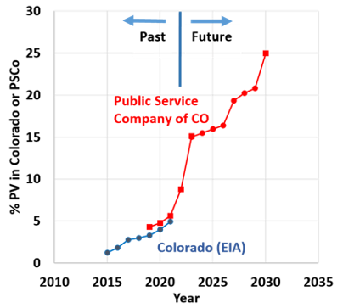
- Percentage of power from PV vs. Year, past [15] and projected [16], for Colorado

Methods For Data analysis
This study analyzed the composition of past and future electricity generation using EIA electricity generation for Colorado and California balancing areas. The percentages of fossil fuels were calculated for 8760 hours per year for both areas using Eq. 1:
$$Fossil fuel generation(t)=\frac{Total generation\left(t\right)-Clean generation(t)}{Total generation(t)}$$ | (1)

where Total generation(t) is the total electricity generation in hour t and Clean generation(t) is the sum of the renewables, hydropower, and nuclear generation in hour t. (Note that Colorado has no nuclear power plants and California generates 8 % from nuclear reported by EIA. For simplicity, we refer to the non-fossil fuel generation as “renewable.”) For Colorado the hourly EIA data [15] for 2019 were used, with projections for PSCo calculated for scaling the PV and wind resources using the resource plans derived from reference [16] (Fig. 1). For California the hourly EIA data [15] for 2022 were used. Here, the geothermal and biomass are assumed to be a part of “other” energy resources in the EIA data. Reference [15] EIA reports the hourly utility-scale solar resources. The small-scale solar generation has grown large enough to affect the calculation in California, so the utility-scale solar was increased by an average factor of 1.6, based on EIA data [17].
The resulting hourly data were plotted as heat maps. The annual average values of fossil-fuel generation for each hour of the day were derived by calculating the average values throughout the entire year.
For the analysis of the pricing data, the California Independent System Operator (CAISO) [18] data for day-ahead price of electricity were used. This set of data is used as the CAISO results for fossils generation (not given here) have similar trends with the state of California. The seasonal averages for both price and fossil-fuel intensity were calculated for Spring (March – May), Summer (June – August), Fall (September – November), and Winter (January – February and December) all in 2022.

Results

Renewable fraction vs. hour and season
Figure 2 shows EIA data for the fraction of total generation from fossil fuels for four cases. The top graphs (Fig. 2a) show the generation reported for 2019 for Colorado. Then, in Figs. 2b and 2c, for 2023 and 2030, the PV and wind from the 2019 data are scaled to the fraction reported by PSCo in their resource planning projections. The fourth and final set of graphs (Fig. 2d) show the composition of electricity generation resources in California for 2022. Here, 2019 (Fig. 2 (a)) and 2023 data (Fig. 2 (b)) are based on the 2016 resource plan approved in 2018, and 2030 generation data (Fig. 2 (c)) is based on the 2023-2030 plan proposed in 2021. The hourly data are shown as heat maps on the left set of graphs in Fig. 2, with the hour of the day plotted on the y axis and the day of the year plotted on the x axis, with the color indicating the fraction of fossil-fuel generation for each hour. The set of graphs on the right side of Fig. 2 show the average daily trends for that year, with the fossil-fuel generation indicated by black and the renewables fraction indicated by green.
The visualizations for 2023 and 2030 are the fossil-fuel percentages that were reported in 2019 with added generation from the PV and wind resources planned for 2023 and 2030. The abrupt increase in PV is obvious in the 2023 projection, as the daytime hours become suddenly very clean with bright green being hours with 100% renewable electricity available due to the 25-39 percent already served by wind. From the 2019 data when there was little PV (Fig. 2a), it is clear that wind has little daily pattern when taken as an annual average. Days become progressively cleaner as the PV additions rise gradually through the decade, arriving at the 2030 visualization, in which daytime is saturated with renewable energy. The difference between night and day makes intuitive sense as well. Onshore wind usually has a capacity factor of about 40-50%. From Figure 2, this wind is not on a daily schedule, but is periodic with a few windy days followed by days with less wind. April was generally windy in 2019. With this pattern, it is difficult to exceed 50% renewables at night on average without extensive curtailment. On the other hand, the capacity factor for PV during daytime hours can be very high. During daytime, the PV and wind generation may displace fossil fuel entirely. The high capacity factor for PV during daytime hours complemented by wind makes it quite straightforward to approach very high fractions of renewables in a region with Colorado’s resources.
Comparing the future predictions of Colorado with the patterns for a location that already has reached a high level of solar energy targets can confirm the accuracy of the projections. California is aiming to obtain 100% clean electricity in the near future based on California’s Senate Bill 100 [19]. California currently uses both clean sources for electricity generation such as utility-scale solar and small-scale solar, wind, hydro, and nuclear electricity and fossil fuels including oil, natural gas, and coal. This state exports/imports significant electricity from/to other neighbor territories which must be considered in the strategy that is used for calculating the percentage of fossils [15]. Here, the calculations are based on electricity generation including exports and exluding imports. Even now, analyzing the electricity generation resources using EIA data [15] illustrated in Fig. 2d can show a high level of clean sources in daylight hours in California. That is to say, the projected green pattern in Colorado 2030 already can be seen in California with about 70% of renewables in noon hours for the average results for 2022.
While Fig. 2 highlights how electricity generation during the day will be cleaner than electricity generation at night, an important question is how the cleanliness of the generation will relate to cost profiles. To assess the relationship between cost and cleanliness, we compare the cost of electricity in California (Fig. 3a) with the seasonal fossil intensity of electricity (Fig. 3b). Both graphs show lower values during the middle of the day, showing strikingly similar general trends when inspected both for the diurnal and seasonal patterns. Thus, lower prices in daylight hours correlate with the higher renewables generation in those same hours. Day-ahead data for the price of electricity from CAISO (Fig. 3a), and EIA data for electricity generation (Fig. 3b) are used [15, 18]. Although the electricity prices often don’t correlate with CO₂ emissions, Fig. 3 shows the anti-correlation between the average price and the average emissions in electricity systems with high penetration of PV resources. Similar trends are seen for all seasons in California for the 2022 year in both price and fossil fuels intensity cases.
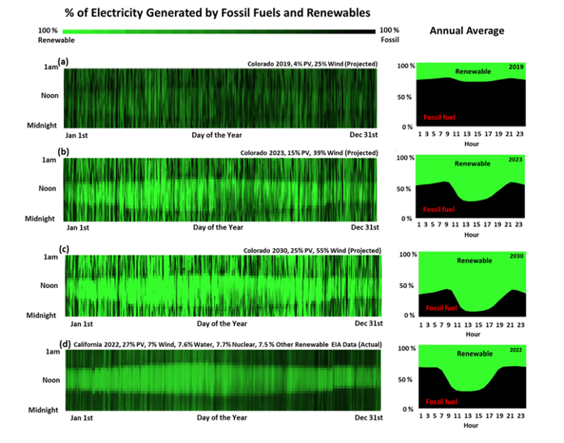
- Percent fossil-fuel generated electricity for 8760 hours per year and annual average percent fossil fuel for each hour based on the EIA data for (a) Colorado for the year 2019 [15], (b) the projection for 2023 [16], (c) the projection for 2030 [16], and (d) California for the year 2022 [15]
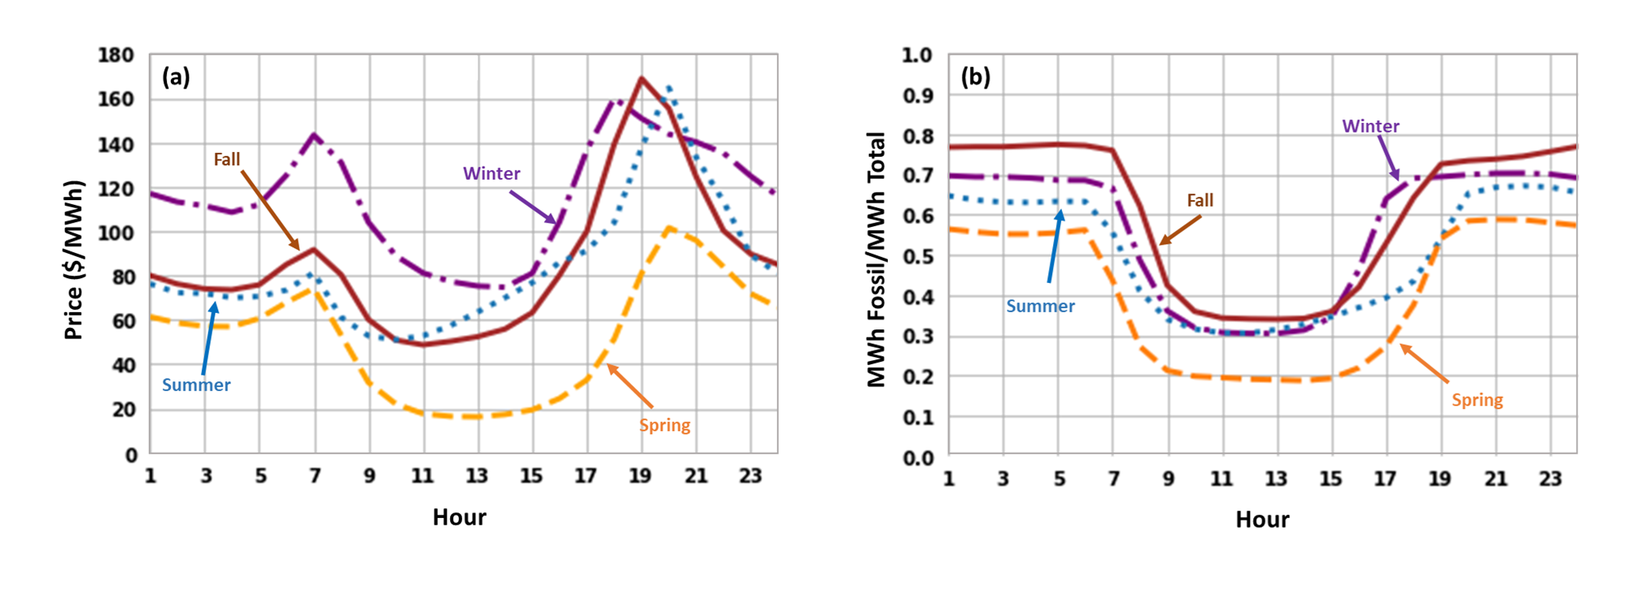
- Seasonal average of a) day-ahead price of electricity [18] and b) the fossil fuel intensity of electricity [15] for California in 2022.

Demand-management design often lags
A discussion of the evolution of demand management for PSCo during this same period is equally interesting in the details for different reasons. The primary tools currently used for demand management include programs to shed load during the demand peaks (especially summer air conditioning peaks) and time-of-use, TOU, rates designed to discourage power use during these summer demand peaks. Both of these techniques have been very slow to change in comparison to the rate of replacement of coal plants with PV and wind. The air-conditioning peaks are quite obvious in Figure 2, for 2019, when the afternoons in August use high fractions of fossil-fueled electricity.
What is evident in Fig. 2 in the hourly average fossil-fuel intensity graphs in 2019 is that the fossil- and wind-driven grid had no strong annual trend to prefer any particular hours to minimize CO₂. In contrast, by 2023, daytime hours become much cleaner. It can be appreciated from the experience of California that high generation of solar electricity during daytime also creates low prices during daytime (Fig. 3).
TOU rate development for PSCo in Colorado started in 2016 [20]. A pilot program was followed by a TOU docket resulting in a settlement to install new meters and implement a TOU rate phased into the entire territory by 2025. The rate chosen, shown in Fig. 4, has vestiges of its origin in 2016 in that it is designed for the 2016 grid, a fossil-fueled grid. Data presented by the utility to optimize the rate was for 2022, which from Fig. 1 can be seen to be just prior to the installation of approximately 1 GW of utility solar. The TOU rate was designed solely to reduce the demand peaks. It was not designed for the future net-demand peaks (demand-renewables) or the cleanest available power when renewables meet large fractions of the load.
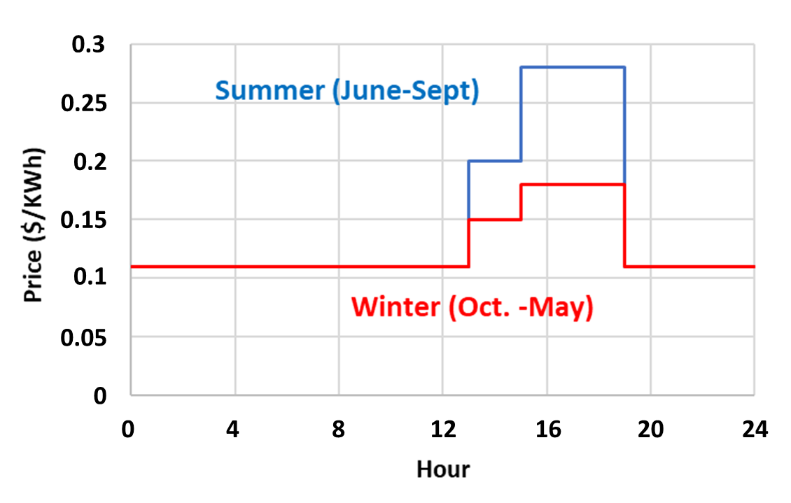
- The time-of-use week-day rates being used in PSCo territory phased in through 2025 [21]
The TOU rate shown in Fig. 4 does not shift power use into daytime when renewables are abundant during all four seasons of the year. The institutional momentum from a process that stretches over nine years results in rate design that fails to adapt to a rapidly changing generation mix.
In the 2021 resource plan to determine retirement dates of coal plants and choose replacement resources, this same TOU rate was assumed to persist through the entire planning period, with a major effect on the assumed hourly demand profile for 30 years. The reason given for this is that it was the only rate approved by the PUC. Any other rates or resulting demand profiles were said to be “speculative” and put off to a future PUC docket dealing specifically with transportation rates [22]. It was not considered suitable for discussion within a resource plan. In a subsequent demand-side management strategic issues docket that is in progress, TOU and EV managed charging are again said to be better handled in future more specialized dockets. The opportunity to change demand patterns to better match renewable generation before 2030 was assumed to have no effect on the choice of new generation.

Opportunity for demand management to affect resource planning
Recent publications have dealt with the very relevant case of EV charging optimization to reduce grid impacts on the Western Electricity Coordinating Council, WECC, grid as it trends towards clean energy with a large fraction of PV [23]. The general conclusion of that study is “…shifting drivers from home to daytime charging improves all metrics of grid impact including ramping, use of non-fossil fuel generation, storage requirements, and emissions.” As illustrated in Fig. 3, EV charging during daytime would use the cleanest and lowest cost electricity in California, as has been discussed in previous publications [24, 25]. Thus, there is an opportunity for a forward-looking demand-management program to influence resource planning. However, the process to develop new rates and demand management is based on historical data, typically including a pilot study of several years, and achieving consensus of all parties that might be impacted by changes in rates.
The results for Colorado and California show the possibility of enjoying low cost and clean sources in daytime if demand management can successfully guide new loads toward daytime. A study of the entire U.S. by Gagnon and Cole [11] demonstrates the impressive opportunity. They studied three metrics including average emission, long-run, and short-run marginal emission rates to show the effect of different demand shape strategies on the mixture of resources selected to address new demands. Three main load interventions used in their study together with the selected combinations of resources based on each load shape are shown in Fig. 5. These three load shapes include adding load during all hours of the day (orange), adding load in non-daylight hours (black), and in daylight hours (green). Gagnon and Cole focused on the conclusion that the long-run marginal emission rate best correlated with the observed results. We have plotted (Fig. 5) their load profiles and the capacity expansion results to better understand the striking result of how adding load during daylight hours results in selection of solar and wind resources to meet the new load.

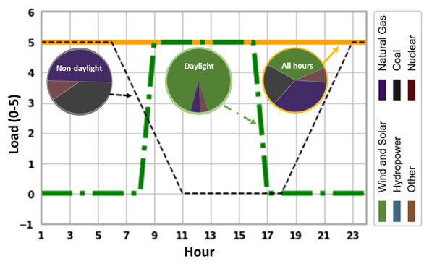
- Three load shapes used by Gagnon and Cole [11] and their effects on projected adoption of electricity generating technology

Challenge of including demand management in resource planning
Because demand projections are central to resource planning (as illustrated graphically in Fig. 5), the lag-time between demand-management program approvals compared to resource additions can have a major impact on resource acquisition. The historical demand profiles, as a function of season and time of day, have been shaped by the electricity supply and costs. Historically, this supply has been a “baseload” system that at one time was mostly coal in many places. The demand profile also depends on the relative use of gas and electrical heating, air-conditioning, building designs and building codes, mostly gasoline-driven transportation, commuting patterns, and industrial power use. All of these factors will be rapidly changing in the near future to meet decarbonization goals. The traditional baseload power system had excess capacity of coal and gas at night, which led to utility messaging to shift power use into nighttime.
Past practice of assuming that this demand shape is slowly varying in the future has been a functional and practical approach in the past. Such an approach is currently evidenced by recent resource plans and proposed demand-management plans in Colorado [26, 27]. The lack of coordination between demand-management planning and resource planning has major implications on resource planning. Simply put, if historical seasonal and daily demand profiles are assumed into the future, then the capacity-expansion models will essentially “choose” a resource mix that can emulate the coal and gas plants that are being retired. There are several mechanisms in the apparently objective resource planning that create this effect. If the projection is that 80% of EV charging for the next 30 years is at night, then resource planning will not select PV to meet this load [25]. More subtle mechanisms also exist. The calculation of effective load-carrying capacity, ELCC, is based on a loss-of-load-probability calculation using historical demand profiles [28, 29]. This also has the effect of valuing resources for how they would have performed in the historical grid with the historical demand profiles, as opposed to how they could perform in the future grid that is increasingly trending towards renewables.
Another effect can be seen in Fig. 2, for the case of Colorado 2030 or California 2022. When there is 25% and 27% of electricity supplied by PV for Colorado and California, respectively, renewables saturate at meeting demand during daytime. This is an inherent limit on the amount of PV that the existing resource-planning process will “choose”. However, if there are massive new loads due to decarbonization of the rest of the economy, then this upper bound on PV is removed. This could be charging EVs during daytime, shifting existing load from night into daytime, producing hydrogen by electrolysis to first replace fossil-fuel-based hydrogen production and then expand this into renewable fuels and new industrial uses of hydrogen that replace CO₂ intensive processes. The implementation of PV could be vastly underestimated in current planning due to the assumptions that historical demand profiles are relevant to the future grids.
One conclusion that might come from these observations is that new methods for predicting demand profile—without extensive historical data—may be vital to the goal of developing optimal demand programs simultaneously with resource planning.

Forward-looking demand response
Given the opportunity to use demand management to shape tomorrow’s resource planning, but the associated practical challenges, what is to be done?
The best forward-looking demand response would strive to shift existing demand from night into daytime and guide new demand (such as EV charging) into daytime. This is the obvious choice for integrating solar PV, which is anticipated to be the dominant new clean electricity resource in most places [14]. Specifically, an example of rapid growth expected for PV is shown in Fig. 1 for Colorado. More difficult, but still possible, would be to shift power use from calm nights (and days) to windy ones.
The hourly projection of fossil-fuel intensity, shown for the 2023 data in Fig. 2, could be used to design a TOU schedule to accomplish the main effect of the shifting demand towards daytime. If the renewables day-ahead and week-ahead projections were available, they could be used to fine tune the choice of days (taking cloudy days into account) as well as provide a signal for times that would be windy.

Conclusions
As the world is rapidly making plans toward 100% renewable systems, demand management to complement these renewables will have beneficial effects. However, optimal demand-management design is lagging the choice of generation to the extent that it is not even used in a co-optimization when planning coal retirements and resource additions. Existing utility and regulatory processes introduce long lag times into implementation of demand-management programs. This study compared current and future electricity generation resources in Colorado with current electricity generation patterns in California to gain perspective on demand-management strategies in electricity systems with high penetration of solar energy. In conclusion, forward-looking demand-management planning and implementation is required in order to better optimize the resource planning and integration of renewables into the grid. Such programs have the opportunity to lead, rather than follow, the adoption of renewable electricity.

References

1. International Energy Agency (IEA). Global EV Outlook 2022. 2022 [cited 2023 May 24]; Available from: https://www.iea.org/reports/global-ev-outlook-2022/trends-in-electric-light-duty-vehicles.
2. International Energy Agency (IEA). The Future of Heat Pumps. 2022 [cited 2023 May 24]; Available from: https://www.iea.org/reports/the-future-of-heat-pumps/executive-summary.
3. Rand, J., et al., Queued up: Characteristics of power plants seeking transmission interconnection as of the end of 2021. 2022, Lawrence Berkeley National Lab.(LBNL), Berkeley, CA (United States).
4. European Environment Agency (EEA). A future based on renewable energy. 2022 [cited 2023 24 May]; Available from: https://www.eea.europa.eu/signals/signals-2022/articles/a-future-based-on-renewable-energy#:~:text=The%20EU%20solar%20energy%20strategy,also%20on%20new%20residential%20buildings.
5. Eid, C., et al., Time-based pricing and electricity demand response: Existing barriers and next steps. Utilities Policy, 2016. 40: p. 15-25.
6. Barbero, M., L.C. Casals, and C. Corchero, Comparison between economic and environmental drivers for demand side aggregator. Utilities Policy, 2020. 65: p. 101077.
7. Albertsen, L.H., et al., Implementing dynamic electricity taxation in Denmark. Energy policy, 2020. 143: p. 111543.
8. Hawkes, A.D., Estimating marginal CO2 emissions rates for national electricity systems. Energy Policy, 2010. 38(10): p. 5977-5987.
9. Thind, M.P., et al., Marginal emissions factors for electricity generation in the midcontinent ISO. Environmental science & technology, 2017. 51(24): p. 14445-14452.
10. Huber, J., et al., Carbon efficient smart charging using forecasts of marginal emission factors. Journal of Cleaner Production, 2021. 284: p. 124766.
11. Gagnon, P. and W. Cole, Planning for the evolution of the electric grid with a long-run marginal emission rate. Iscience, 2022. 25(3): p. 103915.
12. Haegel, N.M., et al., Terawatt-scale photovoltaics: Transform global energy. Science, 2019. 364(6443): p. 836-838.
13. Haegel, N.M. and S.R. Kurtz, Global Progress Toward Renewable Electricity: Tracking the Role of Solar (Version 2). IEEE Journal of Photovoltaics, 2022. 12(6): p. 1265-1272.
14. Breyer, C., et al., On the role of solar photovoltaics in global energy transition scenarios. Progress in Photovoltaics: Research and Applications, 2017. 25(8): p. 727-745.
15. U.S. Energy Information Administration (EIA). Hourly Electric Grid Monitor. [cited 2023 May 14]; Available from: https://www.eia.gov/beta/electricity/gridmonitor/dashboard/electric_overview/US48/US48
16. Direct testimony of Alice K. Jackson, Proceeding number 21A-0141E of the Colorado Public Utilities Commission, Plan overview and appendix 2. (Unpublished). March 2021. p. 47-48 and 296.
17. U.S. Energy Information Administration (EIA). Electricity Data Browser. [cited 2023 May 24]; Available from: https://www.eia.gov/electricity/data/browser.
18. California Independent System Operator (CAISO). LCG Consulting “Energyonline” website, CAISO Day-Ahead Pricing. [cited 2023 April 10]; Available from: http://www.energyonline.com/Data/GenericData.aspx?DataId=22&CAISO___Day-Ahead_Price.
19. California Energy Commission. SB 100 Joint Agency Report. [cited 2023 April 10]; Available from: https://www.energy.ca.gov/sb100
20. Direct Testimony of Gwendolyn Farnsworth, Proceeding number 19AL-0687E of the Colorado Public Utilities Commission (Unpublished). April 2020. p. 6-13.
21. Time of use pricing. [cited 2023 May 13]; Available from: https://co.my.xcelenergy.com/s/billing-payment/residential-rates/time-of-use-pricing.
22. Rebuttal Testimony of Jack W. Ihle, Proceeding number 21A-0141E of the Colorado Public Utilities Commission (Unpublished). Nov. 2021. p. 37.
23. Powell, S., et al., Charging infrastructure access and operation to reduce the grid impacts of deep electric vehicle adoption. Nature Energy, 2022. 7(10): p. 932-945.
24. Sinton, R.A. Visualizing the Promise and Difficulty of Demand Shifting During a Clean-Energy Transition. in 2020 47th IEEE Photovoltaic Specialists Conference (PVSC). 2020. IEEE.
25. Sinton, R.A. Observations On A Colorado Electric-Utility Resource Plan For Increasing Renewables From 55% to 80% By 2030. in 2022 IEEE 49th Photovoltaics Specialists Conference (PVSC). 2022. IEEE.
26. Direct Testimony of Jon T. Landrum, Proceeding number 22A-0309EG of the Colorado Public Utilities Commission (Unpublished). July 2022 p. 21.
27. Direct Testimony of Ryan L Bruers, Proceeding number 22A-0309EG of the Colorado Public Utilities Commission (Unpublished). July 2022. p. 28.
28. Alice K Jackson Appendix E_ELCC Study Report, Colorado PUC Proceeding number 21A-0141E of the Colorado Public Utilities (Unpublished). May 2021.
29. Parks, K., Declining capacity credit for energy storage and demand response with increased penetration. IEEE Transactions on Power Systems, 2019. 34(6): p. 4542-4546.

