Cover Page
STORAGE SCENARIOS SUMMARY for EPC-19-060
(Deliverable for Subtask 3.2)
January 2023
Recipient Project Manager: Sarah Kurtz
Commission Agreement Manager: Jeffrey Sunquist

TABLE OF CONTENTS
Cover Page 1
TABLE OF CONTENTS i
LIST OF FIGURES ii
LIST OF TABLES iii
Executive Summary 4
1. Introduction 5
2. Storage requirements 7
2.1 Energy flows and time scales 7
2.2 Diurnal balancing 9
2.3 Seasonal balancing 9
2.4 Cross day balancing 11
3. Baseline scenario storage technologies 12
3.1 Pumped hydropower storage 12
3.2 Lithium batteries 13
3.3 Hydrogen 18
3.4 Matrix of long-duration energy storage 21
4. RESOLVE Model Inputs for Storage 25
4.1 RESOLVE modeling inputs for pumped hydropower storage 25
4.2 RESOLVE modeling inputs for lithium batteries 25
4.3 RESOLVE modeling inputs for electrolyzers 26
4.4 RESOLVE modeling inputs for matrix of long-duration energy storage 28
4.5 Monetizing value of thermal waste heat from thermal storage 29

LIST OF FIGURES
Fig. 2. 1 Energy storage resources (green boxes) to help balance electricity supply and demand 7
Fig. 2. 2 How types of storage systems (blue) may compete to meet storage needs (green) 8
Fig. 2. 3 Frequency of use of hierarchically used storage resources. 8

Fig. 3. 1 Efficiency observed for EIA-reported batteries as a function of the cycling frequency 14
Fig. 3. 2 Time series of lithium-ion cell prices 15
Fig. 3. 3 Battery capacity as a function of cycling 16
Fig. 3. 4 Measurements of degradation of capacity as a function of equivalent full cycles 17
Fig. 3. 5 Modeling strategy for determining the cost target for candidate storage technologies 21
Fig. 3. 6 Storage power selected as a function of the cost of the long-duration energy storage 22
Fig. 3. 7 Storage energy selected as a function of the cost of the long-duration energy storage 23
Fig. 3. 8 Example anticipated output of modeling strategy following steps in Fig. 3.5. 24

LIST OF TABLES
Table 1. 1 Summary of energy storage technologies 6

Table 3. 1 Pumped hydropower storage included in the Preferred System Portfolio 12
Table 3. 2 Proposed pumped hydropower storage projects in or near California 13
Table 3. 3 Fixed values for PSP model for lithium batteries 18
Table 3. 4 PSP model for lithium batteries 18
Table 3. 5 Current electrolyzer costs 20
Table 3. 6 Projected future electrolyzer costs for modeling 20
Table 3. 7 Candidate long-duration storage technology matrix to be studied 24

Table 4. 1 Pumped hydropower storage modeling inputs 25
Table 4. 2 RESOLVE inputs for Li batteries for UC Merced baseline 26
Table 4. 3 Cost assumptions for electrolyzers 27
Table 4. 4 Calculation of hydrogen selling price based on base scenario inputs for 2030 27
Table 4. 5 RESOLVE inputs for electrolyzers to generate hydrogen 28
Table 4. 6 Matrix of long-duration storage technologies 28
Table 4. 7 Summary of possible applications for waste heat 30

Executive Summary
This Storage Scenarios Summary describes our strategy for modeling storage during Phase 2. We start by reviewing our previous reports to differentiate the various storage applications in terms of energy flows and time scales. We then describe the best-established storage technologies: pumped hydropower storage, lithium batteries, and hydrogen as well as our strategy for studying a range of new storage technologies by defining a matrix of durations, efficiencies, and idle losses. Finally, we tabulate inputs to RESOLVE for implementation of these scenarios.

1. Introduction

The Storage Technology Summary (deliverable of Task 3.1) was submitted to the CEC in December 2022 and is (will be) posted on our website. A draft version was posted for public comment in October 2021. That summary included 1) an overview of what long-duration storage is and how it has the potential to support a decarbonized grid, 2) a review of many of the developed or developing technologies that may be used for storage, and 3) description of an approach to modeling that is meant to identify the cost target that a specific storage technology (defined by efficiency and duration) must achieve to be able to be successful in the market.
Public feedback was collected from the posted Summary. Public input was gathered at https://efiling.energy.ca.gov/Lists/DocketLog.aspx?docketnumber=20-MISC-01. Three documents were submitted to that site and a fourth was sent to Jeffrey Sunquist later. The four submitting organizations were:
- Southern California Gas Company
- Green Hydrogen Coalition
- Form Energy
- CESA
The first two inputs gave a unified message, suggesting that more work should be done on hydrogen and related approaches. The third was a fairly short commentary focused primarily on Form Energy. The final input from CESA reflected a very careful review of the materials and generally suggested more collaboration with E3 to ensure that results are fully implemented into RESOLVE. We provided a detailed review of this public input to CEC in December 2021 entitled “Second Public Workshop Summary.”
Discussions with these groups and others have been ongoing and have influenced what is written in this Storage Scenarios Summary. In particular, there has been much discussion about what to expect for hydrogen. The public feedback is included in this document. The feedback from CESA was especially thoughtful and thorough and has inspired additional discussions in addition to influencing our research approach.

For reference and as a foundation for this document we repeat a summary table from the Storage Technology Summary as Table 1.1. This table summarizes the types of storage technologies we believe should be studied as we develop the storage scenarios.

Table 1. 1 Summary of energy storage technologies
Technology | Strengths | Opportunities (technical and market) | Policy needs
Lithium batteries | High efficiency; ease of use; fast growing, especially in California | Continued growth – is currently expanding very rapidly | Modify market structure to enable more effective use (of all storage)  Support expanded market
Pumped hydropower | High-efficiency; least cost over 100-year lifetime; well established; worldwide is fastest growing storage | Can provide long-term benefit to the community including water and jobs.  Closed-loop implementation may open many new sites | Support to implement large projects through permitting and financing
Gravity | High efficiency; the land footprint can be minimal and or flexible | Can have negligible idle loss even over months of time | Support permitting, deployment to reduce risk
Flow batteries  Metal-air and exfoliated-metal batteries | Potential to be lower cost than Li batteries for higher energy-to-power ratios. More secure and resilient supply chain with raw material availability | May enter market by providing resilience via microgrids during power outages. Potential for distributed applications | Support R&D and deployment to prevent being locked out by Li batteries
Compressed air storage | Decades of experience; Advanced technology has higher efficiency and more flexibility in siting | Has potential for large scale, low-cost deployment once it demonstrates performance; potential integration with thermal storage | Support deployment of advanced version; facilitate permitting
Liquid air | Leverages existing supply chain to be scalable. May achieve high efficiency; ready to scale | Is ready to scale deployment for > 4-h systems | Support deployment and permitting
Thermal – CSP | Recent cost reductions combined with synergy of CSP + storage | Combine generation with storage as costs come down | Support deployment and cost-reduction strategies
Thermal – without solar | Combined with decarbonization of industrial heating.  May use very inexpensive storage media like sand or rocks to increase energy capacity at low cost | Could play primary role of decarbonizing industrial heating, then leverage that to store energy for grid; may be incorporated in existing fossil fuel power plants | Support decarbonization projects that also provide storage; support retrofits
Geomechanical | Leverages oil & gas; could scale rapidly to GWs; relatively high efficiency | Leverages oil & gas expertise & workforce. Once de-risked could scale very rapidly | Support deployment; facilitate permitting
Hydrogen | Can be used as a fuel to replace hydrocarbons | Could provide backbone of decarbonized energy system to drive transportation, heating, steelmaking, and chemical synthesis | Support infrastructure development as well as R&D

2. Storage requirements
Based on information presented in previous deliverables, we summarize here the types of storage that are needed to balance supply and demand, especially in terms of the energy flows and time scales, followed by the efficiency and other attributes needed to fulfill each type of application.

2.1 Energy flows and time scales
Balancing supply and demand benefits from storage with different types of attributes. Most tools that model the need for storage for electrical grids focus on storage resources that are charged and discharged, with a specific energy storage capacity assumed. This is shown in Fig. 2.1, in the box labeled “Energy Reservoir.” The box labeled “Load, Stored energy” is also typically modeled as a shiftable load. It is less common for models to include resources that interact with other sectors as shown in the right two green boxes in Fig. 2.1, related to “other sectors.”

Fig. 2. 1 Energy storage resources (green boxes) to help balance electricity supply and demand

The self-contained storage resources indicated by the “Energy reservoir” box in Fig. 2.1 have a specific energy capacity associated with them and are often described by the “duration,” where the “duration” is the ratio of the energy rating to the power rating, expressed in hours.

Storage resources that are used for cross-sector applications may be complicated to model if one attempts to identify the distribution system and to quantify the total demand that will exist for the generated fuel. Alternatively, cross-sector storage resources may be modeled simply by identifying a sales price for the energy. For example, an electrolyzer that is used to generate hydrogen may be used as a self-contained storage resource if coupled with hydrogen storage and either a fuel cell or a hydrogen-driven turbine. However, an electrolyzer is also anticipated to be used to generate hydrogen that will be sold on a commodity market. In this case, it may not be necessary to model the storage and transport of the hydrogen. A selling price for hydrogen is typically considered to be about $2/kg. Then, the storage and transport costs are reflected by the price of hydrogen for a fuel-cell vehicle is more likely to be $12-15/kg. Rather than modeling the storage and distribution costs that make up the difference between the $2/kg selling price and $12-15/kg purchase price, it is easier for our model to make assumptions about those prices and model the sales directly.

Additionally, the requirements for storage resources can be differentiated according to the frequency of use. Some storage resources will be used every day and others will be used only once per year. Fig. 2.2 shows schematically how different types of storage resources may be used for the range of applications. Fig. 2.3 shows examples of the statistics we may expect for various scenarios for the state of California. The graph shows a natural grouping of the statistics. The first-used storage assets are used almost every day. Depending on the generation mix, we would need between 100 GWh and about 300 GWh of diurnal storage based on the assumptions for Fig. 2.3. In contrast, about 4000 – 10,000 GWh of storage are expected to be used only once per year. These are good candidates for cross-sector storage. In between, 200-400 GWh may be used between 2 and 150 times per year. The requirements for these different applications are discussed next.

Fig. 2. 2 How types of storage systems (blue) may compete to meet storage needs (green)

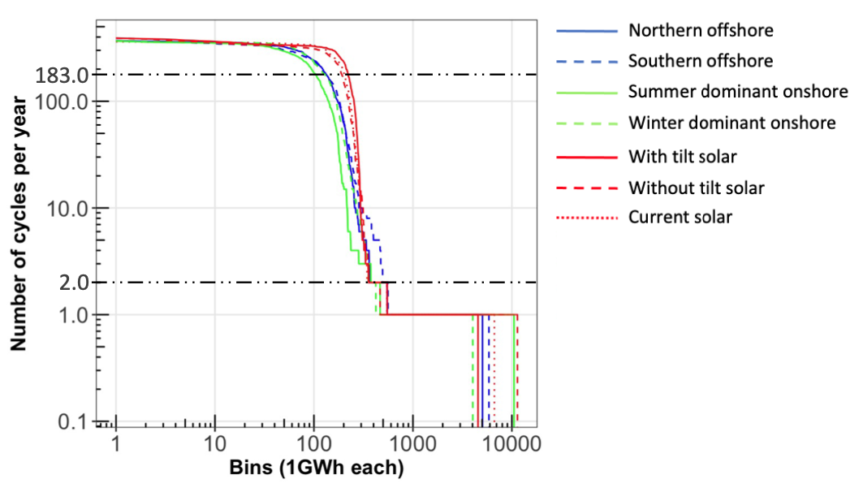
Fig. 2. 3 Frequency of use of hierarchically used storage resources.

2.2 Diurnal balancing
California has remarkably strong solar resources, and, in 2021, 25% of electricity generated in California was from solar energy. The sun rises and sets in a very predictable pattern. While clouds and smoke are less predictable, for a solar-driven grid, diurnal storage will be needed from around sunset until the next sunrise. Such storage may be used every day of the year. It is essential that that storage be
• relatively efficient (>80% is good; >90% is even better)
• cycle life of 3,000-10,000 cycles
• scalable to 100 GWh at a minimum or to 400 GWh if a primarily solar-powered grid is used, and if load is increased as we anticipate it will be as the transportation and other energy sectors are electrified
• the allowed cost will depend on the cycle life and efficiency

Today, the best candidates for meeting diurnal storage needs are pumped hydropower storage (PHS) and lithium batteries. Lithium batteries are more efficient than PHS, but PHS is more scalable, at least in some locations. The two are also differentiated in that lithium batteries can be deployed in a modular way with relatively short installation times, while PHS is typically deployed in very large projects that sometimes take more than 10 years to implement.

2.3 Seasonal balancing
Seasonal balancing may be best done using cross-sector energy storage. Such stored energy may also be used for transportation, heating, or a range of industrial applications. For example, if local storage and manual distribution is needed, storing hydrogen will be very expensive. But, if large storage facilities like underground salt caverns can be accessed using pipelines, the storage and distribution costs of hydrogen could be comparable to those today of natural gas. Requirements for cross-sector seasonal storage include:
• market for seasonally generated fuel or availability of fuel to use for seasonal generation
• efficiency is less important, though high power-conversion efficiency is always useful
• scalability needs to be > 1 TWh for California for most scenarios

Today, billions of dollars are being invested in hydrogen infrastructure. If infrastructure is developed for using hydrogen for transportation, heating, and industrial application, that same infrastructure will be enabling for using hydrogen for seasonal balancing of the electrical grid. The U.S. Energy Department’s “Hydrogen Shot” has set the target of generating clean hydrogen for $1/kg by 2031. The $1/kg hydrogen will be most useful if storage and distribution infrastructure is well developed.

We were encouraged by Southern California Gas Company and the Green Hydrogen Coalition to include a study of the storage and distribution of hydrogen. Given that today’s cost for generating hydrogen is around $2/kg while the retail price may be > $13/kg we agree that understanding the storage and distribution will be critical to understanding how hydrogen will be used. The storage and distribution costs may be reduced by using underground storage and pipelines, like today’s natural gas systems. But, there is a challenge with identifying the underground storage sites and developing a pipeline system comparable to today’s natural gas system is a gigantic undertaking. Many useful studies have been published. We have chosen here to take a complementary approach, allowing us to study how electrolyzers may be used as flexible loads, which plays a similar role to storage by reducing demand at moments when there is a shortage of electricity, as discussed below.

There is also substantial interest in ammonia as an energy carrier, but the investment in ammonia is currently much smaller than the investment in hydrogen. While electrification may reduce energy requirements substantially, it will not be possible to electrify everything in the near term and a carbon-free fuel will be very important toward meeting overall goals to reduce carbon emissions. Inclusion of this anticipated development in our modeling reflects the anticipated reality of tomorrow’s energy system.

Compared with the narrower concept of a self-contained energy storage, we highlight two strategies we expect to be more effective at seasonal balancing: 1) seasonal flexible loads and 2) seasonal generators.

Seasonal flexible loads. Today, the fraction of the load that can easily be shifted is quite small, but in the future, there may be larger opportunities at a range of time scales. Of these, two flexible loads may be most useful for seasonal balancing.
1. Electrolysis to generate large amounts of hydrogen – if electrolyzers can be made at a low enough cost to be able to be used at a relatively low capacity factor, then we expect that a large number of electrolyzers will be operated whenever solar and wind electricity is abundant and then turned off whenever electricity prices go high. The potential size of this load could be as much as 50% of the overall load if green hydrogen becomes lower in cost than blue hydrogen.
2. Direct-air capture of carbon dioxide – If this is scaled to the size that would be needed to reduce the carbon dioxide concentration by a measurable amount, this would require substantial energy. If that energy is provided by electricity, direct-air capture of carbon dioxide would be a huge flexible load that could be used for seasonal balancing.
• Note: EV charging may become a large flexible load. If infrastructure is installed for daytime charging, it may reduce the need for diurnal storage. However, it is unlikely to be helpful for seasonal balancing.

Flexible seasonal generators:
• Biomass has the potential to be used for a subset of the year, effectively making the biomass (or biogas) be the seasonal storage.
• Nuclear or fossil-fuel generators with carbon capture and sequestration may also be candidates for seasonal balancing.
• Cross-sector generators may be able to use fuel cells normally used for transportation or other applications to generate electricity during seasonal shortages. Investment in fuel cells for other sectors may be leveraged to supply the seasonal needs of the electrical grid.
• Curtailed solar and wind may be the most convenient flexible seasonal generators. Currently, California reports the highest curtailment in spring. This is likely to continue to grow and reduces the value of new solar and wind electricity, but curtailment of solar and wind may still present the lowest cost solution in some cases.

It remains to be seen how the larger infrastructure will evolve. Every investor would like to see their capital investment earn a return every hour of the year. Today’s electrical grid has many assets that are used with low capacity factors. In some cases, this is attractive because the market pays for the desired reliability/resiliency. Similarly, in tomorrow’s energy system we anticipate that there will be many assets that are used only a fraction of the year. The details will depend on both the technical capabilities and the market structure.

In addition to the curtailment of solar and wind that is already included in our baseline model, we will include the possibility to install electrolyzers, thereby increasing the load when the electrolyzers are selected and generating income by selling the hydrogen.

2.4 Cross day balancing
It may be possible that the same storage resources and strategies that are used for diurnal and seasonal balancing may be applied to the in between time frames. However, many companies are developing products that are ideally suited to operate in this range. We will explore these new options using a matrix as described in section 4. The concept of using a matrix (variable inputs for the parameters we are exploring) is one that CESA has encouraged us to use. We will attempt to follow CESA’s suggestions there to the extent that is possible.

The candidate storage technologies were described in the Storage Technology Summary as part of Task 3.1. That information is not repeated here, but may be viewed at GIVE WEBPAGE.

3. Baseline scenario storage technologies
For the modeling in RESOLVE, we select two storage technologies for inclusion in all analysis: pumped hydropower and lithium batteries, then add additional candidate storage technologies as described in section 4.

3.1 Pumped hydropower storage
The world’s biggest storage technology today is pumped hydropower. Such storage will continue to be used and new installations are planned. RESOLVE’s current Preferred System Portfolio includes the pumped hydropower storage summarized in Table 3.1.

Table 3. 1 Pumped hydropower storage included in the Preferred System Portfolio
Resource name | Existing capacity (GW) | Existing capacity (GWh) | Can build
CAISO Existing Pumped Storage | 1.8985 | 300.14
Riverside East Pumped Storage | - | - | X
Riverside West Pumped Storage | - | - | X
San Diego Pumped Storage | - | - | X
Tehachapi Pumped Storage | - | - | X

In the Storage Technology Summary Task 3.1 report we summarized planned pumped hydropower storage projects in Table 2.2. Based on more recent information tabulated by Peggy Beltrone (of Cat Creek Energy on behalf of the National Pumped Storage Hydropower Council) as having pending or active permits or licenses, we have updated that table, see Table 3.2.

Table 3. 2 Proposed pumped hydropower storage projects in or near California
Project name | Company | Location & RESOLVE label | Capacity (MW) | Planned start | Notes
Cat Creek Energy and Water Storage | Cat Creek Energy | Idaho | 720 | 2027 | +110 MW wind; +150 MW solar
Eagle Mountain | Eagle Crest Energy | Desert Center (Southern California) | 1300 | 2028 | Closed loop
Mokelumne Water Battery | GreenGenStorage | Calaveras County (Central California) | 250-800 | 2027 | Closed loop
Swan Lake | Rye Development | Oregon | 393 | 2026 | Closed loop
Goldendale | Rye Development | Washington | 1200 | 2028 | Closed loop
San Vicente | San Diego County Water Authority | San Diego | 500 | 2030 | Closed loop
Additions to Table 2.2 in the Storage Technology Summary Task 3.1 report
Eastwood | Southern California Edison | Balsam Creek,  Fresno County | 200
Feather River | California DWR | Lake Oroville (Northern California) | 763
Castaic | California DWR | Castaic Dam (LA) | 800
Helms | PGE | Helms Creek  Fresno County | 1053*
Olivenhain-Hodges | San Diego County Water Authority | San Diego | 40**
Bluewater Renewable Energy Storage | Nevada Hydro | Nevada | 500
Camp Pendleton | Boyce Hydro | San Diego | 300
Tehachapi | Premium Energy | Tehachapi  Kern County | 1000 |  | Closed Loop
Bison Peak | rPlus | Tehachapi  Kern County | 500
San Onofre Ocean | Premium Energy | San Diego | 150
Nacimiento | Premium Energy | Near Morro Bay | 600
Santa Margarita | Premium Energy | Near Morro Bay | 600
Twitchell | Premium Energy |  | 600
Whale Rock | Premium Energy | Near Morro Bay | 600
Hurricane Cliffs | rPlus Hydro | Utah | 500
*In addition to 1212 MW that has been operational since 1984.
** In addition to 40 MW that has been operational since 2012.

3.2 Lithium batteries
The fastest growing storage segment today is lithium batteries. Here we summarize some of the emerging cost, efficiency, degradation, and cycle-life trends for lithium batteries. These show one of the highest roundtrip efficiencies for storage. Compilation of recent data taken from the Energy Information Agency (EIA) shows that the discharge-to-charge ratio taken on a monthly basis for grid-scale storage typically exhibit on average 85% efficiency as shown in Fig. 3.1. Statistically, batteries that are cycled more than 5 times per month show efficiencies between 80% and 90%, with the efficiencies increasing slightly as a function of installation year.

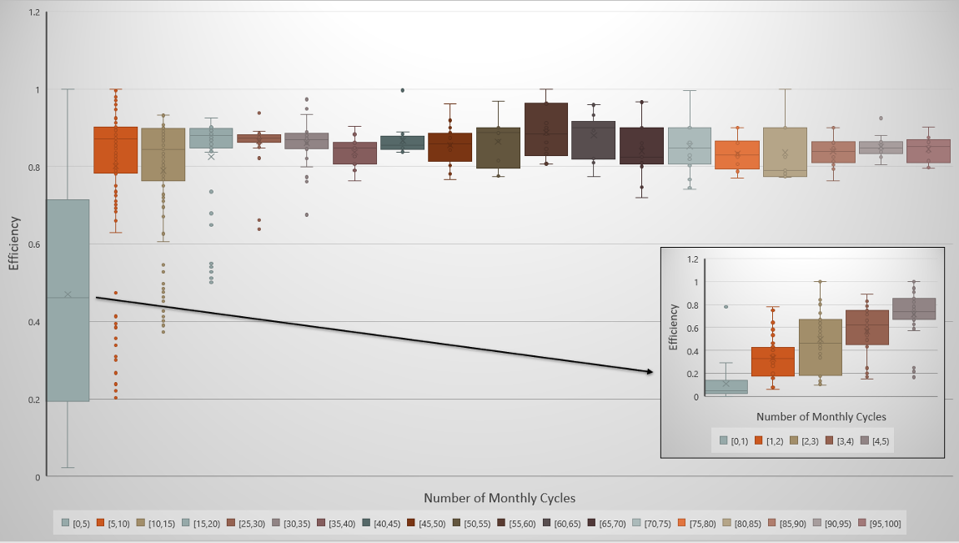
Fig. 3. 1 Efficiency observed for EIA-reported batteries as a function of the cycling frequency

The rapid cost reduction experienced by lithium batteries is putting pressure on long-duration energy storage alternatives to achieve better performance and reduce cost. Lithium battery costs have decreased at a rapid pace – with estimates spanning 14-30% learning rate over the past decade (Fig. 3.2), evidenced by the major trajectories categorizing price trends for lithium batteries, with many cell prices reaching near $100/kWh, though post-pandemic supply-chain issues and lithium shortages are now causing prices to increase temporarily. Cell prices are not the only factor that is important for grid-scale utility storage because the cells are then reconfigured into packs and systems that are deployed on the grid.

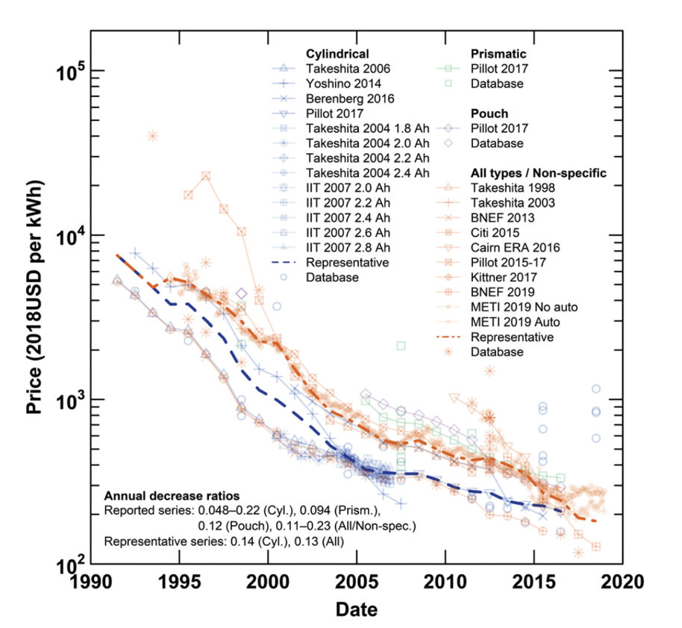
Fig. 3. 2 Time series of lithium-ion cell prices
Estimated learning rates are based on the following set of equations

$P=α+βQ$ (1)
In Eq. (1), $P:$ the logarithmic price (US$/kWh)
$Q:$ the logarithmic cumulative production (MWh)
$α$and $β$: coefficients
$LR=$ 1-$2^{β}$ (2)
In Eq. (2), $LR:$ learning rate (reflects the speed of learning)

Lithium battery systems may be limited in duration. Currently, they are being sold in 4-hour durations for use in California. Despite rapid improvements that may be achieved in the coming decade, there are concerns about their ability to meet longer durations (greater than six hours) and concerns regarding their lifetime. With different use cases, heavy cycling of lithium batteries threatens their durability, especially under rising temperatures. Recent articles such as Preger et al. 2020 document the degradation rates for commercial lithium cells. The roundtrip efficiency for lithium-iron-phosphate grid-scale cells are concerning at higher temperatures. This is due to higher ambient temperatures affecting their overall efficiency. Lithium-iron-phosphate cells have the highest cycle life among many lithium battery chemistries such as NCA (LiNi_{x}Co_{y}Al_{1-x-y}O₂) and NMC (LiNi_{x}Mn_{y}Co_{1-x-y}O₂) cells. The roundtrip efficiency for these cells can vary up to 10% depending on cycling conditions and can decrease more than 5% with age. Therefore, the frequency and cycling of discharging lithium batteries can affect the critical metrics which make lithium batteries attractive in the first place – their roundtrip efficiency and low-cost (moving rapidly toward >90% (for the battery without the power electronics) and <$100/kWh, respectively). The lifetime of a battery is often associated with the point at which the energy capacity drops to 80% of the original capacity. Some recent measurements for three chemistries lithium iron phosphate (LFP), nickel manganese cobalt (NMC), and nickel cobalt aluminum (NCA) are shown in Fig. 3.3. For stationary applications, the longer cycling life of LFP batteries is clear with lifetimes of 10-20 years appearing achievable if the batteries are cycled on average one time per day. These LFP batteries are reported to have less than half the energy density (Wh/kg) of the NMC and NCA batteries. Thus, the NMC and NCA chemistries may be prioritized over LFP for mobile applications, while LFP may be prioritized for stationary applications.
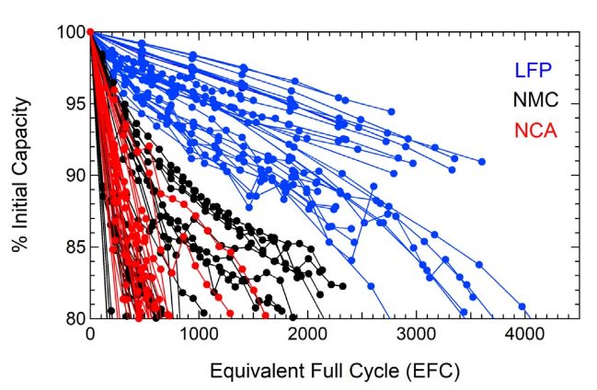
Fig. 3. 3 Battery capacity as a function of cycling

Cycle lifespans for LiFePO₄ cells may allow 2500-9000 effective full cycles until they reach about 80% of their original energy capacity whereas NCA and NMC lithium-ion cells have much lower cycle lifetimes, in the 250-1500 or 200-2500 cycle range. This means that effectively, NCA and NMC lithium batteries of today may only last 1-8 years if cycled one time per day. This may require further improvement and development or production of other storage technologies that can complement lithium batteries in their role on the grid. As discussed above, in addition to low-cost four-hour duration lithium-ion based energy storage, a solar-powered electric grid will require storage options with durations of eight hours or more to make it through nightly routines and avoid a materials crisis in terms of replacing lithium batteries constantly and finding ways to sustainably manage new battery installation and decommissioning of retired storage facilities.

Degradation for lithium batteries is shown to increase under higher temperature conditions. Better performance for lithium-iron-phosphate technology occurs at 15 or 25 degrees C rather than 35 C, where significant degradation and loss of efficiency and energy capacity fade can occur as exhibited in the Fig. 3.4.

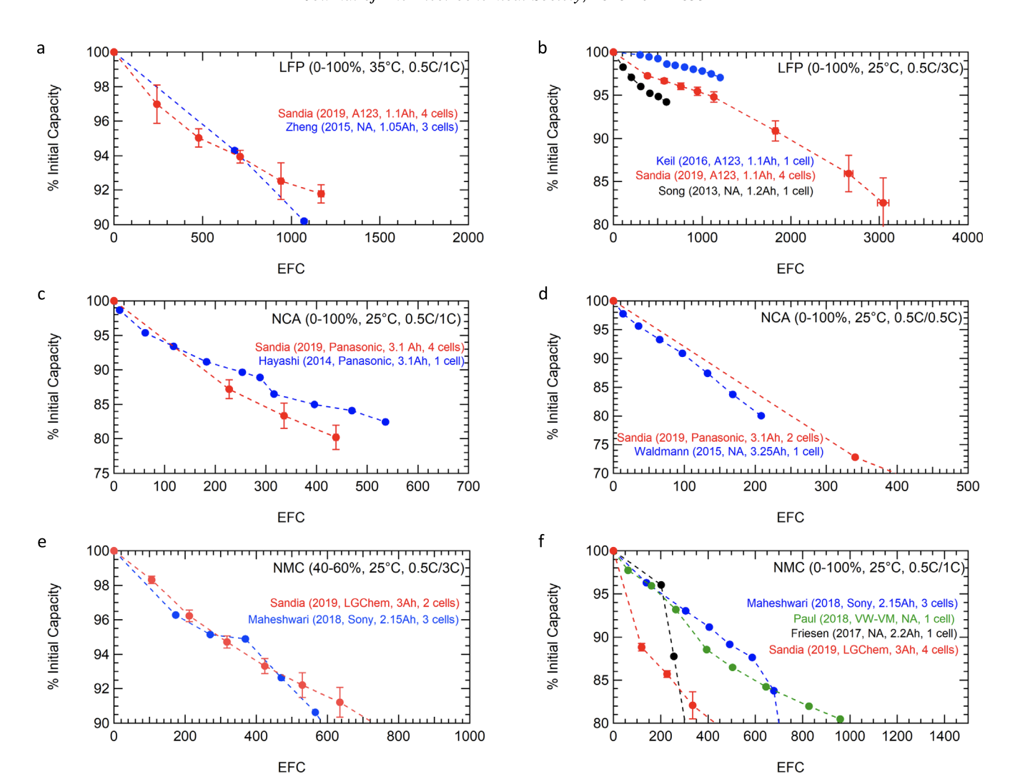
Fig. 3. 4 Measurements of degradation of capacity as a function of equivalent full cycles

The lithium battery model included in the PSP is summarized in Tables 3.3 and 3.4.

Table 3. 3 Fixed values for PSP model for lithium batteries
Attribute | Value
Charging/discharging efficiency | 92.2%
Annual fixed O&M cost relative to power rating | $8.32/kW
Annual fixed O&M cost relative to energy rating | $0/kWh

Table 3. 4 PSP model for lithium batteries
Type of cost | Year of installation | Cost
Annualized cost (relative to power rating) includes both capital cost and O&M costs | 2030 | $22.48/kW
 | 2035 | $21.96/kW
 | 2040 | $21.75/kW
 | 2045 | $21.51/kW
Annualized cost (relative to energy rating) includes both capital cost and O&M costs | 2030 | $13.71/kWh
 | 2035 | $12.71/kWh
 | 2040 | $11.96/kWh
 | 2045 | $11.16/kWh

The values presented in the PSP show much smaller decrease in cost than would be expected from the historically observed learning curves and the currently anticipated growth trajectories. We plan to present our results as costs that are relative to lithium battery costs. To test the sensitivity of this assumption, we will also do some exploratory calculations to identify the effect of more rapid decrease in lithium battery costs. If the selection of other storage options scales with the lithium costs, then we will only use one set of lithium battery costs and will report the relative costs. If the lithium battery cost has effects that are not easily translatable into the effect on the other storage costs, then we will study multiple lithium battery costs.

Section 4 documents how we will model lithium batteries to be 4-h batteries with no option to change the duration. This was chosen to reflect the lithium batteries being used in California today and anticipated to be used in the future, absent a change in policy.

3.3 Hydrogen
As discussed in Section 2.3, hydrogen is an important and emerging area for study within energy storage technology alternatives especially because the investment in new hydrogen technology and infrastructure is surpassing billions of dollars. While hydrogen competes with both lithium and other long-duration energy storage technologies such as flow batteries or pumped storage hydropower – it also belongs in its own class due to flexibility and opportunities to provide cross-sector services in the energy system. Not only does hydrogen provide opportunity for electricity-to-electricity storage, but it also can provide electricity-to-agriculture, electricity-to-industrial, or electricity-to-gas storage. Additionally, hydrogen fuel cells can have high power densities that are useful for industrial applications. The process of generating hydrogen through water electrolysis has experienced some significant new cost breakthroughs in the past 5-10 years, unlocking a new potential role for hydrogen. This section examines learning rates for water electrolysis that can produce lower-cost hydrogen that may be helpful in decarbonization of the energy system.

Learning rates for hydrogen technologies have the potential to provide insights into their feasibility as energy storage or cross-sector storage options. We can differentiate hydrogen electrolyzers into three main technology categories, each with different uses and potentials: Alkaline Water Electrolysis (AWE), Solid Oxide Electrolysis Cells (SOECs), and Polymer Electrolyte Membranes (PEMs). Lee et al. conducted an analysis of each technology and predicted an experience rate of learning-by-doing effects from the year 2025 to 2045. The estimated learning rates are 18 +/- 13 %, 18 +/- 2%, and 28 +/- 16% for AWEs, PEMs, and SOECs respectively. A generalized cost reduction and learning rate for water electrolysis to produce hydrogen is analyzed in Ajanovic, et al. and they estimate a broad learning rate of 20 +/- 3% through the year 2050 based on historical cost reductions, but do not provide technological detail.

As electrolyzers serve the purpose of converting electricity into hydrogen, and fuel cells or turbines serve to turn hydrogen back into electricity, cost metrics such as the H₂ Levelized Cost of Electricity (LCOE) and Levelized Cost of Hydrogen (LCOH) are important to consider. McKinsey & Company developed a hydrogen LCOE on a per decade basis. The LCOE ranges were 25-73, 13-37, and 7-25 USD per MWh for 2020, 2030 and 2050 respectively which were in large part due to a projected 62% decrease in production costs of renewable hydrogen between the years 2020 and 2030. McKinsey also provided predicted LCOHs for the year 2030 based on three different use cases within Europe. Onsite, or industrial and large-scale use, and regional, or end-use in Europe, are predicted to have an LCOH of 2-3 USD per kg. International, or large scale and industrial, received a prediction of 2-7 USD per kg. In a use case in Australia, with a more individual focus, Bruce et al. found the hydrogen LCOE to be 330-410 USD per MWh for PEM fuel cells and predicted that by 2025 the range would fall to 120-150 USD. They additionally predicted that the LCOH would be 4.78-5.84 USD per kg for AEW and 6.08-7.43 USD per kg for PEM electrolyzers. It is notable that Bruce et al 2018 values are higher than McKinsey & Company’s in 2021, perhaps indicative of the rapidly changing cost environment. At the same time, substantial differences are occurring for costs across countries based on water electrolysis. Therefore, more research is needed to understand geographic discrepancies in costs for water electrolysis - part of this could be due to electricity inputs or subsidies. Regardless, this downward cost trend could be indicative of the fast-growing potential for hydrogen technologies.

Potential shortcomings of using a generalized number for the LCOE and LCOH is that different parameters may lead to inconsistent values. Yates et al. analyzed several different regions of hydrogen production within Australia and found that location can have a noticeable impact on variables like LCOE and LCOH. This conclusion is dependent on what resource is producing the electricity used in the electrolyzer. Ajanovic & Hass (2018) found in a general overview of hydrogen electrolysis that the size of an electrolyzer is correlated to the total cost of hydrogen with smaller electrolyzers leading to higher EUR / kWh rates. Electricity supply for the electrolyzer matters – in terms of moving LCOH to the $2-3/kg benchmark, electricity often needs to cost less than $0.04/kWh – since most electrolyzers require a minimum of 50 kWh baseline input electricity to produce 1 kg of hydrogen. This means that low-cost and clean electricity inputs are essential to meeting future hydrogen cost targets.

Current electrolyzer costs are summarized in Table 3.5 including data for alkaline and polymer-electrolyte-membrane electrolyzers. Techno-economic characteristics are reported as well, including the expected lifetime of the stack in terms of operational hours and the system lifetime in years. These summarize the current status of the technologies today. The projected ranges in Table 3.6 capture the capital cost in $/kW for different electrolyzers, agnostic of technology development (noting that these projections are based on overall electrolyzer improvement) and demonstrate where the costs are projected to fall over the next two decades. The baseline and optimistic scenarios provide upper and lower bounds, particularly for costs in 2040 and 2045, when additional technologies could be needed to meet net zero targets. These are within the range being documented currently and have been vetted carefully with our collaborators.

Table 3. 5 Current electrolyzer costs
 | Alkaline Electrolysis | Polymer Electrolyte Membrane Electrolysis
Capital cost [$/kW] | 900-1500 | 1100-1800
Lifetime – system [years] | 20 | 20
Lifetime – stack [hours] | 80,000 | 40,000

Table 3. 6 Projected future electrolyzer costs for modeling
Parameter | Baseline scenario | Optimistic scenario
Electrolyzer | $600/kW @ 2030  $550/kW @ 2035  $500/kW @ 2040  $450/kW @ 2045  99% hydrogen price | $400/kW @ 2030  $300/kW @ 2035  $200/kW @ 2040  $150/kW @ 2045  99% hydrogen price

We will not model the cost of storing and transporting hydrogen. Instead, we will assume that we may sell the hydrogen that is generated. Today, hydrogen can be manufactured from steam reformation for about $2/kg. The DOE Hydrogen Shot sets a target of $1/kg. While these targets do not specify the details of how the targets will be reached, the hydrogen cost may be calculated directly from the model inputs and will decrease as the costs of solar electricity and the electrolyzer decrease. We can use this calculated cost as the basis for selecting the selling price of the hydrogen as discussed in Section 4 of this report.

3.4 Matrix of long-duration energy storage
This study’s objective is to identify the role long-duration storage may play in decarbonizing a renewable-energy-powered grid for California. While non-renewable electricity sources could be used, there is value in achieving a clean-energy system that uses only renewable energy sources. If new storage technologies can duplicate the successes that wind and solar have experienced in the last decades, there is a vision of creating an energy system that meets all our needs at a cost that is lower than today’s energy. However, the pathway is not clear, and success will rely on understanding how multiple technologies can work together to achieve the desired goal.
When the storage companies were asked what information would be useful to them, a key answer was to identify the cost target that a storage product would need to achieve to successfully enter the market. This is a key question that is also relevant to the California Energy Commission as it identifies cost targets and timelines for development of new storage technologies. To answer this question, we propose to use the strategy described in Fig. 3.5.

Fig. 3. 5 Modeling strategy for determining the cost target for candidate storage technologies

Example implementations of this strategy are shown in Fig. 3.6. In the top graph of Fig. 3.6, for low LDES costs, the 8-h storage is selected, mostly displacing the 4-h battery. When the price of the 8-h storage reaches twice that of the 4-h battery, it makes sense that the model only selects to build two 4-h batteries. In the case of the 8-h LDES, the transition from selecting the 8-h LDES to selecting the 4-h battery is quite abrupt, but in the case of the 100-h LDES, a cost that is more than twice the 4-h battery cost still enables a few of the LDES to be built.

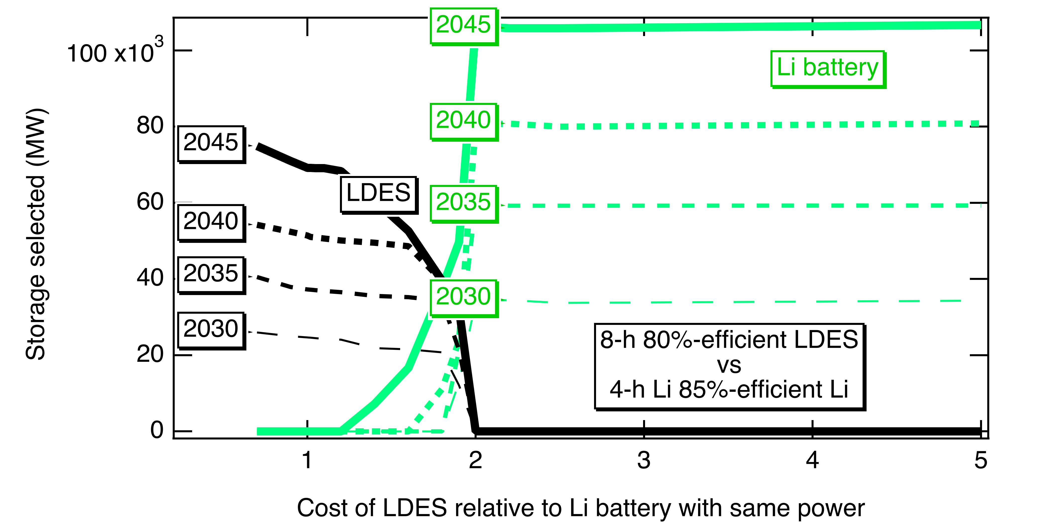
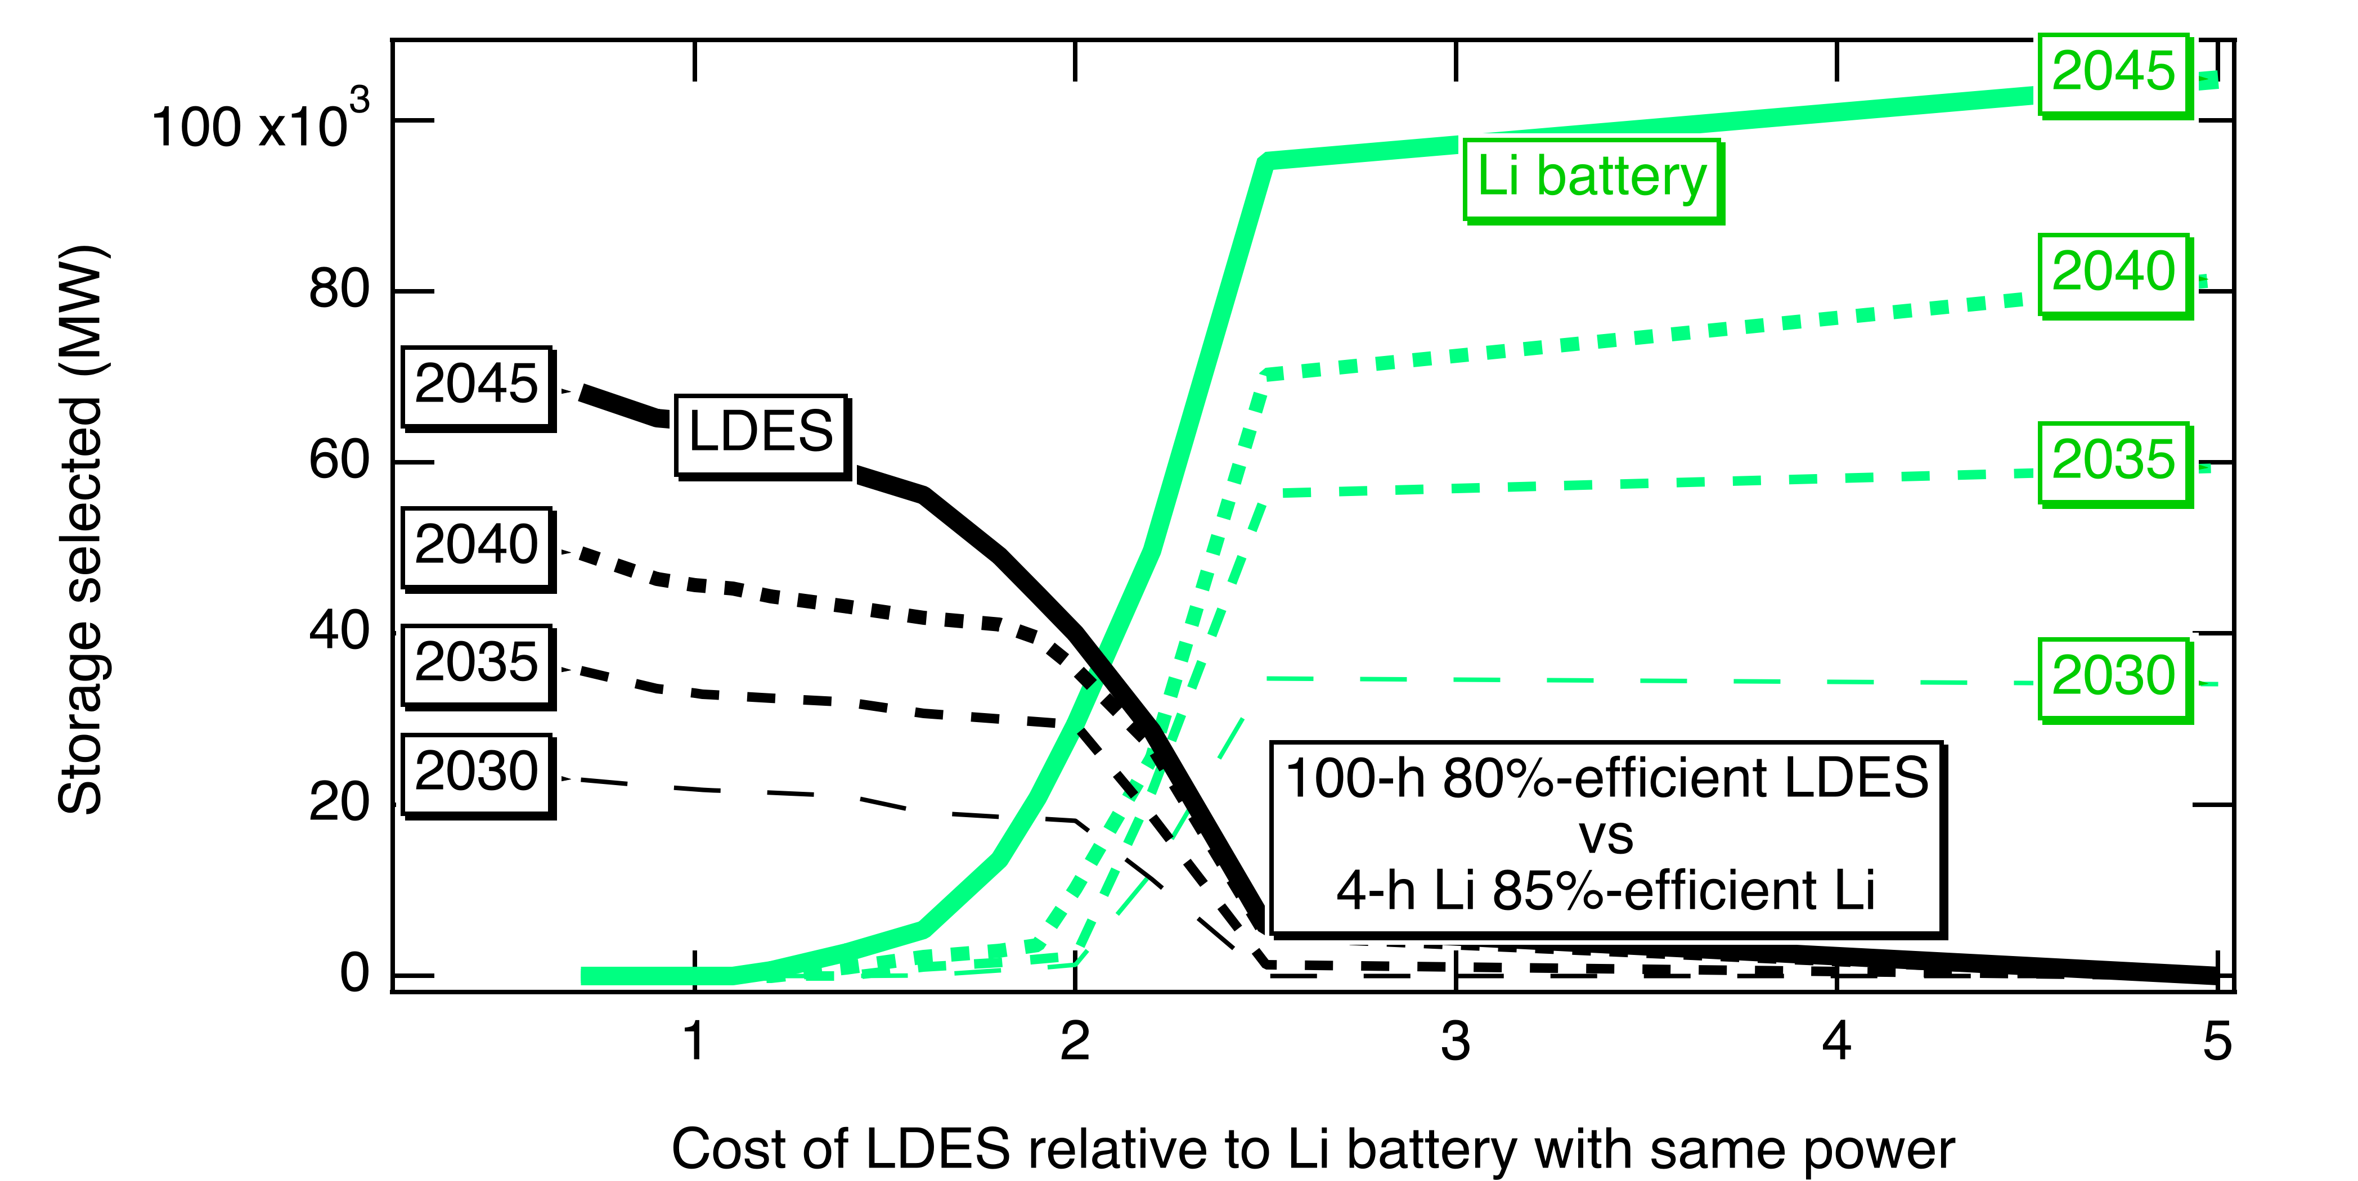
Fig. 3. 6 Storage power selected as a function of the cost of the long-duration energy storage
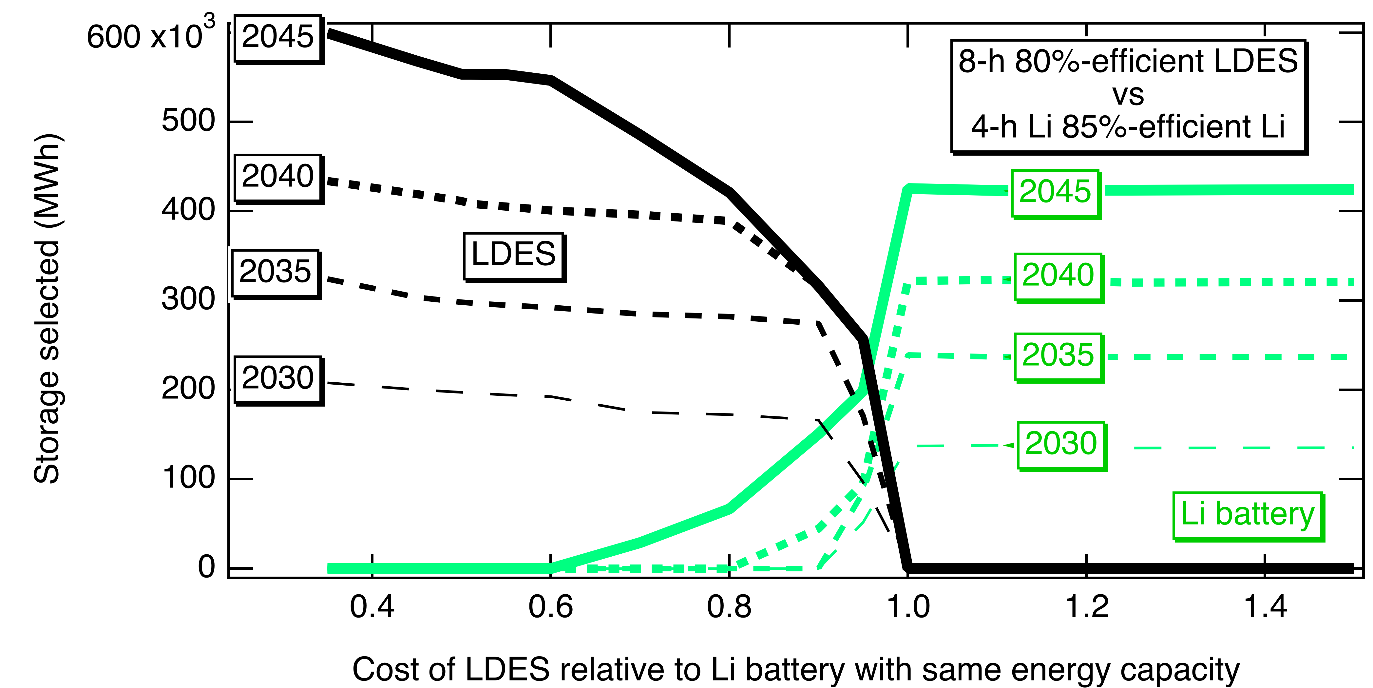
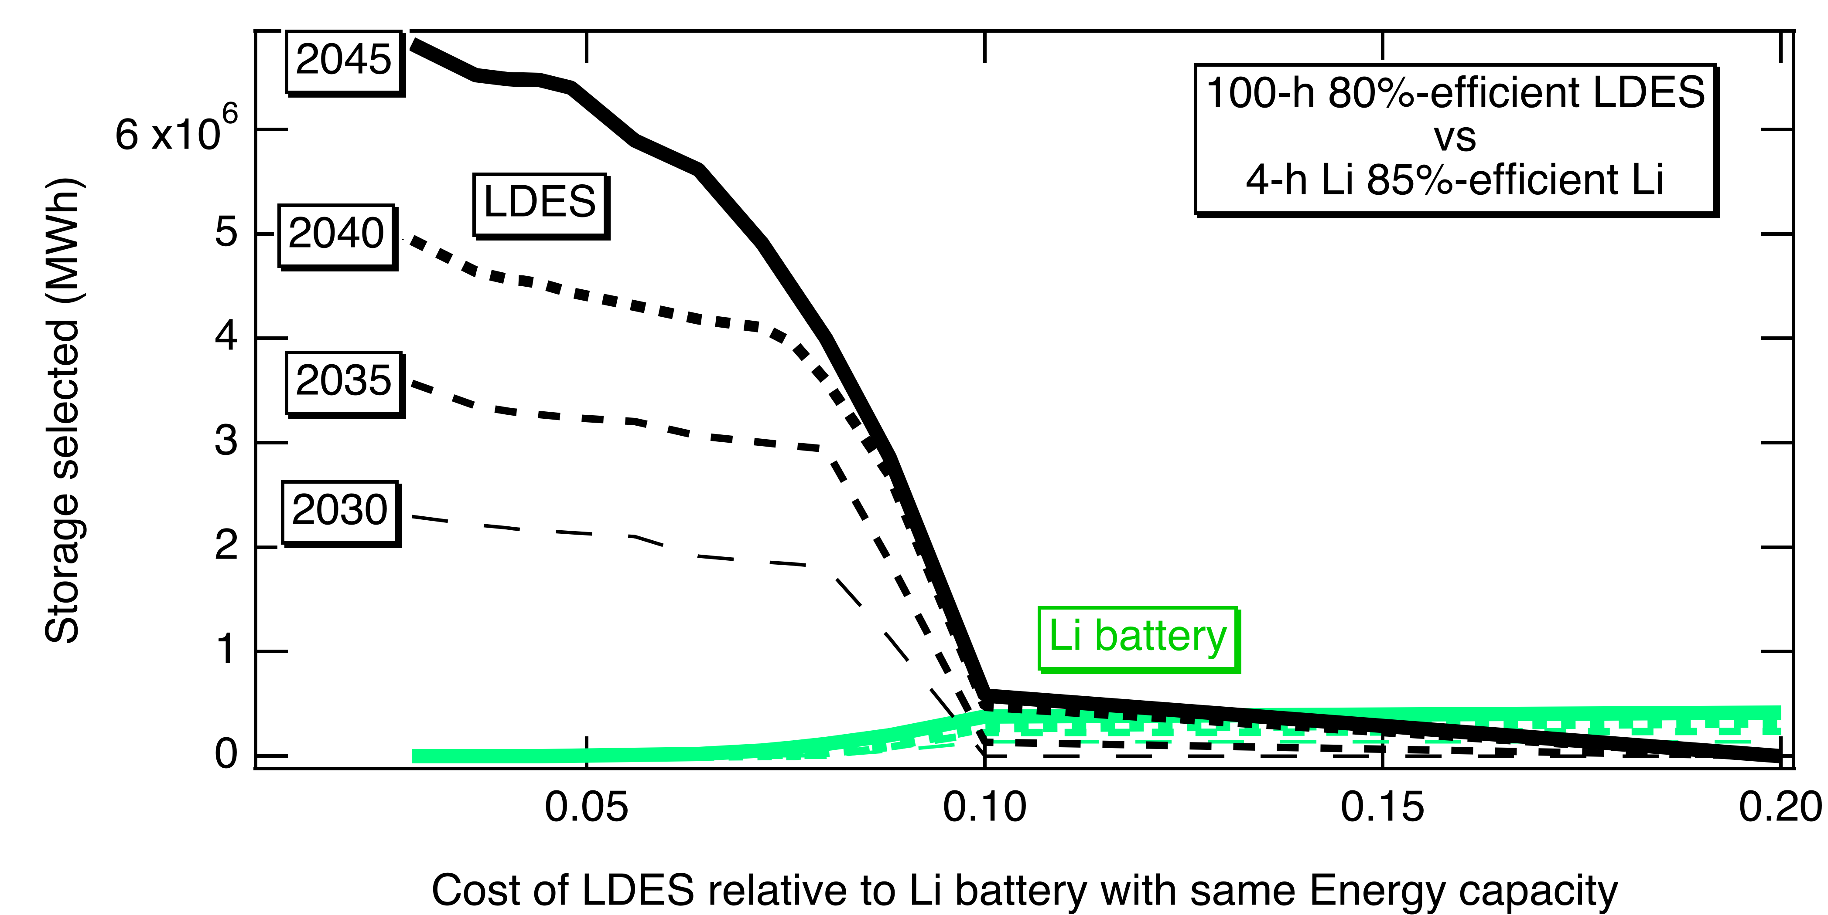
Fig. 3. 7 Storage energy selected as a function of the cost of the long-duration energy storage

The graphs in Fig. 3.6 and 3.7 can be used to create time-dependent cost-target curve, as shown in Fig. 3.8.

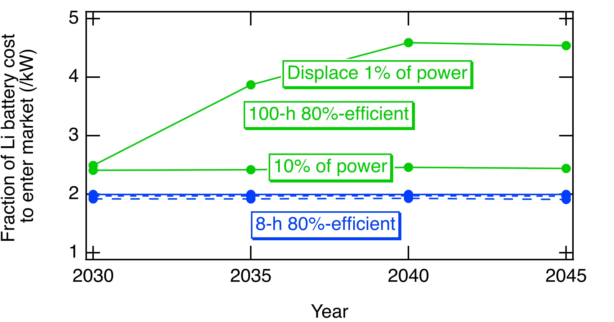
Fig. 3. 8 Example anticipated output of modeling strategy following steps in Fig. 3.5.

The modeling strategy described in Fig. 3.5 anticipates that adoption of a new technology will depend both on its cost relative to Li batteries and the system’s requirement for storage. The cost model for Li batteries is described in Section 3.2. Our baseline scenario will assume (see Section 3.3) that either none or all of today’s planned pumped hydro projects are completed by 2030 (the first period we will model). We expect that the demand for new storage technology will be quite different for the two scenarios.

The output from the modeling, when displayed as shown in Figs. 3.6 through 3.8, will enable companies and the CEC to select products that can be launched in the appropriate time frame. Modeling of a storage product with a specific duration enables optimization of a single cost rather than considering reduction of both energy-associated costs and power-associated costs. However, to understand the potential for longer duration products, we will need to study products with a range of durations. As a starting point, we plan to model storage technologies with the parameters shown in Table 3.11. These may be revised to meet the needs of our stakeholders.

Table 3. 7 Candidate long-duration storage technology matrix to be studied
Efficiency | Duration (h) | Idle loss | Relevant technologies
80% | 8, 12, 100 | 0 | pumped hydro, gravity, flow battery
70% | 8, 12, 100 | 0 | geomechanical, flow battery, metal-air, exfoliated-metal, gravity
60% | 8, 12, 100 | 0 or 1%/day* | flow battery, metal-air, exfoliated-metal, compressed air, liquid air, thermal
50% | 8, 12, 100 | 0 or 1%/day* | Thermal
35% | 8, 12, 100 | 0 or 1%;day* | Thermal
*For thermal storage, we may attempt to monetize the waste heat as discussed in section 4.4.
In addition to plotting results as shown in Fig. 3.8 for each of the candidate long-duration storage technologies noted in Table 3.7, the modeling will enable analysis of the lowest cost approaches to decarbonizing a renewables-powered grid for California, including analysis of how frequently the storage is cycled, how much curtailment of solar and wind can be expected, etc.

4. RESOLVE Model Inputs for Storage

4.1 RESOLVE modeling inputs for pumped hydropower storage
Using RESOLVE, we will model all pumped hydropower storage as planned builds rather than candidate resources that would be selected by the model. We will study three variants of our baseline scenario with respect to pumped hydro storage. The first will include only the CAISO Existing Pumped Storage resource described in Table 3.1. The second will include the proposed projects we have been able to document as described in the first part of Table 3.2, assuming that these would be operational starting in 2030. The third will also include the projects that are tabulated in the lower part of Table 3.2 with these becoming operational in 2035.

To introduce these into RESOLVE, we will use the candidate resources in Table 4.1. The first four of these were included in the PSP as something the model can select to build, with the build costs defined. We feel that the decision to build a pumped hydro storage project is a long-term decision that goes forward based on reviews of permitting and designated public support rather than side-by-side bidding in a competitive market, so we propose to use scenarios, rather than competition, to define its selection.

Table 4. 1 Pumped hydropower storage modeling inputs
Resource name | Modeled Capacity (GW)
Resource name | Baseline scenario | Second scenario  (2030) | Third scenario  (2035)*
Riverside East Pumped Storage | 0 | 1.4 | 1.4 + 1 = 2.4
Riverside West Pumped Storage | 0 | 0.5 | 0.5 + 3.2 = 3.7
San Diego Pumped Storage | 0 | 0.5 | 0.5 + 0.5 = 1
Tehachapi Pumped Storage | 0 | 0.5 | 0.5 + 2.8 = 3.3
Northern Pumped Storage | 0 | 2** | 2 + 0.8 = 2.8
* The additions here are derived from the multiple plants in the lower part of Table 3.2
** This line summarizes Mokelumne Water Battery, Cat Creek, Swan Lake, and Goldendale, all planned to be completed before 2030, our first model year.

Pumped hydro storage has demonstrated its value time and again. It is unclear at this time how many of the proposed projects will be taken to completion, so we undertake to study the collective impact on the value of other long-duration storage technologies if these projects are or are not built. In all cases, we follow the PSP in modeling the charge and discharge efficiencies as 90%, resulting in a round-trip efficiency for the pumped hydro of 81%. In every case we assume that the duration will be 100 hours, for simplicity. This is not enough to provide much seasonal storage but is enough to help through prolonged periods of low wind and sun. Additionally, the efficiency is high enough for use as diurnal storage

4.2 RESOLVE modeling inputs for lithium batteries
Modeling inputs used by the PSP for Li batteries are summarized above in Tables 3.3 and 3.4 for RESOLVE.

We will modify these assumptions slightly by assuming a fixed duration of 4 hours for lithium batteries, reflecting what is seen in the utility-scale market today. It is unclear why lithium batteries would be sold with something other than 4-h duration in the future unless the policy is changed. The resulting inputs are summarized in Table 4.2. While the power and energy costs are separated in Table 3.4, in Table 4.2 we combine them to more easily understand the total cost being assumed. If one assumes a 15-year life with 4% interest, the numbers in the table should be divided by 0.0899 to obtain the upfront cost. When the 0.0899 capital recovery factor is used, the costs in the table translate to an effective upfront cost of $860/kW in 2030 and $736/kW in 2045, (added as a fourth column in Table 4.2, though this does not appear in the resource file). The “all in” fixed cost (in the “value” column with units of $/kW for annualized payment) includes the cost associated with the power rating and with the energy rating, as well as the annual O&M costs. These are higher than the numbers summarized in Fig. 3.2 reflecting a system cost instead of a cell cost and reflecting our assumption that these are 4-h batteries. The relatively small difference in cost between the 2030 and 2045 costs reflects that much of the learning will occur before 2030 and that the learning rate for the system costs is lower than for the cell costs. Charging and discharging efficiencies of 92.2% translate into an efficiency of 85% for the round-trip efficiency, consistent with what is being observed for utility-scale lithium batteries today.
Table 4. 2 RESOLVE inputs for Li batteries for UC Merced baseline
timestamp | attribute | value | scenario | Cost
1/1/30 | duration | 4 | 4hLi
1/1/35 | duration | 4 | 4hLi
1/1/40 | duration | 4 | 4hLi
1/1/45 | duration | 4 | 4hLi
1/1/30 | new_capacity_annualized_all_in_fixed_cost_by_vintage | 77.33 | 4hLi | 860
1/1/35 | new_capacity_annualized_all_in_fixed_cost_by_vintage | 72.81 | 4hLi | 810
1/1/40 | new_capacity_annualized_all_in_fixed_cost_by_vintage | 69.61 | 4hLi | 774
1/1/45 | new_capacity_annualized_all_in_fixed_cost_by_vintage | 66.16 | 4hLi | 736
1/1/30 | new_storage_annual_fixed_cost_dollars_per_kwh_yr_by_vintage | 0 | 4hLi
1/1/35 | new_storage_annual_fixed_cost_dollars_per_kwh_yr_by_vintage | 0 | 4hLi
1/1/40 | new_storage_annual_fixed_cost_dollars_per_kwh_yr_by_vintage | 0 | 4hLi
1/1/45 | new_storage_annual_fixed_cost_dollars_per_kwh_yr_by_vintage | 0 | 4hLi
None | charging_efficiency | 0.922 | base
None | discharging_efficiency | 0.922 | base

4.3 RESOLVE modeling inputs for electrolyzers
RESOLVE has included modeling of hydrogen as an added electrolyzer load and as a fuel for fuel cells. We propose to model hydrogen in a slightly different way by capturing the cost of building electrolyzers and then selling the hydrogen. This is a new approach (for RESOLVE) to modeling cross-sector hydrogen. So, we may vary these inputs after gaining some experience. Table 4.3 summarizes the input cost assumptions based on Table 3.5. The annualized cost is calculated based on 15-y life and 4% interest rates. These are currently quite optimistic but may be appropriate for the modeled time frame. However, we assert that the exact choice is not as important as the match with the selling price of hydrogen. We anticipate that the selling price will vary greatly by location but suggest that a key approach to estimating the market price will be to identify how much it would cost to build a stand-alone solar plant with a directly coupled electrolyzer. This calculation is shown in Table 4.4 for the one-axis tracked, zero-tilt solar profiles.

Table 4. 3 Cost assumptions for electrolyzers
 | Base scenario |  |  | Optimistic scenario
Year | Upfront system cost | Annualized cost* | Lowest hydrogen cost | Upfront system cost | Annualized cost* | Lowest hydrogen cost
2030 | $600/kW | 54.0 | $2.00/kg | $400/kW | 36.00 | $1.70/kg
2035 | $550/kW | 49.5 | $1.89/kg | $300/kW | 27.0 | $1.51/kg
2040 | $500/kW | 45.0 | $1.77/kg | $200/kW | 18.0 | $1.31/kg
2045 | $450/kW | 40.5 | $1.66/kg | $150/kW | 13.5 | $1.20/kg
*In $/kW-y, assuming 15-year life and 4% interest.

Table 4. 4 Calculation of hydrogen selling price based on base scenario inputs for 2030
Solar resource | Annual electricity generation kWh/kW | Annual kg H₂ generated/kW of solar | Annual cost for solar $/kW | Annual cost for electrolyzer $/kW | Total annual cost /kW of solar and electrolyzer | Cost/kg H₂
Tehachapi | 2950 | 59.00 | 64.22 | 53.96 | 118.18 | 2.003
Greater_LA | 2930 | 58.60 | 64.22 | 53.96 | 118.18 | 2.017
Greater_Kramer | 2927 | 58.54 | 64.22 | 53.96 | 118.18 | 2.019
Southern_NV_Eldorado | 2779 | 55.58 | 62.74 | 53.96 | 116.70 | 2.100
Riverside | 2808 | 56.15 | 64.22 | 53.96 | 118.18 | 2.105
Arizona | 2631 | 52.62 | 58.18 | 53.96 | 112.14 | 2.131
Northern_California | 2516 | 50.32 | 64.22 | 53.96 | 118.18 | 2.348

The implementation of the monetization of hydrogen generation will require modification of the inputs. The hydrogen price, documented as a negative “variable_cost_increase_load” will be adjusted based on Table 4.3 and Table 4.5. If the price of the hydrogen is set high, the model will build solar resources to the limits set by the inputs for each resource because if it costs less to make the hydrogen than the selling price, then the model makes money by building more electrolyzers and solar and selling the hydrogen. If this were to happen in the real world, the price of the hydrogen would drop to balance the supply and the demand. Our goal is to define a hydrogen price for which the added investment provides a balance between the value of the hydrogen and the value of having a very large flexible load on the grid. The intent is that if only the solar and electrolyzer were offered to the model (without the opportunity to share electricity with the grid), then model would build no electrolyzers. When the grid provides value to the electrolyzer, or, conversely, the electrolyzer provides value to the grid, then the model will select to build the optimal amount.

As a starting point, we propose to use the lowest cost hydrogen (found for Tehachapi because it has one of the highest solar generation rates) and subtract one penny per kg relative to the calculated “stand-alone” cost (compare the data in Table 4.3 and Table 4.5). The ELZR1 and ELZR2 scenarios reflect the base and optimistic cost scenarios, respectively.

Table 4. 5 RESOLVE inputs for electrolyzers to generate hydrogen
Timestamp | Attribute | Value | Scenario
1/1/30 | planned_installed_capacity | 0 | base
1/1/30 | planned_provide_power_capacity_fixed_om | 0 | base
1/1/30 | increase_load_potential_profile | 1 | base
1/1/30 | new_capacity_annualized_all_in_fixed_cost_by_vintage | 53.96 | ELZR1
1/1/35 | new_capacity_annualized_all_in_fixed_cost_by_vintage | 49.47 | ELZR1
1/1/40 | new_capacity_annualized_all_in_fixed_cost_by_vintage | 44.97 | ELZR1
1/1/45 | new_capacity_annualized_all_in_fixed_cost_by_vintage | 40.47 | ELZR1
1/1/30 | new_capacity_annualized_all_in_fixed_cost_by_vintage | 35.98 | ELZR2
1/1/35 | new_capacity_annualized_all_in_fixed_cost_by_vintage | 26.98 | ELZR2
1/1/40 | new_capacity_annualized_all_in_fixed_cost_by_vintage | 17.99 | ELZR2
1/1/45 | new_capacity_annualized_all_in_fixed_cost_by_vintage | 13.49 | ELZR2
1/1/30 | variable_cost_increase_load | -$1.99/kg | ELZR1
1/1/35 | variable_cost_increase_load | -$1.88/kg | ELZR1
1/1/40 | variable_cost_increase_load | -$1.76/kg | ELZR1
1/1/45 | variable_cost_increase_load | -$1.65/kg | ELZR1
1/1/30 | variable_cost_increase_load | -$1.69/kg | ELZR2
1/1/35 | variable_cost_increase_load | -$1.50/kg | ELZR2
1/1/40 | variable_cost_increase_load | -$1.30/kg | ELZR2
1/1/45 | variable_cost_increase_load | -$1.19/kg | ELZR2
None | can_build_new | 0 | base
None | can_build_new | 1 | ELZR
None | can_retire | 0 | base
None | allow_inter_period_sharing | FALSE | base
None | Electricity_to_hydrogen_kWh_kg | 50 | ELZR

4.4 RESOLVE modeling inputs for matrix of long-duration energy storage
Parameters to be used to describe candidate long-duration storage resources are listed in Table 4.6. The costs for these candidate resources will be varied to identify the cost reduction that is needed to motivate adoption of the candidate resource by the model. The table describes a total of 25 possible long-duration storage candidates. We will select candidates from these and add additional items to explore the full parameter space. Those that are selected in a favorable price range will be widely explored for the multiple scenarios. Those that are not selected by the model may be omitted so that the results of the study are most useful.

Table 4. 6 Matrix of long-duration storage technologies
Round-trip Efficiency | Duration (h) | Idle or operating (parasitic) loss | Relevant technologies
80% | 8, 12, 100 | 0 | pumped hydro, gravity, flow battery
70% | 8, 12, 100 | 0, 1%/day | geomechanical, flow battery, metal-air, exfoliated-metal, gravity
60% | 8, 12, 100 | 0, 1%/day | flow battery, metal-air, exfoliated-metal, compressed air, liquid air, thermal
50% | 8, 12, 100 | 0, 1%/day | Thermal
35% | 12, 100 | 0, 1%/day | Thermal

The charging and discharging efficiencies will each be taken as the square root of the round-trip efficiency.

4.5 Monetizing value of thermal waste heat from thermal storage

Some of the thermal storage technologies may be co-located with industries needing process heat. Such industries can benefit from waste heat from the discharge cycle, thereby reducing usage of natural gas or other source of heat. Table 4.7 summarizes examples of applications that operate processes with relatively low temperatures, potentially benefiting from the waste heat.

To assess the value that can be gained by monetizing such heat, we will adjust the RESOLVE objective function to provide income based on the value of heat delivered. Assuming the system is sized to provide only a small fraction of the heat needed for the industrial process, we assume that all waste heat may be used. In practice, the availability of waste heat may not align exactly with the need for the waste heat.

The amount of waste heat available depends on the process used to convert the heat back to electricity. The available heat may be up to two times the delivered electricity. From Table 4.7, the value of the heat may range from $31/MWh to $143/MWh. Note that Table 4.7 was constructed before the recent increase in natural gas prices. When modeling the 50% and 60% efficient candidate storage products, we will add the value of $31/MWh or $143/MWh to see the effect it might have on the price target for the thermal storage technology. The $143/MWh will represent both the displacement of processes run by electricity and the displacement of natural gas when natural gas prices are higher.

We anticipate that the implementation of the monetization of the waste heat may require modification of the RESOLVE software, which has not yet been completed.

Table 4. 7 Summary of possible applications for waste heat
Industry | Application | Temperature (°C) | Medium | Process | Fuel source replaced | Efficiency | Price | Normalized Price/MWh
Paper & Pulp | Pulping paper | 120-180 | Hot water |  | Natural gas | 82% | $25.47 | $31.06
Lumber & wood | Kiln drying of lumber | 110-180 | Hot air |  | Wood pellets | 78% | $48.76 | $62.51
Fabricated metals | Metal galvanizing | 130-180 | Electrical coils | Batch | Electricity | 98% | $140.10 | $142.96
Food processing | Storage of vegetable oils | 120 |  |  | Electricity | 98% | $140.10 | $142.96
Food processing | Beer pasteurization | 145 | Steam |  | Natural gas | 82% | $25.47 | $31.06
Food processing | Meat scalding, washing, and cleanup | 140 | Hot water |  | Natural gas | 82% | $25.47 | $31.06
Food processing | Meat smoking/cooking | 155 | Hot air |  | Wood pellets | 78% | $48.76 | $62.51
Food processing | Milk pasteurization | 162-185 | Steam |  | Natural gas | 82% | $25.47 | $31.06
Food processing | Vegetable blanching/peeling | 180-212 | Hot water/steam |  | Natural gas | 82% | $25.47 | $31.06
Food processing | Canned sauce concentration | 212 | Steam |  | Natural gas | 82% | $25.47 | $31.06
Food processing | Food – pellet conditioning | 180-190 | Steam | Batch | Natural gas | 82% | $25.47 | $31.06
Food processing | Cooking oil storage | 100-120 | Steam |  | Natural gas | 82% | $25.47 | $31.06
Food processing | Fatty acid removal | 180 | Steam |  | Natural gas | 82% | $25.47 | $31.06
Food processing | Can/Bottle washing | 140-190 | Hot water |  | Natural gas | 82% | $25.47 | $31.06
Food processing | Fructose storage (soft drinks) | 90 | Steam |  | Natural gas | 82% | $25.47 | $31.06
Food processing | Starch and corn steam/steeping | 122 | Steam |  | Natural gas | 82% | $25.47 | $31.06
Chemicals | Soap fatty acid preheat | 130 | Steam jacket | Continuous | Natural gas | 82% | $25.47 | $31.06
Chemicals | Soap mixing tank | 180 | Steam jacket | Continuous | Natural gas | 82% | $25.47 | $31.06
Chemicals | Detergent mixing | 180 | Steam jacket | Continuous | Natural gas | 82% | $25.47 | $31.06
Agriculture | Greenhouses | 80-85 |  | Continuous | Electricity | 98% | $140.10 | $142.96
Agriculture | Poultry brooding | 87-92 |  | Continuous | Electricity | 98% | $140.10 | $142.96
Agriculture | Crop drying | 130-150 | Hot air | Batch | Electricity | 98% | $140.10 | $142.96
Sewage | Wastewater mesophyllic digesters | 95 | Steam |  | Natural gas | 82% | $25.47 | $31.06
Sewage | Wastewater thermophyllic digesters | 120 | Steam |  | Natural gas | 82% | $25.47 | $31.06

Add reference
https://www.socalgas.com/sites/default/files/2021-10/Roles_Clean_Fuels_Full_Report.pdf
https://gasforclimate2050.eu/news-item/european-hydrogen-backbone-grows-to-40000-km/
http://www.apep.uci.edu/PDF_White_Papers/Integrating_Clean_Energy_013020.pdf
https://www.researchgate.net/publication/326049153_Net-zero_emissions_energy_systems
https://www.sciencedirect.com/science/article/pii/S254243511830583X
https://gasforclimate2050.eu/wp-content/uploads/2021/12/Gas-for-Climate-Market-State-and-Trends-report-2021.pdf
https://www.edf.org/sites/default/files/documents/SB100%20clean%20firm%20power%20report%20plus%20SI.pdf
https://www.ghcoalition.org/hydeal-la
https://www.dh2energy.com/project-hydeal
https://about.bnef.com/new-energy-outlook
Abido, et al, 49th Photovoltaic Specialists’ Conference 2022.
https://www.eia.gov/electricity/data/eia923/; https://www.eia.gov/electricity/data/eia860/.
F. ZareAfifi, D. Baerwaldt, S. Hour, Y. H. Zie, and S. Kurtz, “Performance investigation of batteries supporting solar power in the U.S., Proc. IEEE 49th Photovoltaic Specialists’ Conference, 2022.
Ziegler, M. S., & Trancik, J. E. (2021). Re-examining rates of lithium-ion battery technology improvement and cost decline. Energy & Environmental Science, 14(4), 1635-1651.
Preger, Y., Barkholtz, H. M., Fresquez, A., Campbell, D. L., Juba, B. W., Romàn-Kustas, J., ... & Chalamala, B. (2020). Degradation of commercial lithium-ion cells as a function of chemistry and cycling conditions. Journal of The Electrochemical Society, 167(12), 120532.
Preger, Y., Barkholtz, H. M., Fresquez, A., Campbell, D. L., Juba, B. W., Romàn-Kustas, J., ... & Chalamala, B. (2020). Degradation of commercial lithium-ion cells as a function of chemistry and cycling conditions. Journal of The Electrochemical Society, 167(12), 120532.
(Preger, op. cit.)
Lee, B., Lim, D., Lee, H., & Lim, H. (2021). Which water electrolysis technology is appropriate?: Critical insights of potential water electrolysis for green ammonia production. Renewable and Sustainable Energy Reviews, 143, 110963. https://doi.org/10.1016/j.rser.2021.110963
Ajanovic, A., & Haas, R. (2018). Economic prospects and policy framework for hydrogen as fuel in the transport sector. Energy Policy, 123, 280–288. https://doi.org/10.1016/j.enpol.2018.08.063
McKinsey & Company. (2021). Hydrogen Insights: A perspective on hydrogen investment, market development and cost competitiveness. https://hydrogencouncil.com/wp-content/uploads/2021/02/Hydrogen-Insights-2021-Report.pdf
Bruce S, Temminghoff M, Hayward J, Schmidt E, Munnings C, Palfreyman D, Hartley P (2018) National Hydrogen Roadmap [White paper]. CSIRO, Australia. https://www.csiro.au/~/media/Do-Business/Files/Futures/18-00314_EN_NationalHydrogenRoadmap_WEB_180823.pdf
Yates, J., Daiyan, R., Patterson, R., Egan, R., Amal, R., Ho-Baille, A., & Chang, N. L. (2020). Techno-economic analysis of hydrogen electrolysis from off-grid stand-alone photovoltaics incorporating uncertainty analysis. Cell Reports Physical Science, 1(10), 100209. https://doi.org/10.1016/j.xcrp.2020.100209
https://h2.pik-potsdam.de/H2Dash/
Baik, Ejeong, et al. "What is different about different net-zero carbon electricity systems?." Energy and Climate Change 2 (2021): 100046. https://doi.org/10.1016/j.egycc.2021.100046
Farzan ZareAfifi and Sarah Kurtz, “Analytical analysis of stationary Li-ion-battery storage-system efficiency on a large scale,” IEEE Vehicle Power and Propulsion Conference, 2022. https://ieeexplore.ieee.org/document/10003407
We thank Mert of Malta, Inc for sharing this table who compiled it from the following references: - https://www.epa.gov/rhc/renewable-industrial-process-heat - https://www.energy.gov/sites/prod/files/2016/06/f32/QTR2015-6I-Process-Heating.pdf - http://www.calmac.org/publications/California%20Ind%20EE%20Mkt%20Characterization.pdf - https://www.nrel.gov/docs/fy15osti/64503.pdf - https://www.nrel.gov/docs/fy16osti/64709.pdf

