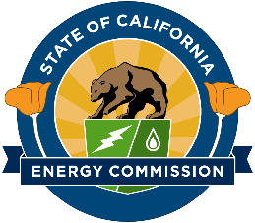

California Energy Commission

Modeling of Long-Duration Storage for Decarbonization of California Energy System
Contract # EPC-19-060 with The Regents of the University of California, Merced

CPR #3 Meeting Agenda

February 16, 2023
10:00 AM – 12:00 PM

- Introduction (5 min)
  - Presenters and Attendees
  - Project Goals and Purpose
- Project Overview & Status (10 min)
  - Completed and Remaining Tasks
  - Project Funds and Timeline
- Final Scenario Analysis (45 min)
  - Inputs and Methods
  - Progress with:
    - Core Scenario
    - Sensitivities
  - Challenges and Opportunities
- Discussion and Q&A (30 min)

