Measurement and Modeling of Injection and Flowback for Subsurface Pumped Energy Storage in Horizontal, Fluid-Filled Lenses

Andrew P. Bunger
University of Pittsburgh

Thursday April 28, 2022, 9 a.m. Central Time

https://utah.zoom.us/j/96292121217
Meeting ID: 962 9212 1217
Passcode: 409309
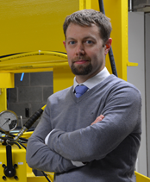
Andrew Bunger is an Associate Professor in the University of Pittsburgh's Department of Civil and Environmental Engineering. Dr. Bunger will speak on Thursday April 28, 2022. The seminar will be at 9:00 Central Time. The topic is “Measurement and Modeling of Injection and Flowback for Subsurface Pumped Energy Storage in Horizontal, Fluid-Filled Lenses.” Prof. Bunger will speak collaboratively for a team that also includes Henry Lau, Scott Wright, Cliff Mauroner, Wilson Pulling, Bunker Hill, and Howard Schmidt all with Quidnet Energy, Houston Texas as well as Dane Kasperczyk with CSIRO Energy, Melbourne, Australia.

Abstract
Cost-effective energy storage and recovery is essential for the deployment of intermittent renewable energy resources, most notably wind and solar. Traditional pumped hydro storage is typically economically advantageous compared to existing battery technologies, but it is limited in scope due to dependency on terrain with suitable elevation changes. On the other hand, a novel approach of pumped energy storage in the subsurface provides the potential to leverage the ubiquitous difference between the density of water and the density of rock to store and recover energy from manufactured fluid-filled lenses in the subsurface.

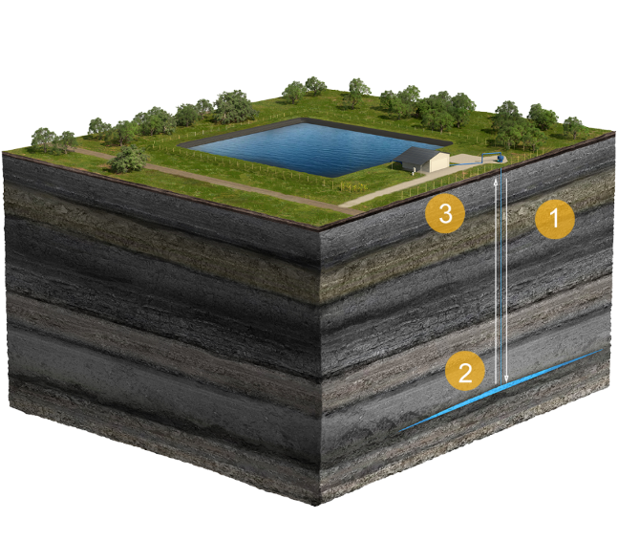
This presentation will focus on measurement and modeling of lens behavior for a first-of-its-kind demonstration project in the Western Canadian Sedimentary Basin, Alberta, Canada. The experiment entails creation of a horizontal subsurface lens through fluid injection via a window cut through the casing in a vertical well followed by cycling of smaller injection and flowback stages. Tiltmeter data indicates subhorizontal lens orientation and nearly circular shape. Pressure, rate, and downhole caliper width measurements indicate flowback behavior that is controllable by a choke at the wellhead and that experiences a period of quasi-steady energy recovery which can be followed by simultaneous decrease of flowing pressure, rate, and wellbore lens width that is associated with lens pinching in the near wellbore region. This behavior consistent with predictions from a mechanical model that couples elastic deformation of the lens with Darcy-Weisbach fluid flow spanning the laminar to turbulent regimes. The striking agreement between measurements and a model of a horizontal, circular lens in a semi-infinite elastic domain validates the application of this fully-coupled mechanical model that makes notable simplifying assumptions on lens geometry. The validated model is then used to predict the domain of the circulating fluid as it travels in and out of the lens and to estimate the corresponding fluid and energy efficiencies associated with given designs.

Overall, the study illustrates the feasibility of generating a horizontal lens with simple geometry and direct connection to a vertical wellbore, thereby advancing subsurface efficient pumped energy storage for renewable, but intermittent, energy resources.

Biography
Andrew Bunger is an Associate Professor in the University of Pittsburgh's Department of Civil and Environmental Engineering. He joined the University of Pittsburgh in 2013 after spending 10 years in Melbourne, Australia working in the Geomechanics Group within the Commonwealth Scientific and Industrial Research Organisation (CSIRO). Prior to that, he received his PhD in Geological Engineering from the University of Minnesota. His research interests include the mechanics of hydraulic fractures, coupled fluid-shale interaction, emplacement dynamics of magma-driven dykes and sills, and development of novel materials for wellbore cementing and plugging.

Connection Information

Join Zoom Meeting
https://utah.zoom.us/j/96292121217

Meeting ID: 962 9212 1217
Passcode: 409309
One tap mobile
+12532158782,,96292121217#,,,,*409309# US (Tacoma)
+13462487799,,96292121217#,,,,*409309# US (Houston)

Dial by your location
+1 253 215 8782 US (Tacoma)
+1 346 248 7799 US (Houston)
+1 669 900 6833 US (San Jose)
+1 301 715 8592 US (Washington DC)
+1 312 626 6799 US (Chicago)
+1 646 876 9923 US (New York)
Meeting ID: 962 9212 1217
Passcode: 409309
Find your local number: https://utah.zoom.us/u/az4zlXAbA

Join by SIP
96292121217@zoomcrc.com

Join by H.323
162.255.37.11 (US West)
162.255.36.11 (US East)
115.114.131.7 (India Mumbai)
115.114.115.7 (India Hyderabad)
213.19.144.110 (Amsterdam Netherlands)
213.244.140.110 (Germany)
103.122.166.55 (Australia Sydney)
103.122.167.55 (Australia Melbourne)
64.211.144.160 (Brazil)
69.174.57.160 (Canada Toronto)
65.39.152.160 (Canada Vancouver)
207.226.132.110 (Japan Tokyo)
149.137.24.110 (Japan Osaka)
Meeting ID: 962 9212 1217
Passcode: 409309

Join by Skype for Business
https://utah.zoom.us/skype/96292121217

