Three parts to modeling hydrogen:
1. Electricity to hydrogen
• Electrolyzer (PEM or alkaline)
Questions to be answered: Cost assumptions for electrolyzers (capex and O&M), operating parameters (efficiency, ramp up/down max rates, shut down costs) for electrolyzers.
Conclusion: Model electrolyzers as alkaline and have model decide how many and when to use them? May need to discuss details.
2. Storage/transport
• Just sell it for a price, don’t store it (vary price to cover relevant ranges – maybe $1, 2 or 3/kg)
• Store it on site (compressed, underground, metal hydride, etc.) – cost range is large and dependent on storage time
• Transport it to low-cost large storage (compressed gas, pipeline, liquid) – cost range is large and dependent on storage time
Conclusion: unless we are wanting to specifically compare two primary storage/transport options, it is easiest just to sell it using cost as $1/kg, $2/kg or $3/kg. When Kenji was studying Japan, he was looking at importing it from Australia. That’s quite important for Japan, but California may not need to think so much about that.

3. Hydrogen to electricity options (short list) – see evaluation on next page.
• Fuel cell
- Dedicated (low capacity factor will be expensive, so need to be high capacity factor)
- Truck – V2G while truck is parked with driver sleeping or while truck is waiting for load
- Rail – V2G while waiting for next load
- Ships – V2G while in port and not needing full power for on board
- All transportation types: could the vehicle be driven to the place where there is an emergency or special need?
• Turbine
- Dedicated – need high capacity factor or is there a “peaker” version?
Conclusion: Need to discuss this one – see next page.

Things that matter (Based on these which options will be viable?):
1. Cost of making hydrogen
2. Cost of transporting hydrogen
3. Cost of storing hydrogen
4. Losses – may be especially important for liquified hydrogen
5. Competition

33.3 kWh/kg = hydrogen lower heating value
39.3 kWh/kg = hydrogen higher heating value

If 100% efficient and hydrogen is $2/kg, then the cost of hydrogen to generate 1 kWh is 2/33 = $0.06/kWh. If the efficiency is 60%, then the cost is $0.10/kWh. If hydrogen could drop to $1/kg, being at $0.05/kWh for fuel cost would open possibilities, as shown by J. Reed’s study.

For discussion: which of the following methods for converting hydroge to electricity might we try to model? (First discuss which would be the first to be selected by the model as these are most important to model, then discuss the inputs – highlighted in red)
Use cases for a range of scenarios for dual-use fuel cells
1. Peaker plant on wheels for emergencies: Truckers would have driven their fuel-cell trucks to Texas to generate electricity for the $9000/MWh price. Questions: availability of local hydrogen and grid connections; I think $9000/MWh would get the truckers to Texas, but what would it take to compensate for their inconvenience? (Model can apply a cost per day per truck plus the cost of the hydrogen plus a cost for the grid connection. Then the asset is utilized 24-7 until the emergency is over – would there be any difficulty implementing this in the model?)
2. Peaker plant on wheels when convenience aligns with high net demand: Truckers could connect their fuel-cell trucks to the grid during the night at a truck stop while they sleep if the price of electricity would cover the cost of the hydrogen plus enough to make it worth their trouble. Questions: how much would the truckers want to make it worth their trouble, how flexible would they be about hours and what would be the cost of creating the grid hook ups? (Model can say that the truck can be connected from 6 pm to 6 am in California (or may be other times?) Note that truckers aren’t allowed to drive more than 11 hours and need to take a 30-min break after 8 hours, so if the driver drove from 6 am to 6 pm, that might be reasonable, but… need to provide cost of hydrogen, hook up and enough to make it worth the hassle – maybe $100 per truck per night? If the truck has a 100-kW fuel cell, then in 12 hours can make 1.2 MWh. So the price will need to be > $250/MWh to make this work, including a cut for the truck stop to pay for the inverter – need to estimate that more accurately)
3. Peaker plant on wheels when convenience aligns with high net demand: Shipping companies could connect their fuel-cell trucks, ships, or locomotives to the grid whenever the vehicle is not in transit and the price of electricity is high enough to cover the cost of the hydrogen plus enough to make it worth their trouble. Also within this would be fuel cells used for fork lifts or any other fuel cell not typically in use at night. Questions: how much would the companies want to make it worth their trouble, what would be the cost of creating the grid hook ups, what would be the most likely use cases? If the value of electricity is low during the day, then they might only do this at night or on cloudy days.)

Note: if you have your choice between using a battery vs using an electrolyzer – to stored hydrogen – to fuel cell, are we agreed that for short term storage, a battery will win every time? The fuel cell only wins if the need is at a time when battery electricity is not available. How does this guide our choices about modeling – does it mean that #2 and #3 aren’t relevant and only #1 matters. (J. Reed suggested that it would become interesting at $1/kg)?

Use cases for dedicated fuel cells (is there only one?)
1. Standard use case. Fuel cell is made to operate whenever the price of electricity is high enough to cover the cost of the hydrogen. Need to be able to recover the cost of the fuel cell during times when the price gets very high. Questions: How much does the fuel cell cost (capex plus fixed and variable O&M – what kind of fuel cell shall we choose to model?); how much does the hydrogen cost? What is the efficiency of the conversion? Do we need to worry about ramp up/down? Startup cost? Then let the model select – so we don’t need to identify a target cost.

Use cases for dedicated turbines (is there only one?)
1. Standard use case. Turbine is made to operate whenever the price of electricity is high enough to cover the cost of the hydrogen. Need to be able to recover the cost of the turbine during times when the price gets very high. Questions: How much does the turbine cost (capex plus fixed and variable O&M – what kind of turbine shall we choose to model?); how much does the hydrogen cost? What is the efficiency of the conversion? Do we need to worry about ramp up/down? Startup cost? Then let the model select – so we don’t need to identify a target cost.

Electrolyzer cost options summary.
Appears best to model alkaline – do we agree on that?
From Rui Shan paper:
 | AEL | PEM
Minimum operating capacity [%] | 20 | 5
Pressure output [bar] | 0 | 30
Power consumption [kWh/m³H₂] | 4.5-7 | 4.5-7.5
CAPEX [$/kW] | 900-1,500 | 1,400-1,800
Lifetime – system [years] | 20 | 20
Lifetime = stack [hours] | 80,000 | 40,000
Table 1 Summary of AEL and PEM technologies [82–86] (Shan paper, in review)
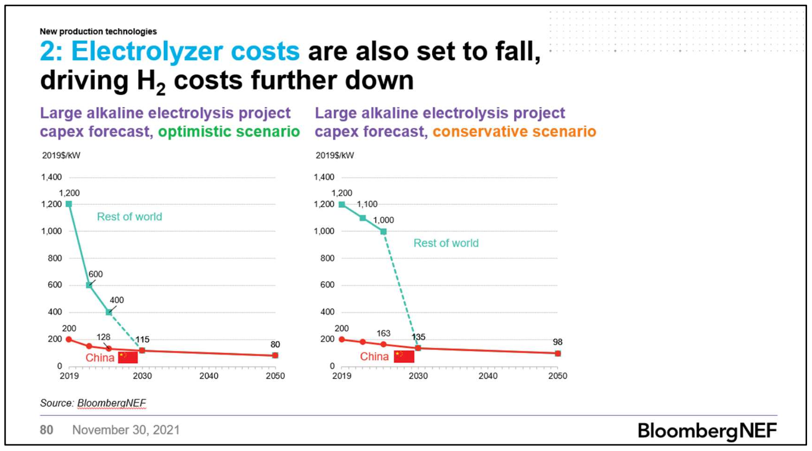
https://about.bnef.com/new-energy-outlook/

