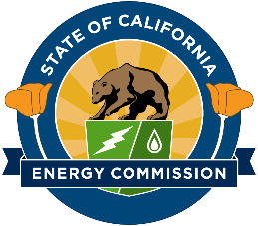

California Energy Commission

Modeling of Long-Duration Storage for Decarbonization of California Energy System
Contract # EPC-19-060 with The Regents of the University of California, Merced

CPR #1 Meeting Agenda

March 25, 2021
10:00 AM – 12:00 PM

- Introductions (5 min)
  - Presenters and Attendees
  - Team Members and Project Partners
- Project Overview & Status (30 min)
  - Project Timeline and Goals
  - Results from the Introductory Public Workshop and the Baseline Development (Task 2)
- Project Approach (25 min)
  - Approach to Storage and Energy Technology Summaries
  - Plans for the Scenario Selection Public Workshop
  - Challenges and Opportunities
- Questions (30+ min)
- CPR Determination April 8, 2021

