Defining directions for the long-duration energy storage study

E3 has asked our feedback on their draft scenario proposal in preparation for defining our complementary directions:
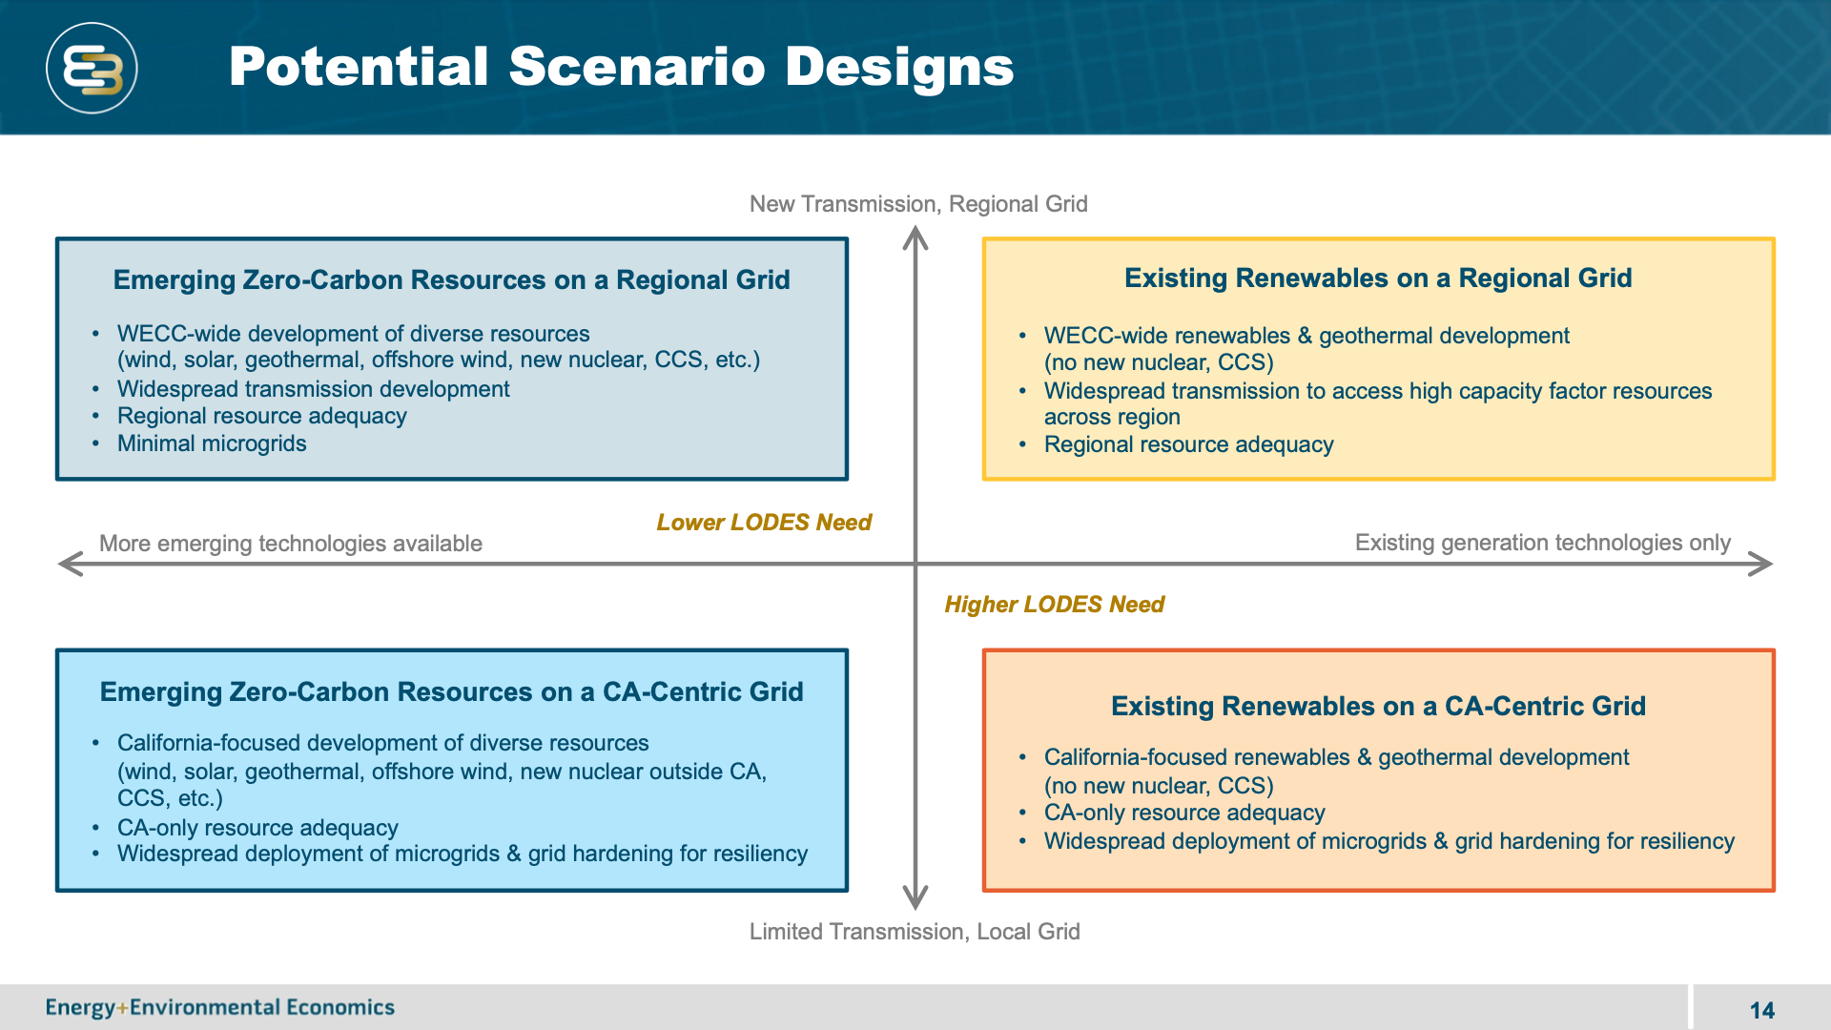

The conclusion that was sent to E3 and CEC:
My team discussed how to best define complementary scenarios that will enable the CEC to learn the most from the two parallel projects and concluded:
• Modeling approaches are differentiating: We propose that the primary benefit will be for us to do independent analysis using a range of modeling approaches (We will use SWITCH, RESOLVE, and other tools that we are developing) and to compare how the outputs of those differ from those found by E3, providing the CEC with an understanding of the uncertainty of the modeling software/approach.
• It’s essential to include all inputs: We discussed our priorities, but it’s not clear that working through those with you will provide value. I think we all agree that the final answers will depend on ALL of the inputs, so for us to say that we won’t consider x or y would potentially compromise the accuracy of the results.

Here are a set of ideas that could be things to explore in a deep dive. My requests:
1. Add more items to the list if I’ve missed something important.
2. Select your favorites: you might do this by selecting your top three or by going through and indicating which ones you find to be of high, medium or low interest..
3. For those that interest you most, if you were to work on them, what approach would you like to take? For example, for the solar overbuild one, is there a particular use of the surplus electricity you would want to study? (I suggested items #2 and #3 as examples of things I would consider)
4. I took notes in the meeting on Jan. 8 – I intend to refer to these – if I didn’t capture your thoughts accurately, please edit these.

For each of these define a baseline point and then look at alternative scenarios

- Overbuild of solar coupled with finding other uses for the surplus electricity
- A subset of #1 would be to make hydrogen with the surplus electricity.
- A subset of #2 would be to use hydrogen and fuel-cells in trucks for seasonal storage
- Hydrogen:
- Other ideas for how hydrogen could be important?
- EV charging strategies (Top for Dan)
- Electrification of buildings and other sectors
- Demand management (e.g. chilling currently done at night is shifted to daylight hours)
- Transmission deployment
- Local storage vs central storage
- Off-shore wind deployment (Top for Dan)
- Large on-shore wind deployment
- Out-of-state wind use
- Geothermal deployment
- Biogas/biomass deployment
- Hydro variability with wet/dry; pumped hydro deployment
- Carbon sequestration coupled with natural gas or biogas plants
Dan’s top two:
EV charging strategies
Off-shore wind deployment
Paty’s list:
Hourly modeling (interplay with transmission)
Geographical scopes between RESOLVE and SWITCH (transmission and resources)
Limiting transmission
Parameter sensitivity to storage (losses, charging efficiencies, etc. – which parameters are important)
Impact of reserve metrics.
Noah’s list:
Location of storage is an important question. Couple with industrial user or microgrid.
Entry strategies (thermal strategies may need industrial users)
Julia’s list:
Hydro variability is interesting – climate impacts on hydro availability.
Climate impacts on air-conditioning load
Cross-sector interactions
EV charging
Demand management
Kenji’s list:
Electrification of transportation (both BEV and FCEV)
Hydrogen for steel making (may leverage Kenji’s other project)
Overcapacity of renewable is key (whether off-shore or solar) (Call it flexible resource)
Sergio’s list:
EV charging
Early retirement of fossil plants from equity perspective
Building electrification (coupled with rooftop solar and storage)
Rui’s list:
Location for storage to enable resilience.
Entry strategies; market design
Proactive curtailment strategy
Fuel cell vehicle. Effect of climate change on charging. Customer choice between EV and FCEV
Pedro’s list:
Overlaps with Paty’s list: geographical scope and transmission.
Congestion; not creating market problems; strategies to keep curtailment small
RESOLVE oversimplifies the resilience – analyze different weather but also different reserve margin
Time sampling question
Jeremiah: fits into the other lists
Russ:
Transmission: interconnection to ERCOT and eastern grid got shelved and is now back. Early indications were that it would have a big impact and reducing storage needs. Could be an important impact. Since NREL has already done a bunch of work, could interview them (Doug Arent is working on it)
Abido’s list:
Overbuild of solar and applications for surplus capacity.
Sarah’s list:
Focus on outcomes:
• Influence policy related to electrification: Transportation sector is #1 GHG emitter currently: so EV adoption is a priority to reduce GHG, but, also, daytime charging of EVs can accelerate the adoption of solar without needing to install as much new storage or nighttime charging can increase the need for storage. Agree with Dan that EV charging is a top priority with the goal of enabling the state to move faster with policy on that in the near term.
• Influence innovation toward cross-sector storage strategies: Identifying cross-sector uses for surplus renewable electricity can provide ultra-low-cost storage. We should get the community thinking about this so that they will invest. It’s an opportunity for creativity.
• Answer question of what carbon price is needed – I haven’t figured out how to do this, but it is one of the most useful things we could do to guide policy.
• Answer question of what price point does each LDES technology need to hit to gain market share. (see next bullet for strategy – recall the graph in the public workshop)
• Feedback from the TAC was to sort out the different types of storage that are needed. Strategy:
- Start with a super simple calculation that can be done very quickly to cover the huge parameter space that we want to cover. (Abido is working on this)
- Evaluate the parameter space by identifying the statistics of how much storage for each duration/efficiency is needed as all of the inputs are varied
- Use the results to select a subset of scenarios to study with RESOLVE
- Use a two-step approach with RESOLVE to identify the capacity expansion plan (to identify how much generation is needed for 2-step days) and then the 8760-hour dispatch to quantify the detailed statistics and refine the selection of the types of storage.
- Vary the costs of different duration storage to create the graph that was in the public workshop presentation.

Ashling made the comments in blue:
Other ideas for how hydrogen could be important?
- We can replace natural gas with Hydrogen at home in fuel cell boilers
- We can replace natural gas with Hydrogen at current power plants and infrastructures
EV charging strategies
- EV charging stations can also help in demand management by sending back stored electricity to the grid at peak hours
Demand management (e.g. chilling currently done at night is shifted to daylight hours)
- We need smarter technology – like AI to register and connect all electronic devices (e.g. cars) in a system and advise on exactly what time and at which charging station your car should be charged to save both energy and money
Transmission deployment
- This may need more (interstate) regulations and public policy making
Local storage vs central storage
- It could be interesting to think of storage stations right next to major transmission lines, so the surplus electricity store in them (is it what you mean by central?)
Out-of-state wind use
- Should be interesting to study trends of wind generation for each neighbor state in winter
Hydro variability with wet/dry; pumped hydro deployment
- We can use cement bricks instead of pumped hydro

A separate question is about your interest in various topics. The energy system is too complex for any of us to be an expert on everything. On a day-to-day basis, I receive notifications of webinars on many topics. I can’t attend all of them, but I would like to be able to forward each announcement to someone within the group. Please add your name to the following table if you are interested (please be selective – I will send the really important webinars to everyone):
Topic | My #1 favorite – I would be willing to serve as the team’s expert in this area (if Sarah has a question, I will get the answer to her question…) | I am interested and would like to be pointed to webinars on this topic
Wind |  | Ashling
Solar | Bimal #3 | Ashling
Geothermal
Biogas/mass
Hydro | Bimal #2
Hydrogen |  | Ashling
Electric vehicle charging |  | Ashling
Demand management |  | Ashling
Heat pumps |  | Ashling
Future load prediction |  | Ashling
Incentive programs |  | Ashling
Resource adequacy calculations |  | Ashling
Flow batteries
Pumped hydro | Bimal #1 | Ashling
Liquid air
Thermal storage |  | Ashling
Geomechanical storage |  | Ashling
Carbon sequestration
Transmission |  | Ashling
Grid storage (AI) |  | Ashling
Add your favorite….

