Defining directions for the long-duration energy storage study

E3 has asked our feedback on their draft scenario proposal in preparation for defining our complementary directions:
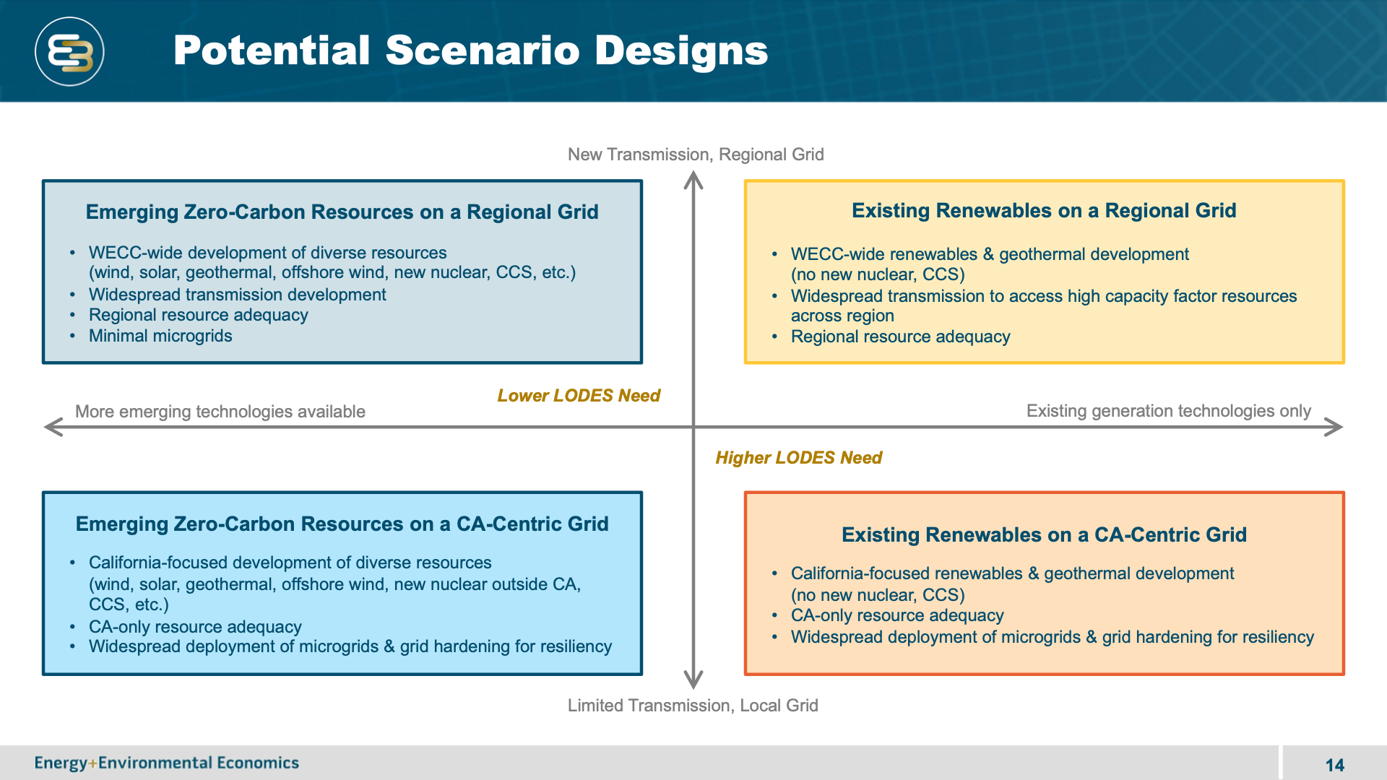

I think we all agree that to obtain meaningful results, we and E3 both need to explore the extent to which we use transmission and the extent to which a range of new technologies are successful (the primary point of the graphic). I was thinking that our complementary studies might be defined less on the range of topics considered and more on the prioritization of where to do a deep dive. E3 has laid out the broad range - which makes great sense - but, it’s not clear to me where E3 is thinking to do a deep dive.

In terms of feedback to E3, I don’t think it’s useful for us to get into details.
Another approach to defining how our studies could be complementary would be to make a list of the most probable pathways to success, especially in the context of actions that CEC could take to enable each of those.

My first question for all of you:
Do you agree that defining complementary scenarios should focus more on defining where to do deep dives and less on the sort of range that they show above?
If so, then please respond to the queries below. If not, how should we define our complementary directions?

Our primary task is to study the value of long-duration storage – how does it compete with short-duration storage and how will it compete with seasonal solutions? Within that context, we may do a variety of deep dives.

Here are a set of ideas that could be things to explore in a deep dive. My requests:
1. Add more items to the list if I’ve missed something important.
2. Select your favorites: you might do this by selecting your top three or by going through and indicating which ones you find to be of high, medium or low interest. Shall I make a survey or we can edit this as a Google doc.
3. For those that interest you most, if you were to work on them, what approach would you like to take? For example, for the solar overbuild one, is there a particular use of the surplus electricity you would want to study? (I suggested items #2 and #3 as examples of things I would consider)
- Overbuild of solar coupled with finding other uses for the surplus electricity
- A subset of #1 would be to make hydrogen with the surplus electricity.
- A subset of #2 would be to use hydrogen and fuel-cells in trucks for seasonal storage
- Other ideas for how hydrogen could be important?
- EV charging strategies
- Electrification of buildings and other sectors
- Demand management (e.g. chilling currently done at night is shifted to daylight hours)
- Transmission deployment
- Local storage vs central storage
- Off-shore wind deployment
- Large on-shore wind deployment
- Out-of-state wind use
- Geothermal deployment
- Biogas/biomass deployment
- Hydro variability with wet/dry; pumped hydro deployment
- Carbon sequestration coupled with natural gas or biogas plants

A separate question is about your interest in various topics. The energy system is too complex for any of us to be an expert on everything. On a day-to-day basis, I receive notifications of webinars on many topics. I can’t attend all of them, but I would like to be able to forward each announcement to someone within the group. Please add your name to the following table if you are interested (please be selective – I will send the really important webinars to everyone):
Topic | My #1 favorite – I would be willing to serve as the team’s expert in this area (if Sarah has a question, I will get the answer to her question…) | I am interested and would like to be pointed to webinars on this topic
Wind
Solar
Geothermal
Biogas/mass
Hydro
Hydrogen
Electric vehicle charging
Demand management
Heat pumps
Future load prediction
Incentive programs
Resource adequacy calculations
Flow batteries
Pumped hydro
Liquid air
Thermal storage
Geomechanical storage
Carbon sequestration
Transmission
Add your favorite….

