PROGRESS REPORT for EPC-19-060
  - October, 2020
  - Recipient Project Manager: Sarah Kurtz
  - Commission Agreement Manager: Jeffrey Sunquist

What we planned to accomplish this period
- Complete negotiation of new approved budget with CEC in preparation for negotiation of subcontracts.
- Begin negotiation of the subcontracts and service agreement
- Meet with E3 to discuss collaboration about coordination of code modifications
- Meet with the CEC and E3 to identify a date for the initial coordinated public workshop
- Define a new timeline for the project to reflect the starts of the subcontracts
- Finalize the initial Benefits descriptions with Braden Henderson
- Make substantial progress toward completion of the baseline description, as required for the first deliverables
- Schedule and plan for the first TAC meeting

What we actually accomplished this period
Budget negotiation: Three new budgets were submitted to CEC. The first two were not approved. We hope that the third version will be approved.
Subcontract and service agreement negotiations: The service agreement is ready to be signed as soon as the new budget is officially approved (we understand that it was unofficially approved already). The subcontracts can be put in place quite quickly as soon as the new budgets are approved.
Meet with E3: The meeting with E3 was held and was extremely helpful in clarifying the situation, enabling us to make more concrete plans about when changes can be made and about how to proceed with the baseline description. We agreed to meet again in early December.
Workshop scheduling: The initial coordinated public workshop has been tentatively scheduled for Nov. 17th. A draft of the presentation for the workshop has been developed and revised in response to input from the project team. It will next be sent to CEC for review on Nov. 2.
New timeline: The new timeline has been developed based on the anticipated completion of the subcontracts and service agreement. As of the end of October, it was estimated that we would have approval to begin negotiation of the agreements sometime in November and be able to complete the agreements in early December, about 5 months after we had originally planned to have the subcontracts competed. Thus, we suggest delaying most due dates by about 5 months with effort made to accelerate the work wherever possible.
Benefits descriptions: After discussion with Braden Henderson and Jeff Sunquist, the initial benefits description was accepted by Braden on Oct. 13.
Baseline description: Work on the baseline development has been progressing for both RESOLVE and SWITCH. See description below.
First TAC meeting: We were requested to delay scheduling the first TAC meeting until after the workshop was finalized.
Work toward deliverables: This month’s description of progress toward defining the baseline scenario is divided into two sections. The first will discuss the selection of the periods and high-level modeling inputs. The second section will discuss the approach to understanding storage.

Defining Baseline Scenario
This section focuses on the input files “period_discount_factors.tab” and “ghg_targets.tab”.
As discussed in the September monthly report, simulating the transition using the periods 2020, 2025, 2030, 2035, 2040, 2045 will better enable study of the steps in the transition. Using the Scenario tool that E3 has published, we ran RESOLVE to identify the results of changing the spacing of the periods. The results of the original RSP appear in Figure 1, showing how very few resources are built between 2020 and 2030, then there is a massive build out between 2030 and 2045. Given that the primary build-out of storage occurs in this case between 2030 and 2045, it is sensible for us to space the periods more uniformly. The result of the 5-year spacing is shown in Figure 2.
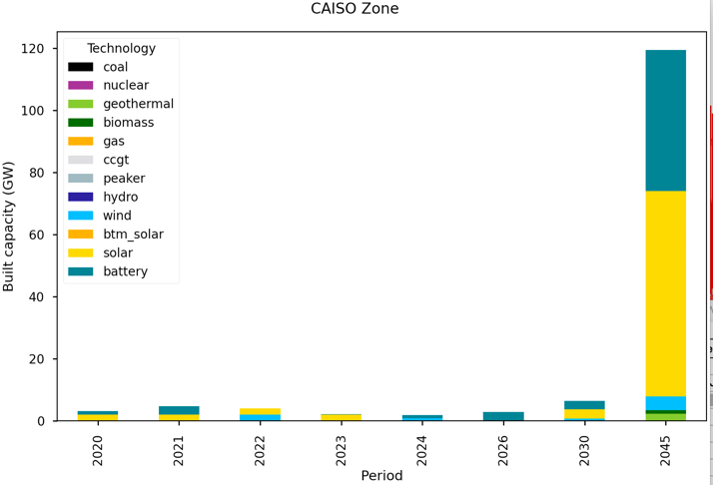
Figure 1. Capacity expansions identified for each period in the Reference System Portfolio (RSP) using the RSP set of periods. Note that the scale is about 120 GW, reflecting the large capacity built between 2030 and 2045.
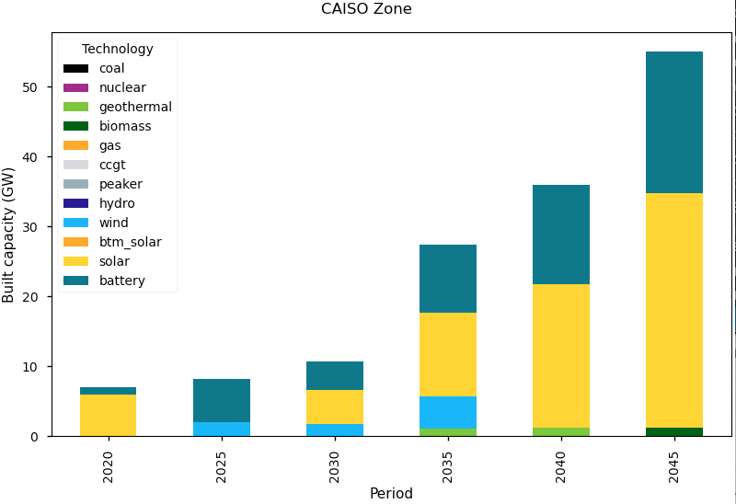
Figure 2. Capacity expansions identified for the RSP when 5-year increments are used to define the periods as calculated by the Scenario tool, which uses 95% discount factor and assumes 23 years for the 2045 period.
The five-year spacing results in more consistent build-out between the different periods, though it still shows greatly expanded build-out in later years relative to the early years. The build-out of solar and storage is driven by the reduced emissions requirements. The larger build-out in 2045 compared to other years may be partially caused by the final period being considered to represent 23 years, much more than the 5 years represented by the other periods. When 5-year-spaced periods are used, it may be best to weight all of the periods equally. A simulation was designed to use a discount factor of unity rather than the 95% used in the RSP and to assume years 2020 and 2045 represented 3-year periods while the others represent 5-year periods. The results of this simulation are shown in Figure 3, with slightly greater build-out in the earlier years and less in the final period.
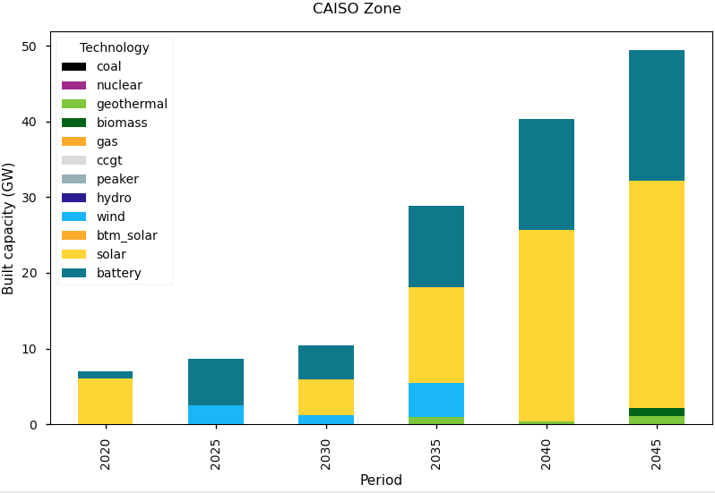
Figure 3. Capacity expansions identified for the RSP when 5-year increments are used to define the periods as for the simulation shown in Figure 2, but changing the 95% discount factor to unity and assuming 3 years for the 2045 period instead of 3 years.
The current RSP does not implement the SB100 emissions goals, instead requiring the emissions to decrease by 87% in 2045. To meet the SB100 emissions goals, we would like to require the emissions in 2045 to be zero. However, if the 2045 period starts in the middle of 2042, it is reasonable to assume that there will be some emissions in the period 2045, reflecting the emissions in the years before that. To obtain a period with zero emissions, it is, therefore, useful to consider adding a period in 2050. The capacity expansions selected for the RSP inputs using the Scenario tool, with 5-year periods extending to 2050, can be seen in Figure 4. The results are similar to those shown in Figure 2 for periods through 2045. The 2050 period builds far fewer resources, probably because of the comparable emissions limits between 2045 and 2050. The simulation through 2050 required many more iterations to solve than the simulation ending in 2045.

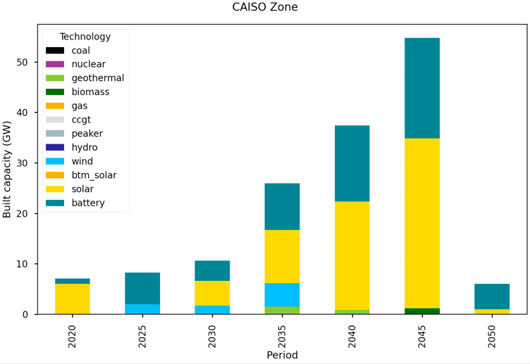
Figure 4. Capacity expansions identified for the RSP when 5-year increments are used to define the periods as calculated by the Scenario tool, which uses 95% discount factor and assumes 23 years for the 2050 period. This simulation differs from the one shown in Figure 2 only in that the period 2050 is added. Note that the GHG emissions targets are set as 2040: 20.8 million tons CO₂/y; 2045: 12.3 million tons CO₂/y; and 2050: 10.4 million tons CO₂/y.
If the RSP is modified to eliminate emissions in the 2045 period, the result is shown in Figure 5.
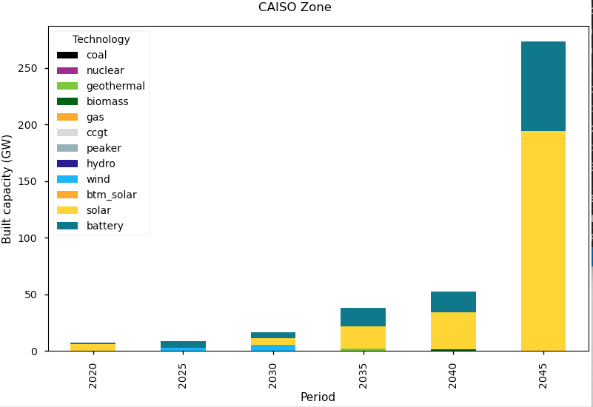
Figure 5. Capacity expansions using the same inputs as Figure 3 but reducing the allowed CO₂ emissions to zero in 2045. Note the expanded scale relative to the previous figures.
Figure 5 demonstrates the great challenge of reaching zero emissions and the large amount of solar and storage that will need to be built in the final years. Of course, this is the opportunity we are exploring – how to reach zero emissions at the lowest total system cost.

Understanding long-duration storage
Quantifying price targets for long-duration storage requires answering the question “What is long-duration storage competing with?” Defining the cost targets needed for long-duration storage requires understanding its competition. To facilitate the discussion, we first define several classes of storage technologies according to the storage duration and according to their application:
- Short-duration storage. Typically, 1 to 4 hours duration. Such storage may be intended to charge when the sun is shining and discharge as the sun sets, providing support through the head of the duck, as portrayed by ‘the duck curve.’ Lithium ion batteries are already showing value to be paired with solar and extend the output of solar plants during this time of day when there tends to be a shortage of electricity.
- Same-day long-duration storage. Typically, 4-10 h duration. Such storage may be intended to charge when the sun is shining and discharge through the night. When coupled with a solar plant in a place with consistent sunshine every day, it can be possible for it to serve as “baseload” solar electricity generation. Today, there are a few systems being installed with this type of operation in mind, but this type of storage will become more important at higher penetration of solar electricity.
- Cross-day long-duration storage. Typically, 10-100 h duration. Such storage may be intended to charge when the sun is shining on a sunny day, then discharge both through the night and on subsequent cloudy days. The longer-duration storage has the possibility of providing “baseload” solar electricity even in a location that doesn’t have consistent sun every day, as long as variability of the sunshine doesn’t exceed the storage capability. As California moves toward zero-carbon electricity, this form of storage will become more important.
- Seasonal storage. May be > 100 h duration. Such storage may be intended to charge during the summer and then discharge once during the winter. In general, the large amount of energy that is needed to get through the winter may require chemical storage such as hydrogen, ammonia, methane, or some other high-density fuel.
Answering the question of “What is long-duration storage competing with?” benefits from considering competition with both short-duration storage and with technologies that address the seasonal challenge.
Lithium ion batteries are currently the most commonly deployed short-duration storage technology. Thus, it is clear that long-duration storage technologies are competing with these in the near future. As the natural gas generators currently used to get through the night are replaced by solar and storage, the short-duration storage may be supplemented by same-day long-duration storage. In the 2020s, we anticipate that long-duration storage will primarily be competing with short-duration storage such as lithium ion batteries. We anticipate that the price target needed to enter the market may follow a curve something like that shown in Figure 6. Note that there are no units on the y axis of Figure 6 – the quantitative value is what we intend to calculate as a key element of our project. The shape of this curve is meant to show trends, not to provide accurate information.
Figure 6. Schematic representation of the target price for market entry of long-duration storage.
Currently, there is little need for long-duration storage, so, depending on the efficiency of the technology and the ratio of the capex price/kW to the capex price/kWh the price target/kW would need to be less than that of batteries. As the value of the long-duration storage becomes greater because of greater solar deployment, the allowed price would increase. When the market is “ripe,” the target price reaches a maximum, identifying an ideal time for a new technology to enter the market. Then, as more long-duration storage is deployed, the costs will drop, and lower price targets will be appropriate as competing long-duration storage technologies are able to reduce their prices.
As the penetration of both solar and storage increases, the long-duration storage will continue to compete with short-duration storage for the daily charge-discharge applications. At the same time, long-duration storage will begin to compete with seasonal storage. Today, the role of seasonal storage is played largely by storage of fossil fuels to use for electricity generation throughout the winter.
One could question whether it’s important to include seasonal considerations or whether it is possible to understand long-duration storage by studying the longest periods of cloudy weather and ignoring the differences between summer and winter. To guide our understanding of the importance of seasonal effects we did a series of simplistic calculations to estimate the needs for resource adequacy for a zero-carbon grid. This simplistic calculation is meant to give an order of magnitude estimate and to better understand the factors that will affect our final results, not to provide accurate predictions. We start by assessing the power needed for resource adequacy using August 14, 2020, which was the first day of rolling blackouts during a heat wave in 2020.
The emergency was declared on August 14, just before the sun set, as labeled in Figure 7, and the energy mix during that hour is summarized in Figure 8. Other days hit higher peak demand earlier in the summer, but usually at a time when the sun was shining. A careful study would consider all days of the summer to select the most challenging day. For this simplistic calculation, the August 14 day was chosen as a good point of reference.
Figure 7. CAISO-reported electricity demand on August 14, 2020. The time when rolling black outs were begun in response to the declared emergency is noted by the arrow.
Figure 8. Nominal CAISO energy mix at the beginning of the emergency on August 14, 2020.
Envisioning a zero-carbon grid, to guarantee resource adequacy for a day like August 14, we assume:
- Thermal generation is no longer available
- Nuclear generation is no longer available
- Imports are not available
- Solar generation will not be available after sun set
- Wind generation is also not available. While wind may be available, one of the reasons why August 14 was problematic was because there was very little wind. In general, we know that there will be some days with very little wind, so to ensure resource adequacy, we need to consider the worst case, which is no wind.
With these assumptions, it is obvious that at least 40 GW of storage (or demand management or other tool) will be needed to meet the peak demand of a zero-carbon grid. It is possible that 50 GW of storage or even more will be needed when load growth is anticipated, but geothermal, biomass and hydro can be counted on to meet part of the load so we will use 40 GW for our simplistic estimate.
While meeting the peak load at the time of sunset is critical, for a zero-carbon grid the storage will need to continue to supply energy throughout the night. The electricity data for August 14 as a function of the energy source is shown in Figure 9. The total load data are also shown in Figure 10, dividing the day into daytime, when overbuilding of solar plants enables charging of the storage, and nighttime, when the storage must supply the load. The total energy discharged during the night is 400 GWh, implying that the 40 GW of storage might optimally be designed to be able to deliver electricity for 10 hours. Thus, based on analysis of this single day, for a zero-carbon grid the size of the storage challenge motivates installation of 40 GW of 10-h duration storage.
Figure 9. CAISO’s energy mix for supplying electricity throughout the day on August 14, 2020.
Figure 10. Schematic of how storage might be charged from solar electricity during the day and discharged at night using August 14, 2020 as an example. The heavy black line shows the load; the dotted line shows the solar electricity that was generated on Aug. 14, 2020.
For this day, 40 GW of 10-h duration storage would appear to be adequate, and days during much of spring and summer could require far less since the length of the day may be greater and the nighttime load smaller. However, during the winter, the nighttime lasts longer, and California is more likely to experience foggy, cloudy, or even rainy days. In some locations, the wind blows reliably during the winter, but, as shown in Figure 11, the wind appears to be unreliable for California in the winter. It may be that off-shore wind or wind electricity imported from Wyoming could be helpful, but in the absence of those, solar electricity may be expected to compose the majority of the electricity generation in a fossil-free California grid.
Figure 11. Historical monthly electricity generation by solar and wind as reported by the EIA.
Based on the lack of reliability of wind, it is reasonable to assume that the transition to a zero-carbon grid will be driven primarily by expansion of solar while removing thermal, nuclear and imported electricity sources. Using 5-min CAISO data for 2019, the thermal, nuclear and imported generation was removed, and the solar generation was increased to equal a factor of four more than was measured in 2019. The factor of four was chosen because it roughly balanced the annual total generation with the annual total load. The difference between the generation and the demand for each 5-min period was calculated to assess the storage charging or discharging that could be expected for each period. The state of charge was calculated as a function of time. For simplicity, the charging and discharging efficiencies were assumed to be 100%. The initial state of charge was adjusted so that the storage state of charge would not drop below zero, as shown in Figure 12.
Figure 12. State of charge for a fleet of storage resources calculated using 2019 load data and generation data with the solar data expanded and other generation sources removed, as described in the text.
From the maximum stored energy shown in Figure 12, about 22 TWh, the duration of storage needed to get through the winter for 40 GW of storage would be 550 hours. This is a very large amount of storage. By comparison, the Hoover Dam generates 4 TWh of electricity annually. From Figure 11, it appears that monthly solar generation in the summer is about twice that in the winter. Thus, if the solar is built to be twice the size needed to deliver the annual electricity load (8 times the size in 2019), the needed storage drops quite significantly, as shown in Figure 13. In this specific case, it is found that the duration of storage needed for the 40 GW of storage drops to about 150 h. However, the fraction of electricity that is supplied above the anticipated load profile is huge (about 50% of the total electricity). It may be possible to use that electricity to make hydrogen or some other energy-intensive task. If a good application cannot be found, then the electricity would be curtailed.
Figure 13. Potential charge of storage if solar is built out to 8X the 2019 value and thermal, nuclear and imports are removed. The shaded region highlights the difference between the potential charge at the beginning of the year and the end of the year. This represents the energy (about 110 TWh) that might be supplied to a different application or represents curtailment.
Looking at the data from this simple exercise helps us to better understand the simulations we will want to do more accurately in order to know how to focus our effort. When the solar build-out is adequate to meet annual needs, we see that the storage fleet reaches minimum charge in early March. This section of Figure 12 is expanded in Figure 14. In the first week of March, some cloudy days result in less charging during the day than discharging through the evening. In the middle of March, the daytime charging begins to exceed the nighttime discharging. At this time of year, the minimum charge is observed around 7 am. When the solar is built out to be 8X bigger than was the actual solar in 2019 (Figure 13), the minimum charge is observed in January.
Figure 14. Expanded version of Figure 12 to show time of minimum charge.
Inspecting Figure 12 (4X solar build out) for the most rapid two weeks of discharge, we find that the middle of January was the worst two weeks in 2019 as shown in Figure 15. Indeed, this corresponds to the time of minimum charge shown in Figure 13.
Figure 15. Expanded version of Figure 12 to show two weeks with largest discharge of storage.
It is easy to see that there is a tradeoff between overbuilding solar and building a huge amount of storage. However, either way, there is a seasonal challenge. If we overbuild solar, then we either have massive curtailment or we need to identify a seasonal use for the solar electricity (generating hydrogen or…). If we don’t overbuild the solar, we will need storage that can charge and discharge over months, which would be seasonal storage. If the seasonal storage is low-cost and convenient, it could potentially replace the need for the long-duration storage described above. Thus, to assess the need for long-duration storage we need to assess the optimal amount of overbuild of solar as well as the seasonal storage opportunities. There are likely to be trade-offs with respect to the nature of any seasonal storage component and self-discharge losses that may require additional storage capacity.

How we are doing compared to our plan
The work is progressing commensurate with the expenditures. We are behind in both spending and project execution.
Upon approval of the revised budget plan the subcontracts will be finalized. We will review with our CAM the revised set of due dates for all of the deliverables that are not yet completed. We anticipate that this will be verified in the November monthly report.

Significant problems or changes
We need to complete negotiations on a revised budget to enable completion of all of the subcontracts. Note: this was written at the end of October. The revised budget was approved on Nov. 6 enabling start of the subcontract negotiations.

What we expect to accomplish during the next period
- Complete negotiation of new approved budget with CEC in preparation for negotiation of subcontracts.
- Begin negotiation of the subcontracts and service agreement
- Schedule the initial coordinated public workshop
- Review the new proposed timeline for the project to reflect the timing of the subcontracts
- Make substantial progress toward completion of the baseline description, as required for the first deliverables
- Schedule and plan for the first TAC meeting

Status of Milestones and Products
Task # | Task | Deliverable | Due date | Status
1.2 | Kick-off meeting | Updated budget | 9/18/2020 | Complete
1.3 | CPR Meeting #1 | CPR Report | TBD
 | CPR Meeting #1 | CPR Meeting #1 | TBD
1.4 | Final meeting | Final Meeting | 11/11/22
 |  | Schedule for closeout
 |  | Draft and Final Written Products
1.5 | Progress Reports & Invoices | Progress Reports | Monthly | Ongoing
 |  | Invoices | Monthly | Ongoing
1.6 | Final Report | Draft Outline | 6/30/22
 |  | Final Outline | TBD
 |  | Draft Report | 8/30/22
 |  | Final Report | 10/31/22
 |  | Written Responses to Comments on Draft Report | 9/15/22
1.7 | Match funds | Status letter | 9/9/20 | Revision submitted
1.9 | Subcontracts | Final subcontracts | 12/10/20 | Awaiting CEC approval of revised budget
1.10 | TAC | List of potential members | 9/9/20 | Completed
 |  | List of TAC members | TBD | Completed
 |  | Documentation of TAC member commitment | TBD | Completed
1.11 | TAC Meetings | Draft TAC meeting schedule | TBD | Completed
 |  | Final TAC meeting schedule | TBD
 |  | Draft TAC meeting agenda | TBD
 |  | Backup materials | TBD
 |  | Final TAC Meeting agenda | TBD
 |  | TAC meeting summaries | TBD
2.1 | Data assembly | Draft baseline description | 2/4/21 | In progress
 |  | Final baseline description | 2/25/21
2.2 | Confirmation of baseline data and approach | Draft modeling approach description | 2/4/21 | In progress
 |  | Final modeling approach description | 2/25/21
2.3 | Implementation of baseline data into models to create initial baseline scenario | Summary of baseline model results | 3/23/21 | In progress
 |  | CPR Report #1 | 3/23/21
3.1 | Evaluate and document future energy storage technology alternatives | Draft storage Technology summary | 7/2/21
 |  | Final storage technology summary | 8/12/22
3.2 | Define representative future energy storage technology alternatives | Draft proposed storage scenarios summary | 4/1/22
 |  | Final | 8/12/22
3.3 | Evaluate and document future energy electricity generation technology alternatives | Draft electricity generation technology summary | 7/2/21
 |  | Final | 8/12/22
3.4 | Define representative future electricity generation technology alternatives | Draft proposed electricity generation scenarios summary | 4/1/22
 |  | Final | 8/12/22
4.1 | Multi-day model optimization | Summary of multi-day baseline model results | 2/12/21
 |  | CPR #2 | 3/5/21
4.2 | Grid scenario selection | Draft grid scenario summary | 6/11/21
 |  | Final | 8/13/21
5.1 | Preliminary Scenario Analysis | Draft preliminary analysis summary | 2/11/22
 |  | Final | 4/15/22
5.2 | Final scenario analysis | Draft final analysis summary | 6/10/22
 |  | Final | 8/12/22
6.1 | Initial public meetings | Opening workshop presentation materials | 11/19/20
 |  | Northern CA workshop | 12/3/20
 |  | Southern CA workshop | 12/3/20
 |  | Opening workshop summary | 1/3/21
6.2 | Public workshop for grid scenario selection | Agenda | 7/2/21
 |  | Presentation materials | 7/2/21
 | Public workshop with CEC and TAC to present proposed scenarios |  | 7/16/21
 |  | Workshop summary | 7/23/21
6.3 | Public workshop for preliminary scenario analysis | Agenda | 3/3/22
 |  | Presentation materials | 3/3/22
 | Public Workshop with CEC and TAC to present preliminary analysis |  | 3/18/22
 |  | Workshop summary | 3/25/22
6.4 | Public Workshop for Final Scenario Analysis | Agenda | 7/1/22
 |  | Presentation materials | 7/1/22
 | Public workshop with CEC and TAC to present final analysis |  | 7/15/22
 |  | Workshop summary | 7/22/22
7 | Evaluation of Project Benefits | Kick-off meeting benefits questionnaire | 9/18/20 | Completed
 |  | Mid-term benefits questionnaire | 2/18/21
 |  | Final meeting benefits questionnaire | 10/14/22
8 | Knowledge transfer activities | Draft initial fact sheet | 7/25/20 | Completed
 |  | Final initial fact sheet | 7/30/20 | Completed
 |  | Draft final project fact sheet | 7/21/22
 |  | Final project fact sheet | 7/28/22
 |  | Draft knowledge transfer plan | 10/9/20
 |  | Final knowledge transfer plan | 2/26/21
 |  | Draft knowledge transfer report | 8/30/22
 |  | Final knowledge transfer report | 10/31/22

