Technology Projection 1. Battery Storage
1. NREL Annual Technology Baseline 2020
NREL Annual Technology Baseline 2020 (ATB) projects CAPEX, fixed O&M costs, and variable O&M costs of utility-scale, 4-hour battery storage based on Cole and Frazier (2020). ATB sets three projection scenarios to reflect the speed of technological innovation: Conservative, Moderate, and Advanced Scenarios. Table 1 qualitatively summarized these scenarios.

Table 1: Three Projection Scenarios
Scenario | Description on technological innovation
Conservative | - Today's technology with little innovation  - Continued industrial learning  - Decreased public and private R&D
Moderate | - Widespread adoption of today's cutting edge  - Expected level of innovation  - Current levels of public and private R&D
Advanced | - Markets success of currently unproven innovation  - New technology architectures  - Increased public and private R&D

The raw data of battery energy capital costs, battery power capital costs, and fixed O&M costs are summarized in Figure 1. Regardless of scenarios or year, variable O&M is 0 $/MWh. ATB assumes 15 years lifetime. Any of these numbers do not include policy support such as subsidy.

Figure 1: Projections of battery energy capital costs (top left), battery power capital costs (top right) and Fixed O&M (bottom) of utility-scale 4-hour battery storage in real $2018 of three scenarios from ATB

2. Comparison with current RESOLVE and SWITCH inputs
Figure 2 summarized the projection of annualized battery energy capital costs, annualized battery power capital costs, and fixed O&M costs of ATB three scenarios, SWITCH, and RESOLVE. In annualizing capital costs of ATB, 15 years lifetime and 7% discount rate were assumed.

The annualized battery energy capital costs of RESOVLVE is between those of ATB Conservative scenario and those of ATB Moderate scenario. The annualized battery power capital costs of RESOVLVE is close to ATB Advanced scenario. On the other hand, fixed O&M costs of RESOLVE is far lower than those of ATB advanced scenario.

The annualized battery energy capital costs and battery power capital costs of SWITCH are much higher than those in ATB Conservative scenario. While fixed O&M costs of SWITCH is lower than any of ATB scenarios in 2020, the projected costs of ATB become lower than that of SWITCH at least after 2035.

For sensitivity check, 2.5% discount rate were assumed for ATB scenarios in annualizing capital costs. The results are summarized in Figure 3. Because of the change, annualized capital costs curves shift downwards. As a result, the battery energy capital costs and battery power capital costs of RESOLVE are close to ATB Coservative scenario and ATB Moderate scenario, respectively.
Figure 2: Projections of annualized battery energy costs (top left), annualized battery power costs (top right), and fixed O&M (right) of utility-scale 4-hour battery storage in real $2018. The assumed lifetime of SWITCH and ATB are 10 and 15 years, respectively. When annualizing capital costs, 7% discount rate is assumed.

Figure 2: Projections of annualized battery energy costs (top left), annualized battery power costs (top right), and fixed O&M (right) of utility-scale 4-hour battery storage in real $2018. The assumed lifetime of SWITCH and ATB are 10 and 15 years, respectively. When annualizing capital costs, 2.5% discount rate is assumed.

Table 2: Annualized battery energy capital costs of ATB, RESOLVE, and SWITCH
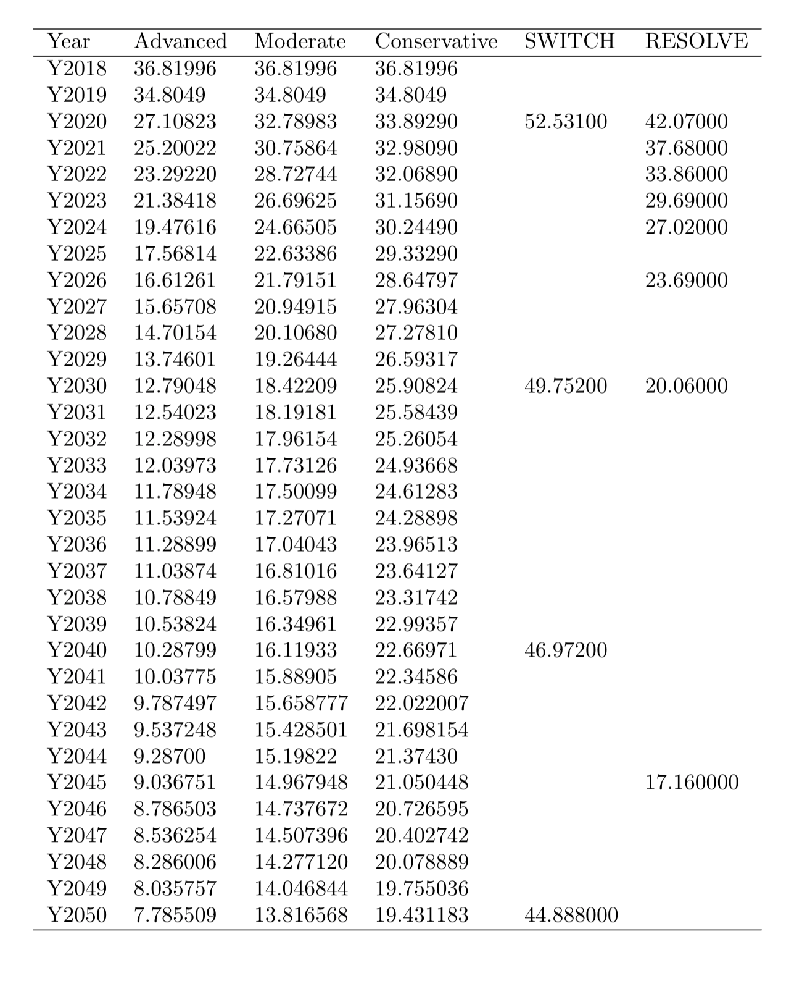

Table 3: Annualized battery energy capital costs of ATB, RESOLVE, and SWITCH
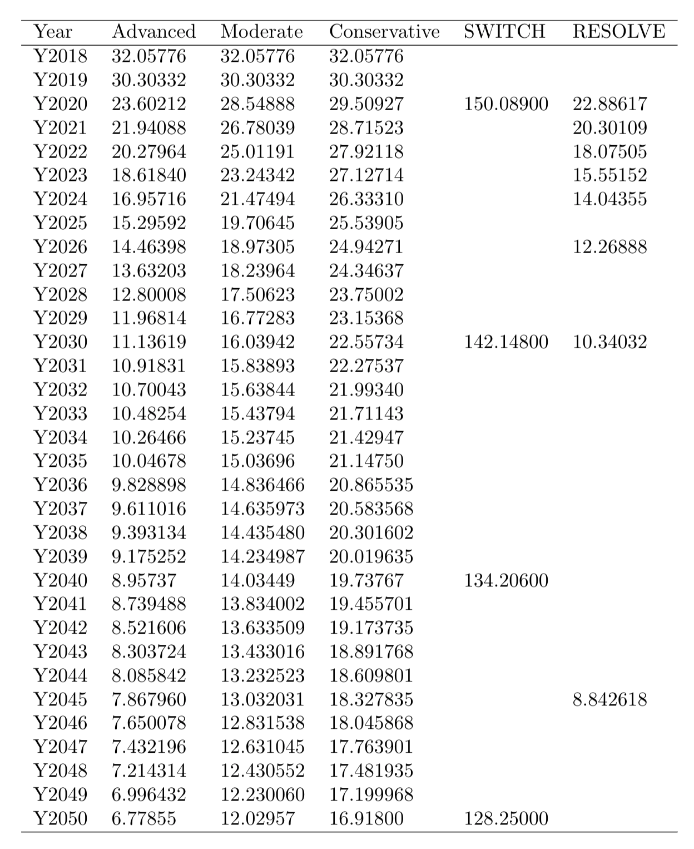
Table 4: Fixed O&M of ATB, RESOLVE, and SWITCH
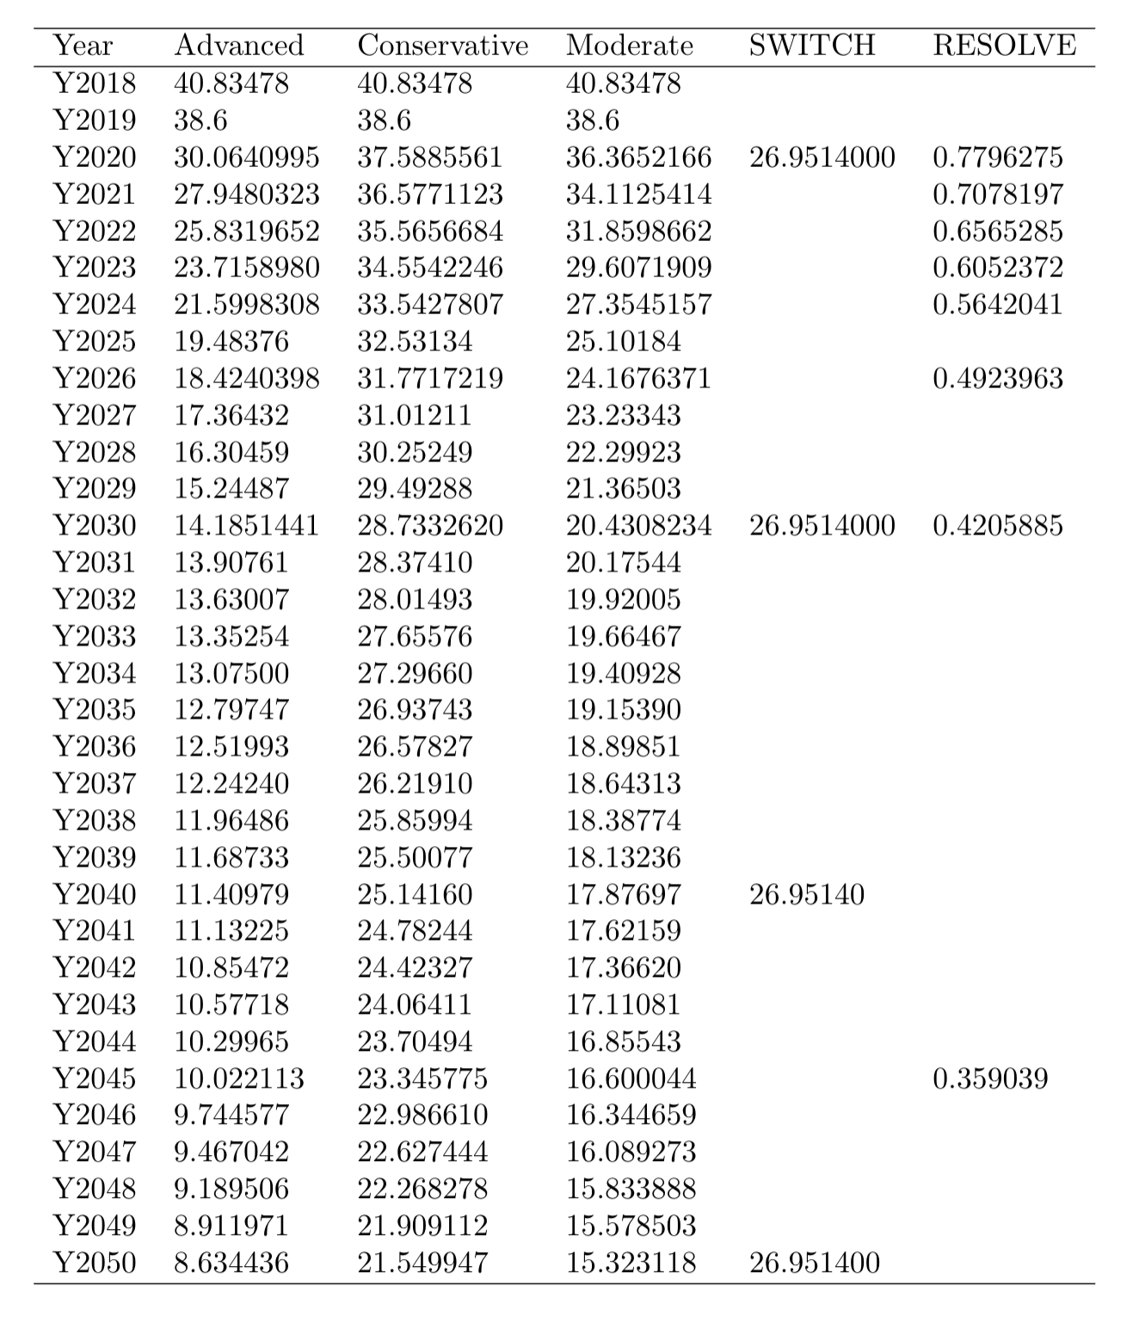

Reference

W. Cole and A.W. Frazier. 2020. "Cost Projections for Utility-Scale Battery Storage: 2020 Update" TP-6A20-75385. National Renewable Energy Laboratory
https://www.nrel.gov/docs/fy19osti/73222.pdf

