Technology Projection 1. Battery Storage
1. NREL Annual Technology Baseline 2020
NREL Annual Technology Baseline 2020 (ATB) projects CAPEX, fixed O&M costs, and variable O&M costs of utility-scale, 4-hour battery storage based on Cole and Frazier (2020). ATB sets three projection scenarios to reflect the speed of technological innovation: Conservative, Moderate, and Advanced Scenarios. Table 1 qualitatively summarized these scenarios.

Table 1: Three Projection Scenarios
Scenario | Description on technological innovation
Conservative | - Today's technology with little innovation  - Continued industrial learning  - Decreased public and private R&D
Moderate | - Widespread adoption of today's cutting edge  - Expected level of innovation  - Current levels of public and private R&D
Advanced | - Markets success of currently unproven innovation  - New technology architectures  - Increased public and private R&D

The raw data of CAPEX and fixed O&M costs are summarized in Figure 1. Regardless of scenarios or year, variable O&M is 0.85 $/MWh. ATB assumes 15 years lifetime. Any of these numbers do not include policy support such as subsidy.

Figure 1: Projections of CAPEX (left) and Fixed O&M (right) of utility-scale 4-hour battery storage in real $2018 of three scenarios from ATB

2. Comparison with current RESOLVE and SWITCH inputs
Figure 2 summarized the projection of annualized CAPEX and Fixed O&M costs of ATB three scenarios, SWITCH, and RESOLVE. In annualizing CAPEX of ATB, 15 years lifetime and 7% discount rate were assumed. The annualized CAPEX of SWITCH is between ATB advanced and ATB moderate in 2020, but its cost declines in ATB are much faster than that of SWITCH. While fixed O&M costs of SWITCH is lower than any of ATB scenarios in 2020, the projected costs of ATB become lower than that of SWITCH at least after 2035.
Annualized CAPEX and fixed O&M costs of RESOLVE is lower than those of ATB advanced scenario.

Figure 2: Projections of annualized CAPEX (left) and Fixed O&M (right) of utility-scale 4-hour battery storage in real $2018. The assumed lifetime of SWITCH and ATB are 10 and 15 years, respectively. When annualizing CAPEX, 7% discount rate is assumed.

Table 2: Annualized CAPEX of ATB, RESOLVE, and SWITCH
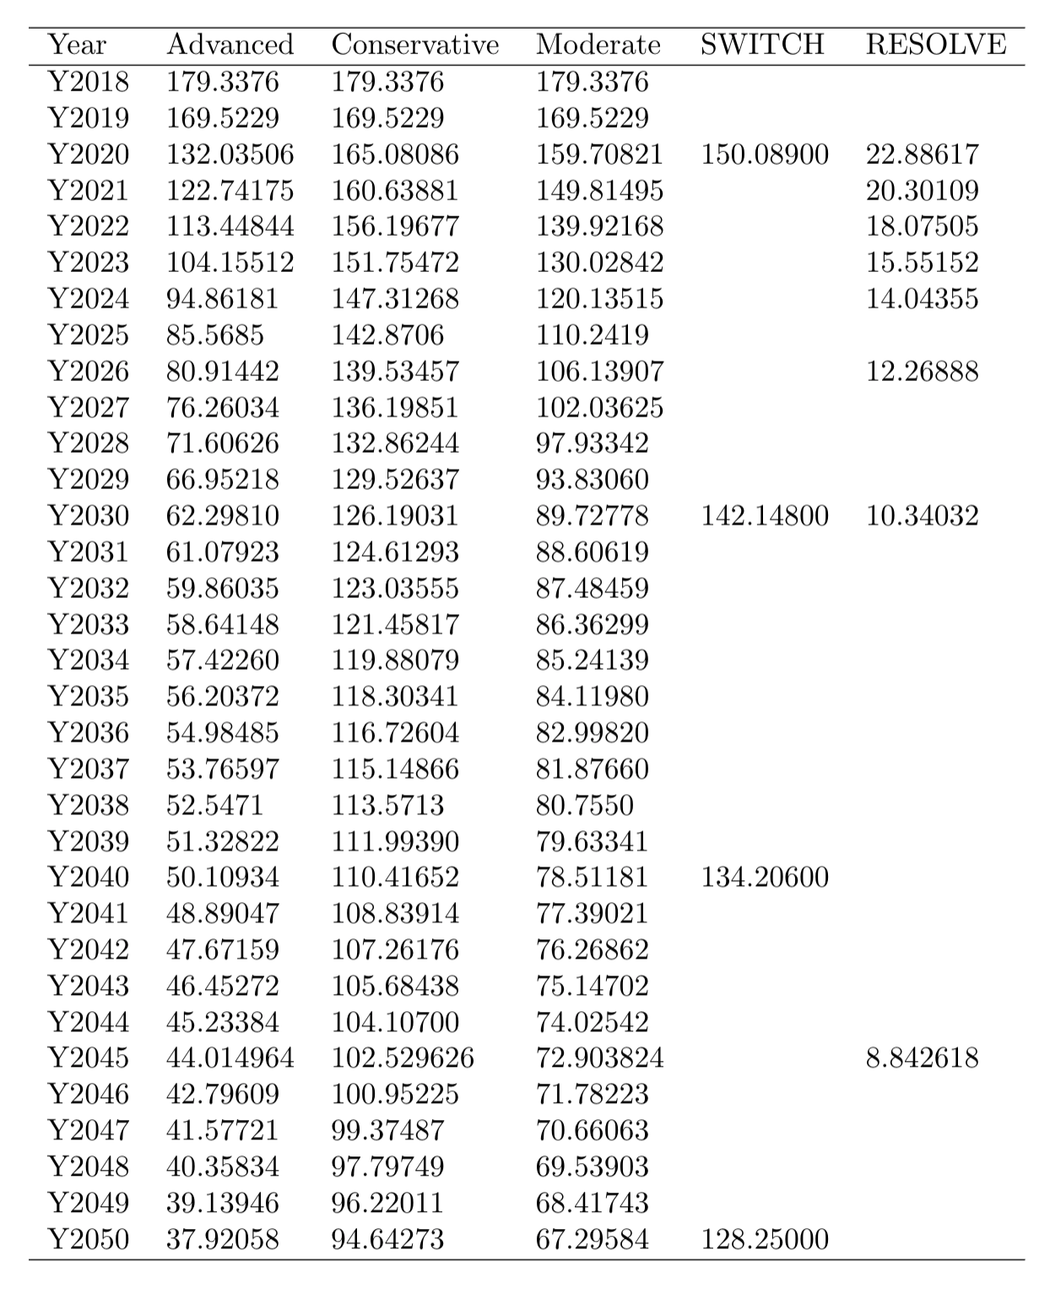

Table 3: Fixed O&M of ATB, RESOLVE, and SWITCH
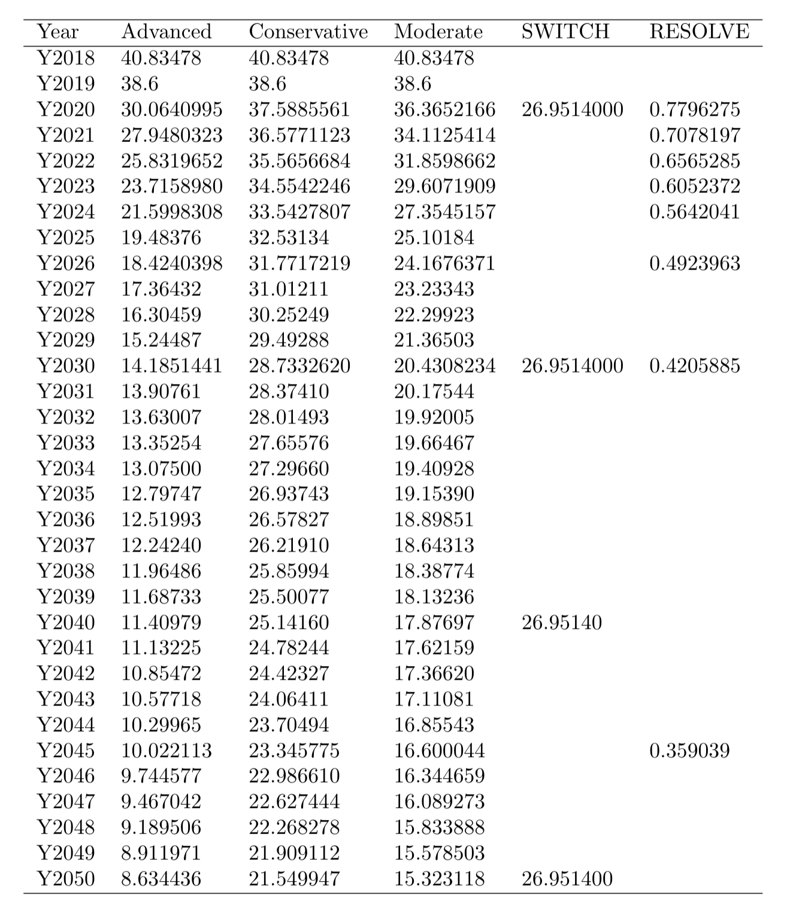

Reference

W. Cole and A.W. Frazier. 2020. "Cost Projections for Utility-Scale Battery Storage: 2020 Update" TP-6A20-75385. National Renewable Energy Laboratory
https://www.nrel.gov/docs/fy19osti/73222.pdf

