Comparison of Technological Projection in SWITCH and RESOLVE

1. Projections on the capital costs and fixed O&M costs of major technologies

The costs inputs of central PV, onshore wind, natural gas-fired power plants (CCGT), and battery storage in SWITCH (Base-case with updated solar, geothermal, and offshore wind) and RESOLVE are compared in this document.

1.1 Generation technologies
In SWITCH, costs for most technologies are assumed to stay constant in real terms through 2050 as these technologies are considered mature. In the selected technologies, onshore wind and CCGT are assumed to be mature. On the other hand, solar and battery storage technologies are assumed to decline in capital costs and/or fixed O&M costs through 2050. These projections originate from Black and Veatch (2012) for CCGT and Wind and E3 for central PV. Figure 1 and 2 summarized the annualized capital costs and fixed O&M costs in both models, respectively.

For CCGT, the annualized capital costs in both models are almost identical throughout the investment periods. On the other hand, the fixed O&M costs in RESOLVE is 65% higher than that of SWITCH.

For central PV, the annualized capital costs in SWITCH is twice as large as that in RESOLVE in 2020 and converge into the same level after 2030. The source of difference in 2020 is inclusion of policy support (ITC) in RESOLVE. Fixed O&M costs in SWITCH is five times larger than that in RESOLVE. This large deviation in fixed O&M costs is from the difference in data source. SWITCH uses Black and Veatch (2012). The fixed O&M costs need to be examined with latest data if they are appropriate.

For wind, SWITCH assumes wind as a mature technology and its capital costs and fixed O&M costs are constant throughout the study period. Both cost components are higher in SWITCH than in RESOLVE by 35% to 80%.

Figure 1: Annualized capital costs, in real $2018, of selected generation technologies

Figure 2: Fixed O&M costs, in real $2018, of selected generation technologies

1.3 Battery storage technologies
In SWITCH, battery storages are assumed to decline in costs through 2050 based on the Black and Veatch projections. Battery storage costs showed the largest disparity between SWITCH and RESOLVE model in the selected technologies. Figure 3 summarized annualized capital costs per kWh per year (left), annualized capital costs per kW per year (middle), and fixed O&M costs per kW per year (right). At most, these costs of SWITCH are higher than those of RESOLVE by factor of 2, 16, and 72, respectively.

Figure 3: Storage costs, in real $2018 (left: annualized capital costs [$/kWh/yr], middle: annualized capital costs [$/kW/yr], right: fixed O&M costs [$/kW/yr]

Table 1: Cost data summary for selected technologies
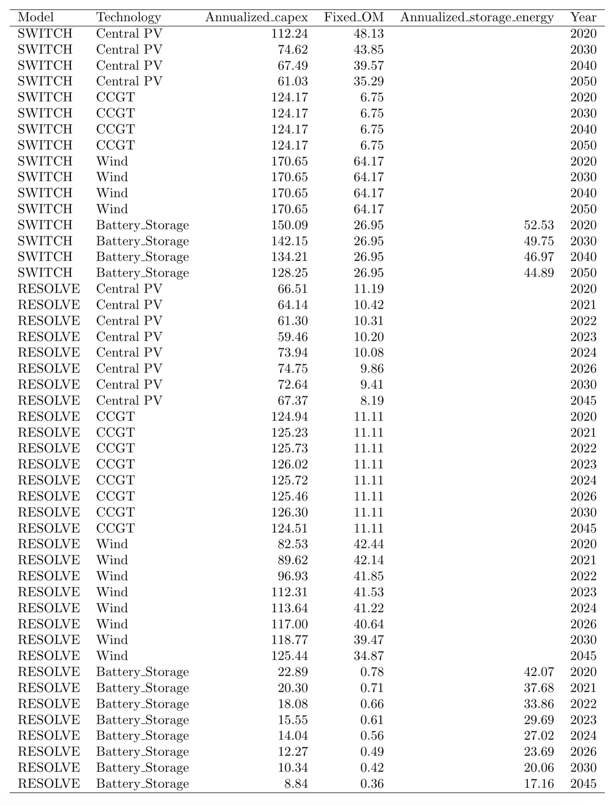

2. Other cost-related inputs of SWITCH

Discount Rate | 7%
Regional Economic Multiplier | 0.88-1.18  All costs in the model are multiplied by a regional economic multiplier of nearest MSA (US Metropolitan Statistical Areas) (USDOL 2009)
Connection Cost  (USEIA 2007) | Generic  $103,200/MW ($2013)  - Nuclear  - Gas Combined Cycle  - Gas Combustion Turbine  - Coal Steam Turbine  - Coal Integrated Gasification Combined Cycle  - Biomass Integrated Gasification Combined Cycle  - Biogas  - Battery Storage  - Compressed Air Energy Storage | Site-Specific  $74,200/MW ($2013) Substation Cost  + Additional Distance-Specific  Transmission Costs  - Wind  - Offshore Wind  - Central Station Photovoltaic  - Solar Thermal Trough, No Thermal Storage  - Solar Thermal Trough, 6h Thermal Storage  - Geothermal | Distributed  $0/MW ($2013)  (interconnection included In capital cost)  - Residential Photovoltaic  - Commercial Photovoltaic
Fuel Prices | Natural Gas  - USEIA Annual Energy Outlook 2012  - Extrapolate after 2035 | Coal and fuel oil prices  - USEIA Annual Energy Outlook 2009 | Uranium price  - California Energy Commission's 2007 Cost of Generation Model (Klein 2007)

3. New generator and storage project parameters of SWITCH

Fuel | Technology | Heat Rate (MMBtu/MWh) | Thermal Efficiency, Net (%) | Construction Time (Yr) | Lifetime (Yr) | Forced Outage Rate (%) | Scheduled Outage Rate (%) | Carbon Emissions (tCO₂/MWh)
Bio Gas | Bio Gas | 13.5 | 25.3 | 1 | 20 | 11 | 4 | 0
Bio Solid | Biomass IGCC | 12.5 | 27.3 | 2 | 40 | 9 | 7.6 | 0
Bio Solid CCS | Biomass IGCC CCS | 16.3 | 20.9 | 2 | 40 | 9 | 7.6 | -1.309
Coal | Coal IGCC | 7.9 | 42.9 | 2 | 40 | 8 | 12 | 0.759
Coal | Coal Steam Turbine | 9.0 | 37.9 | 2 | 40 | 6 | 10 | 0.860
Coal CCS | Coal IGCC CCS | 10.4 | 32.9 | 2 | 40 | 8 | 12 | 0.149
Coal CCS | Coal Steam Turbine CCS | 12.1 | 28.2 | 2 | 40 | 6 | 10 | 0.173
Gas | CCGT | 6.7 | 50.9 | 2 | 20 | 4 | 6 | 0.356
Gas | Compressed Air Energy Storage | 4.9 | 69.5* | 6 | 30 | 3 | 4 | 0.261
Gas | Gas Combustion Turbine | 10.4 | 32.8 | 2 | 20 | 3 | 5 | 0.551
Gas CCS | CCGT CCS | 10.1 | 33.9 | 2 | 20 | 4 | 6 | 0.080
Geothermal | Geothermal | - | - | 3 | 30 | 0.7 | 2.4 | 0
Solar | Central PV | - | - | 1 | 20 | 0 | 2 | 0
Solar | Commercial PV | - | - | 1 | 20 | 0 | 2 | 0
Solar | CSP Trough 6h Storage | - | - | 1 | 20 | 6 | 0 | 0
Solar | CSP Trough No Storage | - | - | 1 | 20 | 6 | 0 | 0
Solar | Residential PV | - | - | 1 | 20 | 0 | 2 | 0
Storage | Battery Storage | - | - | 3 | 10 | 2 | 0.5 | 0
Uranium | Nuclear | 9.7 | 35.1 | 6 | 40 | 4 | 6 | 0
Wind | Offshore Wind | - | - | 2 | 30 | 5 | 0.6 | 0
Wind | Wind | - | - | 2 | 30 | 5 | 0.6 | 0

References

Black and Veatch, 2012. Cost and performance data for power generation technologies. Overland Park, KS, 2012; http://bv.com/docs/reports-studies/nrel-cost-report.pdf. (this link is expired)

Klein, J., 2007. Comparative costs of California central station electricity generation technologies: cost of generation model. California Energy Commission, Sacramento, CA, 2007; http://www.energy.ca.gov/2007publications/CEC-200-2007-011/CEC-200-2007-011-SD.PDF

Mileva, A., et al. 2016. Power system balancing for deep decarbonization of the electric power sector. Applied Energy, 162, 1001-1009

McGowin, C., 2007. Renewable Energy Technical Assessment Guide. TAG-RE:2007. Palo Alto, CA: Electric Power Research Institute.

United States Department of Labor, 2009. Occupational pay comparisons among metropolitan areas. Bureau of Labor Statistics, Washington, DC, 2009.

United States Energy Information Administration, 2007a. Form EIA-860 database annual electric generator report. Washington, DC, 2007.

United States Energy Information Administration, 2012. Annual energy outlook 2012. Washington, DC, 2012.

