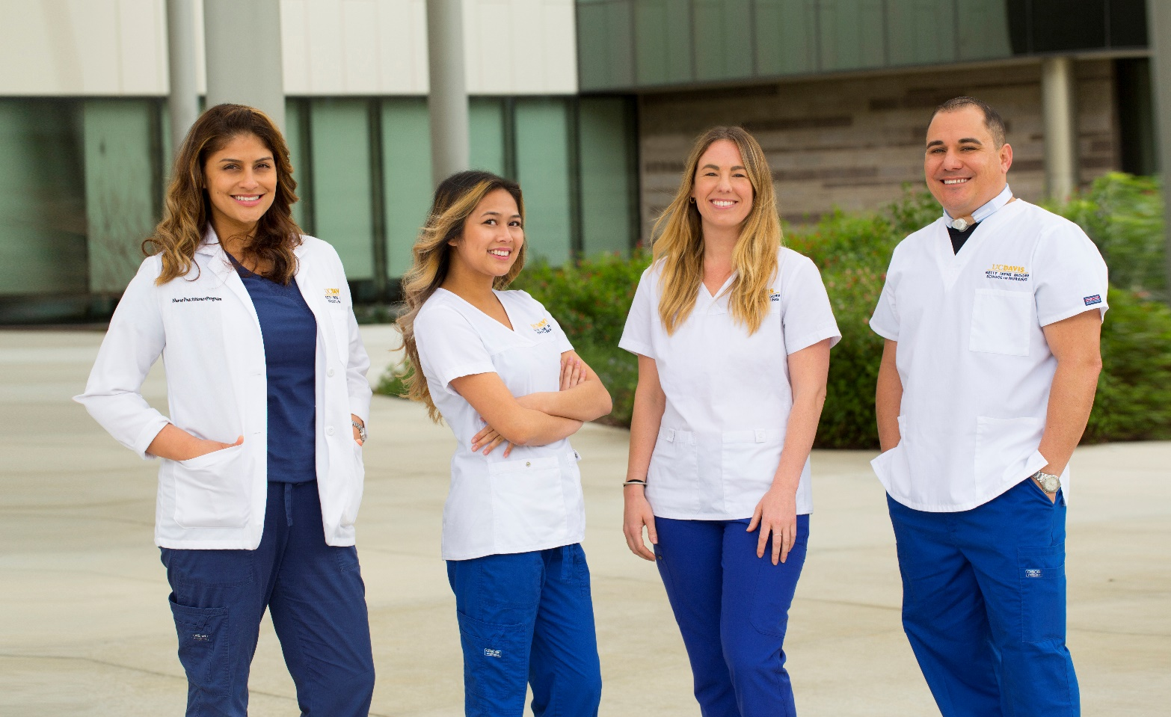

**Master’s Entry Program in Nursing**

Tuesday, October 20

1 p.m. – 2 p.m.

**Zoom Link:**

Meeting ID: 969 7537 4852   
Passcode: SON

**Physician Assistant Studies**

Wednesday, October 21

2 p.m. – 3 p.m.

**Zoom Link:**

Meeting ID: 961 9235 7012   
Passcode: SON

**Discover the path to your future**

Whether you see your future as a nurse, physician assistant, family nurse practitioner or researcher, the Betty Irene Moore School of Nursing at UC Davis is ready for you. Ranked among the nation’s top 50 nursing schools by *U.S. News & World Report*, our innovative teaching and expert faculty help students build a foundation for a brighter future.

With state-of-the-art facilities located on the UC Davis Sacramento campus, you’ll experience hands-on learning, high-tech simulation training, and the best educators who invest in your success. Take the next step so you can achieve your dreams and become a health care leader. Advance your career with our graduate programs:

* Master's Entry Program in Nursing
* Master of Health Services – Physician Assistant Studies
* Master of Science – Family Nurse Practitioner
* Doctor of Philosophy

Learn more at **nursing.ucdavis.edu**.

October

**20 & 21**