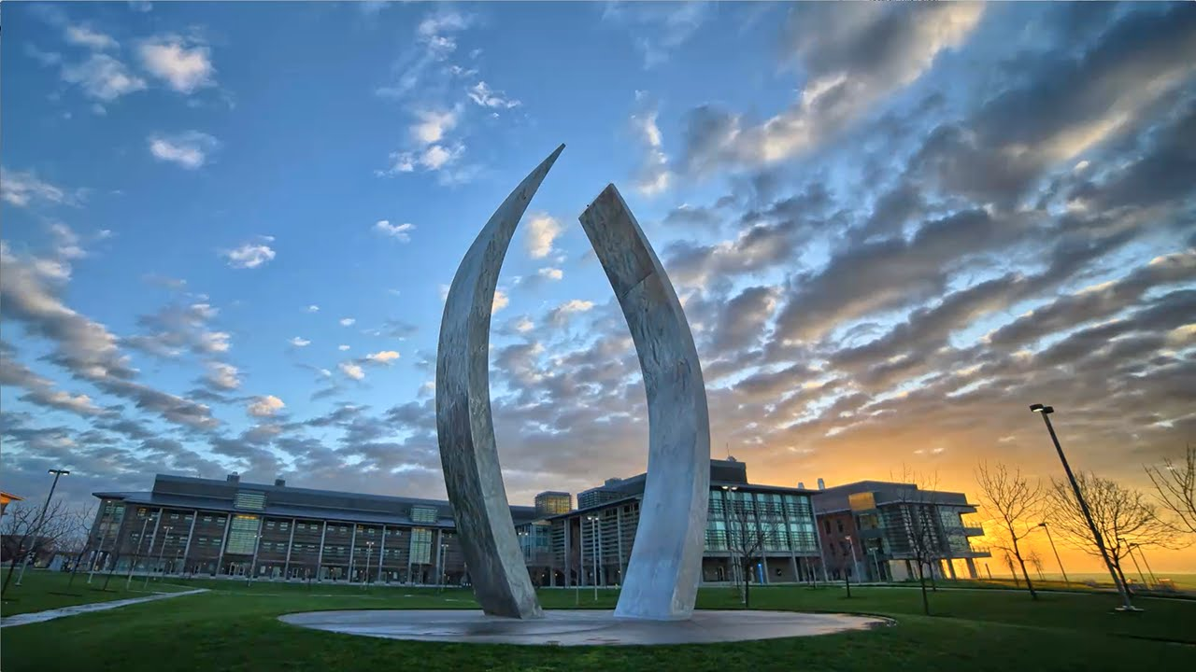

MCAT Tips

By Dr. K

-------------------------------------

**Monday, April 29**

**1:30 PM to 2:30 PM**

**Science and Engineering 1**

**Room # 270K**

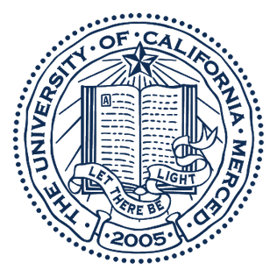**By participating in this informative session, you will have the opportunity to answer the following questions:**

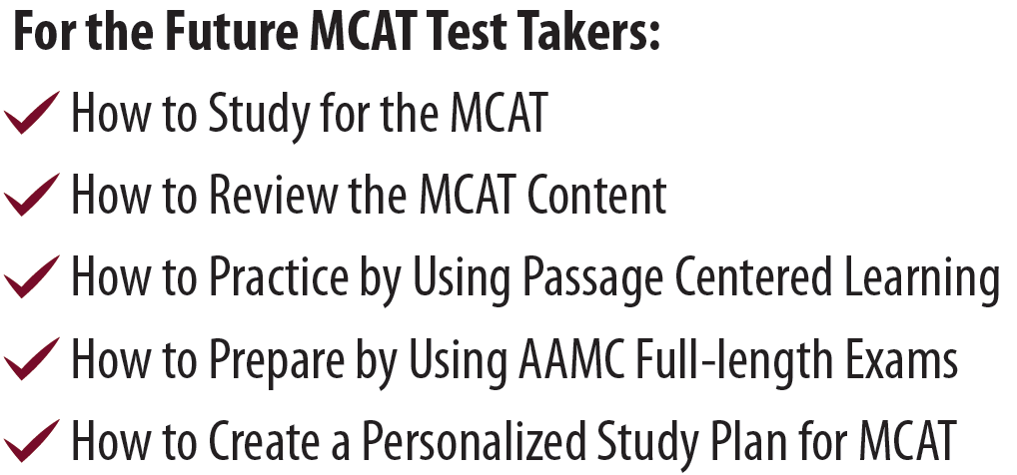

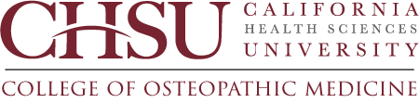

*Presentation by Dr. Samuel Kadavakollu (Dr.K) Associate Professor of Biomedical Education and MCAT Faculty from CHSU College of Osteopathic Medicine, Clovis. Dr. K has been teaching MCAT prep courses and test taking strategies for the last seven years and has helped hundreds of pre-med students to improve their test scores by 35% on average after finishing his prep courses. If you would like to know more about the new osteopathic medical school in the central valley and like to score >500 on your MCAT, come and join this presentation.*